**Experiment #1: Simple Harmonic Oscillator – mass on a spring**

**A. Objectives**

The main objectives of this lab are the following: To understand simple harmonic motion of a mass attached to a spring, to measure the spring constant using two methods, and to examine how the period of oscillations changes with the amplitude and the mass attached.

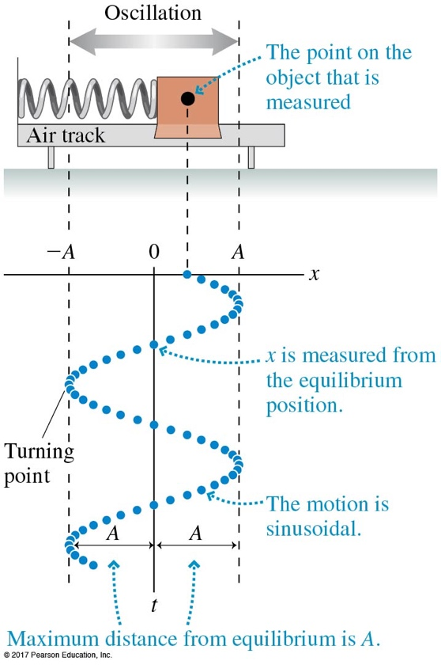**B. Equipment Used**

Springs, C-clamps, posts, metal arm with screws, 2-m stick and rulers, stopwatch *(use user phone as stopwatch),* assorted weights and hangers, balance.

**C. Theory**

The equation of motion for a mass *m* oscillating on a an ideal spring of stiffness *k* is given by

*m* d2x/dt2 = -*k*x, (1)

producing a sinusoidal solution for displacement of the mass from equilibrium

x(t) = A cos(ωt + ϕ0), (2)

where ω = is the angular frequency of the spring-mass oscillator, measured in *rad/s.*

The period of oscillations can be determined as T = 2π/ω, or

(3)

***In this lab we will first determine the spring constant k***of a vertical spring by measuring the spring deformation ΔL when different masses are suspended to its end, and applying Hook’s law to find the relationship between the mass and the spring constant.

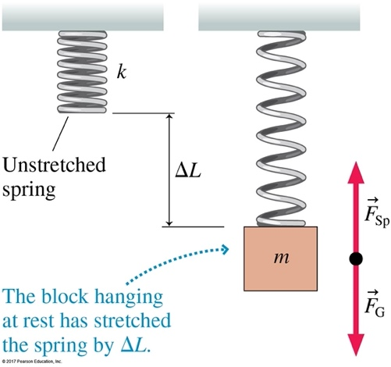At equilibrium

*FG = FSp 🡪 m*g = *k*ΔL, (4)

where ΔL = L – L0 is the amount the amount that the spring stretches when applying the mass m.

**Second, we will investigate the way the period of oscillations depends on the mass** attached *m* and use this as a second methos to determine the spring constant.

**Third, we check how the amplitude A** of the motion affects the oscillation period T.

**D. Determine the spring constant *k* using Hook’s Law**

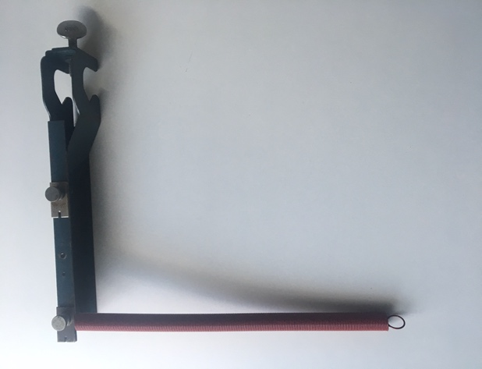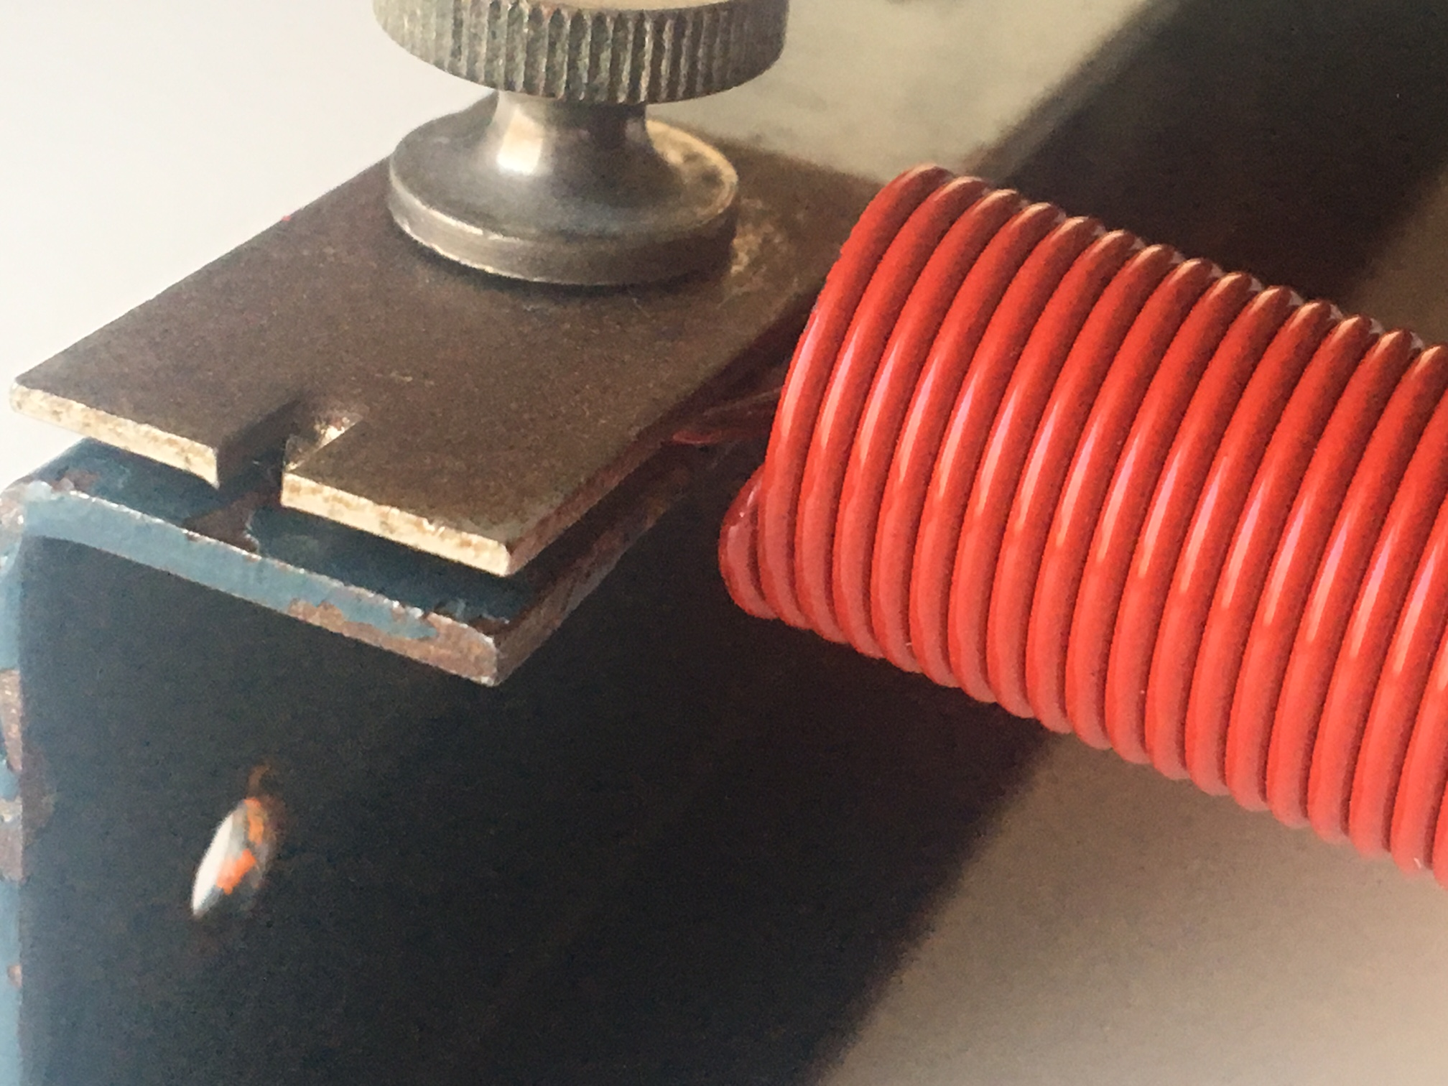

Mount the metal post to the table by using the C-clamp, and the metal arm horizontally at a convenient height. Mount ***one spring of your choice*** to one of the screws of the metal arm as shown in the figure, and secure the thumb screw to metal plate to limit the swinging of the spring (allow only vertical oscillations). Record the length of the spring before attaching any weights.

Spring color: ___________________

Length of unstretched spring: L0 ______________________

This is the un-extended length of the spring that you will use for the rest of your calculations (for this spring). ***Make sure that all the length measurements you will be making for this spring are between the same two points you used here***.

Attach masses to the end of the spring using the hangers provided and measure the length of the spring. Record the values in the table below. You should use 8 – 10 masses, with values between 250g and 800 g, in increments of 50 g - 100 g*.* ***Make sure you include the mass of the hanger, but do NOT include the mass of the spring***.

**Table 1. Measurements of the spring** (color:_________ ) **length versus mass**

|  |  |  |  |
| --- | --- | --- | --- |
| Mass m (Kg) | Fg = m⋅g (N)  *(take g = 9.80 m/s2)* | Spring length L (m) | ΔL = L - Lo (m) |
| 0.300 | 2.94 |  |  |
|  |  |  |  |
|  |  |  |  |
|  |  |  |  |
|  |  |  |  |
|  |  |  |  |
|  |  |  |  |
|  |  |  |  |
|  |  |  |  |
|  |  |  |  |

Using Excel, Google Sheets, or any other software of your choice, make a graph for FG = *mg (y-axis)* vs *ΔL = L-L0* (x-axis) and fit with a straight line. Determine the slope and the y-intercept and use this information to find the spring constant *k.* **Display the fitting function and parameters on the graph, including R2.**

*slope: ________________ intercept: _____________*

*kmeas* = _________________ R2 = ________________

Attach the graph with your worksheet, making sure your data displays properly (over more than 75% of the graph area), label the axes and include units.

Briefly discuss your observations and sources of errors/uncertainties.

**E. Determining the spring constant from measurements of the period of the motion T**

Keeping the amplitude sufficiently small and starting with a mass of 250 g, set the spring-mass system into simple harmonic motion and measure again the time for 10 complete oscillations as you did to part D. Increase the mass in 50 g – 100 g increments and repeat these measurements. Calculate the period of motion T and T2 and enter in Table 2. *Make sure you again that you include the mass of the hanger.*

|  |  |  |  |  |  |  |
| --- | --- | --- | --- | --- | --- | --- |
| Mass (Kg) | Δt for 10 osc. (s) | Tmeas=Δt/10 | T2 (s2) | *kmeas (E)* | *kmeas (D)*  (Hook’s Law) | % uncertainty |
| 0.300 |  |  |  |  |  |  |
|  |  |  |  |
|  |  |  |  |
|  |  |  |  |
|  |  |  |  |
|  |  |  |  |
|  |  |  |  |
|  |  |  |  |
|  |  |  |  |
|  |  |  |  |
|  |  |  |  |
|  |  |  |  |

Table 2. Measurements of the period vs mass

Use Excel to make a plot of T2 vs m using SI units for all quantities. Fit with a line, and determine the slope and the intercept, and display these values and R2 on your graph.

From equation (3) we find that T2 = *(*4π2*/ k)* *m*. The slope of your graph is *(*4π2*/ k)*.

Determine kmeas and compare it with the value obtained at part D.

*kmeas F* = _________________ R2 = __________________

% error = | *kmeas F – kmeas D*| */ kave x 100 = _____________________*

Discuss errors/uncertainties and sources of uncertainties.

Attach this second graph with your worksheet, making again sure your data displays properly (over more than 75% of the graph area), label the axes and include units.

**F. Measuring the period of the motion (T) vs Amplitude of motion (A)**

Choosing a mass value in the mid of the range used at part D, displace the mass by a small amount (e.g. 2-5 cm) from the equilibrium position, setting the mass-spring system into small oscillations. Measure the time Δt for **10 complete oscillations** and calculate the period of oscillations Tmeas. Increase the amplitude in 1-2 cm increments and repeat 4 more times.

Calculate the period of simple harmonic motion using Equation (3) and compare with the measured values.

Table 3. Measurements of the period vs amplitude of motion

|  |  |  |  |  |
| --- | --- | --- | --- | --- |
| Amplitude (cm) | Δt for 10 osc. (s) | Tmeas=Δt/10 | Tcalc= 2π (*m / k*)1/2 | % uncert. = |Tmeas – Tcalc|/Tcalc x 100 |
|  |  |  |  |  |
|  |  |  |  |
|  |  |  |  |
|  |  |  |  |
|  |  |  |  |

What do you observe?

Discuss errors and sources of errors.