

Hey,

Welcome to project!

!

l

Main idea
To facilitate the public in all possible ways

Topic: Fatehz Rozgaar
And humainity foram

March 23

Submitted to Sir Laeeq khan Niazi.
Authored by: Manahil Fatimah.

Our services are available in different cities Of Pakistan.
FATEHZ ROZGAAR AND HUMAINITY FOARM

________________________________________________________________________
THIS PROGRAM PROVIDE AND INTRACTION BETWEEN
NEEDY PERSONS AND HUMAINITY CENTER

If a user wants need any financial support our team will urgently facilitate him.

User is given by following options:
- Home construction for widows.
- A rikshaw provider for jobless people.
- Coffee shop construction.
- Free education institute.
- Free medical service provider.
- Free books uniform & stationary provider.
- As a cyber security manager.
- A female transport rider only for girls.
- Donation for earth quake surviver.
- Free food provider.
- Free mental health service provider.

Here user have to select one of the following
option… after selecting Option he will be taken
to his required menu.

After entering menu user is asked to enter his information related to his problem:

Wireframes are given as following:
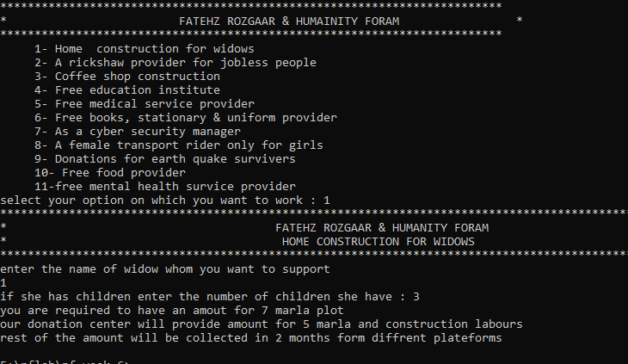

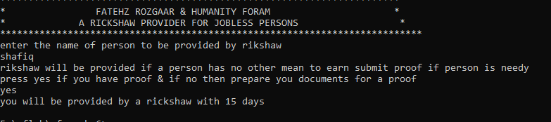

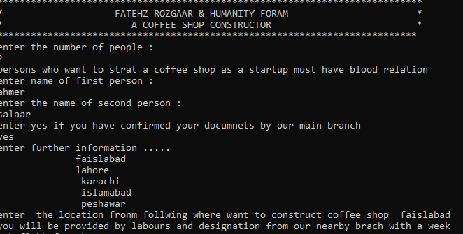

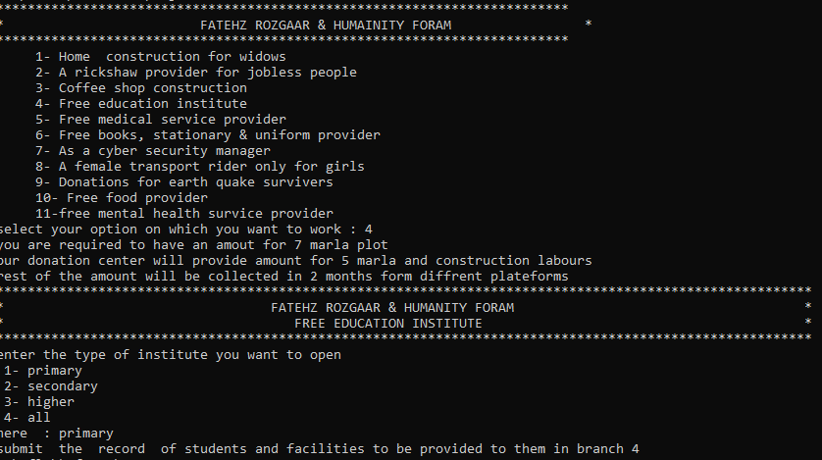

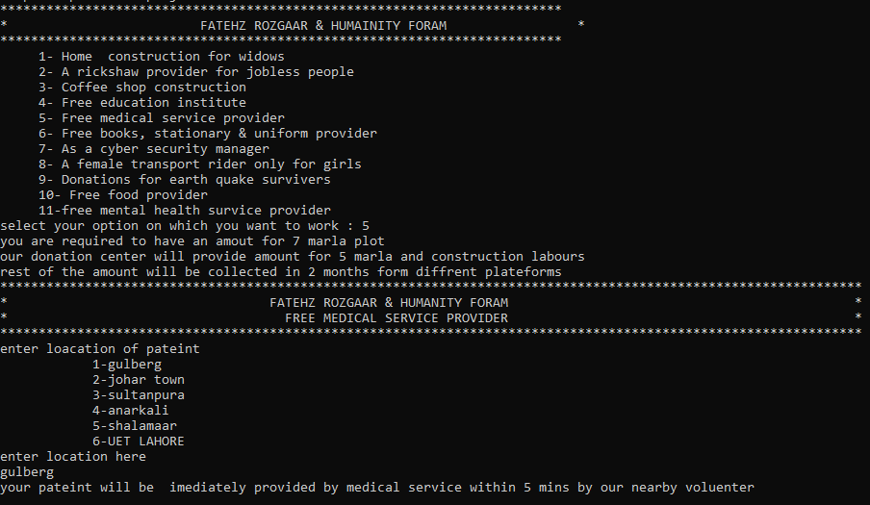

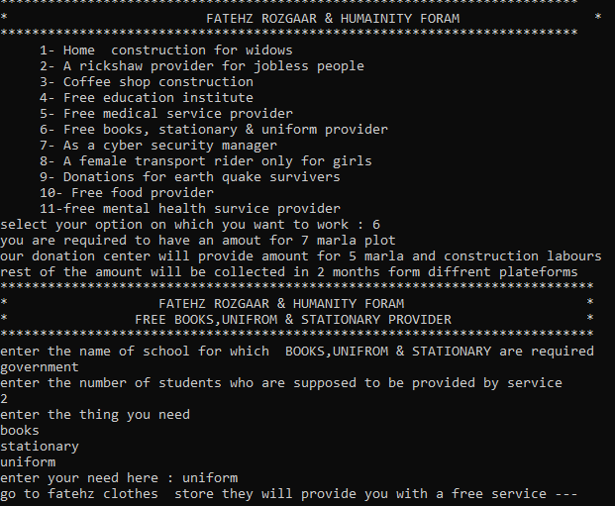

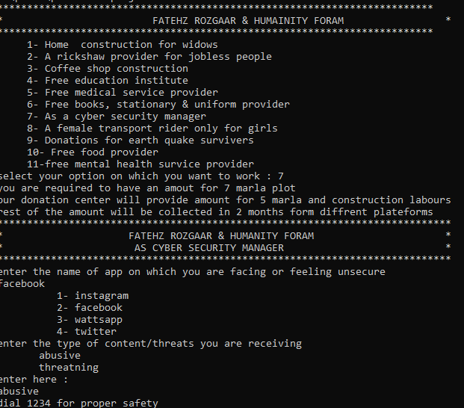

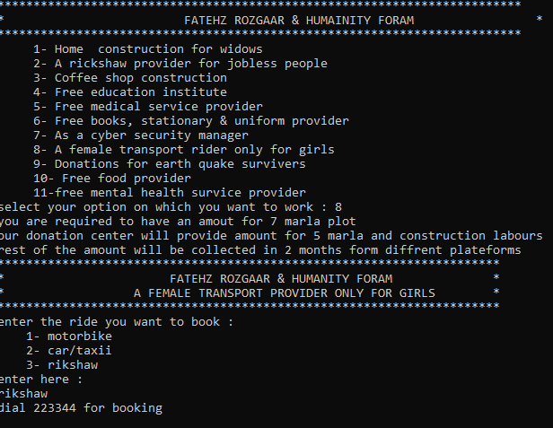

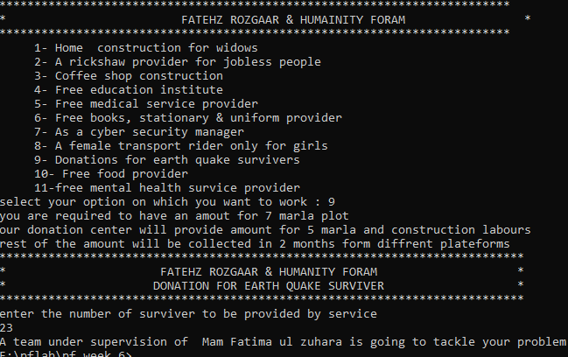

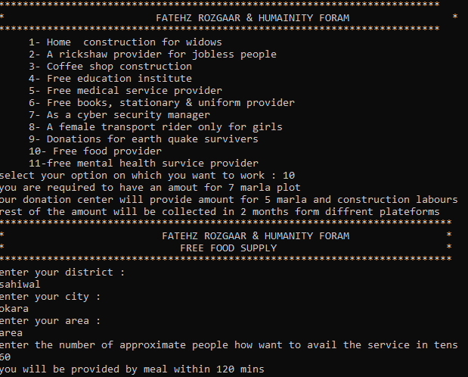

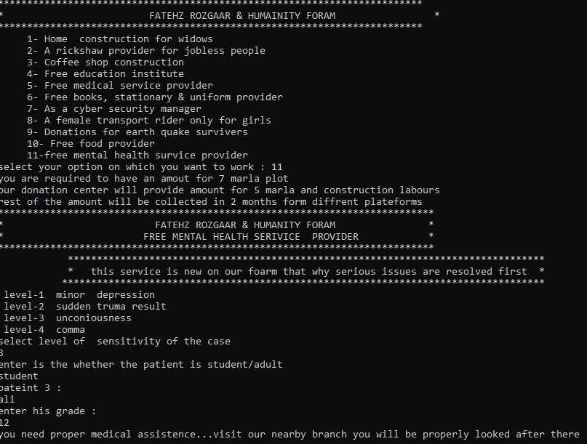

Once mahatra ghandhi said :
“ the greatness of humanity is
not in being human,but in being humane”
thanks for contacting
fatehz rozgaar and humainity foarm.

