LAB # 09
NAIVE BAYES CLASSIFIER
Procedure:
Task 1:
Source Code And Output:
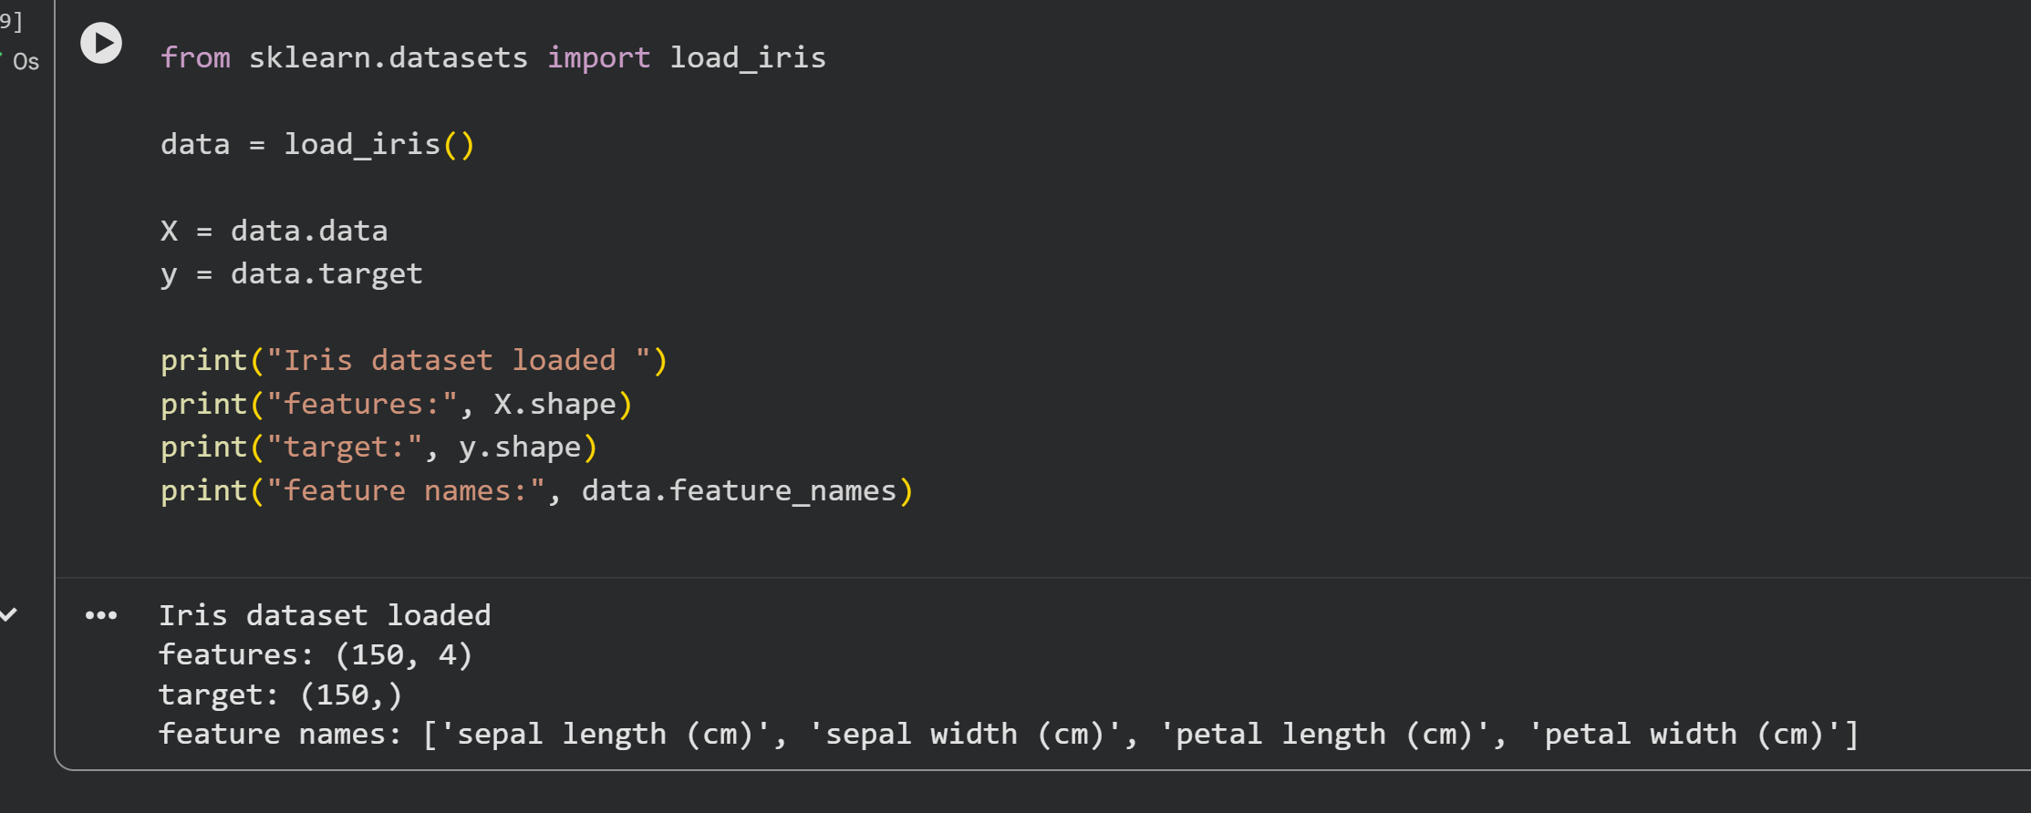

Task 2:
Source Code And Output:
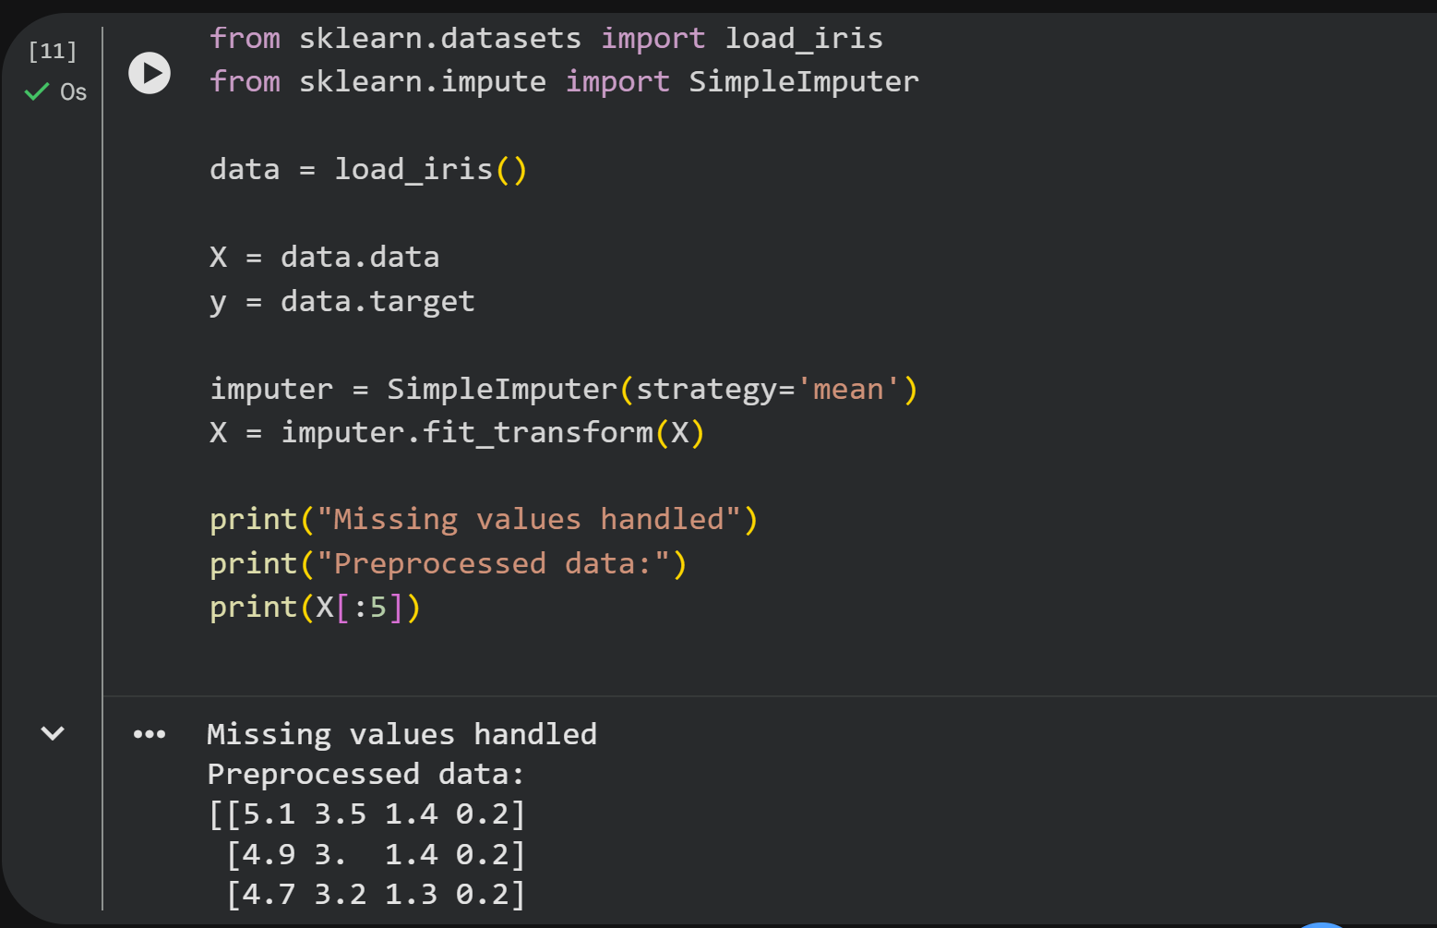

Task 3:
Source Code And Output:
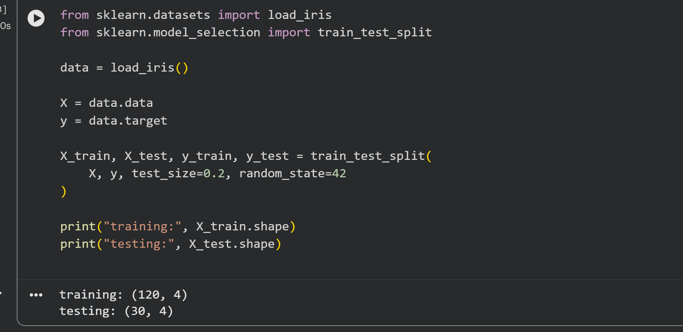
Task 4:
Source Code And Output:
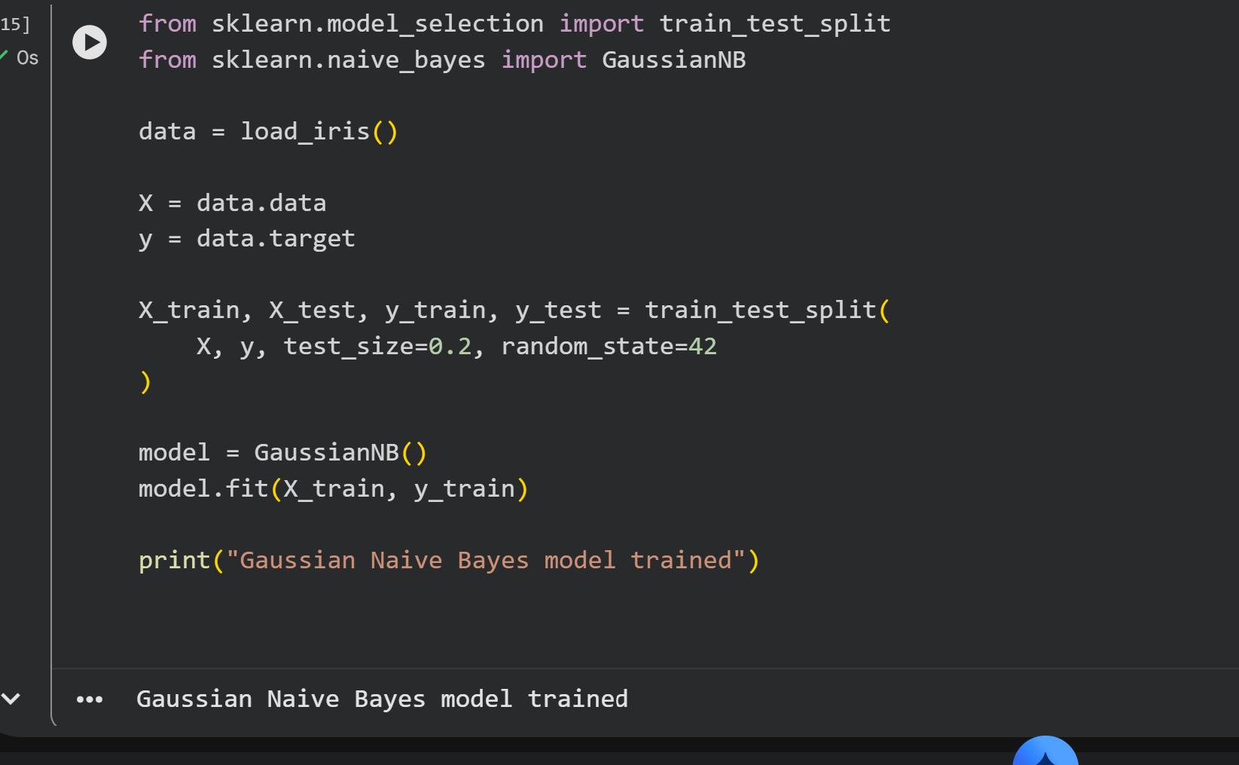

Task 5:
Source Code And Output:
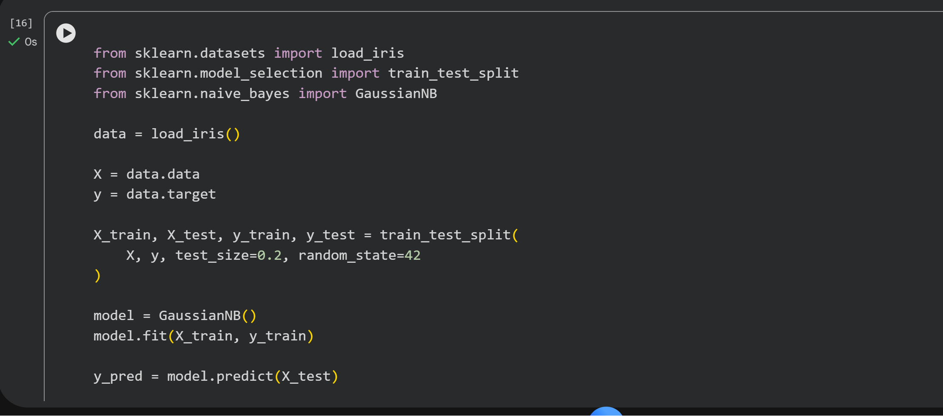
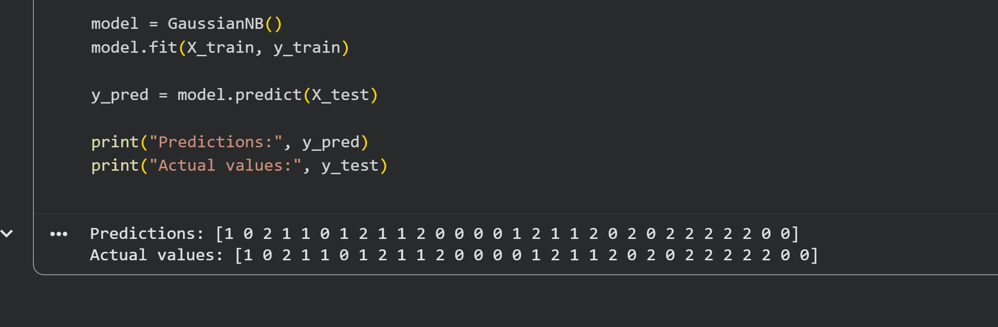

Task 6:
Source Code And Output:
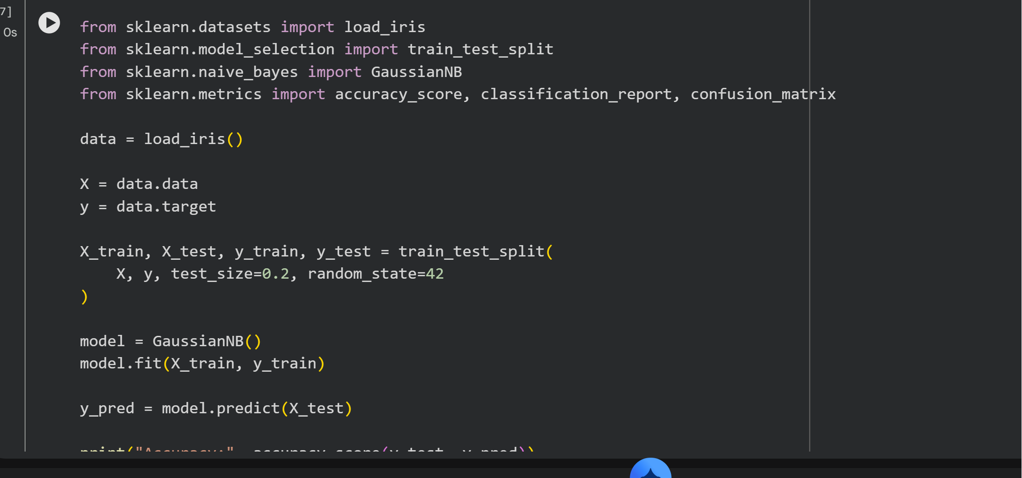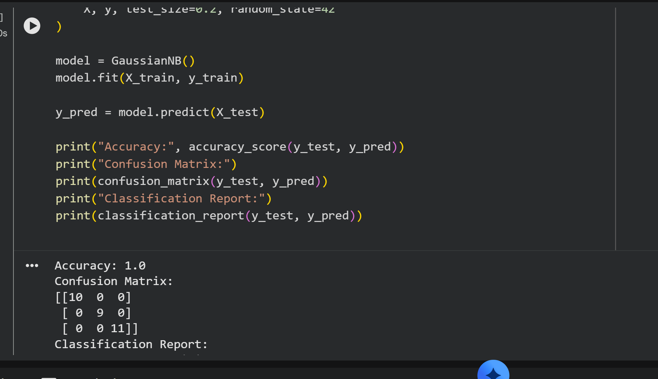
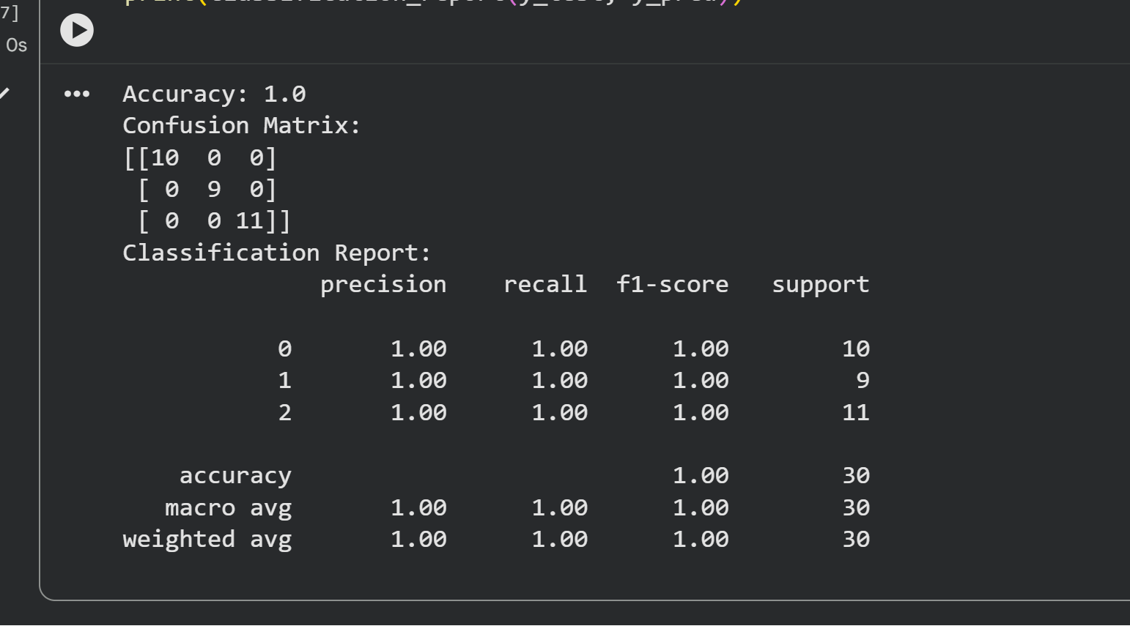

Task 7:
Source Code And Output:


