LAB # 05 RANDOM FOREST CLASSIFIER

Task 1:
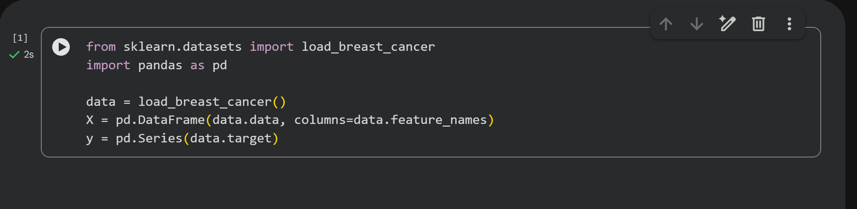
Task 2:
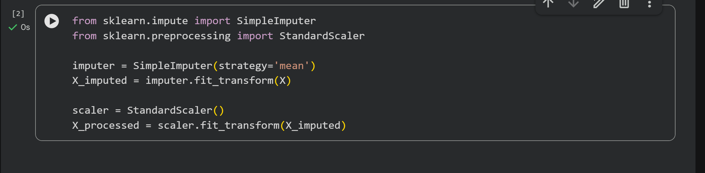
Task 3:
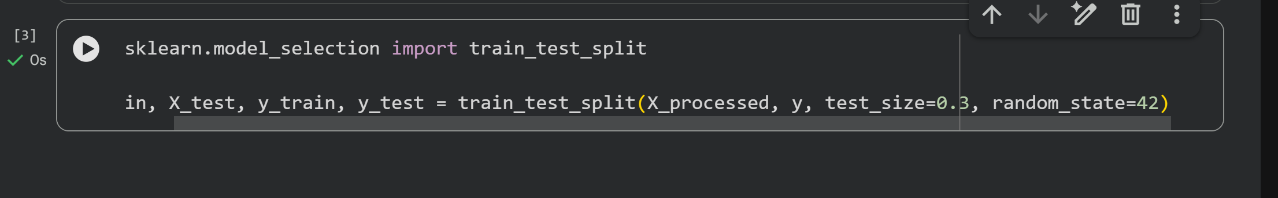

Task 4:
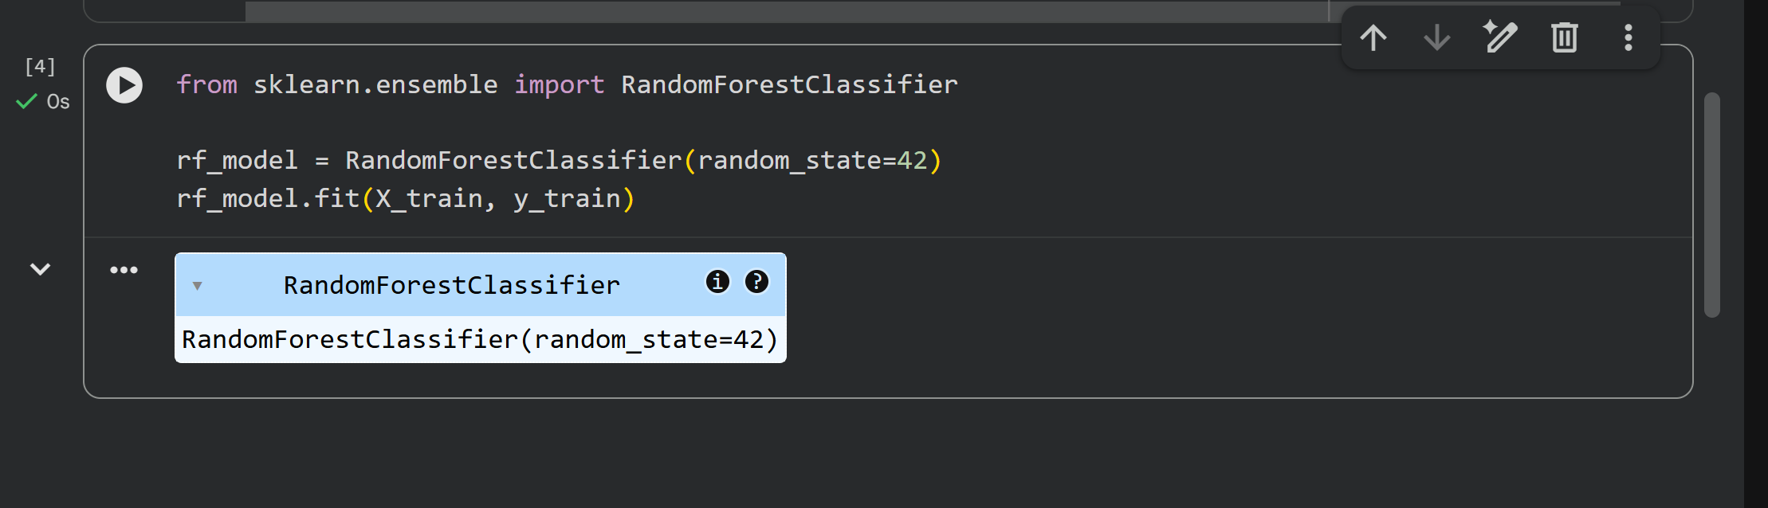

Task 5:
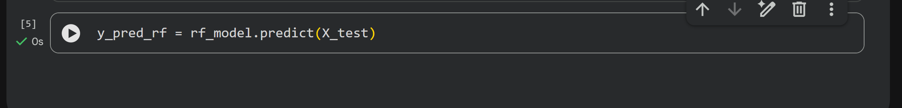
Task 6:
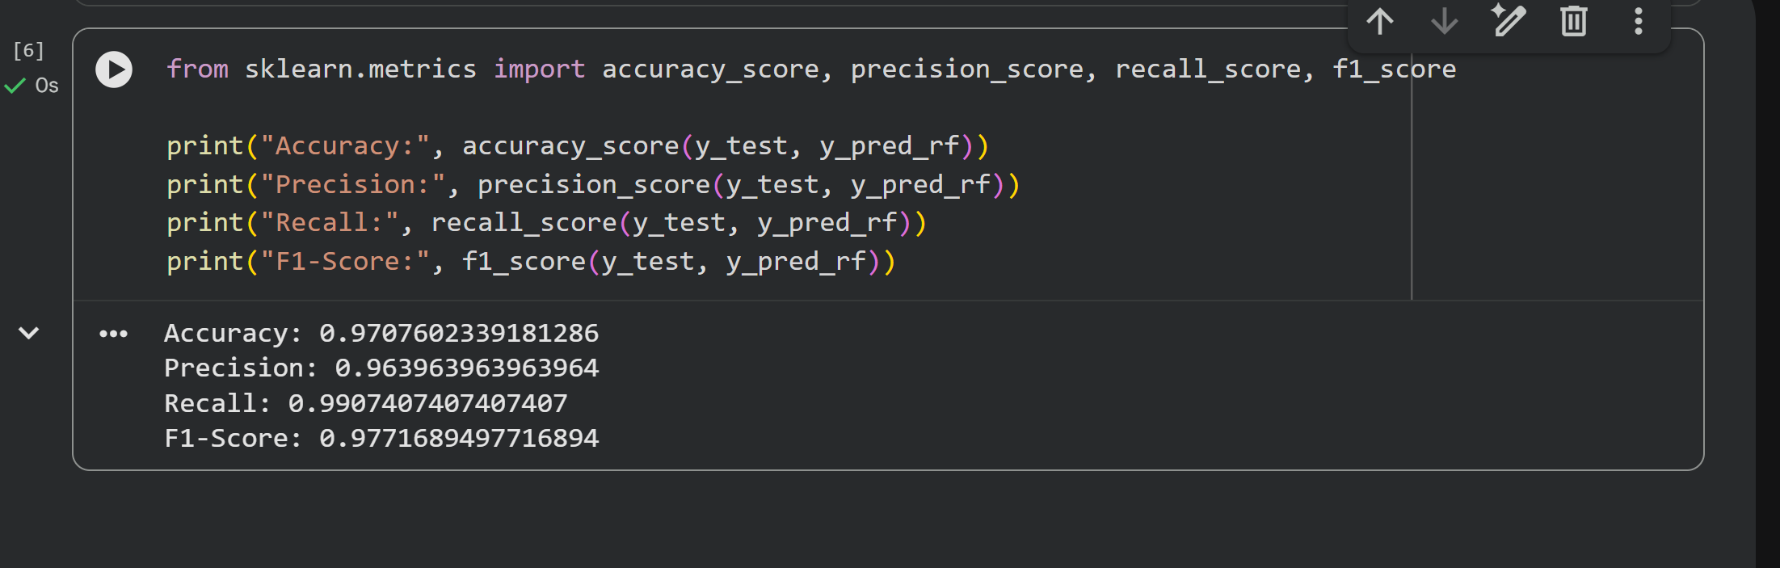

Task 7:
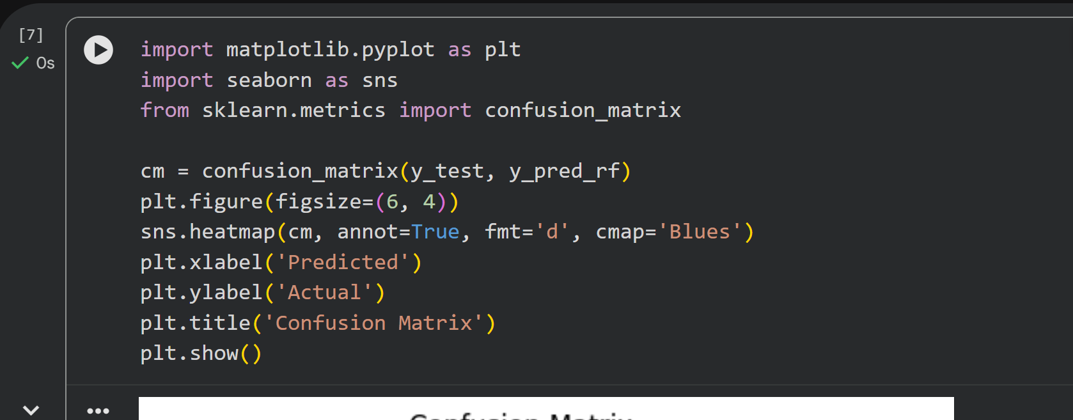
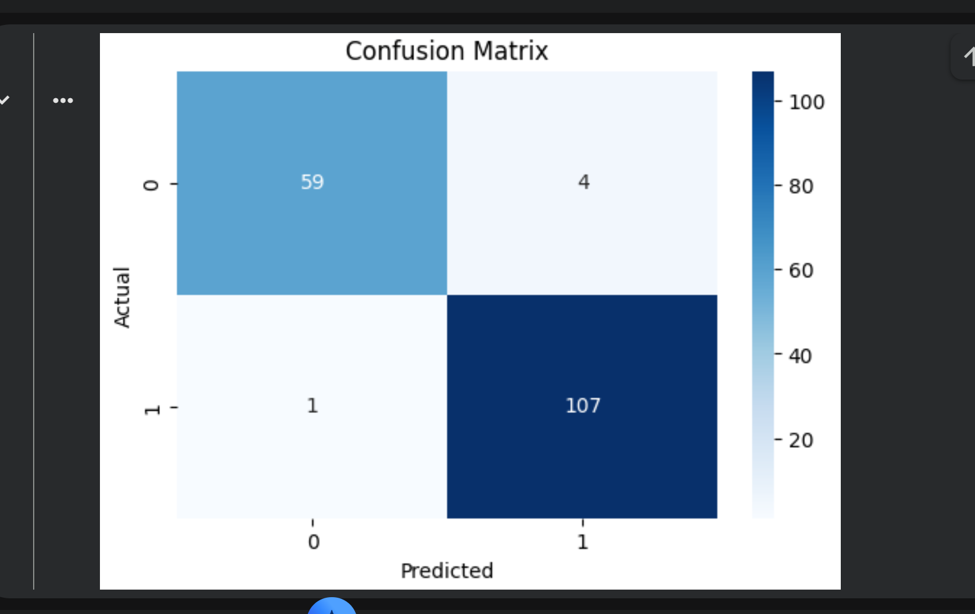
Task 8: 

