Lab No: 2
SIMPLE AND MULTIPLE LINEAR REGRESSION

Task 1:
Code:
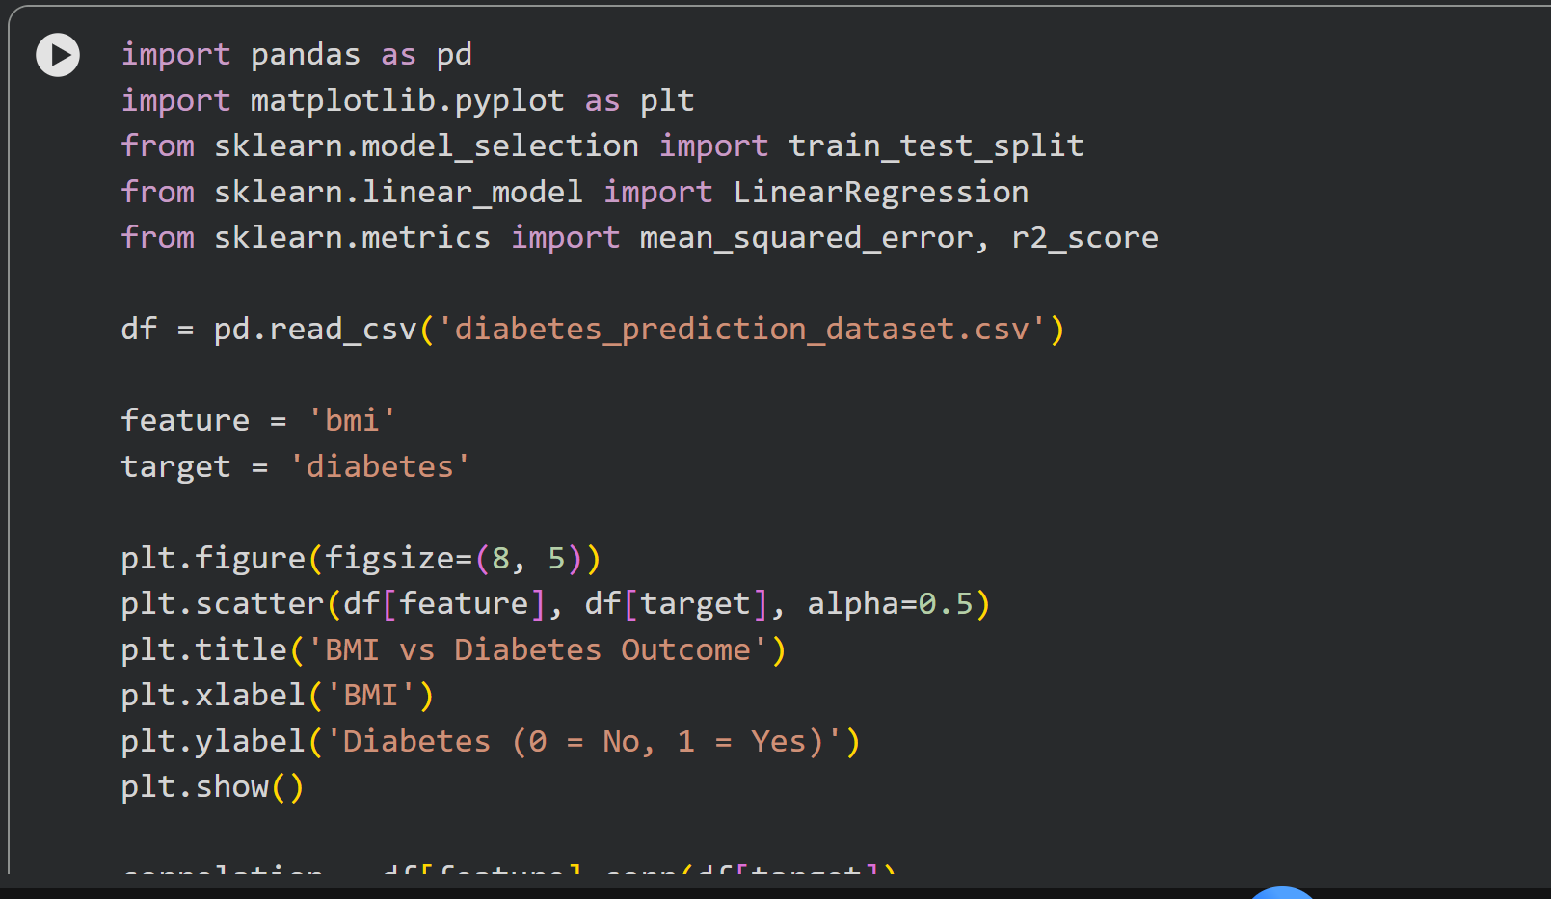
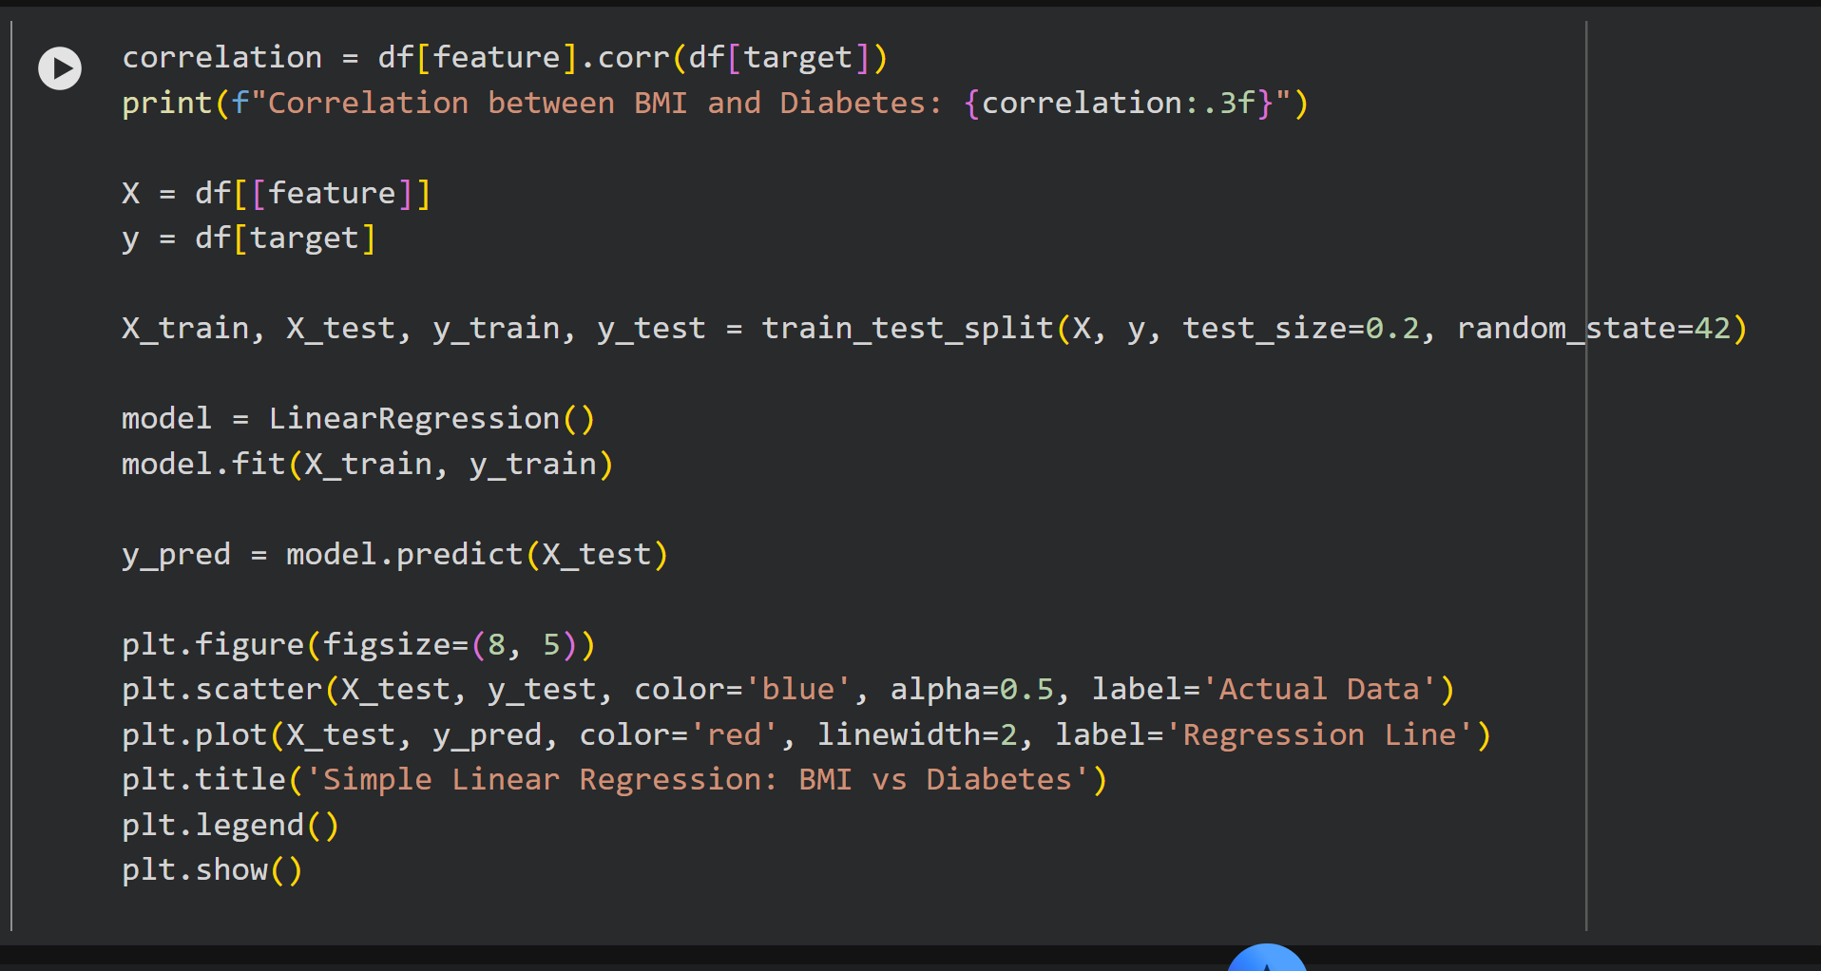
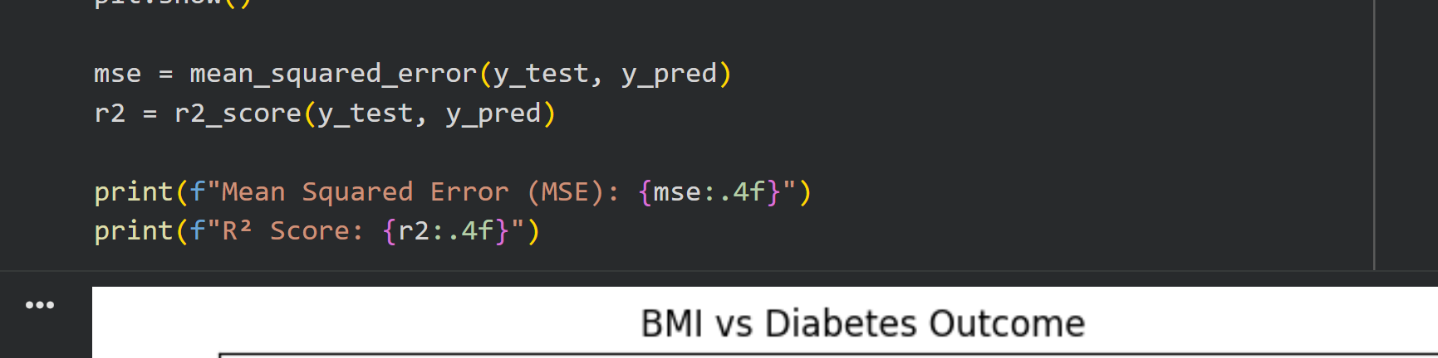
Output:
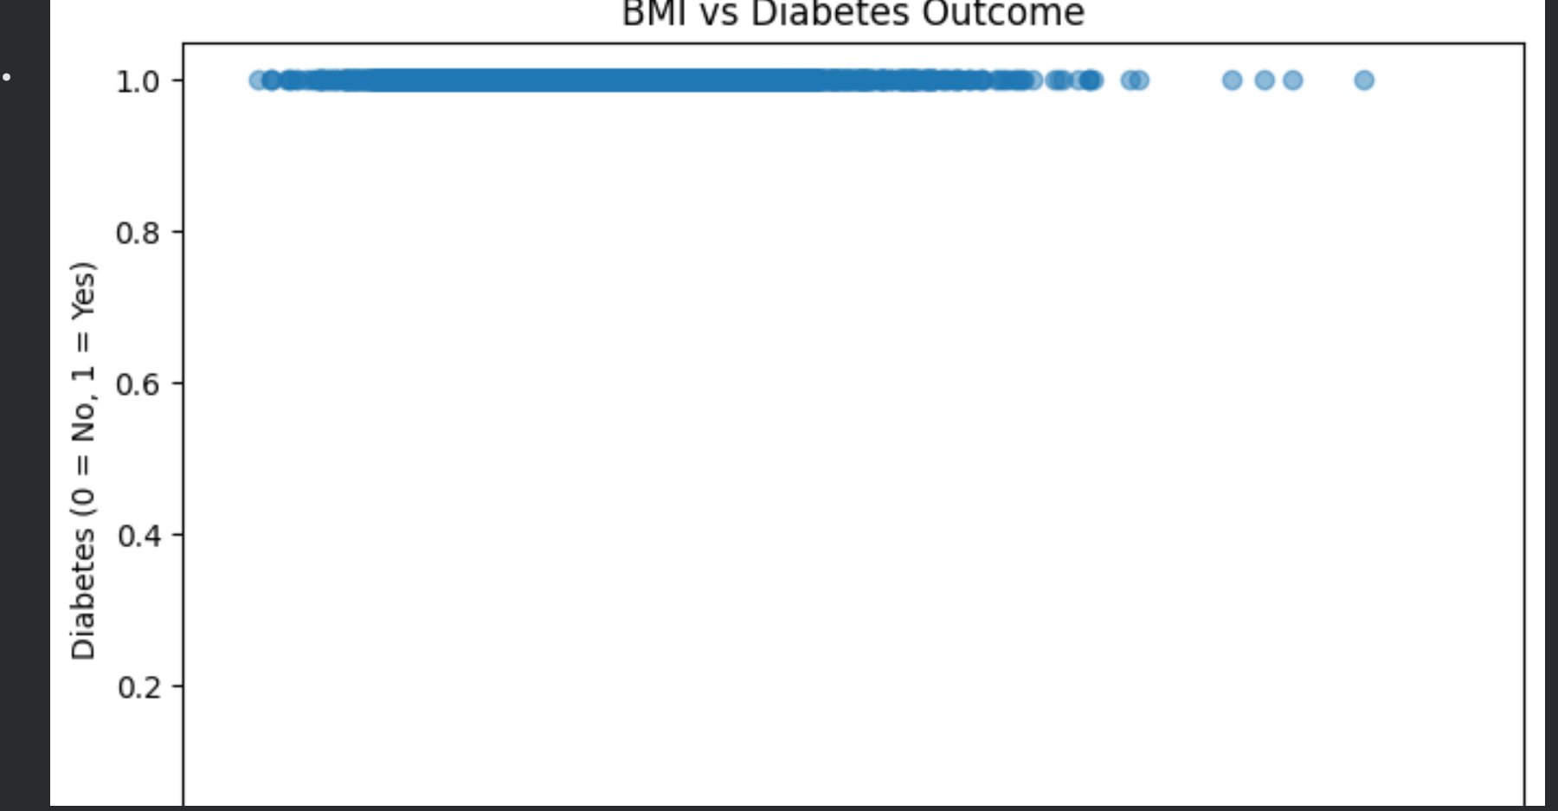
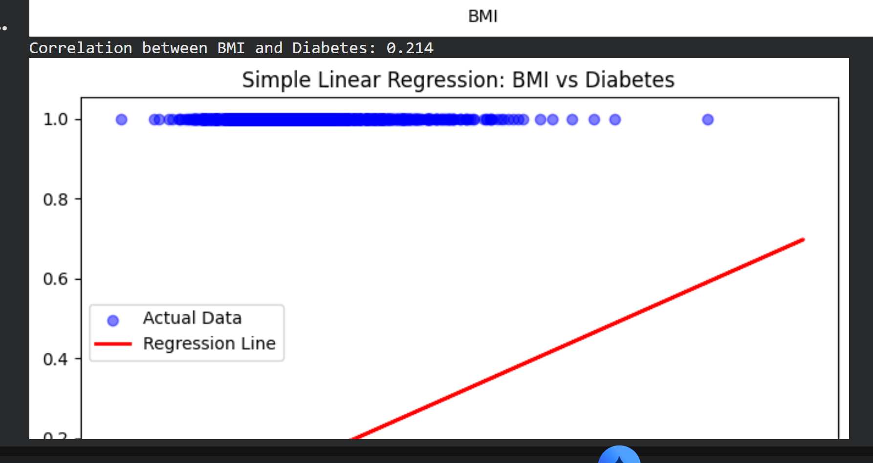
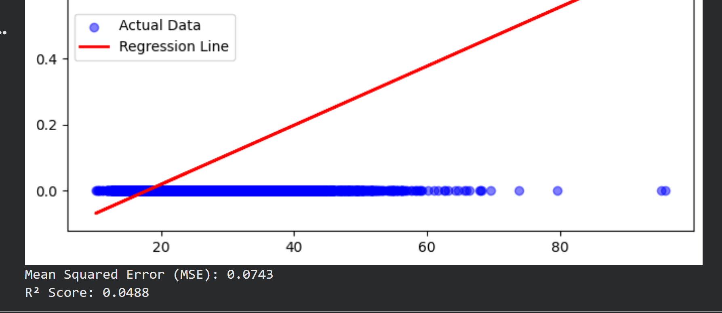

Answer:
No, BMI alone does not explain most of the variation in diabetes outcome. The R² score is 0.0488, which means BMI only explains about 4.88% of the variance in the target variable. This is a very low R², indicating that the other 95% of the variation is due to factors not included in this simple model.

Task 2:
Code:
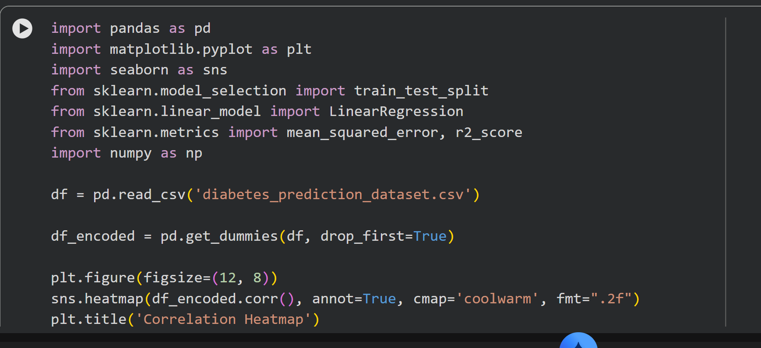
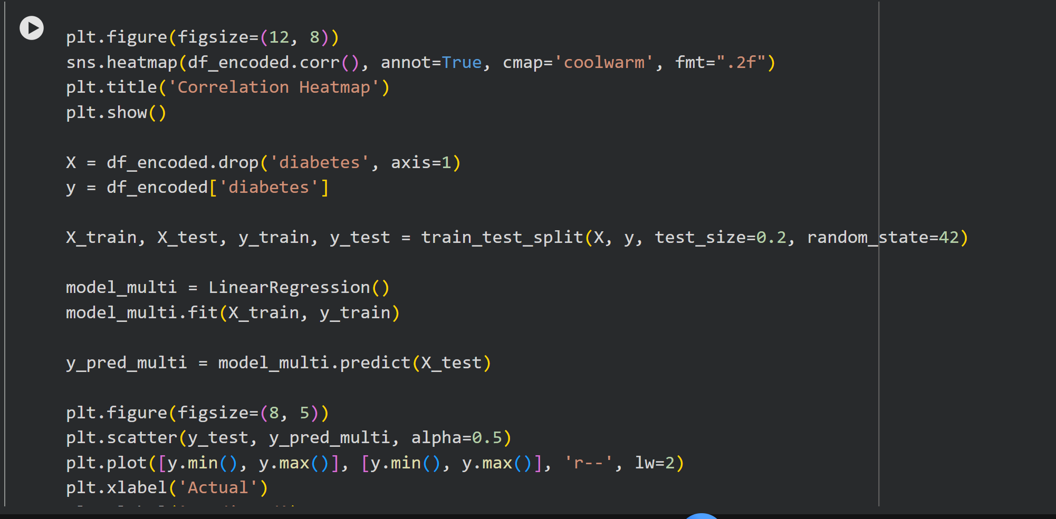
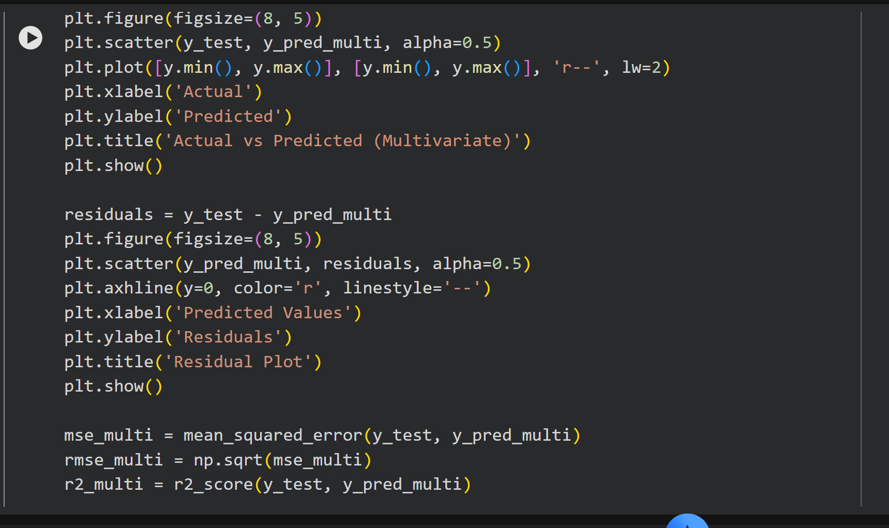
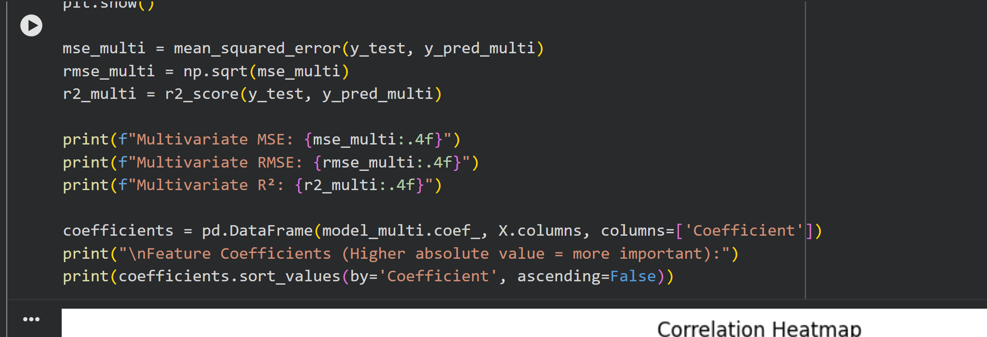

Output:
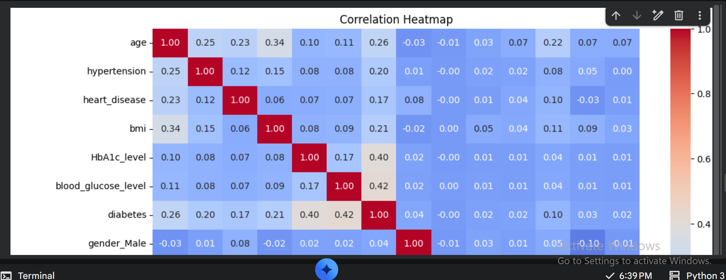
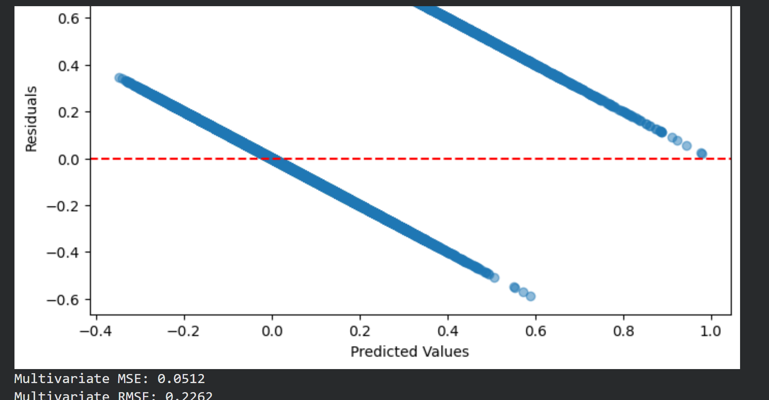
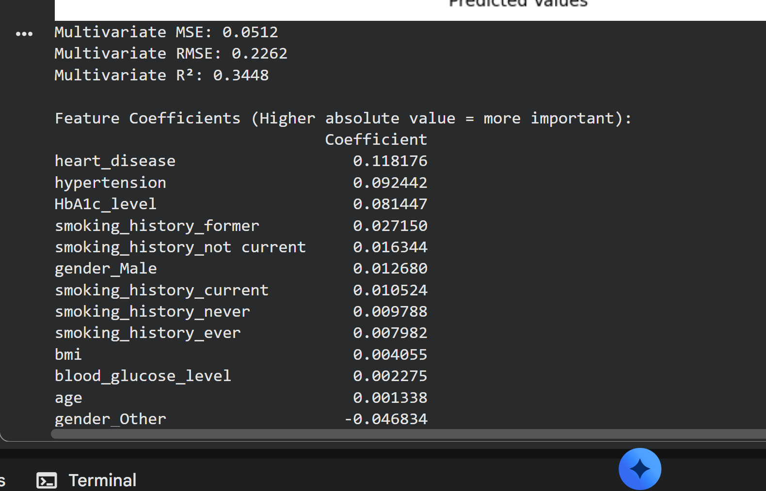

Answer:
Based on the Feature Coefficients table, the independent variables that contribute the most to predicting diabetes are heart_disease (0.118), hypertension (0.092), and HbA1c_level (0.081). Interestingly, BMI contributes very little in this multivariate model (0.004), showing that other health factors are much stronger predictors.

Task 3:
Answer:
The Multivariate Linear Regression model performs significantly better than the Simple Linear Regression model. The R² score increased from 0.0488 to 0.3448, and the Mean Squared Error decreased. This proves that predicting diabetes requires looking at multiple health factors (like HbA1c level, heart disease, and blood pressure) rather than just BMI alone.

