LAB # 03
LOGISTIC REGRESSION

Import Required Libraries · Load Dataset
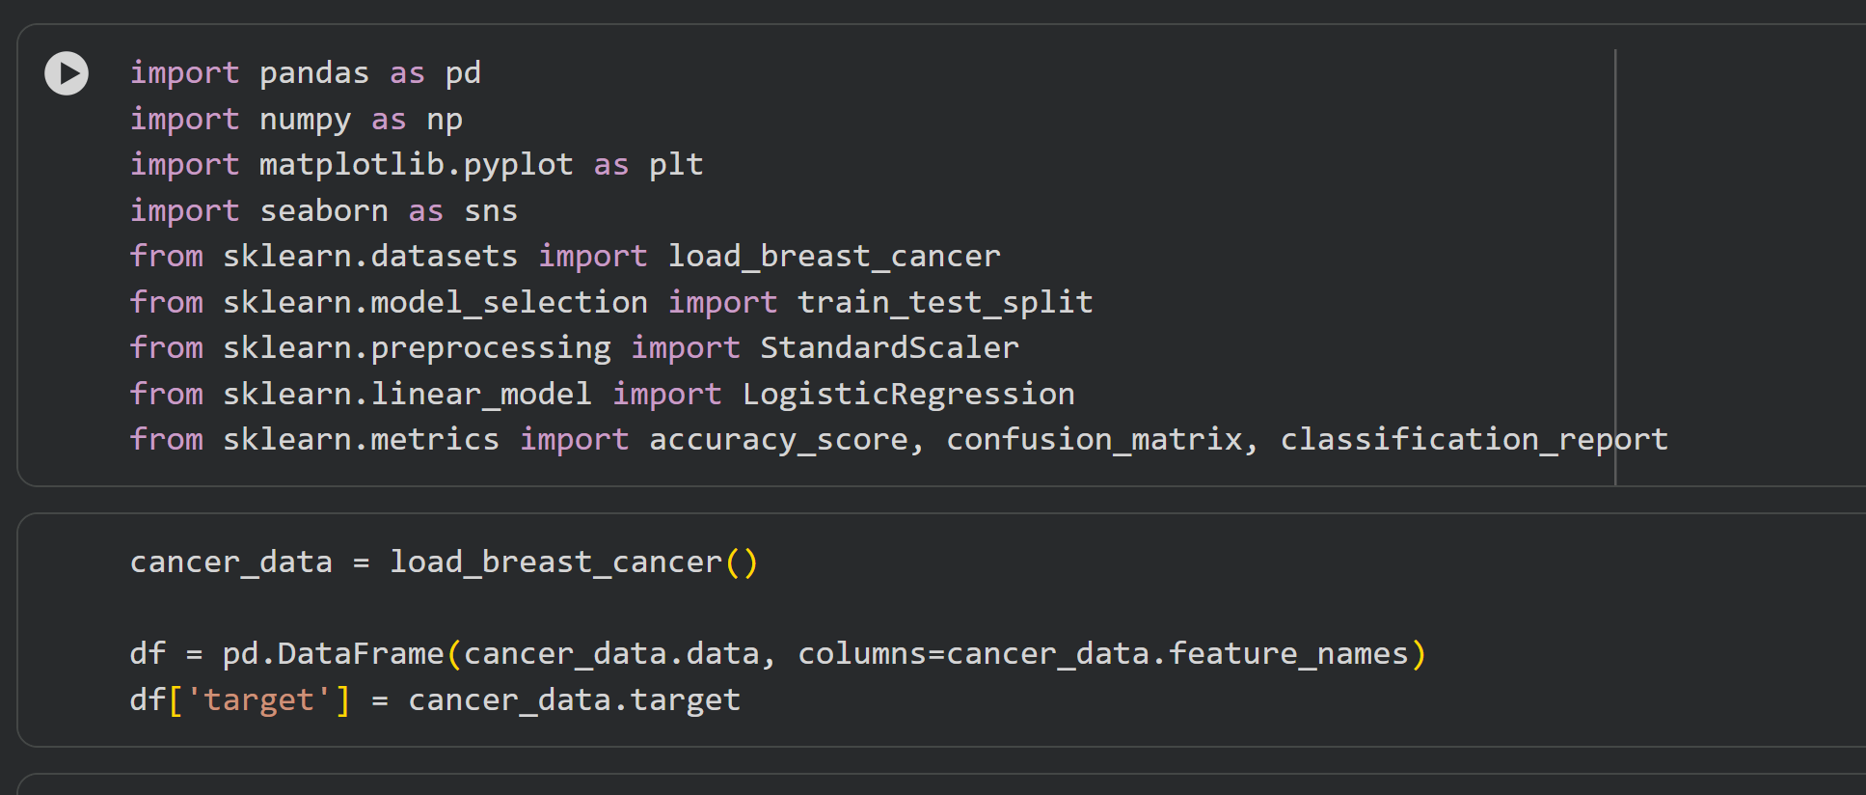
• Use a dataset Breast Cancer Dataset from sklearn.datasets. · Exploratory Data Analysis (EDA) • Display first few rows of the dataset.
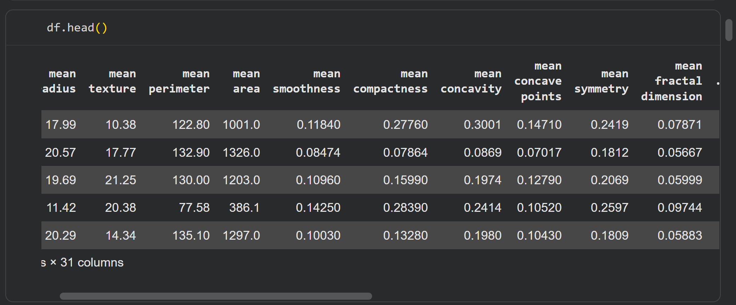

• Check for missing values
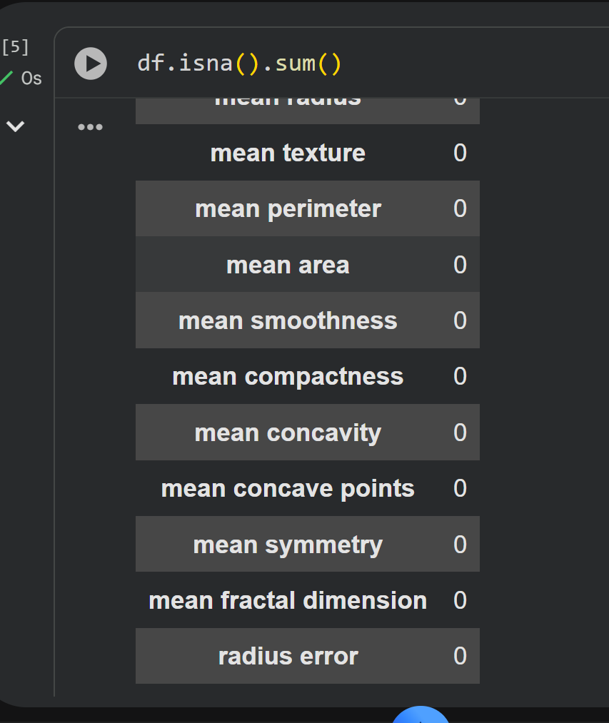

• Plot histograms or distribution of features.
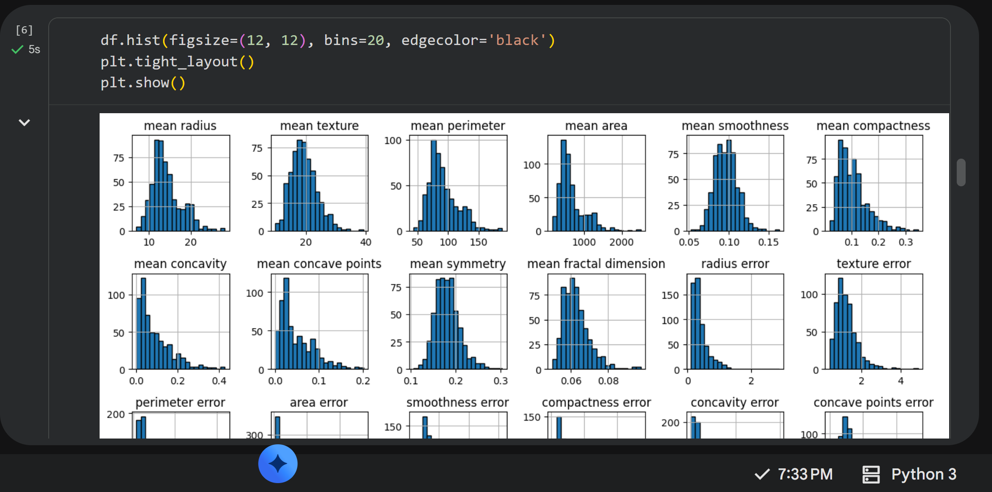

• Check class distribution (malignant vs. benign).
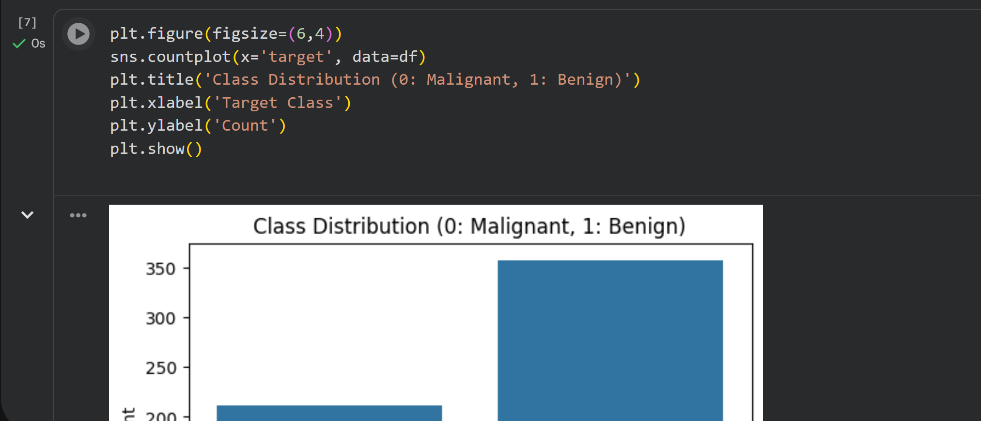

· Data Preprocessing • Split features and labels. • Standardize features using StandardScaler. • Train-test split
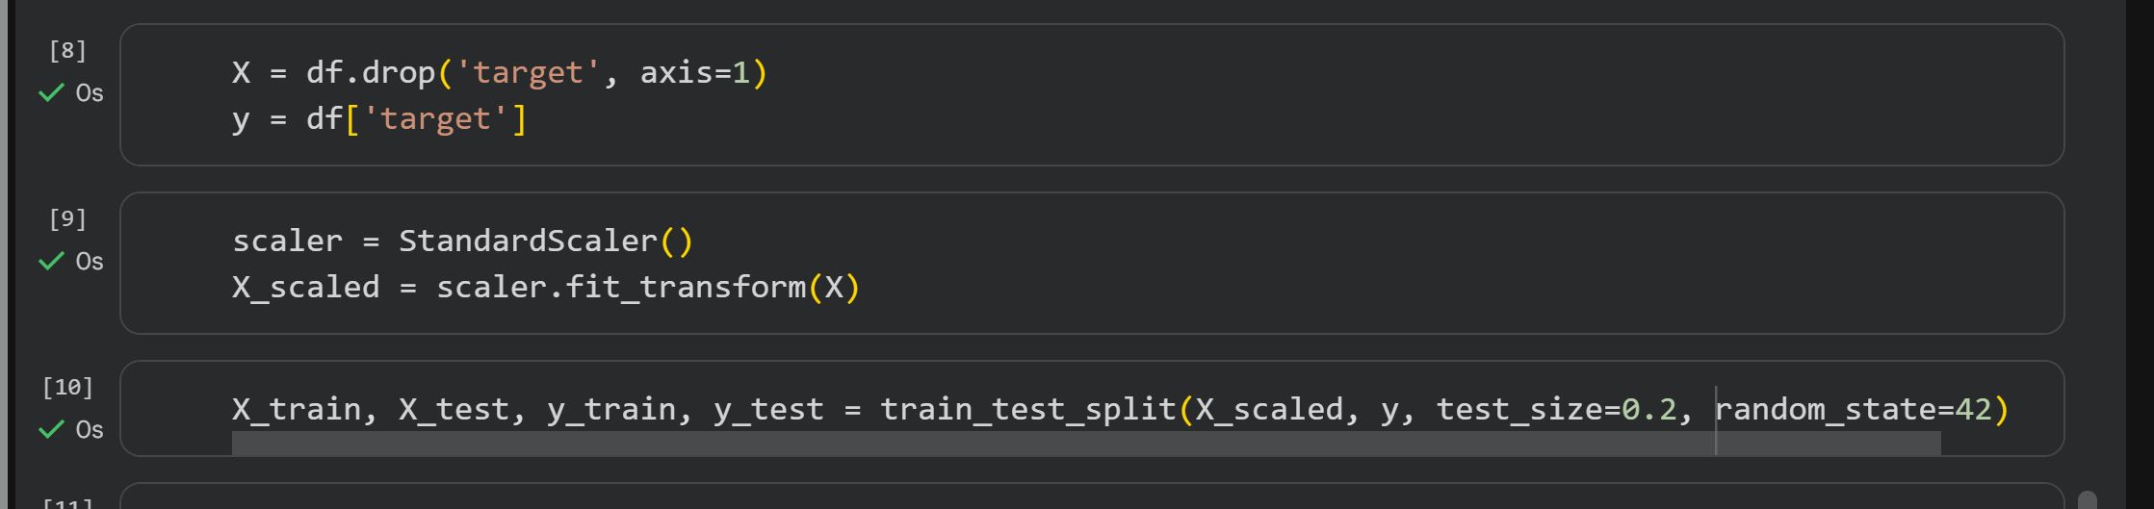
Model Implementation
• Use sklearn.linear_model.LogisticRegression.
• Train the model on the training data.
• Predict on the test data.
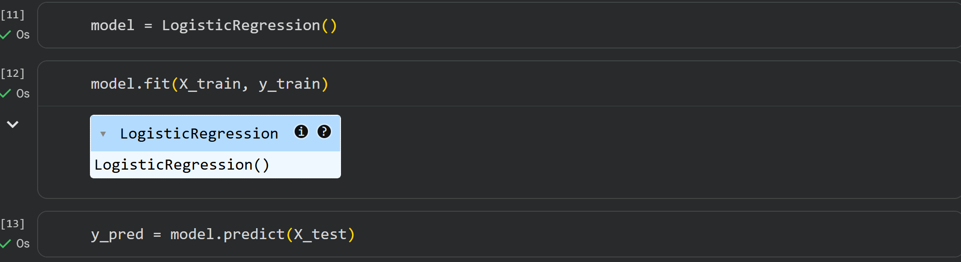
· Evaluation
• Accuracy score.
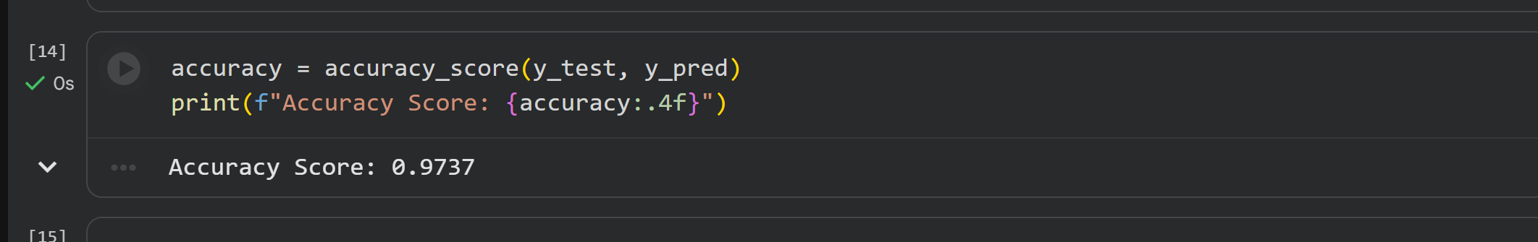

• Confusion matrix.
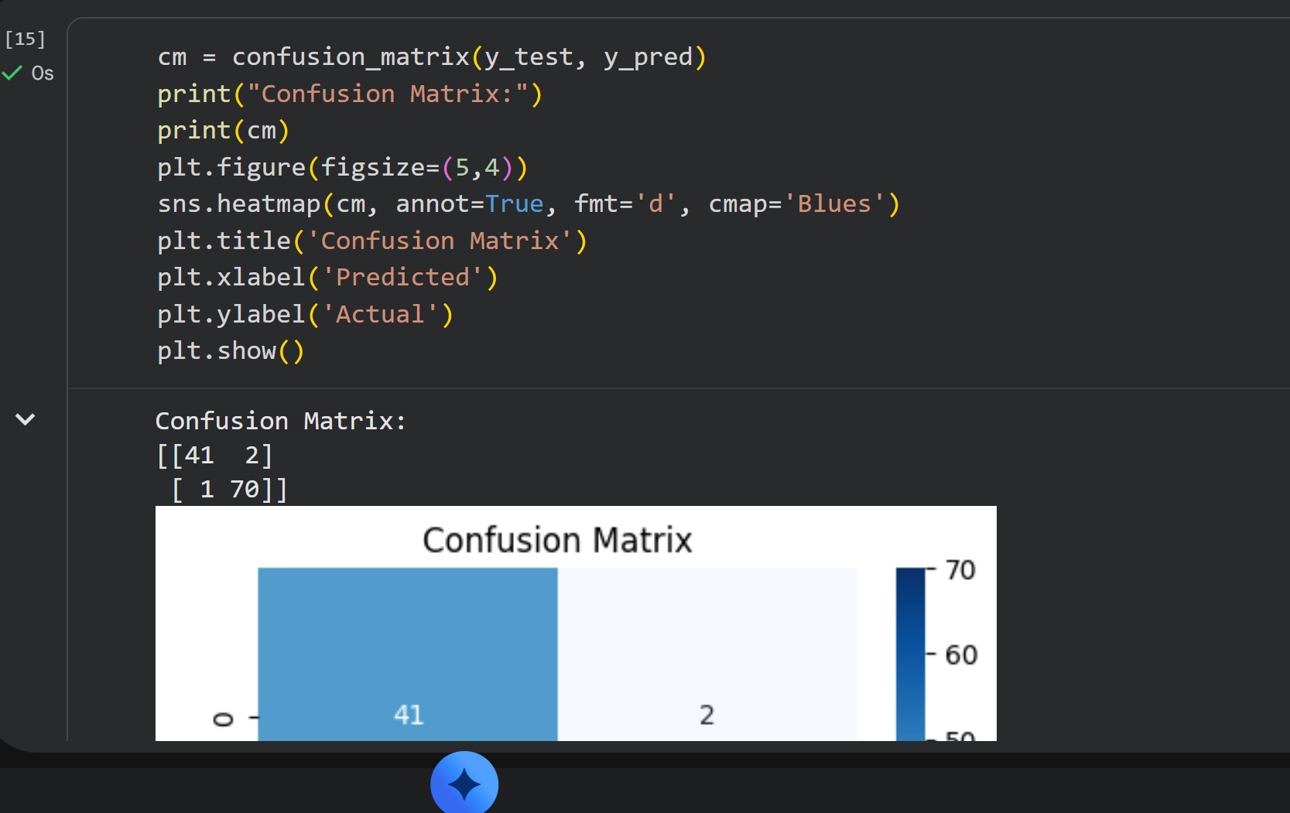
• Precision, Recall, F1-score.


