**Student ID**: STU6407ec1e09ed81678240798

**Name:** Manakavoo siva balaji A

P12 - Health Care Data Driven Decisions using Power BI (DA)

Week 4

Overview

[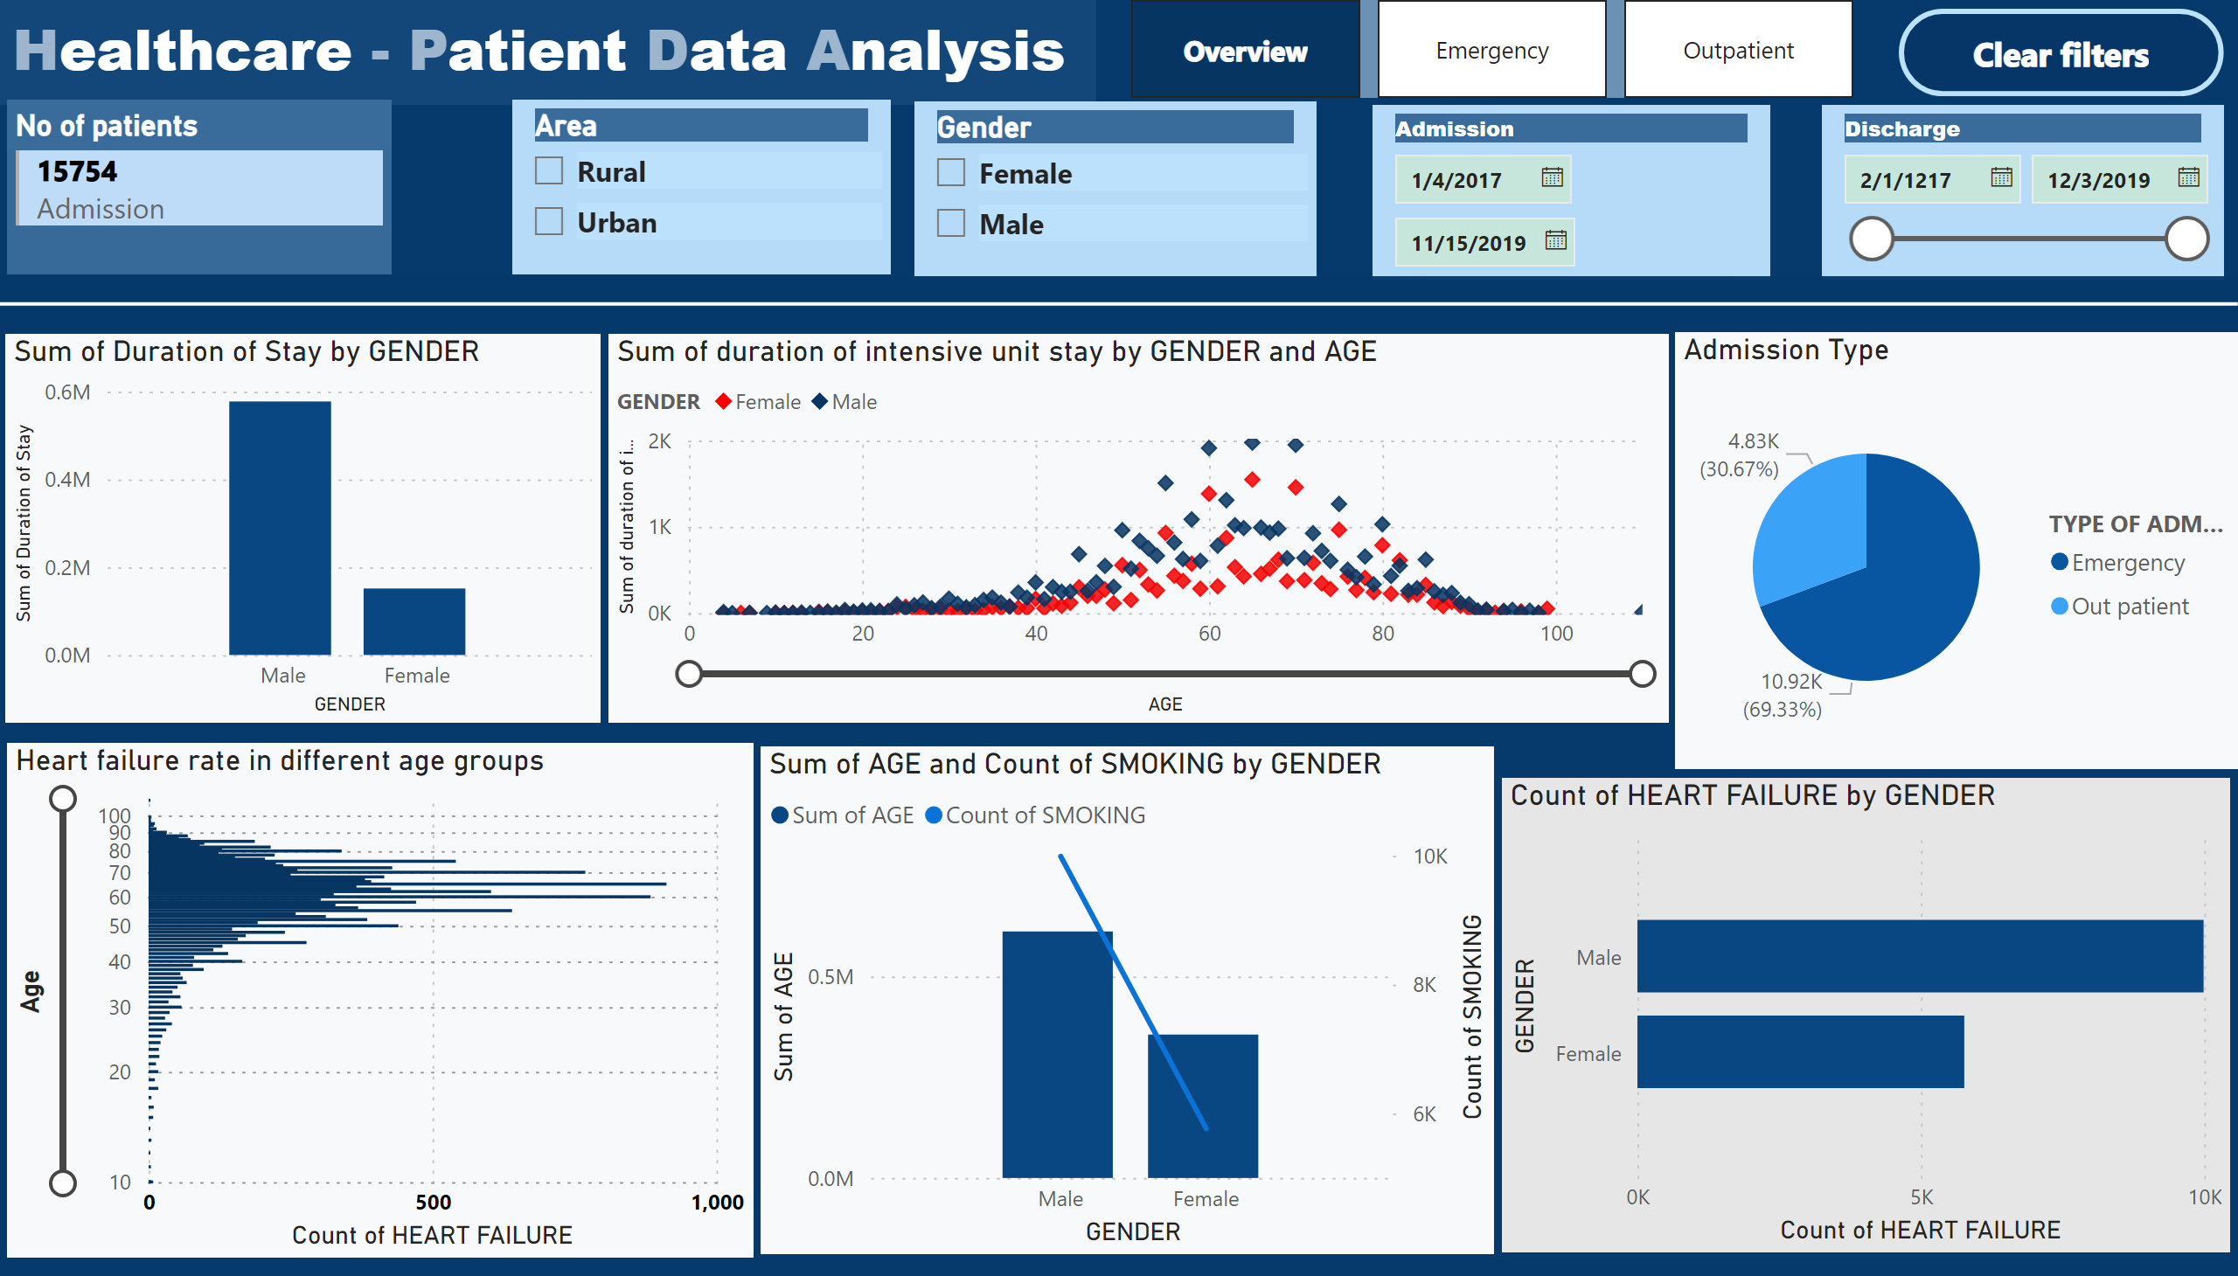](https://app.powerbi.com/groups/me/reports/4b5a516d-b193-4466-8452-71ff3837bca4/?pbi_source=PowerPoint)

Emergency

[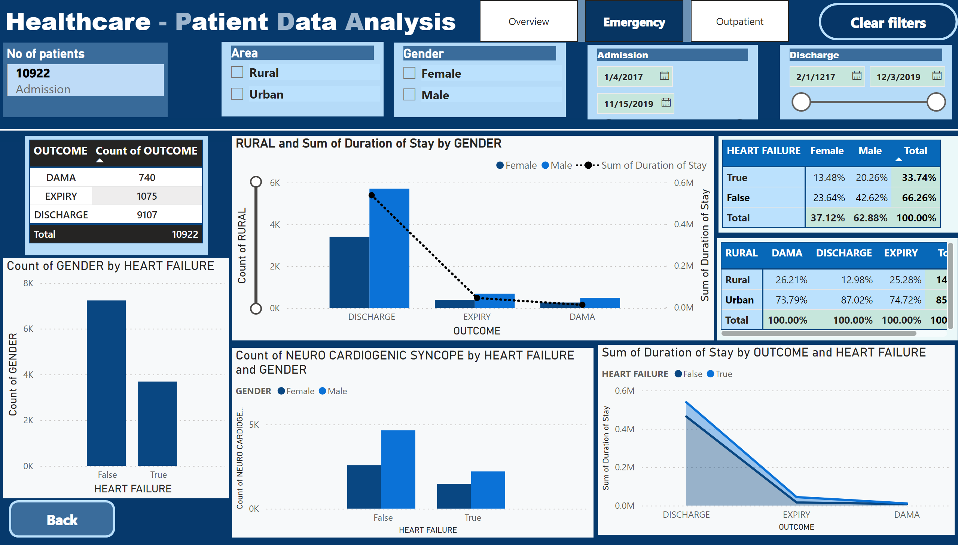](https://app.powerbi.com/groups/me/reports/4b5a516d-b193-4466-8452-71ff3837bca4/?pbi_source=PowerPoint)