Your CEP Project, Explained
Can LLM Assistance Reduce Human Error in Cloud Security Configuration?
Manal Aamir (SE-23070) and Syed Abdullah Hyder (SE-23091). Where the project stands on 1 November 2026.
The short version
- The question. Do people make fewer security mistakes when they set up cloud resources with help from an AI assistant (an LLM)?
- How we answer it. Participants configure cloud resources in a pretend cloud console we built. They do half the tasks with the AI assistant and half without. An automatic marker, the validator, counts their mistakes. The AI never sees the marker's results.
- What is built. All the software is built and tested: the tasks, the data format, the validator, the console, the AI assistant panel, the event log, the offline AI check and the analysis scripts. We also measured how often real engineers made the same mistakes, and downloaded 30 real projects for the AI check.
- The AI model. The assistant uses NVIDIA Nemotron 3 Ultra through OpenRouter, and the real connection works.
- Plain words. Screens are written for someone with no cloud knowledge. The AI still receives the exact technical details, which are not displayed.
- What is next. The offline AI check, a pilot with 2 or 3 classmates, the real study, and the write-up (section 7).

1. The study in plain words
Cloud services such as Amazon Web Services (AWS) let anyone create servers, storage and databases in minutes. They also make it easy to leave a door open: a server anyone on the internet can log into, a storage bucket that is public, a database without backups. Most cloud security incidents come from settings like these, not from clever attacks. Our study asks whether an AI assistant helps people avoid these mistakes.
Each participant does six short tasks in our pretend console. For example, one task says: create a web server for a small bakery, where customers can open the website but only the office computer can log in remotely. Some settings are pre-filled with unsafe values, just as real consoles and templates sometimes are. The participant has to notice and fix them.
The six tasks come in three matched pairs, Set A and Set B, built to be equally hard. Each participant does one set with the AI assistant and the other without. Comparing the two tells us whether the assistant made a difference.
Nothing is ever created on real AWS. The console only produces a description of the settings (a small JSON file), and the validator marks that. This keeps the study free, safe and repeatable.

Who does what, and in which order
Participants are split into four equal groups, so that neither the task set nor the order favours the assistant:
Group | First part | Second part
1 | Set A, no assistant | Set B, with assistant
2 | Set B, no assistant | Set A, with assistant
3 | Set A, with assistant | Set B, no assistant
4 | Set B, with assistant | Set A, no assistant

Everyone first does a short practice task, which is not scored, to learn the form.

What we measure
Measure | Meaning
Error count | How many of the task's security rules the participant broke
Weighted score | The same mistakes weighted by seriousness: serious = 3, medium = 2, minor = 1. Lower is better.
Task success | Whether the configuration had no serious mistakes at all
Time and corrections | How long the task took, and how many changes were made (from the event log)

2. How the system fits together
Part | What it does | Who sees it | Status
Task files | The six tasks plus the practice task: the story, the requirements, the pre-filled form, and the hidden marking rules | Participants see only the story and the form | Done (Step 1)
Data format (schema) | Fixes exactly what a configuration looks like, so every part reads the same thing | Researchers | Done (Step 2)
Validator (the marker) | 15 rules that check a configuration and give the scores above. It never talks to the AI. | Researchers only | Done (Step 3)
Console (the form) | The web pages participants use: task text at the top, the settings form, and a Create button | Participants | Done (Step 4)
AI assistant panel | A chat panel, shown only in the assisted part, that answers questions about the current task and settings | Participants (assisted part) | Done (Step 5)
Event log | Records every change, question, answer and submission for the analysis | Researchers | Done (Step 6)
Real-world dataset | Configurations real engineers wrote in 2022, used as a comparison and as a test for the AI | Researchers | Baseline done; 30 projects fetched

Two rules keep the experiment fair.
- The AI assistant never sees the validator's findings. If it did, we would be measuring the marker, not the AI.
- Participants never see their scores during the study. Otherwise both groups would get hints, and the comparison would no longer isolate the AI.

3. Progress through the 10-step plan
Step | What it is | Status | What exists now
1 | Define the configuration tasks | Done | 6 tasks in 3 matched pairs plus a practice task, each with 2 planted traps
2 | Define the data format | Done | One schema file covering all three resource types
3 | Build the validator | Done | 15 rules; 23 automatic tests pass
4 | Build the form-based console | Done | Web app with the full participant journey, including consent and questionnaires, in plain words; 38 tests pass; checked in a browser
5 | Add the AI assistant panel | Done | Panel, prompt and OpenRouter connection; tested against the real service, and automatic tests use a fake server
6 | Add event logging | Done | One log file per session part, recording every change, question, answer and submission
7 | Test the AI on its own (offline check) | Ready to run | 30 planted-error cases ready; 30 real projects downloaded, hand conversion not started
8 | Pilot with 2 or 3 classmates | Not started
9 | Run the study (20 to 30 participants) | Not started
10 | Analyse and write Sections 3 to 6 | Scripts ready | Analysis scripts tested on made-up logs only; Section 3 drafted; no real results yet

4. What was built, step by step

Step 1: the tasks
Each pair uses the same kind of cloud resource and the same traps; only the story, names and addresses change. That keeps Set A and Set B equally hard. All organisations are made up, and the internet addresses come from ranges reserved for documentation, so nothing points at a real network.
Resource | Set A | Set B | Unsafe values already filled in (the traps)
Web server | Crumb & Co. Bakery | Northfield Community Library | Remote login (SSH) open to the whole internet; disk encryption off
Storage bucket | Riverside Physiotherapy Clinic | Westbrook College exam board | 2 of the 4 public-access blocks switched off; access logging off
Database | Paperleaf Books | Harbour Street Gym | Reachable from the internet; automatic backups switched off (kept 0 days)

Each trap copies something that really happens. For example, Amazon's own server wizard proposes a remote-login rule open to every address until the user narrows it. Some fields start empty (such as the bucket's encryption choice), so the participant must make a decision. The rest start correct and must not be broken: the website must stay reachable, for instance.

Step 2: the data format
Every form, whatever the task, turns into a small structured text file. The validator marks it, the AI will read it, and the log will record it. A shortened example for the web server:
{ "resource": "web_server", "instance_type": "t2.micro",
"ingress": [ {"port": 22, "protocol": "tcp", "source": "0.0.0.0/0"} ],
"disk_encryption": false, "public_ip": true }
Here "source": "0.0.0.0/0" means "anyone on the internet", which is the trap.

Step 3: the validator (the marker)
The validator has 15 rules. Each one checks a single thing and gives a weight: 3 for serious, 2 for medium, 1 for minor. The weights are not our opinion. They come from how seriously Amazon's own security checker, AWS Security Hub, rates the matching check. Where a rule matches a requirement in the industry standard, the CIS AWS Foundations Benchmark, that requirement is recorded too.
Rule | Mistake it catches | Weight
WS-01 | Remote login (SSH) open to the internet | 3 (serious)
WS-02 | Remote login allowed from more than the administrator's address, or the administrator locked out | 2
WS-03 | Remote Desktop (RDP) open to the internet | 3 (serious)
WS-04 | Website no longer reachable over HTTP (catches locking the server down too far) | 1 (minor)
WS-05 | Website no longer reachable over HTTPS (the same, for secure web traffic) | 1 (minor)
WS-06 | Server disk not encrypted | 2
ST-01 | Bucket's public access not fully blocked | 3 (serious)
ST-02 | Bucket not encrypted | 2
ST-03 | Bucket versioning off (deleted files cannot be recovered) | 1
ST-04 | Access logging off, or sent to the wrong bucket | 2
DB-01 | Database publicly accessible | 3 (serious)
DB-02 | Database port open to the internet | 3 (serious)
DB-03 | Database reachable from more than the application server, or the server cut off | 2
DB-04 | Database storage not encrypted | 2
DB-05 | Backups kept fewer than 7 days | 2

How we know it works. Every task's correct answer passes all its rules. Every task's starting form fails exactly its traps. 36 hand-made unsafe configurations each fail exactly the one rule they target. We also planted 6 deliberate bugs in copies of the validator, and the tests caught all 6.

Step 4: the console
The console is a small website that runs on one lab computer. The researcher enters a participant ID and group, then hands over the computer. The participant goes through:
- the practice task;
- part 1 (three tasks);
- a break page;
- part 2 (three tasks);
- a thank-you page.
Each task page shows the story and requirements at the top, the settings form below, and a Create button. The form checks only that fields are filled in correctly. It never hints at which value is safe. The scores are kept on the computer running the console and never sent to the participant's screen. Researchers have a separate preview mode, never used with participants, for trying any task and seeing its score.
How we know it works: 38 automatic tests, plus a run in a real browser through the web server, storage and database tasks and the practice flow.

Plain words on screen, exact details for the AI
Participants may know nothing about the cloud, so what they see avoids technical terms. The file behind the form, the marker and the logs do not change, and neither do the exact details the AI receives.
The real setting | What the participant sees | What the AI and the validator get
Remote login rule | "Remote login (to manage the server)" | port 22
Open to everyone | "Anyone on the internet" | source 0.0.0.0/0
Open to one computer | "Only this address" and a box showing 203.0.113.25 | source 203.0.113.25/32
Storage bucket | "Storage space" | storage_bucket

Each task therefore has two wordings: plain words for the screen, and the exact technical words, sent only to the AI. A check confirms both ask for the same things. The AI is also told the form's labels, so it can say which one to change, and it is asked to answer simply. Answers appear with proper formatting, such as bold text and numbered steps.

Step 5: the AI assistant
In the assisted part, a chat panel sits beside the form. When a participant asks something, the server builds a message containing the exact technical task text, the form's current settings, the form's labels and the question, and sends it to the model. The model never receives the validator's findings, the traps or the correct answers, and automatic tests check this.
The model is NVIDIA Nemotron 3 Ultra, reached through OpenRouter, a service that gives access to many AI models with one API key. It runs with temperature 0 and a fixed seed, so that answers vary as little as possible, and with at most 2000 output tokens. Backup models are switched off, so every answer comes from this one model or the request fails. You sent JavaScript example code; we use the same service and model from Python, so the server has nothing new to install.
How we know it works. The real service answered through the test command, a full participant path and the panel in a browser, in 11 to 33 seconds per answer. The key did not appear in the pages, responses or logs we checked. Automatic tests use a fake OpenRouter server on this computer, covering retries, limits and empty answers. We also planted 12 deliberate bugs in copies of the code, and the tests caught all 12.

Step 6: the event log
Each session part writes its own file in the logs folder. It records consent and questionnaire answers, the start of each task, every field change, every question with its answer, rejected submissions, and each final submission with its score and time. All the study's measures are calculated from these files.

Steps 7 and 10: the offline check and the analysis
The offline check asks the AI about 30 configurations with planted errors, and later about the real cases, with no participants involved. Two researchers then mark whether its advice found each mistake and whether any advice was wrong. The analysis scripts calculate the study's statistics from the logs. They have only been run on made-up logs so far, so there are no real results yet.

5. The real-world dataset

Why we need it, and the "written by people, not AI" test
To say anything about human error, we want examples of configurations real engineers wrote without AI help. So a dataset only counts if it was collected before AI coding tools were common. ChatGPT came out on 30 November 2022. GitHub Copilot, an AI coding assistant, opened as a preview in June 2021 and became generally available in June 2022.
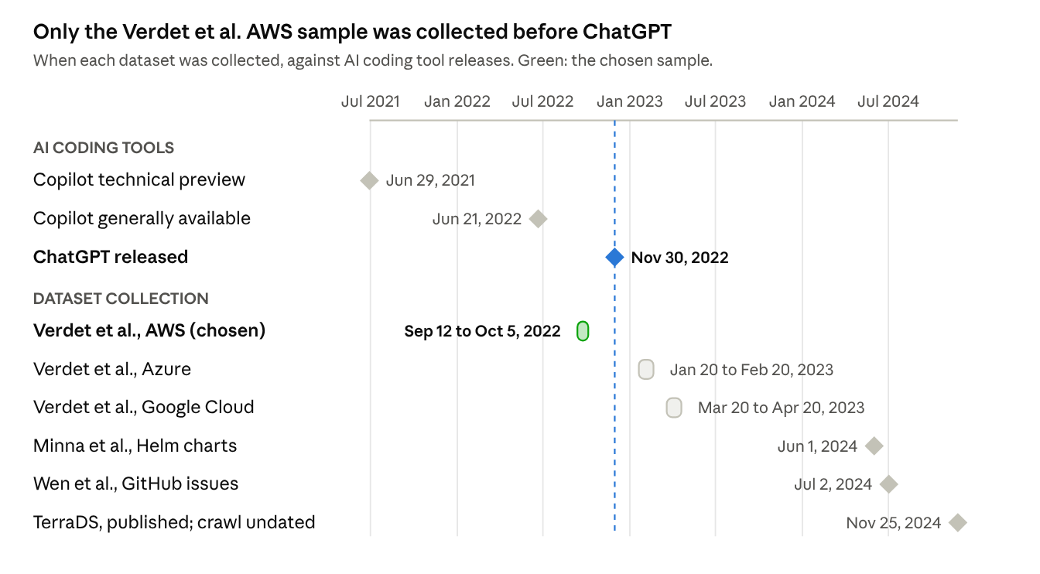
Only the Verdet et al. AWS sample was collected before ChatGPT (the dashed line).

What we chose
We chose Verdet et al. (2025), published in Empirical Software Engineering, the same Web of Science journal as two papers already in our references. It covers 401 real open-source projects that set up AWS with Terraform (a popular tool for writing cloud settings as files), collected in September and October 2022. Tutorials, student assignments and deliberately insecure projects were removed. Four other datasets were checked and set aside:
Dataset | Why not chosen
TerraDS (2024) | Very large and openly licensed, but its collection date is not published, so AI-era code cannot be ruled out. It is the backup option.
Wen et al. (2026) | Collected in July 2024, covers serverless function settings rather than our security rules, and a quarter of its cases have errors inserted by the authors
Minna et al. (2025) | Kubernetes, not AWS; collected June 2024; the current download holds only a PDF
Rahman et al. (2023) | Kubernetes, not AWS; no public data link found

How we use it
The dataset runs alongside the study; it does not replace it. It has two jobs:
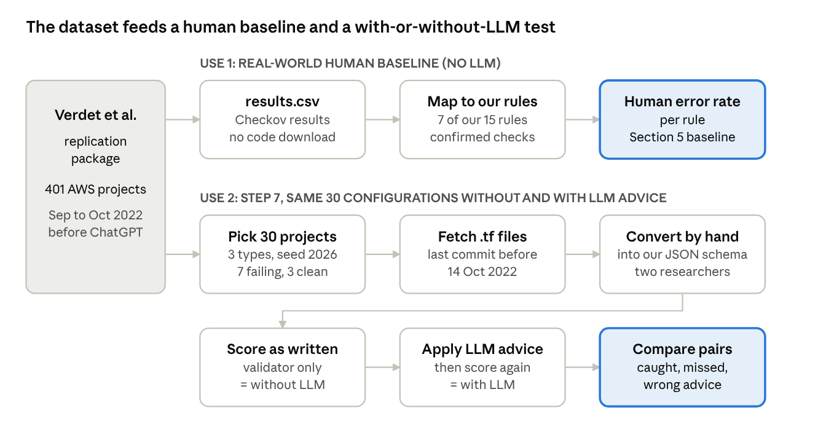
- Real-world human baseline. The authors published, for every project, which security checks passed or failed. We mapped those checks onto 7 of our 15 rules. This gives "how often real engineers made this mistake without AI". It needed no project code to be downloaded.
- Test set for the AI (Step 7). We downloaded 30 real projects exactly as they were in October 2022 (2,813 Terraform files), and will convert one resource from each by hand. Each is marked twice: as the human wrote it, and after following the AI's advice. That shows which mistakes the AI catches, which it misses, and when its advice is wrong.

First results: how often real engineers made the mistakes
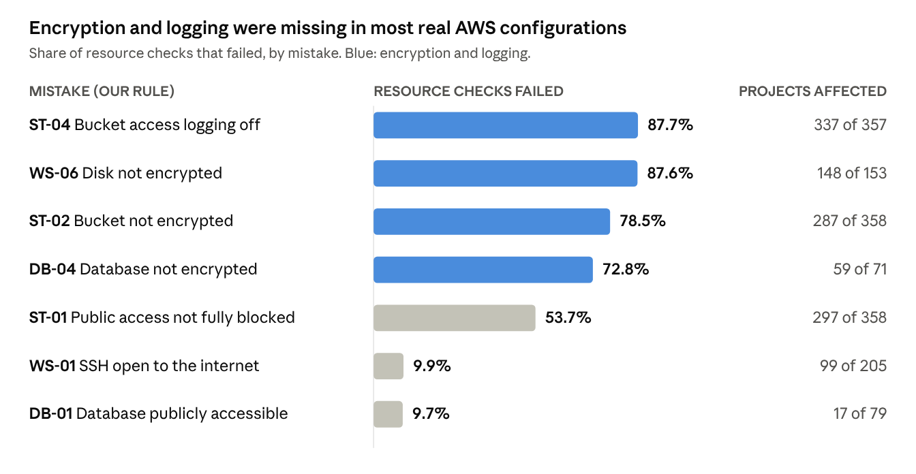
Source: Verdet et al. (2025) results for 369 AWS projects, checked on 13 October 2022.
Encryption and logging were missing most of the time (73% to 88% of checks failed). Open remote login and public databases were rarer, about 1 check in 10. They still affected many projects: 99 of the 205 projects with firewall rules had remote login open to the internet somewhere.
Results exist for 369 of the 401 projects: 7 were listed twice, and the authors' scanning tool skipped 25. These numbers come from the authors' scanning tool (Checkov), not our validator. They are comparable in kind, which the report must say.
Main limits, and how we handle them:
- The original files are not included, so we fetch each project exactly as it was before 14 October 2022, never today's version.
- Some projects have been deleted since 2022: 3 of the 30 we chose were gone. Reserves from the same groups replaced them, and the report must state this.
- Some downloaded projects may be demos or test files rather than real work, so each is checked before use (section 7).
- A setting may be open on purpose, such as a public website. Open-access mistakes are reported separately from encryption, logging and backup mistakes.
The full dataset guide, with all details and references, is online: Human-Written Cloud Configuration Datasets.

6. Where everything lives
Everything is in the folder CEP\cep-llm-config:
Folder | What is inside
tasks | The task files, the 15 rules with their standard mappings, the groups, and TASKS.md, a readable sheet of every task
schema | The data format, and a page explaining every field
validator | The marker, its tests, and a page with text you can adapt for the report's Section 3
app | The console web app, including the assistant panel and event log, and its tests
llm | The AI prompt, the OpenRouter connection, the offline check and their tests
logs | One log file per session part, created when sessions run
analysis | The statistics scripts and their tests
dataset | The real-world dataset scripts, downloaded files (raw) and results (results\baseline.md, and results\worksheets for the hand conversion)
docs | This document and the draft of the report's Section 3

Each folder has a README with more detail. The top-level README lists the commands.

7. What happens next, and what we need from you

The AI connection
Your key is in the .env file and works. The console reads that file only when it starts, so restart the console after changing it. Its first line of output says whether the assistant is ready. python -m llm.check sends one real question at any time, and it never prints the key.

Three things to know about this model
- Daily limit. The free model allows 20 requests a minute and 50 a day. That rises to 1,000 a day once the account has bought about 10 credits. At about 15 questions per participant, 50 a day covers only about 3 participants, and the offline check alone uses 30. Either spread the sessions over many days or buy the credits. If the limit is reached during a session, the assistant stops working for that participant, which would spoil that session.
- Privacy. OpenRouter does not state a data policy for this free model, so assume questions may be logged or used for training. The consent page now tells participants their questions go to an outside AI service and asks them not to type personal details. Check the privacy settings on your OpenRouter account too, because a strict setting can block free models.
- Keep it fixed. Do not change the model or its settings once the pilot starts. Free models can also be withdrawn, so check that it is still listed before the study.
- It makes mistakes. In testing, an answer said "bucket" once, and two answers wrongly said an empty address row was open to everyone. The offline check measures errors like these, so report them rather than hide them.
The key stays on the lab computer and never reaches the participant's browser. This project is in a OneDrive folder, so .env is synced to OneDrive as well: do not share the folder, and delete the key on OpenRouter after the study.
Check this in the pilot: are the tasks now too easy? Plain labels such as "Anyone on the internet" make the planted mistakes easier to spot, and the requirements say what is needed. If nearly everyone gets everything right even without the AI, the study cannot show a difference. If that happens, make the requirements less direct, for both sets equally, before the real study.

Convert the real cases
The two of you convert one resource per project by hand, following dataset\cases\README.md. At least 10 are converted by both of you to check agreement. dataset\results\worksheets has one sheet per project showing where to look.
Check each project first. Going by their names and paths, some look like demos or test files rather than real work, such as a code scanner's own test files. Seven projects also have no obvious resource to pick. dataset\README.md lists them all. Replace a project with a reserve only because of what it is, and decide that before seeing its score, so the choice cannot bias the results.

After that, in order
- Step 7: the offline AI check.
- Before the pilot: delete the test log files for P02 from the logs folder, so they are not counted as data.
- Step 8: a pilot with 2 or 3 classmates, to fix confusing wording and confirm the two sets are equally hard.
- Step 9: the study with 20 to 30 participants.
- Step 10: the analysis, and Sections 3 to 6 in Overleaf.
Also worth knowing:
- The CIS benchmark and Amazon's documentation are standards and manuals, not journal articles. Ask the instructor how they may be cited, given the Web of Science rule for references.
- Before adding Verdet et al. to the bibliography, confirm the journal's current Impact Factor in Journal Citation Reports, as was done for the other papers.

8. How to run things on this computer
Run these from the cep-llm-config folder:
To do this | Type
Check the task files | python tasks/check_tasks.py
Run all automatic tests (127) | python -m unittest validator.test_rules app.test_app llm.test_llm llm.test_openrouter dataset.test_dataset analysis.test_analysis
Test the real AI connection | python -m llm.check (needs the key in .env)
Start the console for a participant | python -m app, then open http://127.0.0.1:5000
Try tasks yourself and see scores | python -m app --preview, then open http://127.0.0.1:5000/preview (never with participants)
Run the offline AI check | python -m llm.offline_check run --provider openrouter; if the daily limit stops it, add --resume and the run folder the next day
Rebuild the real-world baseline | python -m dataset.baseline

9. Words used in this document
Word | Meaning
LLM | Large Language Model, an AI that reads and writes text, such as ChatGPT, Claude or Gemini
Configuration | The settings of a cloud resource: who can reach it, whether it is encrypted, whether it keeps backups
Misconfiguration | A setting that leaves a resource less safe than it should be
API key | A secret password that lets a program use an online service; whoever owns it is responsible for its use
OpenRouter | A service that gives access to many AI models through one API key
Validator | Our automatic marker: 15 rules that check a configuration
Trap | An unsafe value already filled in on the form, which the participant should notice and fix
SSH, RDP | Ways to log into a server remotely; they should never be open to the whole internet
Encryption | Scrambling stored data so it is unreadable without the key
Terraform | A popular tool for writing cloud settings as text files instead of clicking in a console
Checkov | An open-source tool that scans Terraform files for security problems
CIS Benchmark | An industry security standard for AWS
Commit | A saved snapshot of a project's files at one moment in time
Pilot | A small trial run of the study with a few classmates, to fix problems before the real thing

10. Key sources
- CEP Build Plan: LLM-Assisted Cloud Security Configuration (the 10-step plan this work follows).
- Verdet, A., Hamdaqa, M., Da Silva, L., & Khomh, F. (2025). Assessing the adoption of security policies by developers in Terraform across different cloud providers. Empirical Software Engineering, 30(3), Article 74. doi:10.1007/s10664-024-10610-0.
- AWS Security Hub CSPM User Guide: the control pages for EC2, S3 and RDS, and the CIS AWS Foundations Benchmark mapping, checked 18 October 2026.
- OpenRouter API documentation and model listing for NVIDIA Nemotron 3 Ultra (free), checked 31 October 2026.
- GitHub Blog (Copilot preview, 29 June 2021; general availability, 21 June 2022), and Wikipedia's ChatGPT article (release on 30 November 2022).

