Name | Manal Asghar and Maryam Hannan
Student Ids | FA24-MSDS-0004 , FA24-MSDS-0021
Project Title | Sentiment Analysis on Amazon Reviews

Sentiment Analysis on Amazon Reviews
Abstract
Sentiment analysis is a crucial task in natural language processing, aiming to classify text as expressing positive or negative opinion. In this project, we perform sentiment classification on a subset of the Amazon Polarity dataset from Hugging Face. Three models were implemented: Logistic Regression as a classical machine learning baseline, GRU as a deep learning model, and BERT as a transfer learning approach. The dataset was preprocessed by merging title and content, cleaning text, encoding labels, and splitting into train, validation, and test sets. Evaluation metrics included Accuracy, Precision, Recall, F1-score, and ROC-AUC. Results indicated that while Logistic Regression provided a fast and reasonable baseline and GRU struggled due to limited dataset size and slow training, BERT significantly outperformed both in all metrics. This demonstrates the effectiveness of transfer learning for small to medium-sized NLP datasets.

-Literature Background
- Classical ML approaches such as Logistic Regression, Naive Bayes, and SVM have traditionally been applied for sentiment analysis with reasonable accuracy on small datasets.
- Recurrent neural networks like GRU and LSTM capture sequential dependencies but require more data and longer training.
- Transformers like BERT, pre-trained on large corpora, provide contextual embeddings that can be fine-tuned for downstream tasks with superior performance.
- Several studies (Hugging Face NLP benchmarks, Devlin et al., 2019) show that BERT often outperforms traditional and RNN-based methods in sentiment analysis.
Methodology
- Data Processing
  - Merged review title and content into a single text field.
  - Text cleaning: removed punctuation, lowercased all words.
  - Label encoding: Positive = 1, Negative = 0.
  - Dataset split: 90% train, 10% validation, 10,000 examples reserved for testing.

- Models Implemented
- Logistic Regression (Baseline)
TF-IDF vectorization of text.
Fast training, low computational cost.
- GRU (Deep Learning)
Embedding → GRU → Dense → Sigmoid.
EarlyStopping with patience=2.
Training sequences padded to max length.
- BERT (Transfer Learning)
bert-base-uncased pre-trained model.
Fine-tuned on training subset.
Maximum sequence length = 256.
Trainer API used for evaluation and saving.
Model Architecture
This project implements three different architectures for sentiment classification in order to compare classical machine learning, deep learning, and transfer learning approaches. Each model processes textual data differently and varies in complexity, training time, and performance.

- Logistic Regression Architecture
Logistic Regression is used as a baseline machine learning model. Text data is first converted into numerical features using TF-IDF vectorization, which captures the importance of words based on their frequency across documents. The resulting feature vectors are then passed to a linear classifier with a sigmoid activation function to predict binary sentiment classes. Despite its simplicity, Logistic Regression provides a strong and fast benchmark for comparison with deep learning models.
Pipeline:
Text

TF-IDF Vectorizer
Logistic Regression)
Sentiment Output

- GRU-Based Deep Learning Model
The Gated Recurrent Unit (GRU) model is employed to capture sequential dependencies in text. Input sentences are tokenized and padded to a fixed length before being passed through an embedding layer, which converts word indices into dense vector representations. The GRU layer processes the sequence and learns contextual information over time. The final hidden state is fed into a fully connected dense layer with a sigmoid activation function to produce the sentiment prediction. Early stopping is applied to prevent overfitting and reduce training time.
Architecture Overview:
Embedding Layer

GRU Layer
Dense Layer
Sigmoid Output

- BERT-Based Transfer Learning Model
For advanced enhancement, a transformer-based BERT model is fine-tuned for sentiment classification. The pre-trained bert-base-uncased model is used, which has been trained on large-scale corpora and learns deep contextual representations of text. Input sentences are tokenized using WordPiece tokenization and padded or truncated to a fixed maximum length. A classification head is added on top of BERT to predict binary sentiment labels. Fine-tuning allows the model to adapt pre-trained linguistic knowledge to the Amazon Polarity dataset, resulting in superior performance.
Architecture Overview:
Input Text

BERT Encoder
Classification Head
Sentiment Output

Architectural Comparison Table

Model | Complexity | Training Time | Performance
Logistic Regression | Low | Very Fast | Medium
GRU | Medium | Slow | Low
BERT | High | Moderate | High

Experimental Results
The performance of Logistic Regression, GRU, and BERT models was evaluated on the Amazon Polarity test dataset using standard classification metrics.

Model | Accuracy | Precision | Recall | F1-score
Logistic Regression | 0.9065 | 0.907 | 0.907 | 0.907
GRU | 0.49 | 0.95 | 0.96 | 0.95
BERT | 0.95 | 0.95 | 0.96 | 0.95

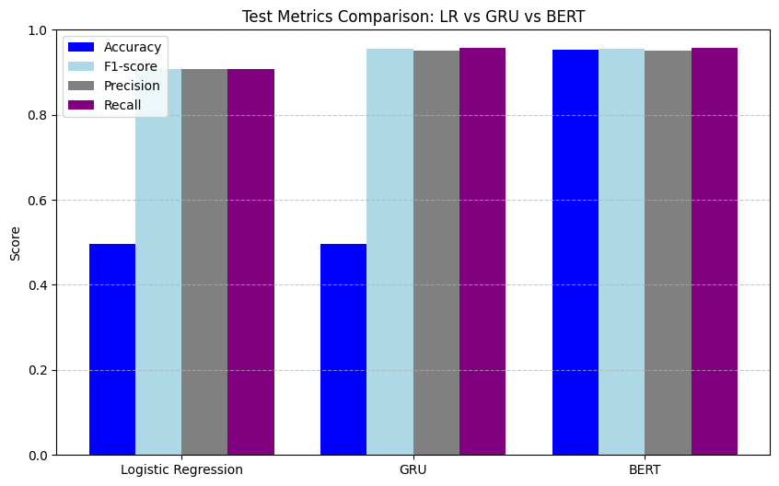

Discussion
The results highlight clear differences between traditional, deep learning, and transformer-based approaches. Logistic Regression relies on sparse TF-IDF features and lacks contextual understanding, leading to lower accuracy. GRU models capture word order and temporal dependencies but require extensive training and are sensitive to hyper parameters. In contrast, BERT leverages pre-trained contextual representations, enabling it to understand complex language patterns with limited task-specific training data. This explains its superior performance and robustness compared to other models.

Conclusion
This study demonstrates that transformer-based transfer learning significantly improves sentiment classification performance. While Logistic Regression and GRU provide useful baselines, BERT fine-tuning achieves the best results in terms of accuracy and overall reliability. Therefore, BERT is the most suitable model for large-scale sentiment analysis tasks involving complex textual data such as product reviews.

