**Mastermind**

**Description:**

Mastermind is a board game for two players. Simply, the first player is trying the guess the secret code given by the other player. The secret code is a sequence of colours, for example 4 colours. There are a number of attempts and with each attempt the player will receive a respond as a hint. There are two kinds of hints. First, right colour and right position. Second, right colour but wrong position. Each hint will be represented as either black or white.

In the project, the players will be the user and the computer. The user shall select the sequence of colours. The application shall check if the sequence is matched. The application shall show the respond as below:

* if there is any match colour, show white circle.
* If there is any match colour and position, show black circle.
* If there are no colours, show none.

Check figure 4, the left side shows the black/white hints. At the end the application shall show a congratulation message if user wins (figure 5), otherwise, show a hard luck message (figure 6).

**Wireframes:**

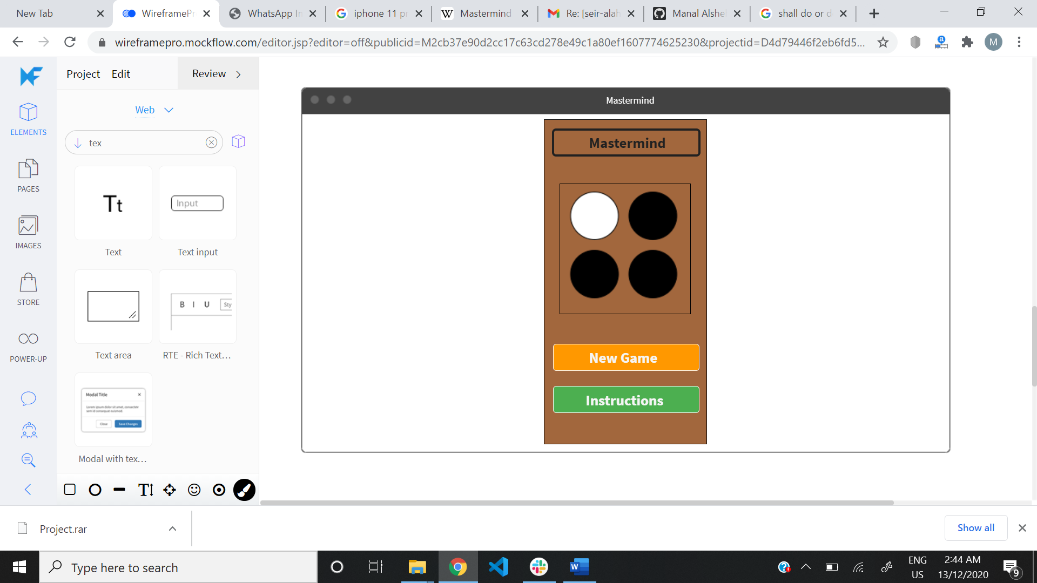Figure 1 Welcome Interface

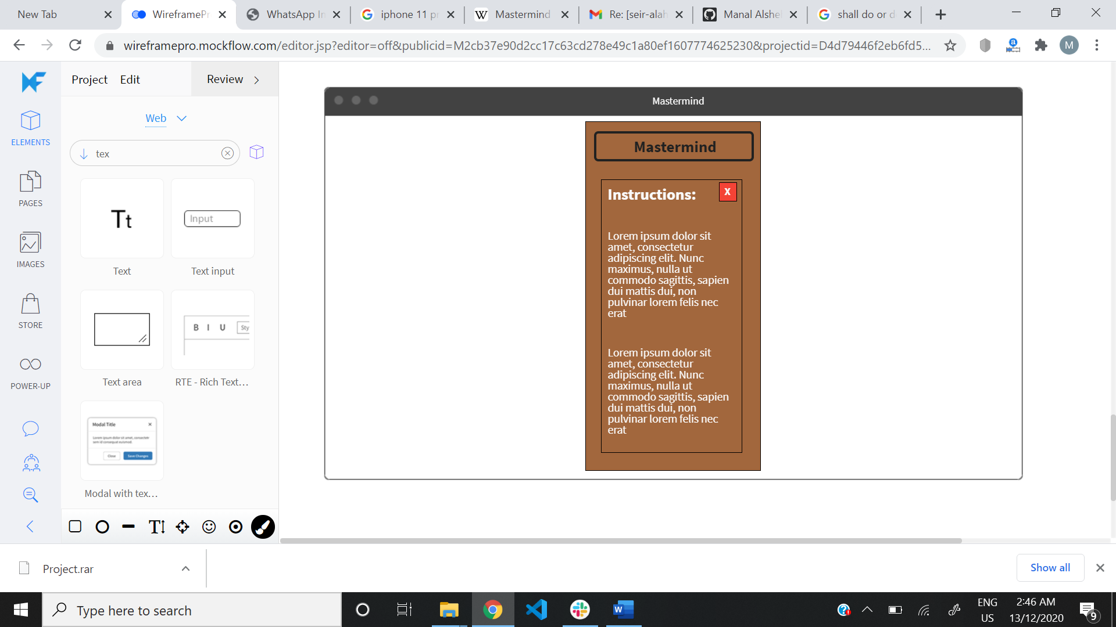

Figure 2 Instructions Interface

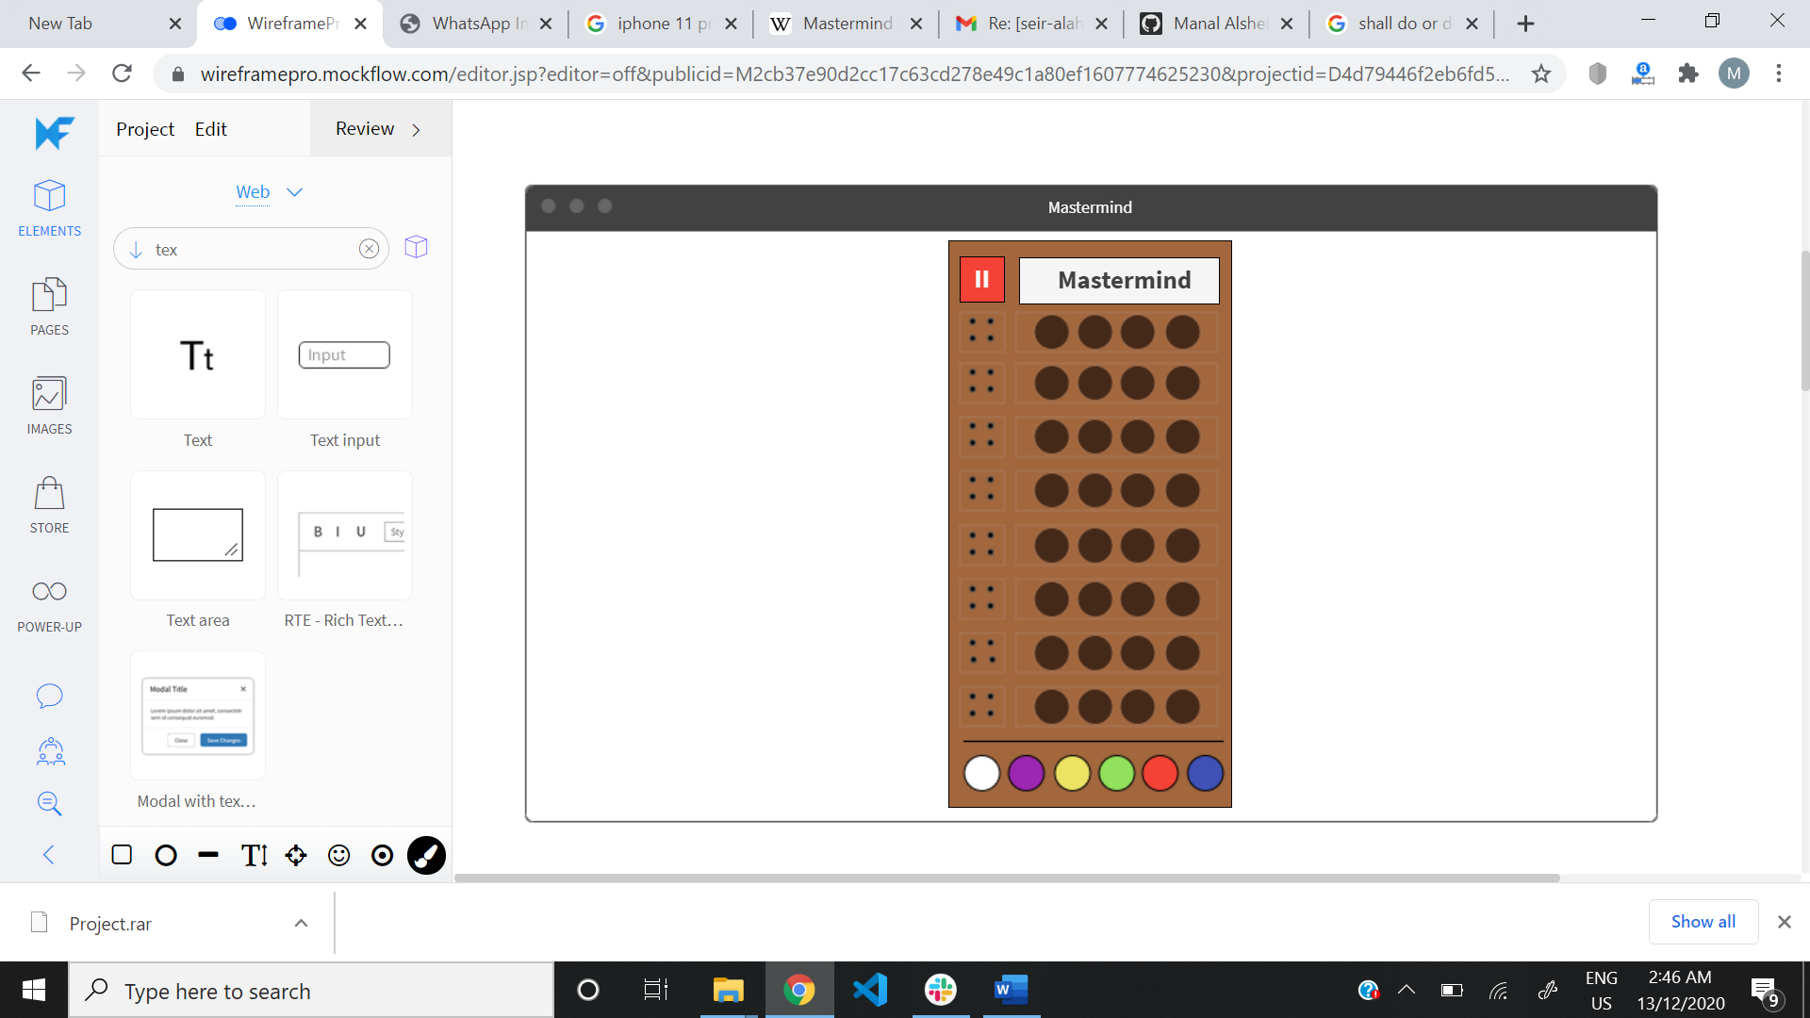

Figure 3 When player starts to play

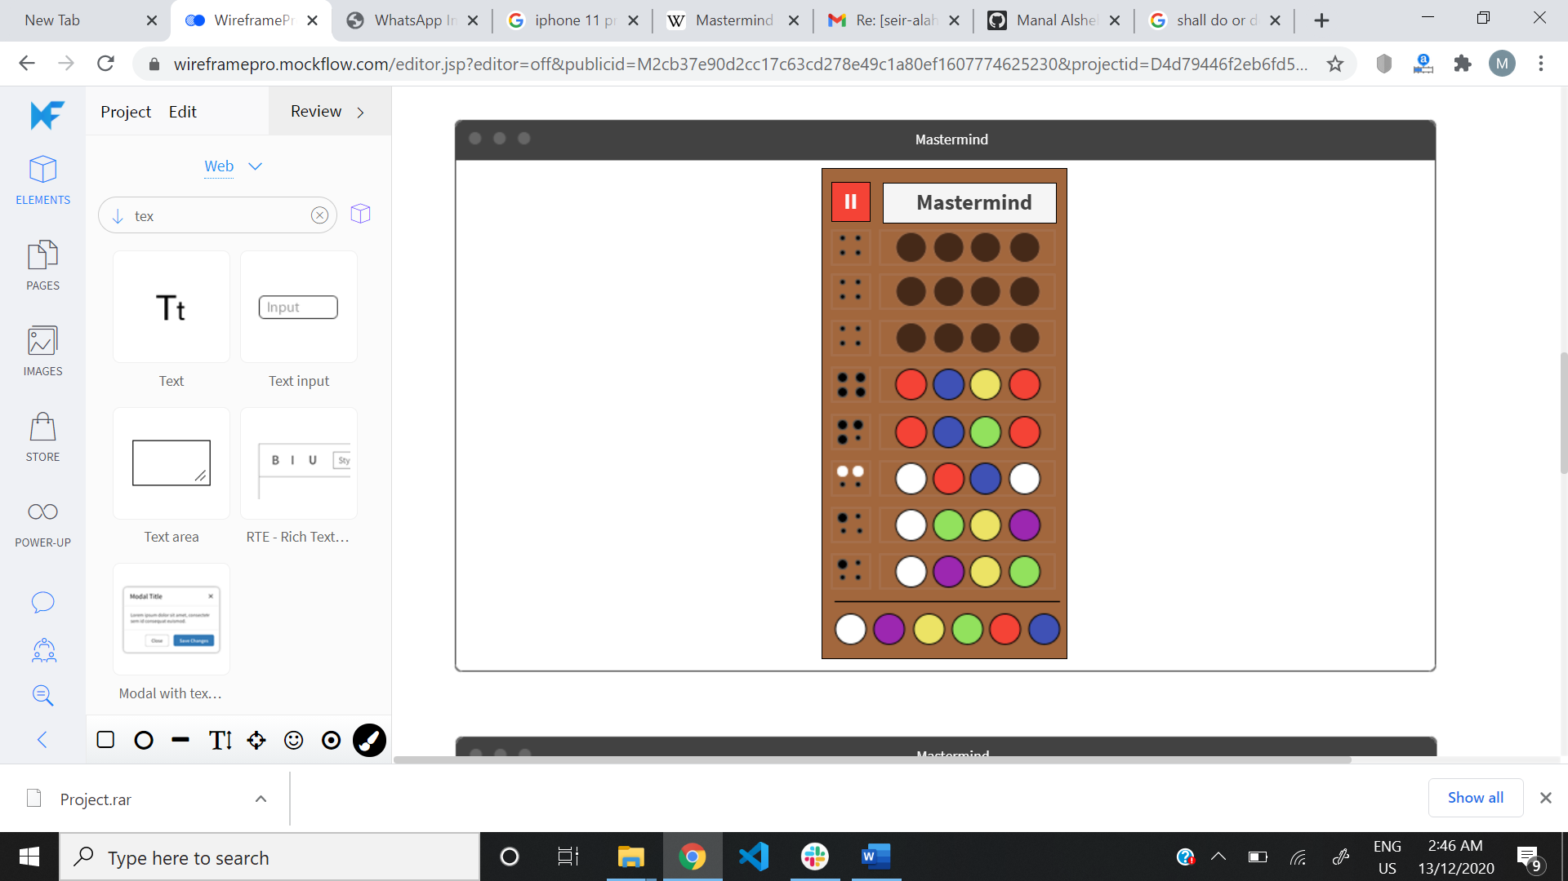

Figure 4 a case when player guesses the code and before congratulations appears!

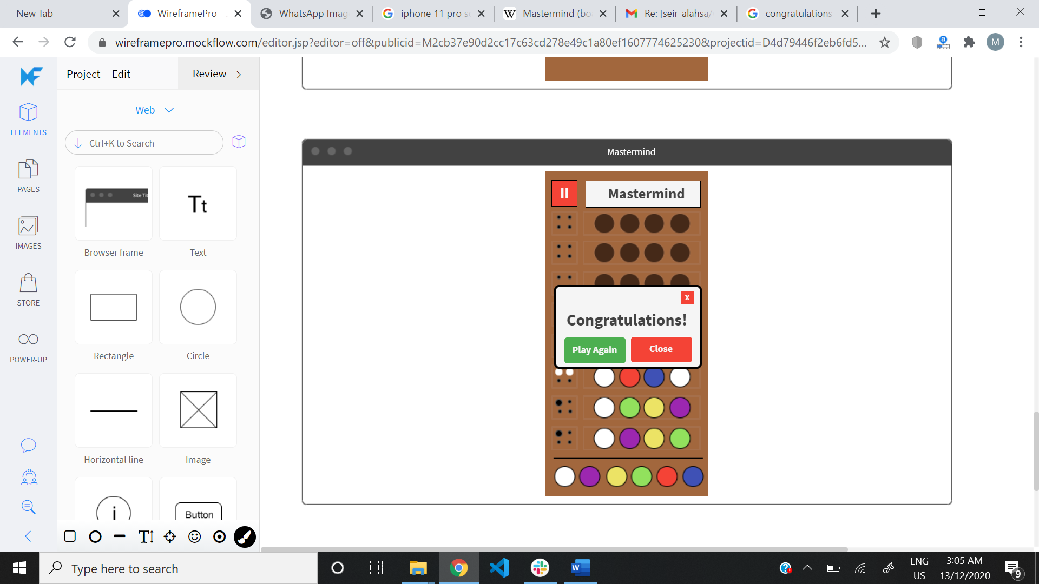

Figure 5 when player wins

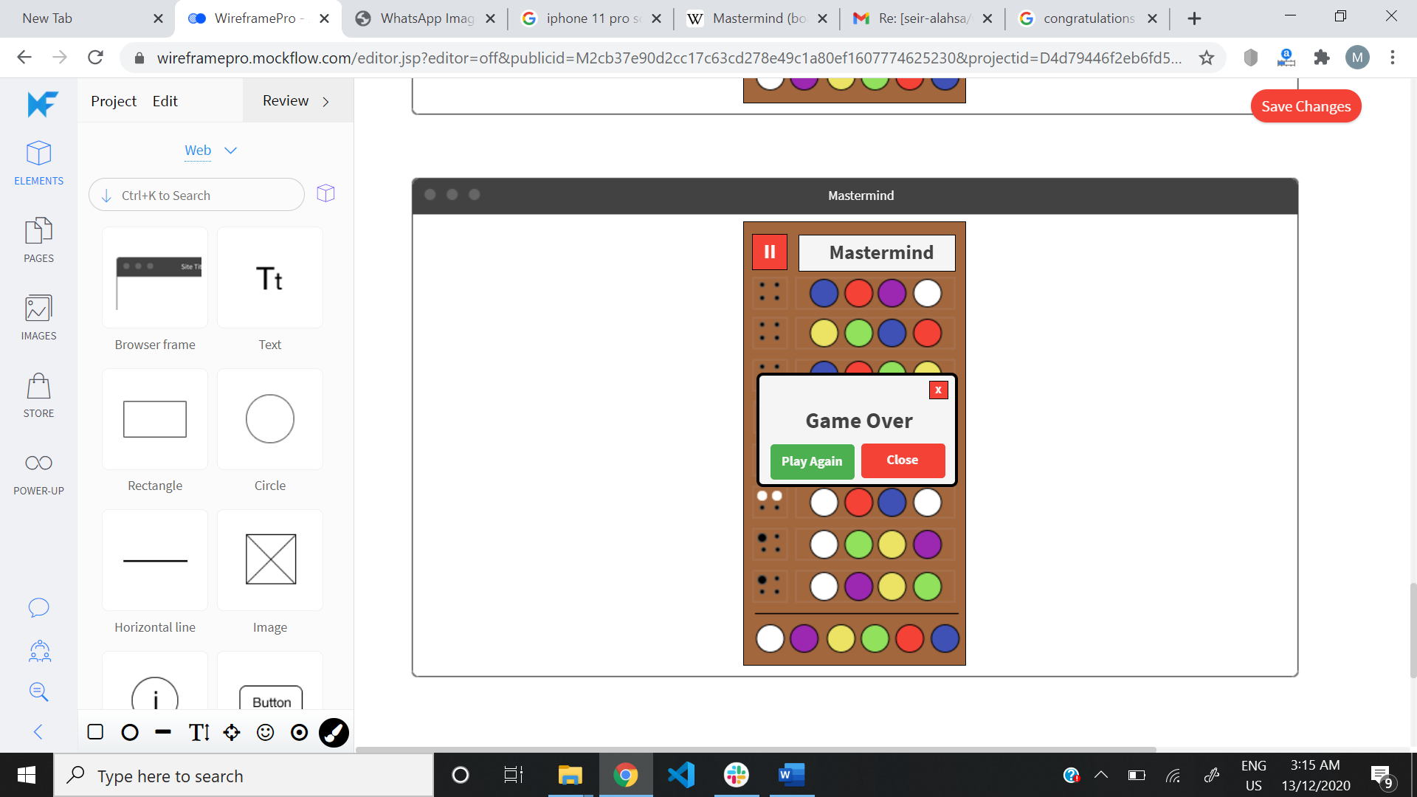

Figure 6 when player loose