Git – Commands Assignment

Contents
Instructions: ……………............................................................................................................................1
TASK 1: Repository Setup ……………………….............................................................................................1
TASK 2: Branch Creation & Work ……………………….................................................................................2
TASK 3: Branch Switching Observation .………………………........................................................................2
TASK 4: Undo a Mistake ..………………………..............................................................................................2
TASK 5: Merge Feature Branch (6 Marks) ……………………….....................................................................3
TASK 6: Checkout a Commit (Detached HEAD) (4 Marks) ……………………................................................3

Instructions:
1. This is a local Git assignment only
2. Do NOT use GitHub
3. Use Command Prompt / Terminal
4. Commit messages must be meaningful
5. Screenshots for each step in each task
6. Follow steps in sequence

TASK 1: Repository Setup
Goal: Initialize Git and create first commit
Steps:
- Create a folder named git-assignment-yourfullname
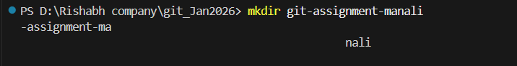

- Navigate into the folder
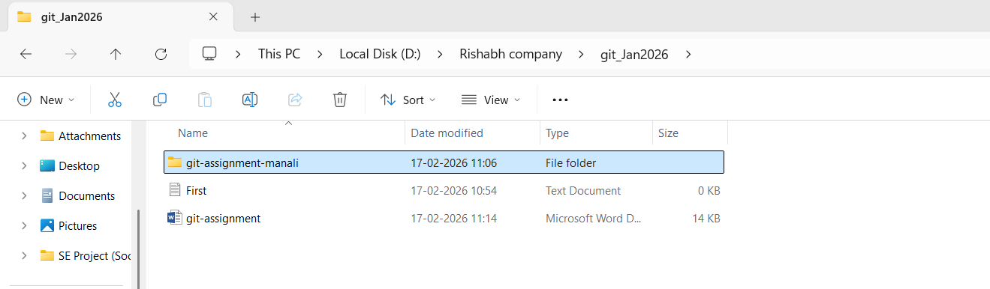
- Initialize Git repository
- Create a file named index.txt
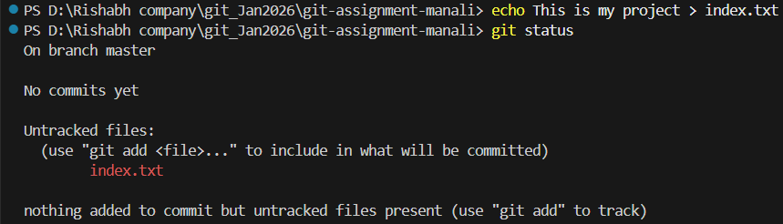
- Check repository status
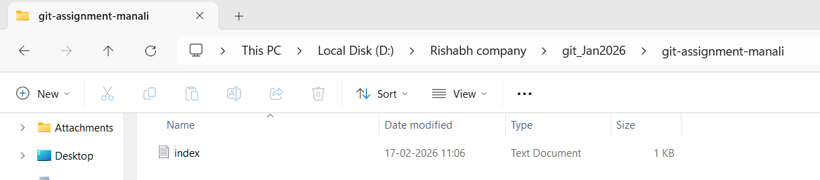
- Stage the file
- Commit with message:
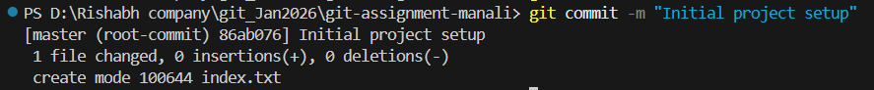
Initial project setup

TASK 2: Branch Creation & Work
Goal: Work independently in a branch
Steps:
- Create a branch named feature-header
- Switch to feature-header
- Create a file named header.txt
- Stage the file

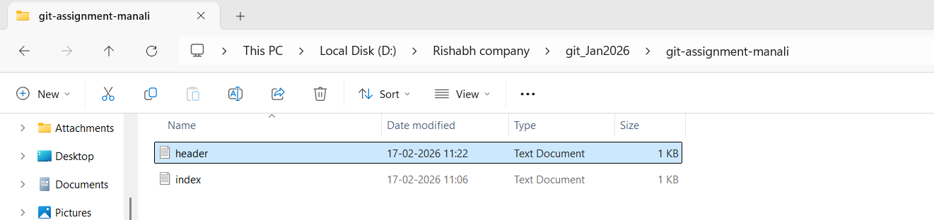
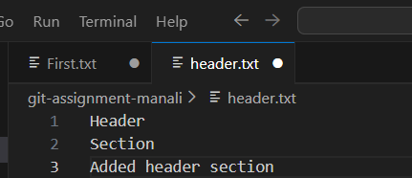
- Commit with message:
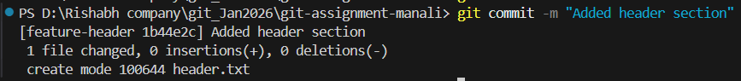

Added header section

TASK 3: Branch Switching Observation
Goal: Observe branch isolation
Steps:
- Switch back to master
- List files and observe
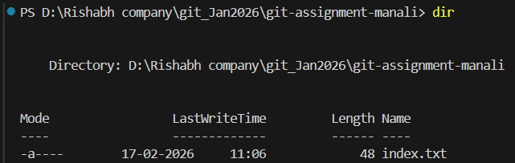
- Switch again to feature-header
4. List files and observe
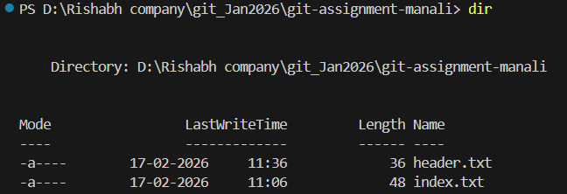
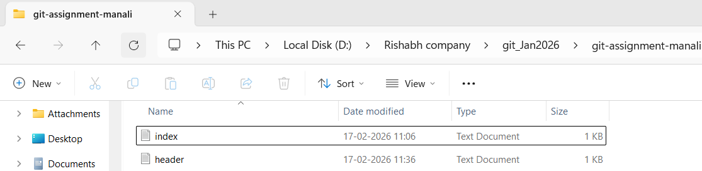

TASK 4: Undo a Mistake
Goal: Safely undo file changes
Steps:
- In feature-header, modify index.txt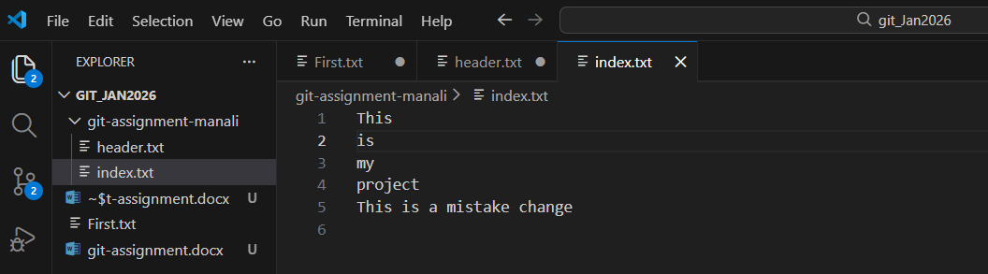
- Check repository status
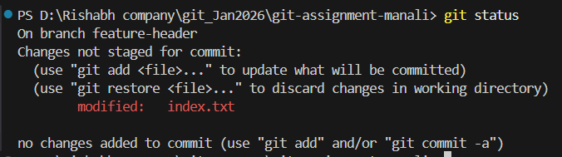
- Undo the change using Git
- Verify status again
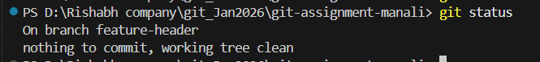

TASK 5: Merge Feature Branch
Goal: Combine work into master
Steps:
- Switch to master
- Merge feature-header
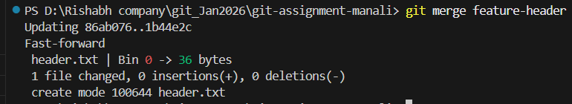
- Verify merged files
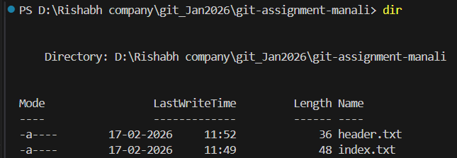
- Check commit history

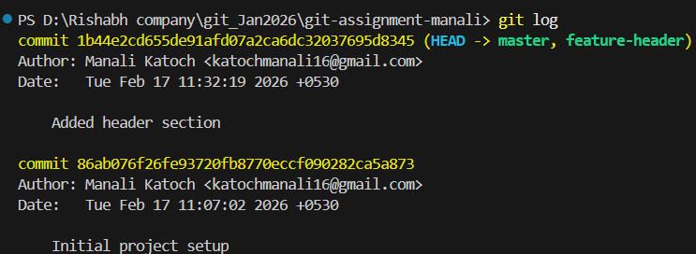

TASK 6: Checkout a Commit (Detached HEAD)
Goal: Understand commit-level navigation
Steps:
- View commit history
- Checkout any older commit
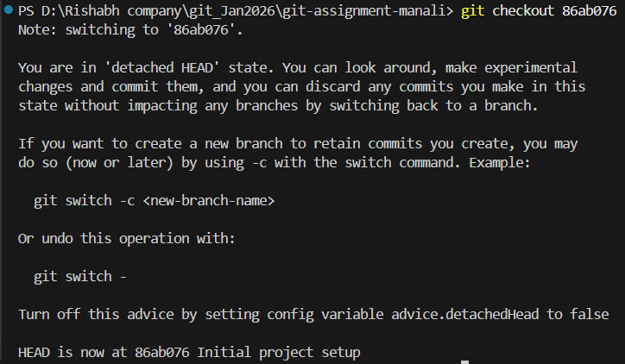
- Check current branch status
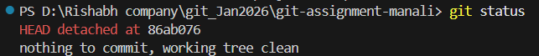
- Switch back safely to master

