IBM DATA SCIENCE COURSE 9.

# Applied Data Science Capstone:

# The Battle of Neighbourhoods.

|  |
| --- |
| INDEX |
| 1. INTRODUCTORY SECTION. |
| 2. DATA SECTION. |
| 3. METHODOLOGY SECTION. |
| 4. DISCUSSION SECTION. |
| 5. CONCLUSION AND RESULTS SECTION. |

# 1. INTRODUCTORY SECTION: ANALYSIS OF DUBAI NEIGHBOURHOODS.

Dubai is one of the most popular and modern cities in the world. It has lots of monuments, high rising skyscrapers and vast spread deserts. As a result, Dubai attracts a lot of tourists every year. The figures can even be as high as 15 million. Such a huge tourist crowd is very likely to enjoy great variety of foods. As a result, setting up a restaurant in Dubai would be an incredible idea. It was seen that Dubai lacks Mexican restaurants in some neighbourhoods.

For the project, we will determine the best neighbourhood in Dubai to open a Mexican restaurant.

We will use Foursquare and cluster neighbourhoods in Dubai to determine the best neighbourhood for opening up the restraint in that location. The objective is to have a location that is within one of the more reasonable rent zones, but also within a close enough range to a high rent zone.

# 2. DATA SECTION.

**FILES AND LANGUAGES:**

We will use an excel file named “Dubai_Neighbourhoods.xlsx” as our main dataset.

We will convert this file into a pandas dataframe.

We will use the location and venue information from Foursquare.

The code is written in Python.

**SOFTWARE REQUIREMENTS:**

Jupyter Notebook.

Adobe Reader.

Microsoft Excel.

Foursquare, etc.

**DATA DESCRIPTION:**

The dataset used for analysis is an Excel file named “Dubai_Neighbourhoods.” Based on average rent prices and distances from places of high rent, we will determine which neighbourhoods is most suitable for the Mexican restaurant.

The files consists of 8 attributes or columns namely, Neighbourhood, Average rent per unit, Z-Score, Distance from Palm, Distance from Zabeel, Distance from Jumeriah, Latitude and Longitude.

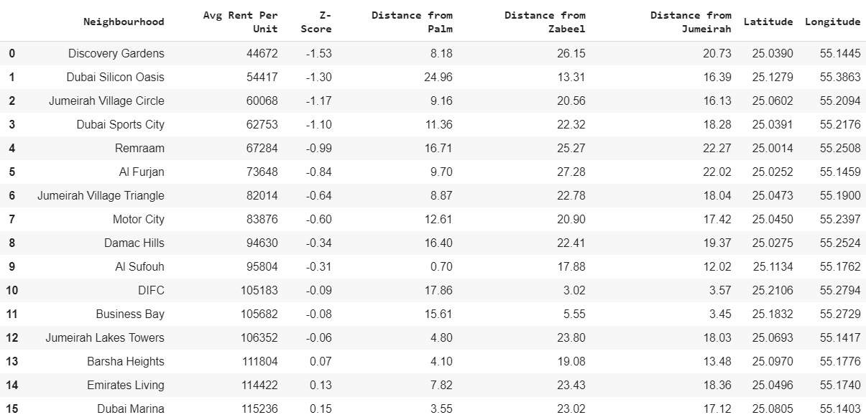

For examination of neighbourhoods, we will make use of Foursquare. With the help of Foursquare, we will cluster most common venues in Dubai.





# 3. METHODOLOGY SECTION.

A diagram of obtained venue count from all the neighbourhoods in Dubai shows that DIFC, Dubai Marina and Barsha Heights. Here’s a diagrammatic representation of the results.

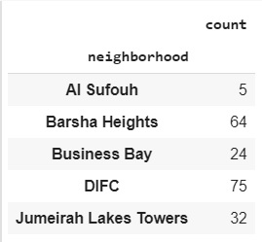

Further, a direct comparison between number of hotels and number of restaurants was made in each of the selected neighbourhoods and the following result was obtained.

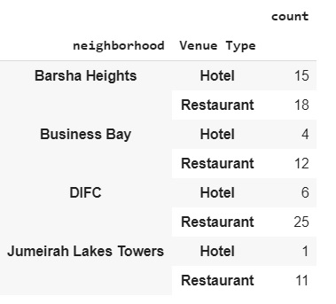

Further, the distance of the high rent areas from each of the venues were observed and the venue DIFC was chosen to be the ideal location for opening of the restaurant. DIFC is close to three high rent neighbourhoods. The number of restaurants in DIFC are less in ratio with the number of hotels in the venue. Hence, the idel venue for the restaurant is chosen to be DIFC.

# 4. DISCUSSION SECTION.

We can observe the following from the data visualizations and results obtained:

* Dubai Marina consists of a lot of restaurants. Hence, it is saturated.
* Barsha Heights has lots of venues to visit and restaurants are relatively less in the area.
* Barsha Heights is close to only one high rent neighbourhood.
* DIFC is a very tourist attractive zone.
* DIFC does not have much restaurants compared to the number of hotel in the place.
* DIFC is close to three high rent neighbourhoods.

# 5. CONCLUSION AND RESULTS SECTION.

The Python code was implemented and executed successfully. From the Results and Discussion section, we can conclude that Dubai International Finance Center (DIFC) would be the best location to open up a Mexican restaurant after examining all the factors: medium rental index, it is close in proximity to other high rent neighbourhoods, and the ratio of hotels to restaurants is not too high. Other neighbourhoods that were considered were Barsha Heights and the Dubai Marina. Although Barsha Heights seems preferable given the low ratio of hotel venues to restaurants, but it is not close to many high rent neighbourhoods. Dubai Marina was not a preference as it is already saturated with restaurants. Hence, the final destination selected is DIFC.