DOCUMENT PREPARED BY AKSHAY DHAVAN, SHWETA MERCHANT, GOVIND CHAUHAN

CSRF

**Requirements:**

1. Xampp
2. DVWA: <http://www.dvwa.co.uk/>

**STEPS**

1. Extract the downladed zip and add DVWA to Xampp htdocs.
2. Start Apache.

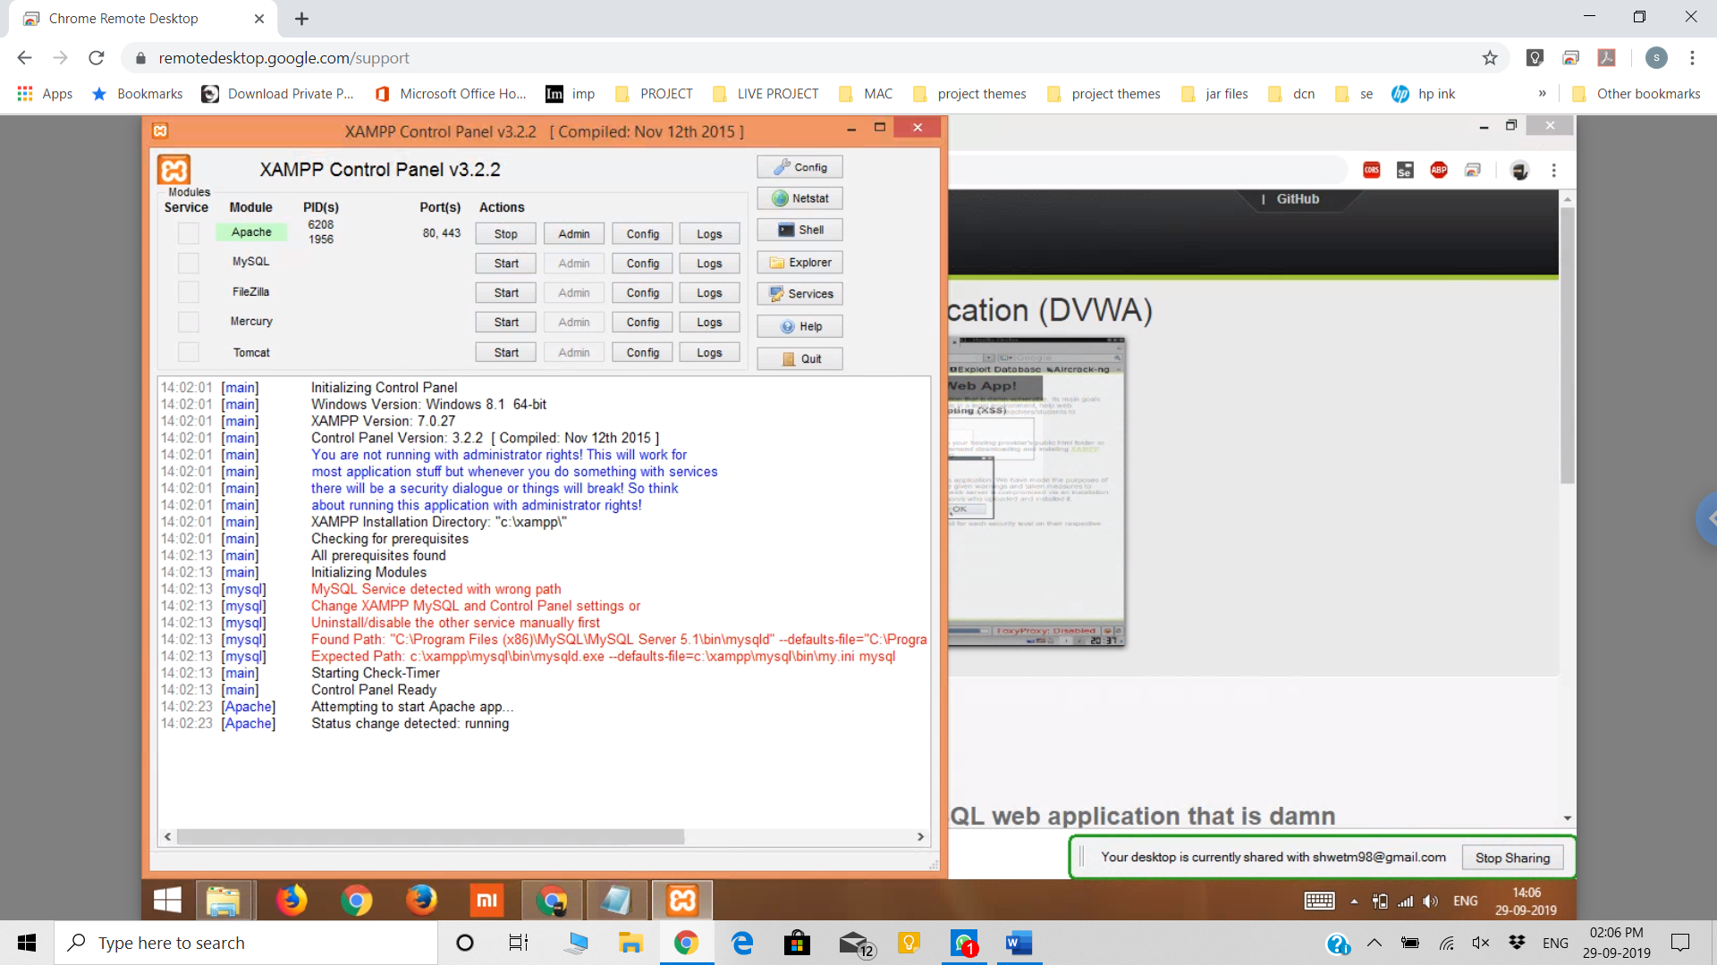

1. Open DVWA via localhost.

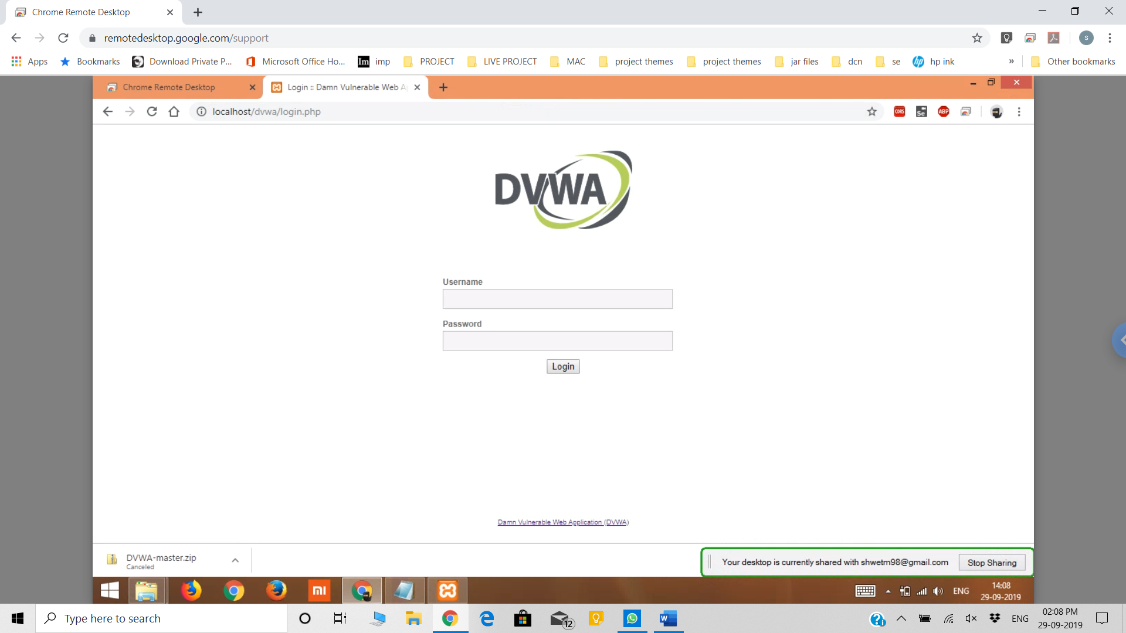

DEFAULT VALUES

Username: admin

Password: password

1. Then click on login.
2. Go to CSRF.
3. Right-Click and go to Inspect and copy the code.

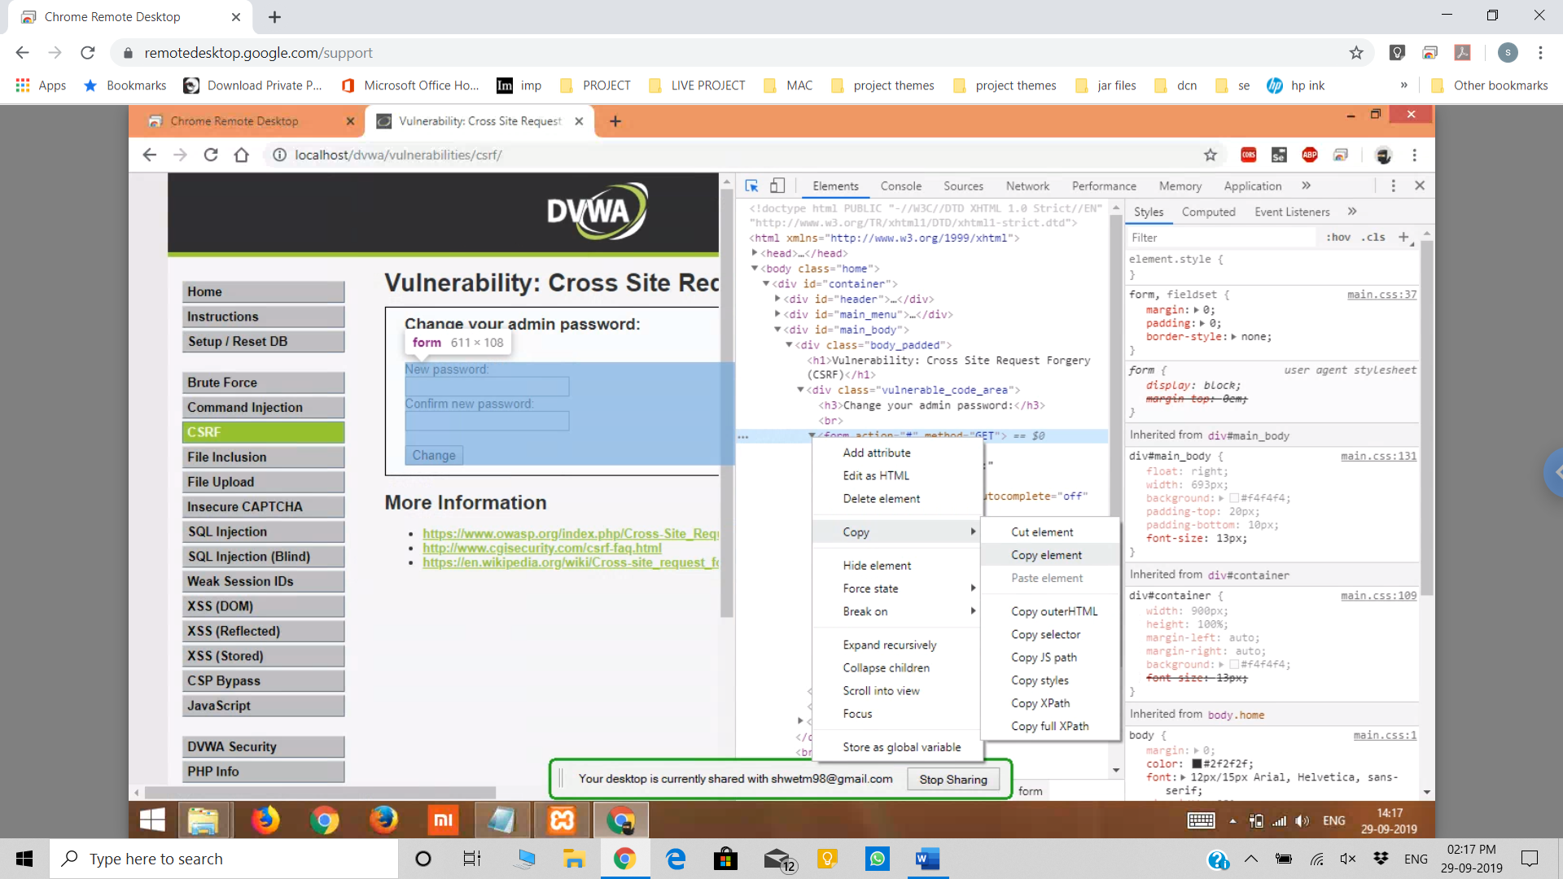

1. Paste the code in a .html file and make changes according to the image.

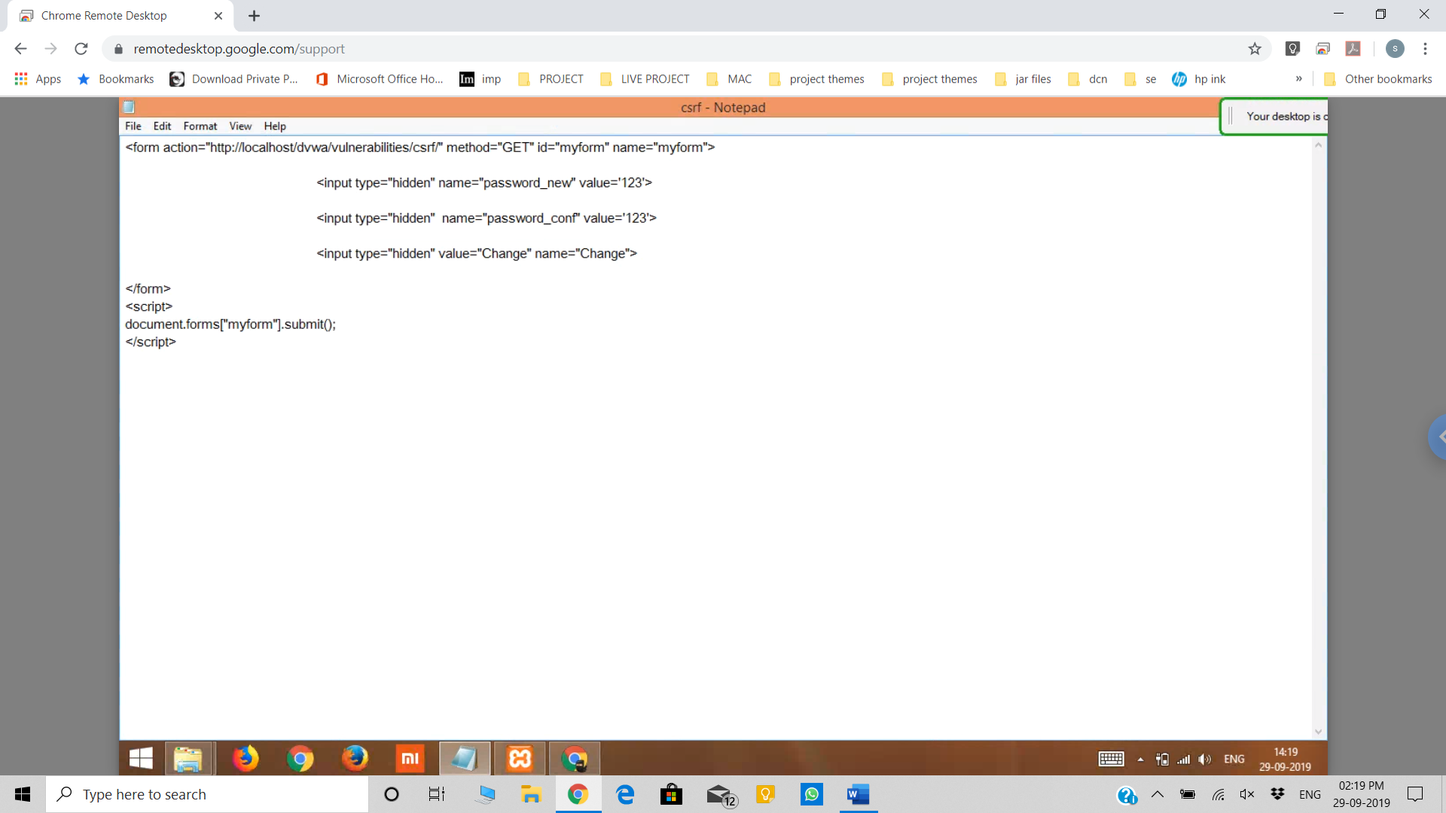

1. Open the html file in chrome using drag- and – drop.
2. The new tab will show the CSRF page and the password will be changed.

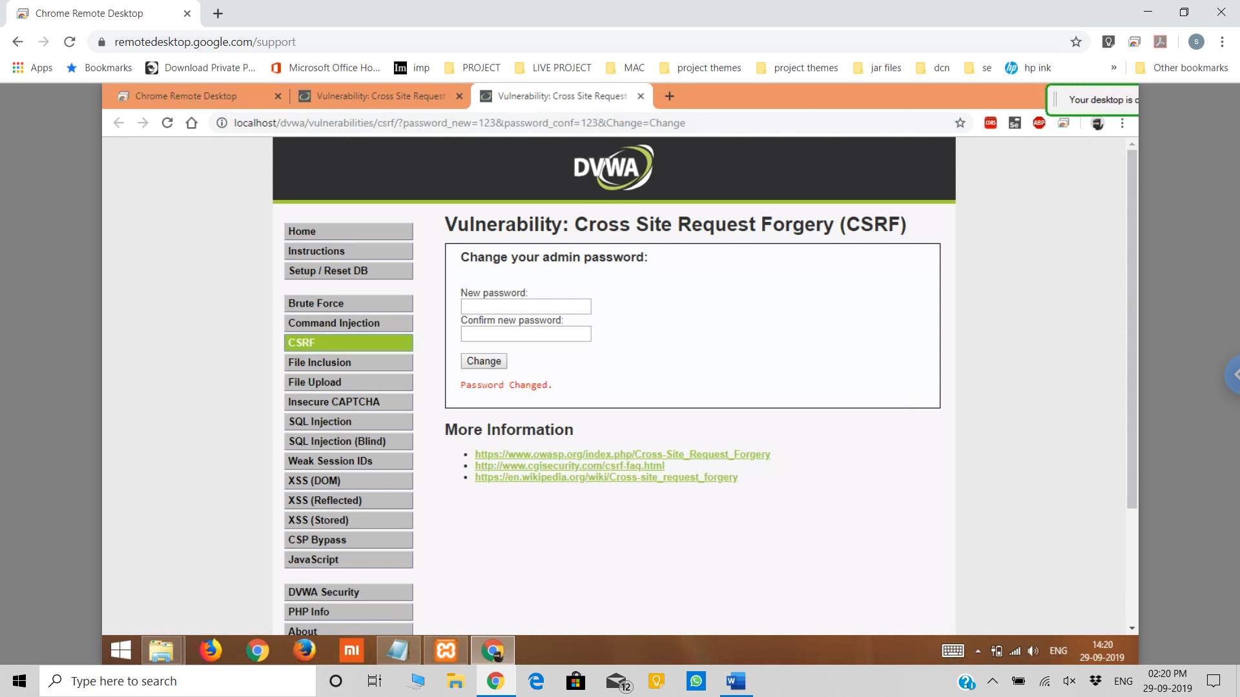

1. Now, click on logout.
2. Then try to login with your new password.