SYNORA

A Personalized Student Productivity and Academic
Management Workspace
“One calm home for everything you’re studying.”
A PROJECT REPORT
Submitted in partial fulfilment of the requirements for the course
Front End Engineering – II (Semester 3)
Submitted by
Manan Kochhar (2510993803)
Arshpreet Kaur (2510992817)
Atharv Bains (2510993832)
Group/Team no: 3G3/PID-1
Under the guidance of
Mr Amitabh Shrivastava

Bachelor of Engineering in Computer Science & Engineering
CHITKARA UNIVERSITY, PUNJAB
Chandigarh–Patiala National Highway, Rajpura (Patiala) – 140401, India
August 2026

Abstract
A student’s academic life is scattered across disconnected tools: deadlines in one app, a timetable as a photograph, attendance on paper, grades in an ad-hoc calculator, notes in yet another place. This fragmentation forces the same information to be re-entered inconsistently and never adds up to a single picture of “where I stand this semester.”
Synora is a personalized, browser-based workspace that brings these threads into one calm home. It unifies task management, an academic calendar, quick notes, a class timetable, subject-wise attendance, CGPA computation, an achievements system and a notification centre behind one coherent dashboard. Its defining idea is a centralised subject model: the subjects defined once during onboarding become the single source of truth that attendance, CGPA and the timetable reference by identifier rather than by name, so changing or removing a subject cascades correctly across every academic module.
The application is built deliberately with foundational web technologies only — semantic HTML5, a token-driven CSS3 design system, and vanilla JavaScript — with no frameworks, bundler or backend. All data is persisted per-account in the browser through the localStorage API, namespaced per username for isolation. Derived values such as attendance percentages, CGPA and “classes you can still miss” are never stored; they are computed on demand from a single set of counts, so the interface can never disagree with itself.
The interface is fully responsive across desktop, tablet and mobile using Flexbox, Grid and media queries, and ships with a persisted light/dark theme. Interactivity — creating and editing records, live form validation, quick attendance adjustments, dynamic charts and reconciled notifications — is delivered through direct DOM manipulation and delegated event handling. In short, Synora began with fundamental web-development concepts and was developed into a complete, responsive and personalized student productivity platform through thoughtful UI/UX design, structured frontend architecture, dynamic JavaScript behaviour, academic data modelling and persistent client-side data handling.

Table of Contents
Abstract i
1. Introduction 1
1.1 Background and Motivation 1
1.2 Objectives 1
1.3 Scope and Target Users 1
1.4 User Journey 2
1.5 Report Organisation 2
2. Problem Statement 2
3. Proposed Solution 3
3.1 System Overview 3
3.2 Core Idea — the Centralised Subject Model 4
3.3 Design Philosophy 4
3.4 Data Flow 5
3.5 Storage Architecture 5
3.6 Application and File Structure 5
4. Technical Details 6
4.1 HTML5 and Semantics 6
4.2 CSS3 Design System 8
4.3 JavaScript 9
4.4 Development Environment and Version Control 10
4.5 Syllabus Mapping 10
5. Key Features 11
5.1 Onboarding and the Dashboard 11
5.2 Task Management 12
5.3 Timetable, Calendar, Notes, Achievements and Settings 13
5.4 Attendance 14
5.5 CGPA 15
6. Project Advantages 16
7. Result 18
7.1 Testing and Validation 19
7.2 Summary of Results 20
8. Conclusion 20
8.1 Future Scope 21
8.2 Learning Outcomes 21
References 22

1. Introduction

1.1 Background and Motivation
Undergraduate study is organised around a dense mesh of recurring obligations — assignments and deadlines, a fixed weekly timetable, per-subject attendance requirements, internal and end-term assessments that roll up into a cumulative grade average, and a constant stream of notes. Each obligation is individually simple, yet the tools students reach for were each built for one narrow purpose and never intended to cooperate. The same subjects and dates are entered repeatedly and inconsistently, and when something changes the copies drift apart.
Synora begins from one observation: almost everything a student tracks is derived from a small, stable set of facts — who they are and which subjects they take this semester. Capture that once and treat it as authoritative, and attendance, grades and the timetable stop being separate tools to keep in sync and become different views of the same data. A second motivation is pedagogical: rather than hiding the fundamentals behind a framework, the project demonstrates that semantic markup, a disciplined styling system and plain JavaScript are, on their own, enough to build a polished, genuinely useful product.
This reframing has a practical consequence for the student. Because a subject is defined exactly once, there is no moment where a change has to be remembered in several places; because the numbers that matter — attendance, CGPA, how many classes can still be missed — are computed from that definition rather than stored beside it, the workspace can never show two figures that disagree. The effort a student would otherwise spend maintaining and reconciling separate tools is returned to them, and the product can focus on presenting a single, trustworthy picture of the semester at a glance.

1.2 Objectives
- Design a unified, single-user workspace that consolidates the principal academic-management tasks a student performs each semester.
- Model subjects as a centralised source of truth that attendance, CGPA and the timetable reference, keeping academic data internally consistent.
- Build the entire product using only HTML5, CSS3 and vanilla JavaScript — no frameworks, build step or backend.
- Provide a responsive, accessible interface with a coherent design system and a persistent light/dark theme.
- Persist all data on the client via localStorage with strict per-account isolation, deriving every academic figure on demand.

1.3 Scope and Target Users
The scope is a complete front-end application covering authentication, guided onboarding, and ten functional areas: dashboard, tasks, calendar, quick notes, timetable, attendance, CGPA, achievements, notifications and settings, together with persistence, responsiveness, theming and a branded loading experience. A production backend, server-side authentication and cross-device synchronisation are out of scope and treated as future work; the architecture, however, was chosen so a backend could be added without redesigning the interface. The primary users are undergraduate students who want one place to manage the operational side of a semester, on any device, with no installation.

1.4 User Journey
A new student progresses through a deliberate sequence that is reassuring but never a trap — onboarding can be revisited from settings, and the dashboard shows a gentle setup prompt rather than forcing completion.
1 Landing -> Sign up / Sign in -> Confirmation
2 -> Onboarding: avatar -> program -> semester
3 -> subjects + credits + track-attendance?
4 -> attendance target -> appearance (theme)
5 -> Dashboard
6 -> Tasks / Calendar / Notes / Timetable
7 -> Attendance / CGPA
8 -> Achievements / Notifications / Settings
Listing 1.1 — The Synora user journey, from first visit to daily use.

1.5 Report Organisation
The remainder of this report is organised as follows. Chapter 2 states the problem Synora addresses and the shortcomings of the fragmented tools students use today. Chapter 3 presents the proposed solution — the system overview, the centralised subject model, the design philosophy, and the data-flow, storage and file structure. Chapter 4 covers the technical details: the technology stack and the HTML5, CSS3 and JavaScript implementation, together with an explicit mapping of the work to the course syllabus. Chapter 5 documents the key features module by module, and Chapter 6 sets out the project’s advantages. Chapter 7 presents the results, including responsive views and the testing performed, and Chapter 8 concludes with the learning outcomes and realistic future scope, followed by the references.

2. Problem Statement
Consider the tools a student uses in a single week. Deadlines are noted in a phone’s reminder app or a chat group. The class timetable is a photograph of a printed sheet. Attendance is tracked, if at all, by counting rows in a register or spreadsheet. Grades from past semesters are re-computed by hand whenever the student wonders where they stand. Notes are split across a notebook, a notes app and message drafts. Each tool works, but none of them knows anything about the others, and the burden of keeping them agreed falls entirely on the student.
The deeper issue is that this information should reinforce a single picture of “where I stand this semester”, yet it is instead broken into silos that never speak to one another. A deadline in a reminder app has no idea which subject it belongs to; an attendance spreadsheet has no idea what target the student is aiming for; a grade calculator has no idea what the subject’s credits are. Effort that should go into studying is spent instead on maintaining the tools and reconciling their disagreements.
A typical student’s week is therefore spread across single-purpose tools that never cooperate, which creates several concrete problems:
- Duplicated data entry — the same subjects and dates are typed into several unrelated tools.
- Data drift — when a subject or credit value changes, the copies fall out of step and it is unclear which is correct.
- No shared context — a generic to-do app does not understand “subjects”, “credits” or “attendance targets”, so it cannot link a deadline to its subject or warn about falling attendance.
- Fragmented attention — answering “what matters today?” means opening and mentally merging several apps.
What is missing is not another tool but a workspace that understands the student’s academic context. If subjects are defined once and every feature refers to that single definition, duplicated entry and data drift disappear by construction; if derived numbers are computed rather than stored, the interface can never contradict itself. Synora’s approach is exactly this: capture the profile and subjects once during onboarding, attach tasks, notes, timetable, attendance and grades to that record, derive everything else on demand, and organise the whole experience around a dashboard that answers “what needs my attention today?”

3. Proposed Solution

3.1 System Overview
Synora is a static, multi-page client-side application. A public landing page introduces the product; an authentication layer manages sign-up and sign-in; a guided onboarding captures the profile and subjects; and an authenticated shell hosts the dashboard and ten functional pages. There is no application server and no database process — each HTML page links the shared stylesheets and a shared JavaScript core, then loads a small feature script. The core exposes a single global namespace, keeping data shape and behaviour uniform across pages.
The technology layers are deliberately thin and explicit. HTML5 provides structure and semantics; CSS3 provides the design system and responsive layout; JavaScript provides logic, DOM updates, events and storage, with a small derivation layer turning stored data into display figures. This separation — structure, presentation and behaviour each in its own layer — mirrors the fundamentals the course teaches, and it means each part of the system can be understood, and changed, largely on its own. The core script establishes the shared utilities, the subject model, the derivations and the achievements and notification engines, then dispatches a ready event once the DOM is parsed, after which each page’s feature script renders and wires up that page.
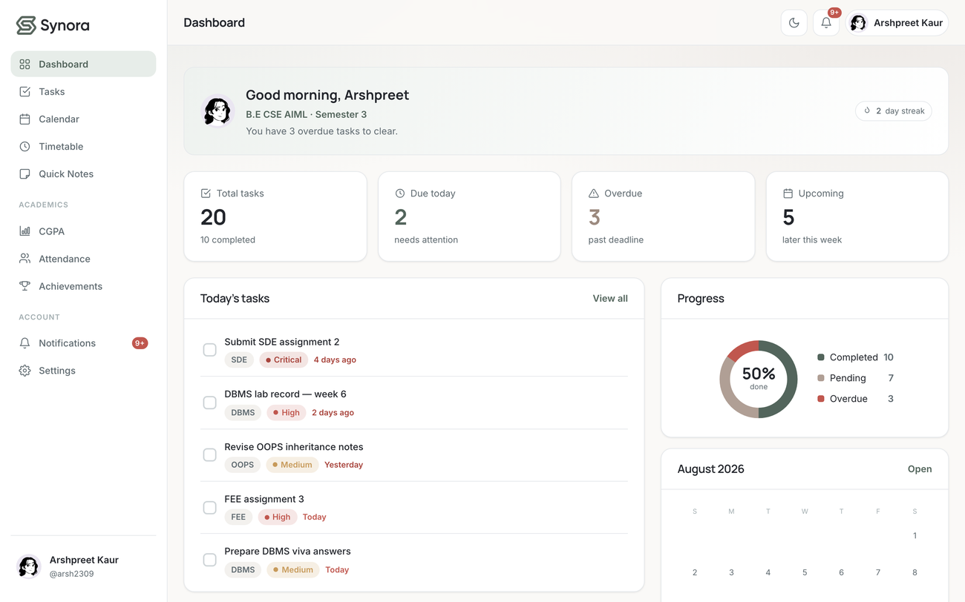
Figure 1. The Synora dashboard — the central surface answering “what needs my attention today?” with task statistics, today’s classes, progress and a mini-calendar.

3.2 Core Idea — the Centralised Subject Model
During onboarding the student defines their subjects, each with a name, a credit value and a flag for whether attendance is tracked. This list is the authoritative academic record. Attendance rows, CGPA entries and timetable entries never store a subject name — they store the subject’s identifier and resolve the name and credits from the central list at read time. Removing a subject cascades to remove its attendance, grade and timetable references. The subject record is a small, flat object:
1 { id: "<stable id>", name: "Database Management Systems",
2 credits: 3, trackAttendance: true }
Listing 3.1 — The subject record, the single definition of a subject for the whole workspace.
Centralising subject data matters because it removes every opportunity for the same subject to be described two different ways. The subjects API normalises on read — a missing trackAttendance is treated as true — exposes a filtered list of tracked subjects for the attendance system, and cascades deletions so that removing a subject also removes its attendance, grade and timetable references. The trackAttendance flag controls attendance visibility only, never CGPA: a subject the student chooses not to keep a register for still carries credits and a grade and still contributes to the average. This one modelling decision is what makes the rest of the workspace consistent without any feature having to remember to keep copies in step.

3.3 Design Philosophy
The visual and interaction design follows a calm, restrained philosophy. A warm off-white background, a sage-green brand accent and a warm taupe secondary accent replace the high-contrast palettes common to consumer apps; motion is subtle and purposeful. Because the design system is tokenised and componentised, the interface is consistent without effort — a button, field or card looks and behaves the same on every page, and a single change to a token restyles the whole product, which is itself a usability feature since the student learns the interface once.
Common tasks are quick and forgiving: creating a record is a short, validated form; destructive actions ask for confirmation; feedback is immediate through inline validation and transient toasts; and the dashboard means the student rarely has to hunt for what needs doing. The onboarding is guided but never a trap — it can be revisited from settings, and the dashboard shows a gentle setup prompt rather than forcing completion — so the workspace stays a place the student is willing to return to daily.

3.4 Data Flow
All data flows through one storage module; no feature touches localStorage directly. It reads and writes JSON under namespaced keys, applies defaults, normalises on read and cascades deletions. After any mutation the app calls a global refresh that re-derives dashboard figures, reconciles notifications and re-renders the affected views. This unidirectional flow — mutate through the store, then refresh — is what keeps the many independent pages coherent without a framework’s reactivity system, and it makes the relationship between a user action and the resulting screen update easy to trace.
1 User
2 +-- Profile ....... name, program, semester, avatar, theme, target
3 +-- Subjects (source of truth: id, name, credits, trackAttendance)
4 | +-- Attendance (subjectId -> held/attended)
5 | +-- CGPA (subjectId -> grade)
6 | +-- Timetable (subjectId -> day, start, end)
7 +-- Tasks +-- Notes +-- Achievements +-- Notifications
Listing 3.2 — The per-user data model; attendance, CGPA and timetable reference subjects by identifier.

3.5 Storage Architecture
Persistence is provided entirely by the Web Storage API. Every account owns an isolated set of collections stored under keys of the form synora:<username>:<collection>, so two students signed in on the same browser never see each other’s data. The store serialises collections with JSON.stringify on write and parses them with JSON.parse on read, wrapping both in error handling so that corrupt or absent data falls back to a sensible default rather than throwing. Because reads normalise their result, older data written by an earlier version of the app is upgraded transparently.
Table 1. The localStorage key scheme: global keys are shared; per-user keys are namespaced for isolation.
Storage key | Contents
synora-users / -session / -theme | Global: account registry, active session, theme preference.
synora:<user>:profile | Name, program, semester, avatar, attendance target.
synora:<user>:subjects | The central subject list (source of truth).
synora:<user>:tasks / notes | Tasks and quick notes.
synora:<user>:attendance / cgpa / timetable | Per-subject counts, grades and class entries.
synora:<user>:achievements / notifications | Unlocked-badge state and generated alerts.

3.6 Application and File Structure
The repository separates concerns cleanly into markup, styles and scripts, with assets kept apart from the application itself. A branded loading screen bridges the moment between navigation and a ready interface, using CSS animation for the motion and JavaScript only for timing.
1 Synora/
2 index.html landing page
3 app/ login signup onboarding dashboard tasks
4 calendar notes timetable attendance cgpa
5 achievements notifications settings (13)
6 styles/ tokens base components landing auth
7 onboarding app (7 stylesheets)
8 scripts/ storage app(core) avatars theme auth ...
9 + one feature script per page (18 files)
10 assets/ logos, avatars, preview images
Listing 3.3 — The Synora source layout: 14 HTML pages, 7 stylesheets, 18 scripts, no framework or build directory.
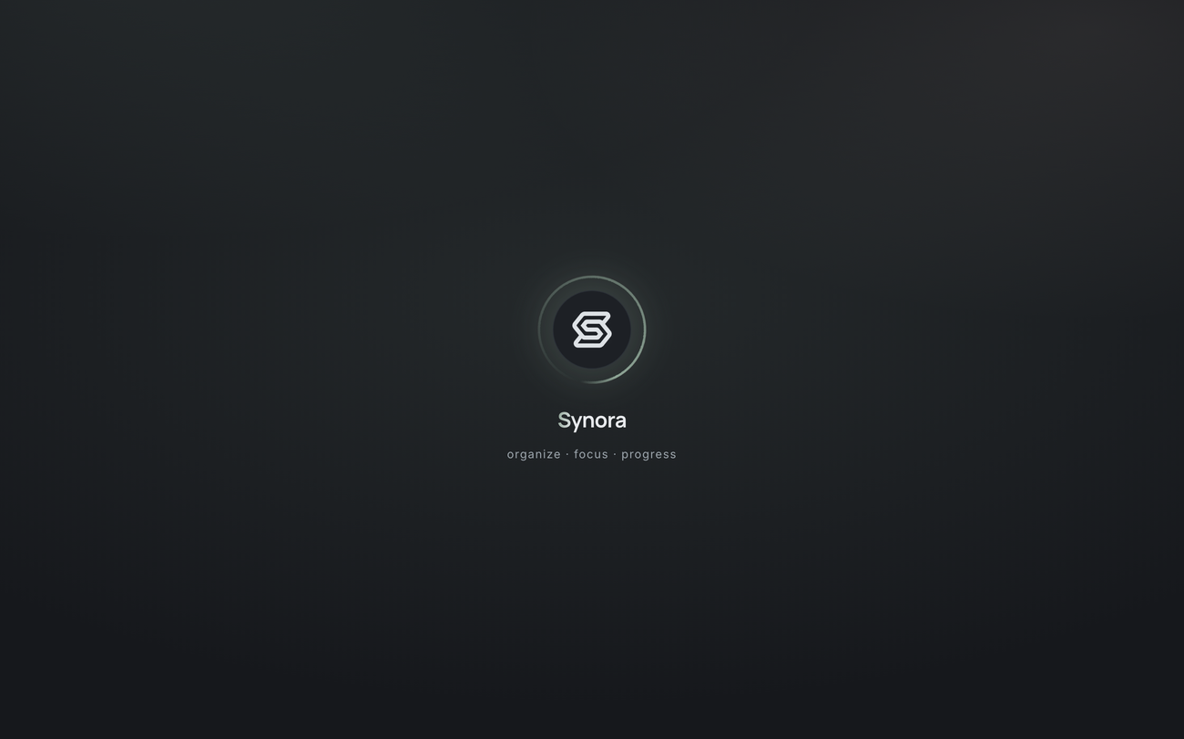
Figure 2. The branded loading screen: a CSS-animated splash provides a calm transition while the first page initialises.

4. Technical Details
Synora uses a deliberately minimal stack, and every item listed is genuinely used in the shipped product.
Table 2. The Synora technology stack — framework-free by design.
Technology | Role in Synora
HTML5 | Semantic structure of all 14 pages: landmarks, headings, forms and controls.
CSS3 | Token-driven design system, layout via Flexbox and Grid, responsive media queries, light/dark theme.
JavaScript (vanilla) | All logic: state, DOM manipulation, events, form validation, calculations, rendering.
DOM API | querySelector/All, getElementById, createElement, appendChild, element.remove.
Web Storage (localStorage) | Persistent, per-account client-side data with JSON serialisation.
Browser / BOM APIs | location for navigation; matchMedia for system theme detection.
Git & GitHub | Version control and hosting of the source repository.

4.1 HTML5 and Semantics
Every page shares one structural pattern: a head declaring character set and viewport and linking the shared styles, then a body organised into meaningful regions. Authenticated pages share a shell — a branded sidebar, a top bar with the theme toggle, notification bell and profile menu, and a main content region into which each feature renders. The sidebar is grouped into the daily tools, the academics section and the account section, with the active page indicated visually, so the user’s mental model never has to reset when moving between pages.
Markup favours elements that describe their role — navigation, main, sections, ordered headings — which aids assistive technology and gives the stylesheet and scripts stable, meaningful hooks. Forms are central to Synora: sign-up, sign-in, onboarding and the create/edit dialogs for tasks, notes, timetable entries, attendance and grades each use native input controls with associated labels, appropriate input types and required attributes, giving sensible default behaviour and accessibility over which JavaScript layers live validation. Accessibility is addressed at the level of fundamentals: labelled controls, a logical heading order, real buttons and links for keyboard and screen-reader support, a visible focus ring defined in the design system, and legible light and dark palettes.
The public landing page introduces Synora to a first-time visitor as a sequence of clearly delineated sections — an introduction, a “look inside” using genuine application screenshots, an explanation of how it works, and a contact section. The authentication pages present focused forms; on success the user reaches a confirmation step that offers an explicit next choice rather than a timed redirect.
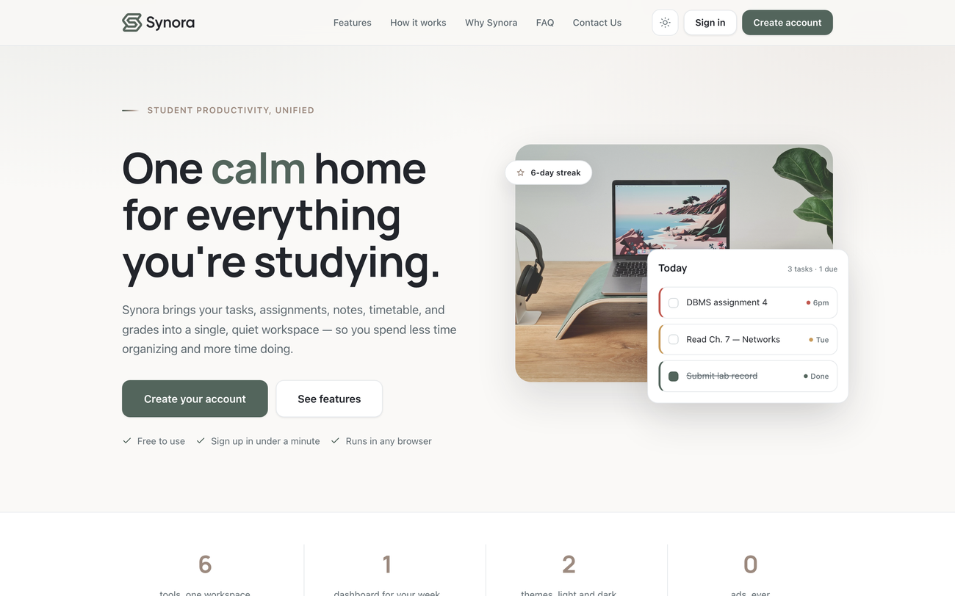
Figure 3. The public landing page; the “look inside” section shows genuine application screenshots rather than mock-ups.
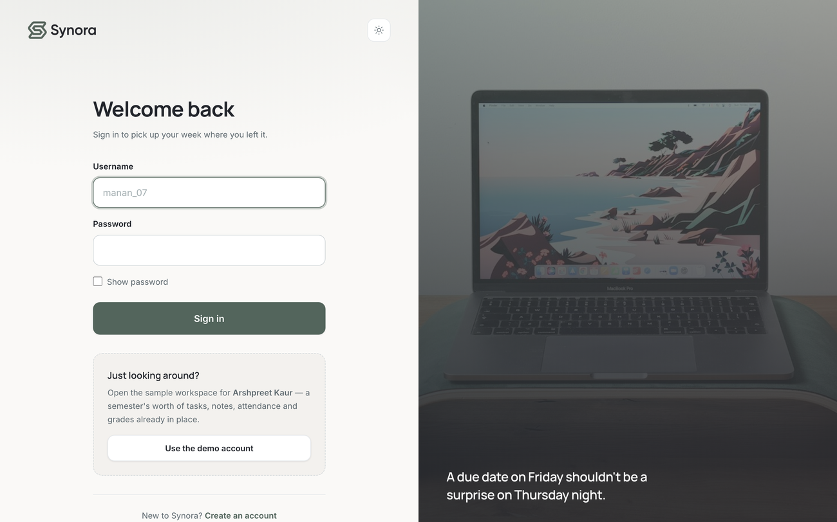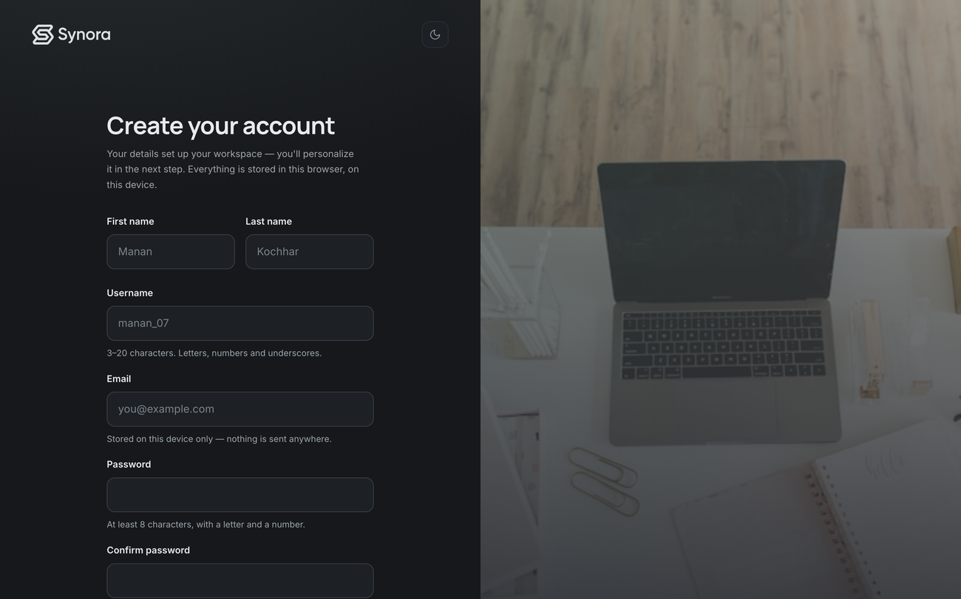
Figure 4. Authentication: the sign-in page (left) and sign-up page (right), each with native controls and live validation.

4.2 CSS3 Design System
Styling is organised as a small design system: a tokens layer defines the raw decisions, a base layer sets element defaults, a components layer styles reusable pieces once, and page layers handle the landing, auth, onboarding and app shells. Over one hundred custom-property definitions — colours, spacing, radii, shadows, motion and type — live on the root element, and components consume these variables rather than literal values. The dark theme is simply the same variable names redefined under a [data-theme="dark"] selector.
1 :root {
2 --color-bg: #FAF9F7; /* warm off-white */
3 --color-brand: #53655C; /* sage */
4 --color-accent: #B09F95; /* taupe */
5 --color-text: #22252B; /* ink */
6 --radius-lg: 16px; --space-16: 16px; /* + scale */
7 }
8 [data-theme="dark"] { --color-bg: #16181C; --color-text: #E5E8EB; }
Listing 4.1 — Semantic tokens with a themed override; redefining the same names switches the entire theme.
The palette is five deliberate colours, each with a clear job, expressed as semantic tokens rather than raw values scattered through the code, so a single change propagates everywhere.
Table 3. The five-colour Synora palette, defined once as semantic tokens.
Role | Value | Usage
Ink | #22252B | Headings, dark bands, primary text.
Sage | #53655C | Brand accent: buttons, links, active states.
Slate | #A3AEB1 | Dividers and quiet icons.
Mist | #E5E8EB | Borders and subtle separators.
Taupe | #B09F95 | Warm accent: numbers and underlines.

Every card, form field and button is a controlled application of the box model — content, padding, border and margin drawn from the spacing and radius scales — so components share one internal rhythm and the interface reads as one system rather than a collection of independently styled boxes. Type pairs a clear heading face with a comfortable reading face on a consistent scale, using weight and size rather than colour or decoration to establish hierarchy, which keeps the interface calm and legible in both themes.
Layout uses Flexbox for one-dimensional alignment — the top bar, navigation rows, button groups, form rows and the many small clusters of an icon beside a label — appearing well over a hundred times across the stylesheets. CSS Grid handles two-dimensional structure: the dashboard’s statistic cards, the overall content layout, the calendar’s seven-column month and the responsive galleries of screenshots, adapting cleanly at breakpoints by redefining the track template. The design is fluid and adapts through more than twenty media-query blocks, desktop-first: the rich layout is defined for wide screens and progressively simplified — multi-column grids collapse to single-column stacks and navigation reflows for touch — as the viewport narrows. Dark mode is a first-class part of the design, achieved by overriding the palette variables under a data-theme attribute; the theme module persists the choice and can follow the operating-system preference via matchMedia.
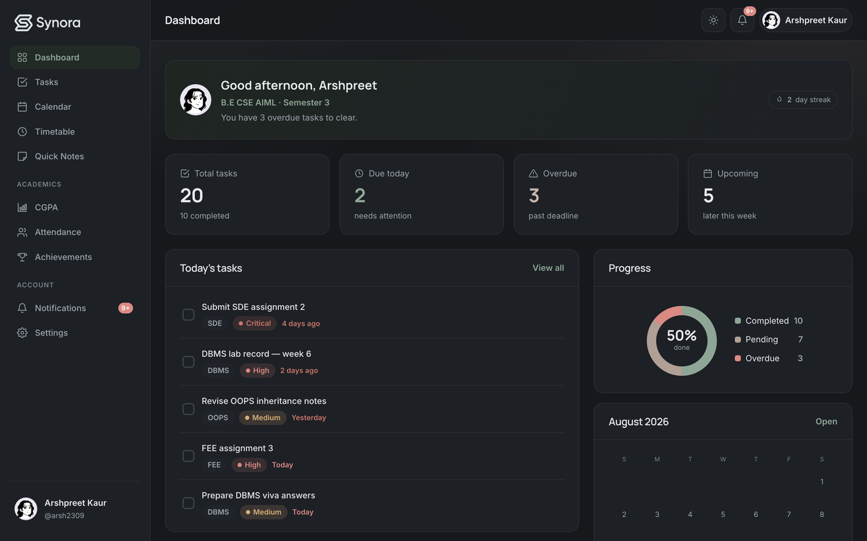
Figure 5. The dashboard in light and dark themes; only the palette tokens differ, while layout and behaviour are shared.

4.3 JavaScript
All scripts contribute to a single global namespace. A core script establishes shared utilities, the subject model, the derivation functions and the achievements and notification engines, then dispatches a ready event; each page loads a small feature script that renders and wires it up. Collections are arrays of plain objects processed with filter/map/sort/forEach; the interface is built by direct DOM manipulation — createElement, appendChild, element.remove() — with elements located via querySelector(All) and getElementById. Interaction is driven by addEventListener, most of it through event delegation: one handler on a stable container uses closest() to find the acted-upon item, so handlers stay correct as lists re-render. Forms validate live, and persistence goes through the store using JSON.stringify/JSON.parse under error handling.
1 // One delegated handler survives every re-render of the list.
2 taskList.addEventListener("click", function (e) {
3 var card = e.target.closest("[data-task-id]");
4 if (!card) return;
5 var id = card.getAttribute("data-task-id");
6 if (e.target.closest("[data-complete]")) toggleComplete(id);
7 else if (e.target.closest("[data-delete]")) remove(id);
8 });
Listing 4.2 — Event delegation: a single listener handles clicks for every task, present and future.
Application state is the user’s data, held in localStorage and read through the store on demand rather than duplicated into long-lived in-memory variables; feature scripts hold only transient view state — the note currently being edited, the month currently shown — and always treat the store as the source of truth. The academic figures are produced by a small set of pure derivation functions that turn stored data into display values, keeping calculation cleanly separate from rendering. Forms validate as the user works: required fields, well-formed email addresses, matching passwords at sign-up and sensible numeric ranges for credits and attendance counts are all checked before a record is accepted, with invalid fields marked and submission blocked until corrected. Beyond the DOM, Synora uses only a small, honest set of browser-level APIs — location for navigation and matchMedia for theme detection — and does not claim capabilities it does not use.

4.4 Development Environment and Version Control
Development used a standard code editor and a modern browser with its developer tools. Because there is no build system, the edit–refresh loop is immediate: the application is served over HTTP and reloaded to see changes, with the browser’s tools used for inspection and debugging. The absence of transpilation or bundling means the code that is written is exactly the code that runs, which keeps debugging direct — a value in the source maps straight to a value in the running page, with no intermediate representation to reason about.
The project is version-controlled with Git and hosted on GitHub. Version control supported incremental development across the project’s phases and preserved a history of the architecture as it matured, from the first landing page through authentication, onboarding and each functional module to the final design pass. Keeping the whole product framework-free also keeps the repository self-contained: cloning it and opening it over a static server is all that is required to run Synora, with no dependency installation step.

4.5 Syllabus Mapping
The project demonstrates the Front End Engineering syllabus through real features. Each concept below is mapped to where it is genuinely used; where a concept is relevant but not exercised, it is marked honestly rather than claimed.
Table 4. Mapping of syllabus concepts to their real demonstration in Synora.
Syllabus concept | Demonstration in Synora | Status
HTML5 & semantic markup | All 14 pages; navigation, main, sections, headings. | Implemented
Forms & accessibility | Auth/onboarding forms; labelled controls, focus ring. | Implemented
Box model & CSS tokens | Cards, fields, buttons; 100+ custom properties. | Implemented
Flexbox & CSS Grid | Nav and rows (100+); dashboard, calendar (50+). | Implemented
Responsive & media queries | Fluid layout; 20+ breakpoint blocks (desktop-first). | Implemented
Dark mode | Token override under a data-theme attribute. | Implemented
Variables, functions, loops | Store-backed state; helpers, derivations, render loops. | Implemented
Arrays & objects | Tasks, subjects, notes, timetable; record objects. | Implemented
DOM manipulation & selectors | createElement/appendChild/remove; querySelector(All). | Implemented
Event handling & validation | addEventListener with delegation; live validation. | Implemented
Browser storage & BOM | localStorage (namespaced); location, matchMedia. | Implemented
Explicit event capturing | Not required by any feature; standard bubbling used. | Concept only

5. Key Features
The authenticated workspace is organised into ten modules, summarised below and illustrated with genuine screenshots of the running application. Each module is documented in terms of what it does, how the student interacts with it, how it is implemented and the data it depends on. What they share is the central subject model and the shared design system, so although each page has its own purpose, they read as one coherent product rather than a collection of separate tools.
Table 5. The ten functional modules of the Synora workspace.
Module | Purpose
Dashboard | At-a-glance summary of tasks, today’s classes, progress and academic standing.
Tasks | Create, edit, prioritise, complete and filter subject-linked assignments.
Calendar | Month view of dated tasks and deadlines, navigable by month.
Quick Notes | Lightweight, persistent notes for quick capture.
Timetable | Weekly class schedule built from the central subject list.
Attendance | Subject-wise counts, percentages, target line and a chart.
CGPA | Credit-weighted grade-point average over graded subjects.
Achievements | Goal-based badges that unlock dynamically as the student works.
Notifications | Reconciled alerts for deadlines, overdue tasks, attendance and achievements.
Settings | Profile, subjects, attendance target, appearance and data management.

5.1 Onboarding and the Dashboard
A guided, multi-step onboarding captures the profile and the all-important subject list — avatar, program, semester, subjects with credits and a per-subject attendance preference, an attendance target, and the theme — in that order, mirroring progress into a draft so an interrupted setup is not lost. Everything captured here can later be revised from Settings, which reuses the same components and the same subject model, so a change made afterwards cascades through attendance, CGPA and the timetable exactly as it would during setup.
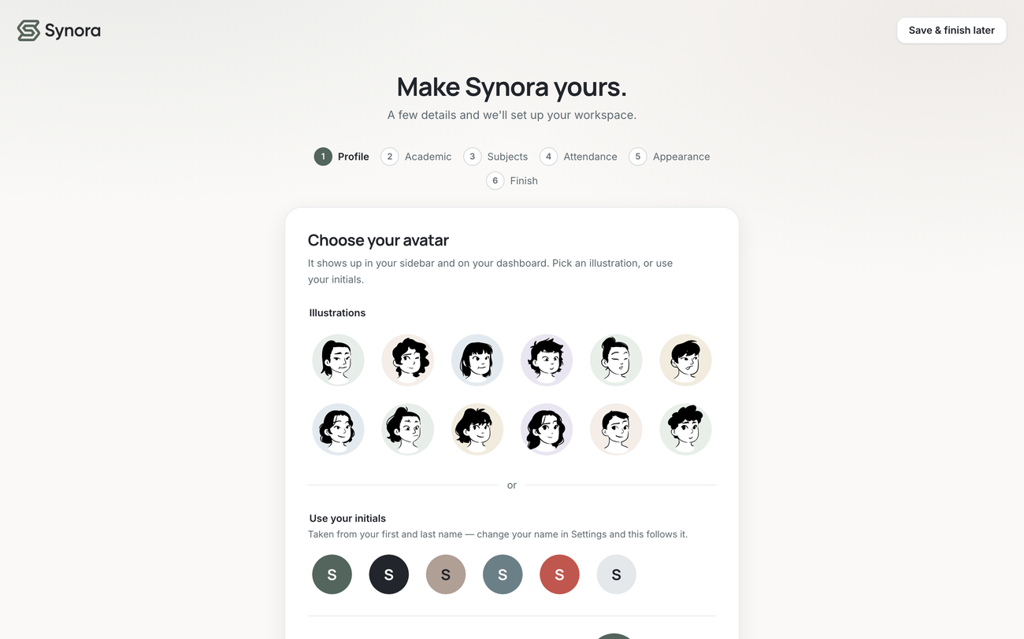
Figure 6. The guided onboarding flow, capturing the profile and subjects that become the workspace’s source of truth.
The dashboard is the workspace’s home and its answer to “what needs my attention today?” A greeting and profile summary sit above four statistic cards — total, due today, overdue and upcoming tasks — followed by a list of today’s tasks, a progress ring, a mini-calendar and quick links into the deeper pages. A dashboard script reads the store, calls the shared derivations for task statistics and today’s classes, and renders each panel, re-rendering on the global refresh so the summary is always current.

5.2 Task Management
Tasks are the operational heart of the workspace. Each task carries a title, an optional subject drawn from the central list, a deadline, a priority and a status. A create/edit dialog validates input; the list renders from the tasks collection and uses a single delegated click handler for completion and deletion so it stays correct through re-renders. Tasks can be filtered by state, completion is a single click, and completing tasks feeds the achievements engine and updates the dashboard statistics immediately.
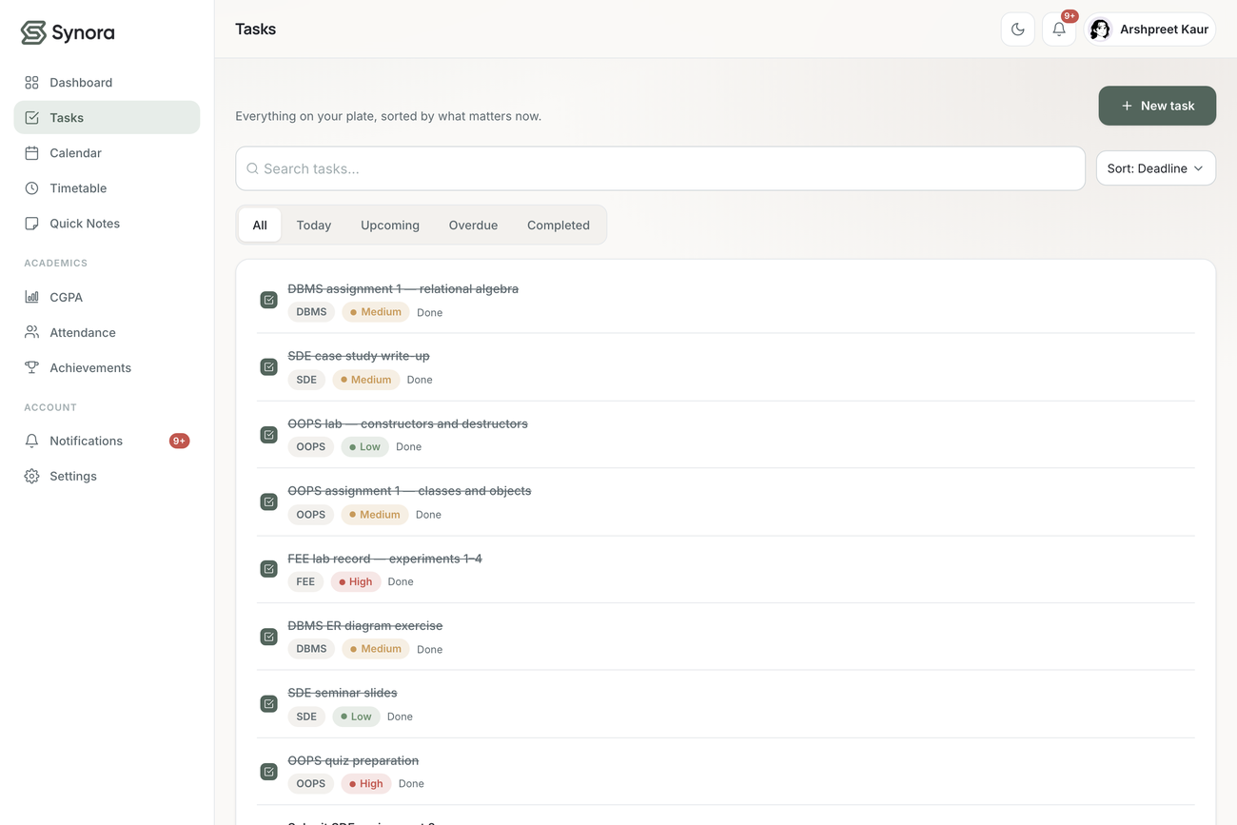
Figure 7. Task management: each task carries a subject, deadline, priority and status, with create, edit, complete, delete and filtering.

5.3 Timetable, Calendar, Notes, Achievements and Settings
The timetable stores entries by subject identifier, so today’s classes surface on the dashboard with names always consistent with the rest of the workspace. The calendar renders a seven-column month grid marking days that carry task deadlines, drawn from the same task records the Tasks page uses — the integration is real because both read one source rather than a second copy. Quick Notes is a lightweight, persistent surface for short reminders that survive between visits.
Achievements are seven goal-based badges — complete your first task, complete five and ten tasks, reach a three-day completion streak, finish tasks before their deadline, add a timetable, and write five notes — that unlock dynamically as the underlying goals are met, recording when each was earned. Settings manages the profile, subjects, attendance target and appearance, reusing the onboarding components. Notifications are generated from live data and reconciled on every refresh, so an alert whose cause has gone away — a task completed, attendance recovered — is dropped rather than left stale, keeping the feed trustworthy.
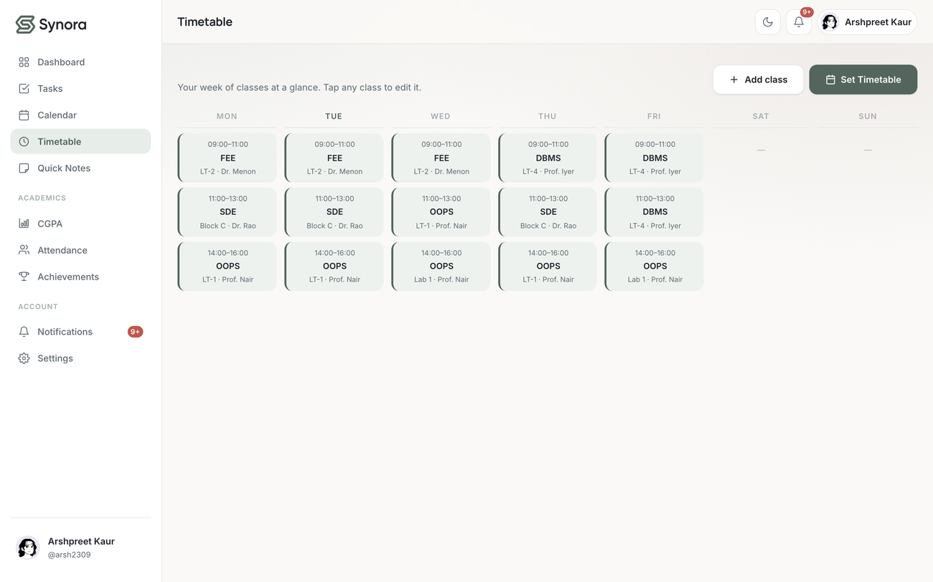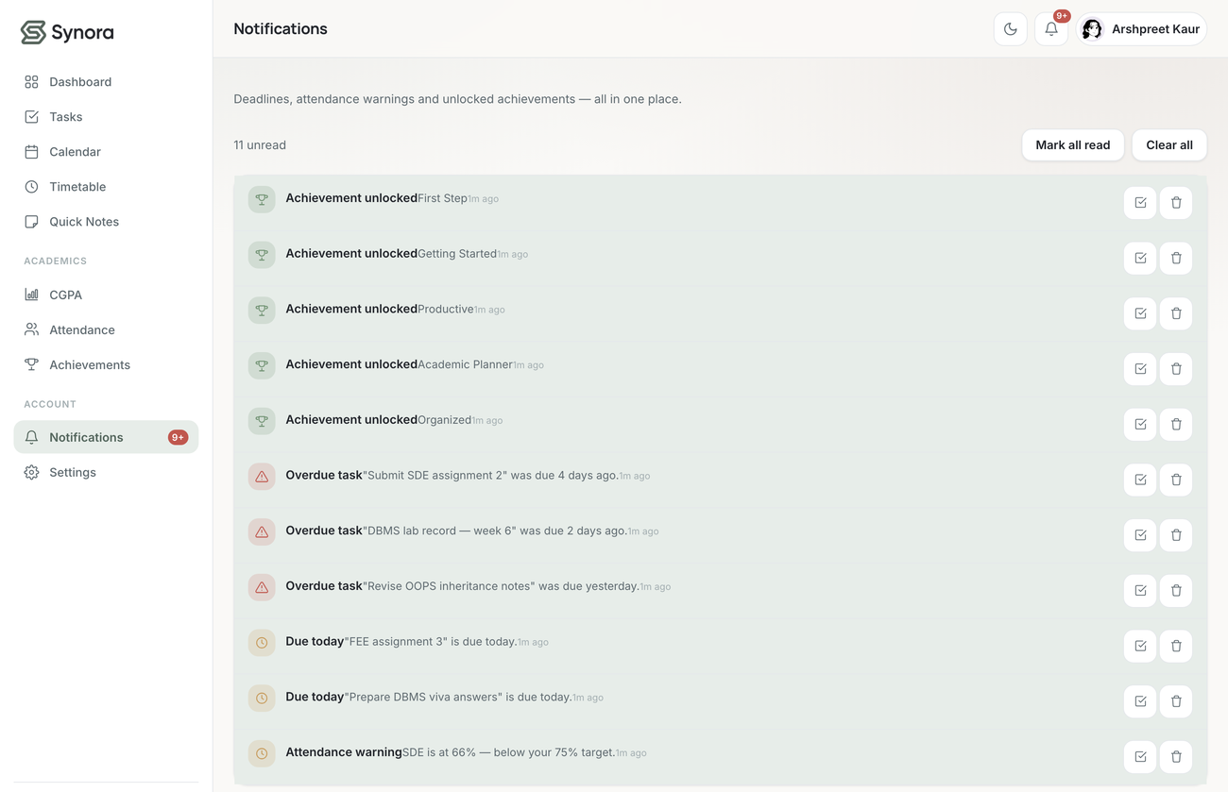
Figure 8. The weekly timetable (left), built from the central subjects, and the reconciled notification centre (right).
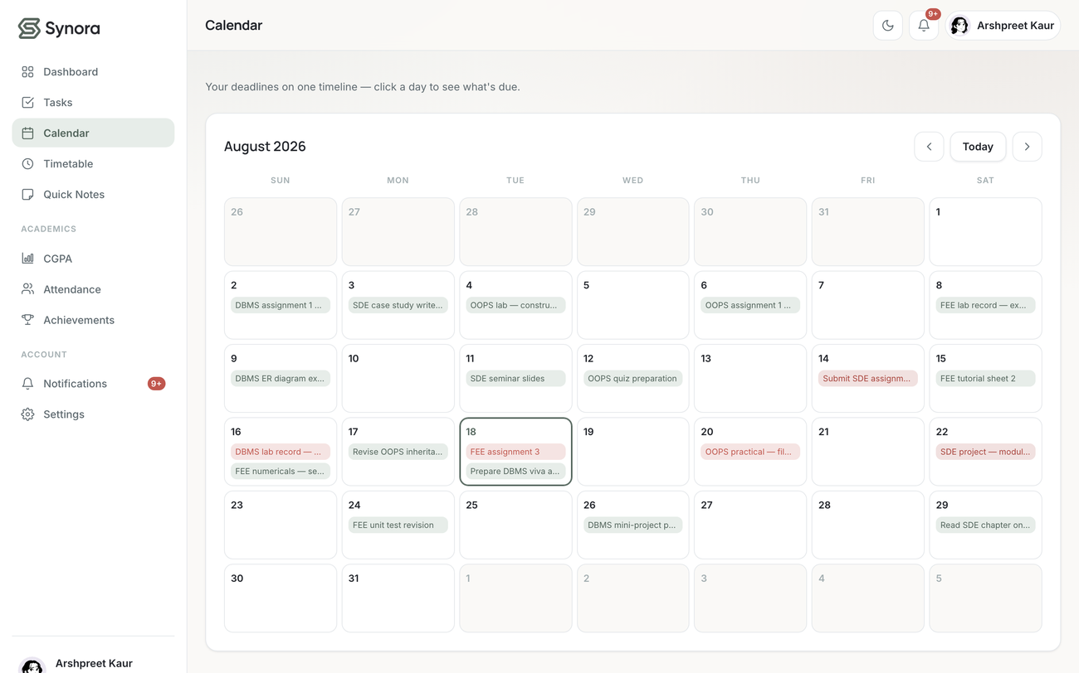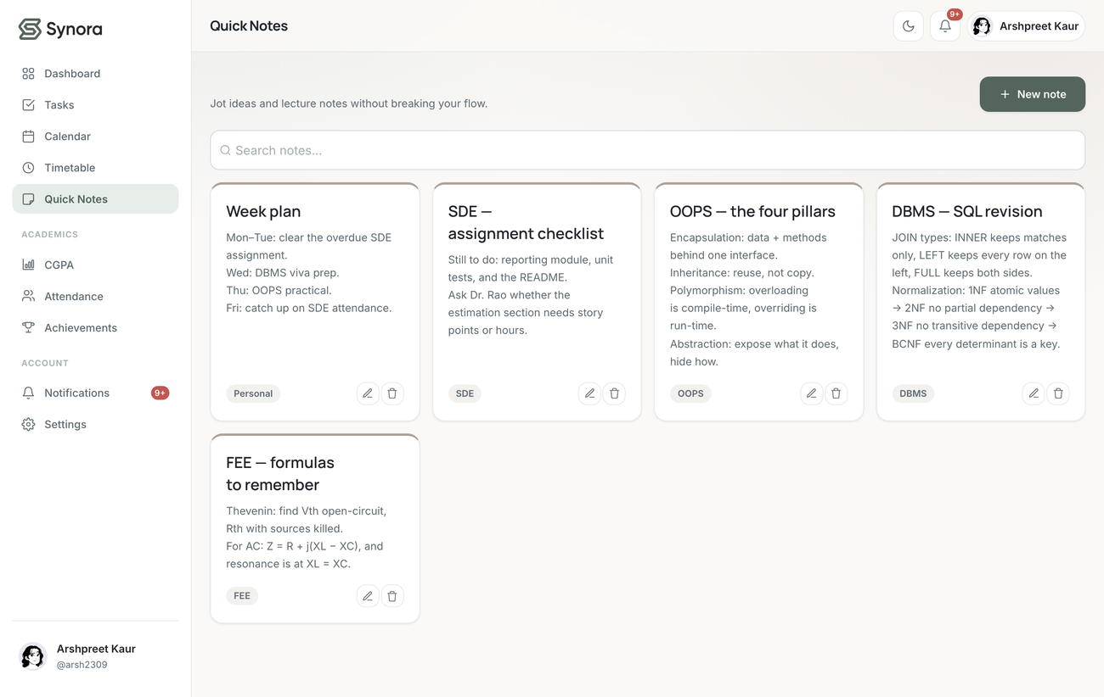
Figure 9. The month calendar (left) marking task-deadline days, and Quick Notes (right) for lightweight persistent capture.
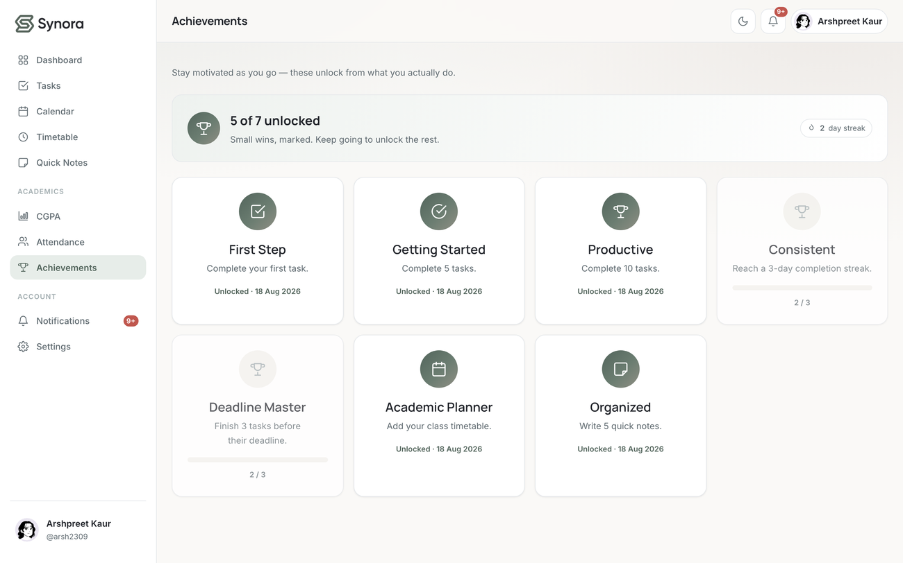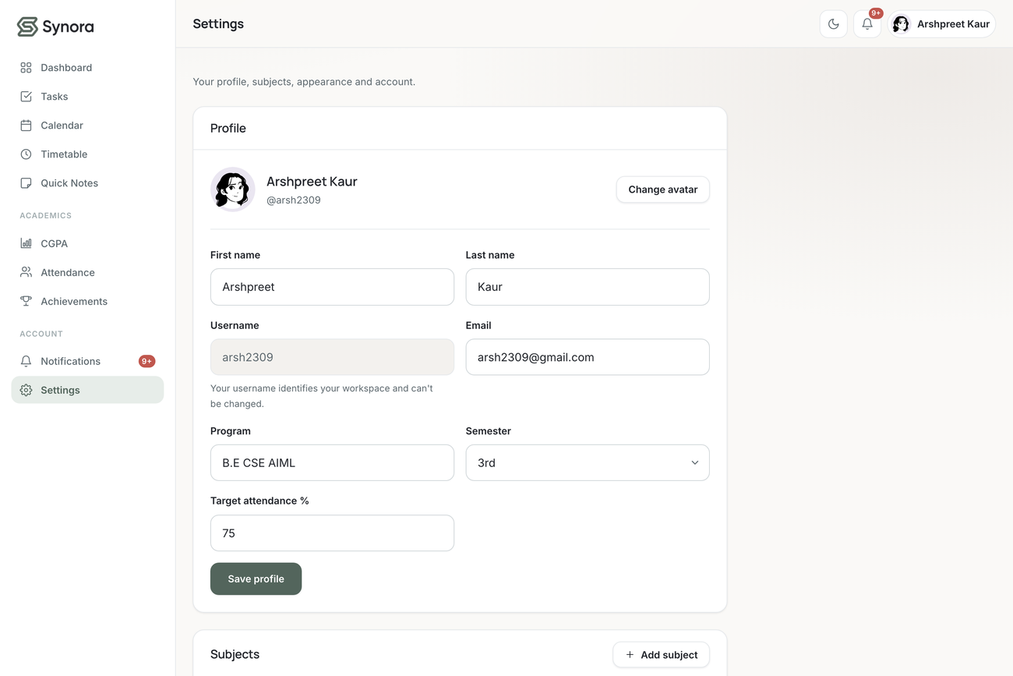
Figure 10. Achievements (left) unlock dynamically as the student works; Settings (right) manages the profile and subjects.

5.4 Attendance
Attendance illustrates the “derive, don’t duplicate” principle. Rows store only counts; the percentage is computed as attended / held × 100, with held = 0 treated as “nothing recorded”. Quick controls increment and decrement counts (validated so held is never negative and attended never exceeds held). From a target set during onboarding (default 75%), Synora derives how many classes may still be missed while staying at or above target, and, when below, how many consecutive classes are needed to recover.
1 can miss = floor(attended * 100 / target) - held
2 catch up = ceil((target*held - 100*attended) / (100 - target))
Listing 5.1 — The “classes you can still miss” and “classes needed to catch up” derivations.
Attendance is charted on a fixed 0–100% axis with the target as a reference line, and a below-target subject generates a warning that is reconciled away once attendance recovers. The per-subject trackAttendance flag controls attendance visibility only — never CGPA; an untracked subject still carries credits and a grade.
Attendance is visualised on a chart with a fixed zero-to-one-hundred-per-cent axis and the target drawn as a reference line, so the height of a bar is always meaningful and directly comparable between subjects. Because the attendance view is driven by the list of tracked subjects rather than by stored rows, a newly added subject appears immediately at zero, and a subject whose tracking is switched off disappears from the page, the chart and the warnings at the same instant, with no stale row left behind to explain — the correctness comes from the data model rather than from remembering to filter after the fact.
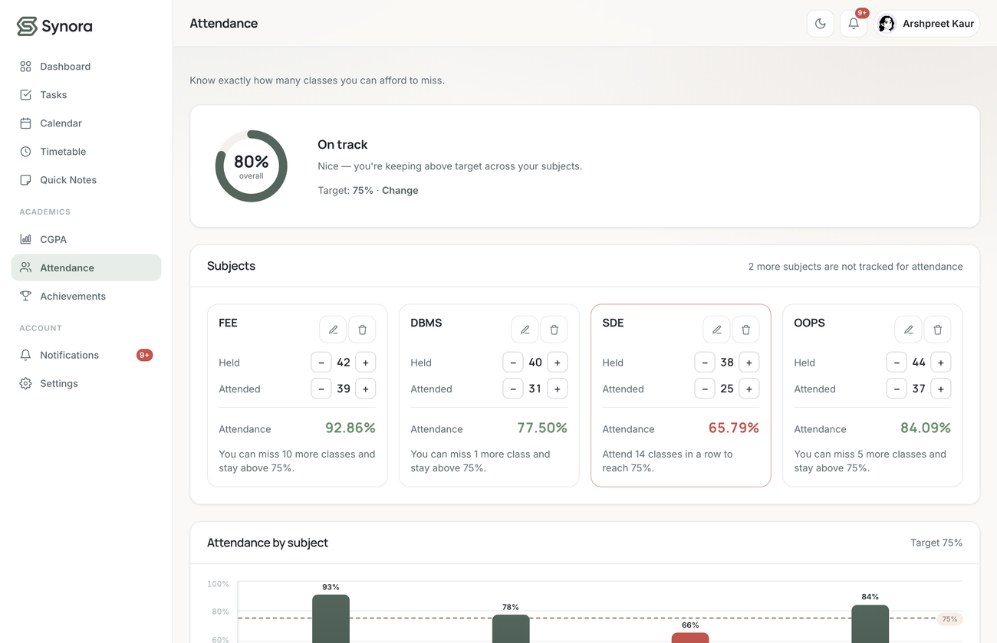
Figure 11. Attendance: per-subject counts drive a fixed 0–100% chart with the target as a reference line; percentages are computed, never stored.

5.5 CGPA
Synora implements a single ten-point grading system. The CGPA is the credit-weighted average Σ(credits × grade point) / Σ(credits), with credits from the subject record and grades from the CGPA record. Failure grades (E1, E2, E3) score zero points but still contribute their credits — a deliberate choice reflecting that a failed subject counts against the average until cleared. Grades are plotted on a labelled axis: passing grades rise above a baseline and the three failure results hang below it as three separate labels.
Table 6. The ten-point grading model; failure grades score zero but still contribute credits.
Grade | Point | Meaning
O | 10 | Outstanding
A+ | 9 | Excellent
A | 8 | Very good
B+ | 7 | Good
B | 6 | Above average
E1 | 0 | Failed in internals
E2 | 0 | Failed in end-term exam
E3 | 0 | Failed in both

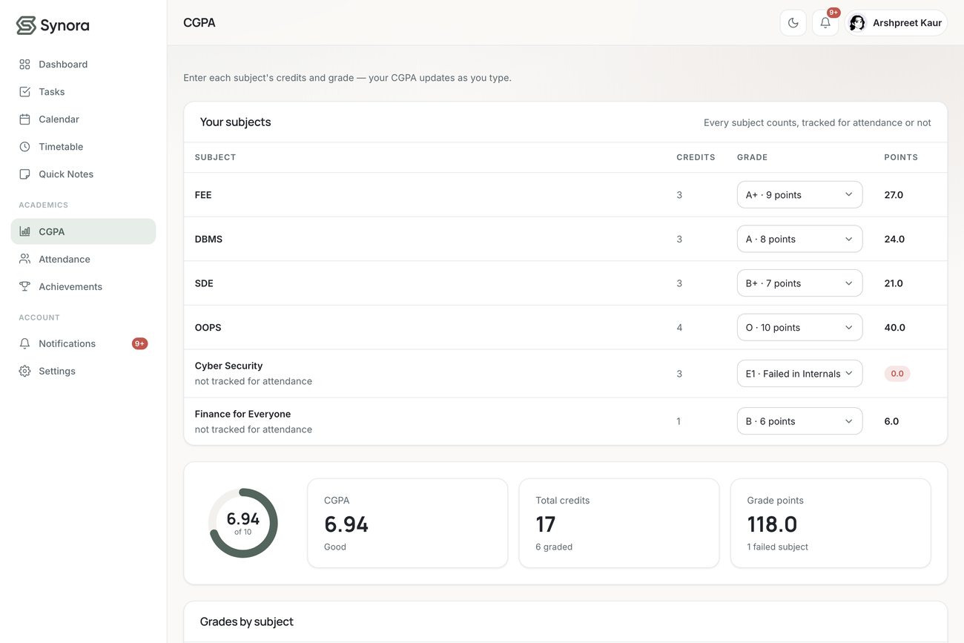
Figure 12. CGPA: grades on a labelled axis with failure grades shown distinctly below the baseline; the average is credit-weighted.

6. Project Advantages
The design decisions described in this report translate into concrete advantages for the student who uses Synora and for the developer who maintains it.
- A unified workspace brings tasks, calendar, notes, timetable, attendance, CGPA, achievements and notifications into one place, so the student’s academic picture is whole rather than scattered.
- A single source of truth — subjects are defined once and referenced by identifier, eliminating duplicated entry and data drift.
- Always self-consistent — percentages, averages and counts are derived on read, so no two views can ever disagree.
- Genuinely personalised and portable — set up per student, remembered across visits, adaptive to device and theme, with no install, build or server.
- A cohesive, accessible design system with semantic markup, labelled controls, a visible focus ring and legible light/dark themes.
- Lightweight and modular — a framework-free front end with clear separation of pages and scripts over a shared core, making new features straightforward to add.
- An honest demonstration of fundamentals — every syllabus concept claimed is exercised by a real feature a student would actually use.
These advantages are not independent claims bolted onto the product after the fact; each follows directly from the two architectural decisions at the centre of the design — treating subjects as a single source of truth and deriving every academic figure on demand rather than storing it. Consistency, the absence of duplicated entry, and the ability to add a backend later without redesigning the interface are all consequences of that same discipline. In other words, the project’s advantages and its architecture are two descriptions of the same thing, which is why they hold together rather than trading off against one another.

7. Result
The completed application delivers every module described in this report — authentication, onboarding, dashboard, tasks, calendar, notes, timetable, attendance, CGPA, achievements, notifications and settings — backed by persistent per-account storage and a consistent design system. It is responsive across devices, themeable, accessible in its fundamentals, and internally consistent by construction because every derived figure is computed from a single source of truth. The interface adapts from a full multi-column desktop layout, through a reduced tablet layout, to a single-column touch-friendly layout on a phone, from one responsive codebase.
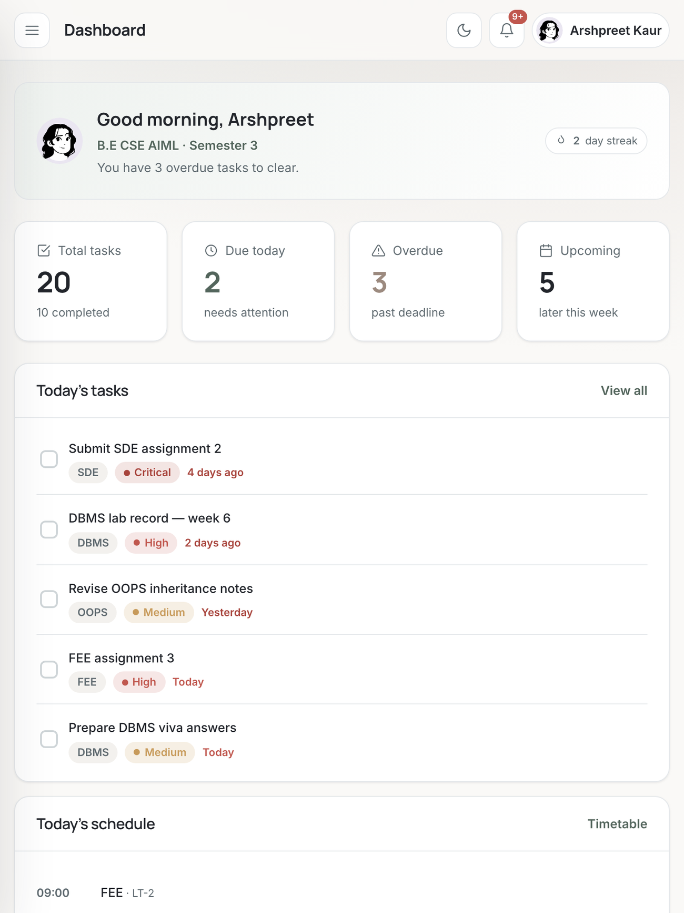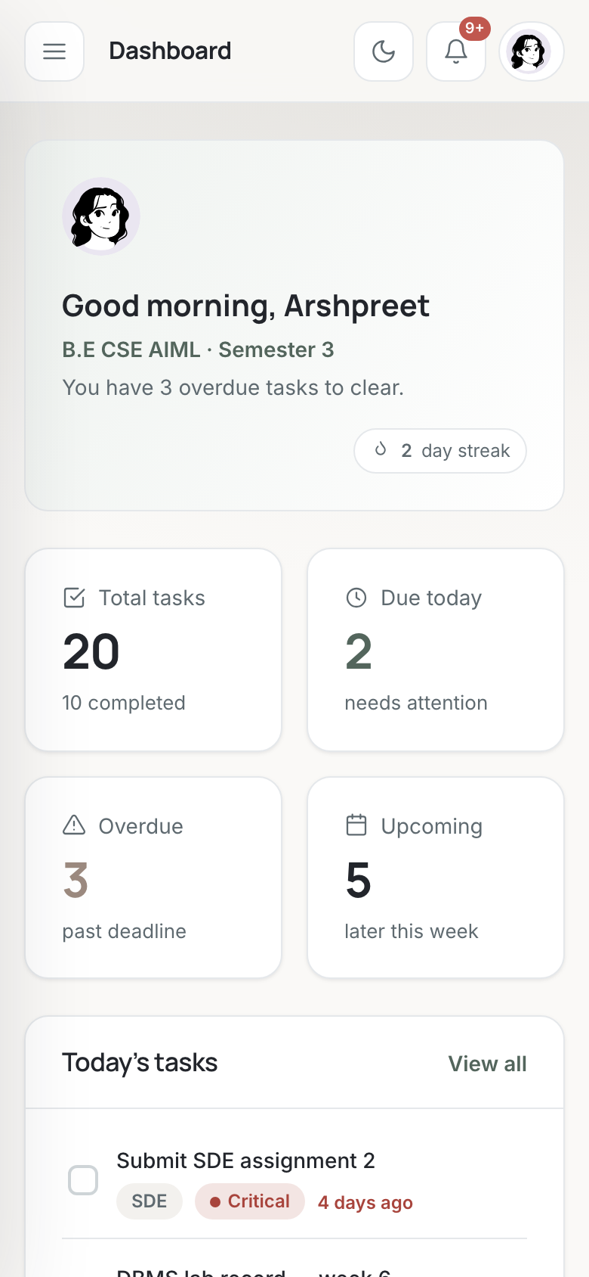
Figure 13. The responsive dashboard on tablet (left) and mobile (right); the same content reflows through Flexbox, Grid and media queries.
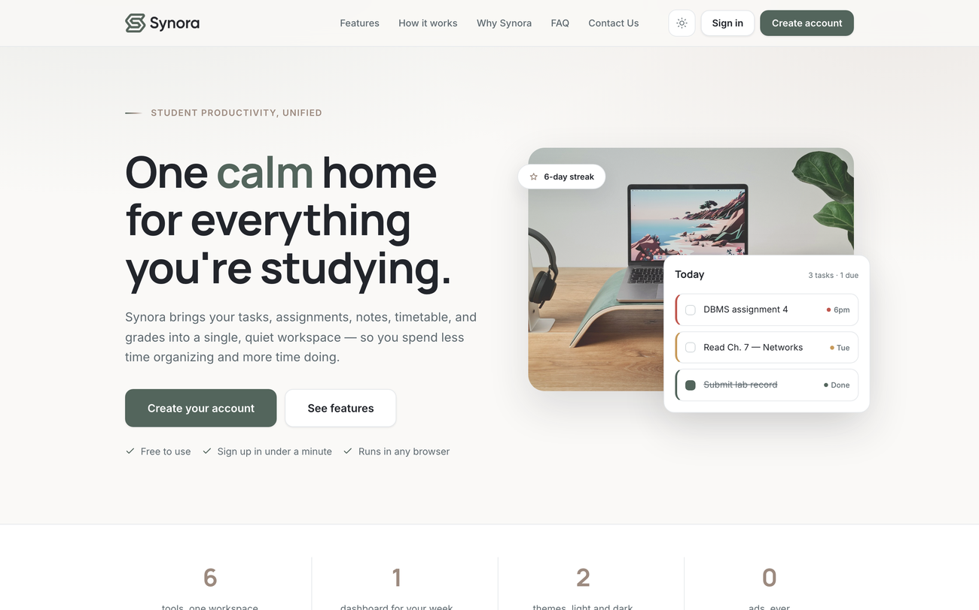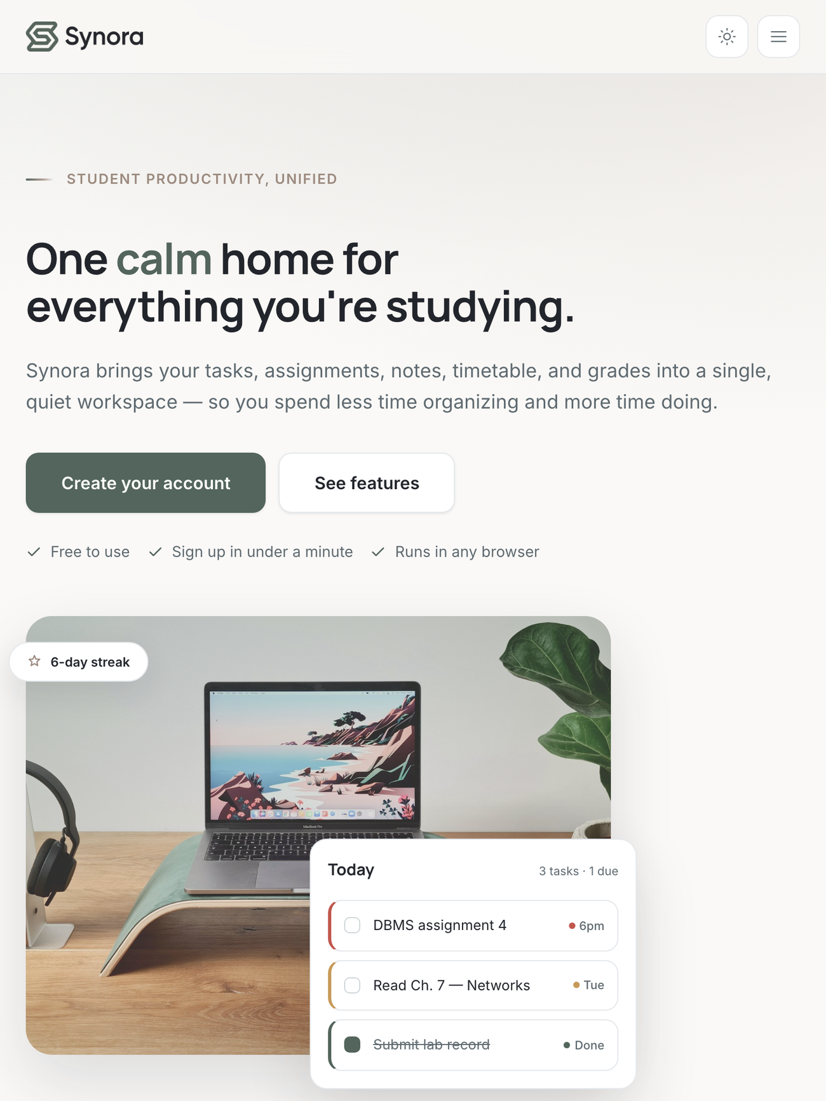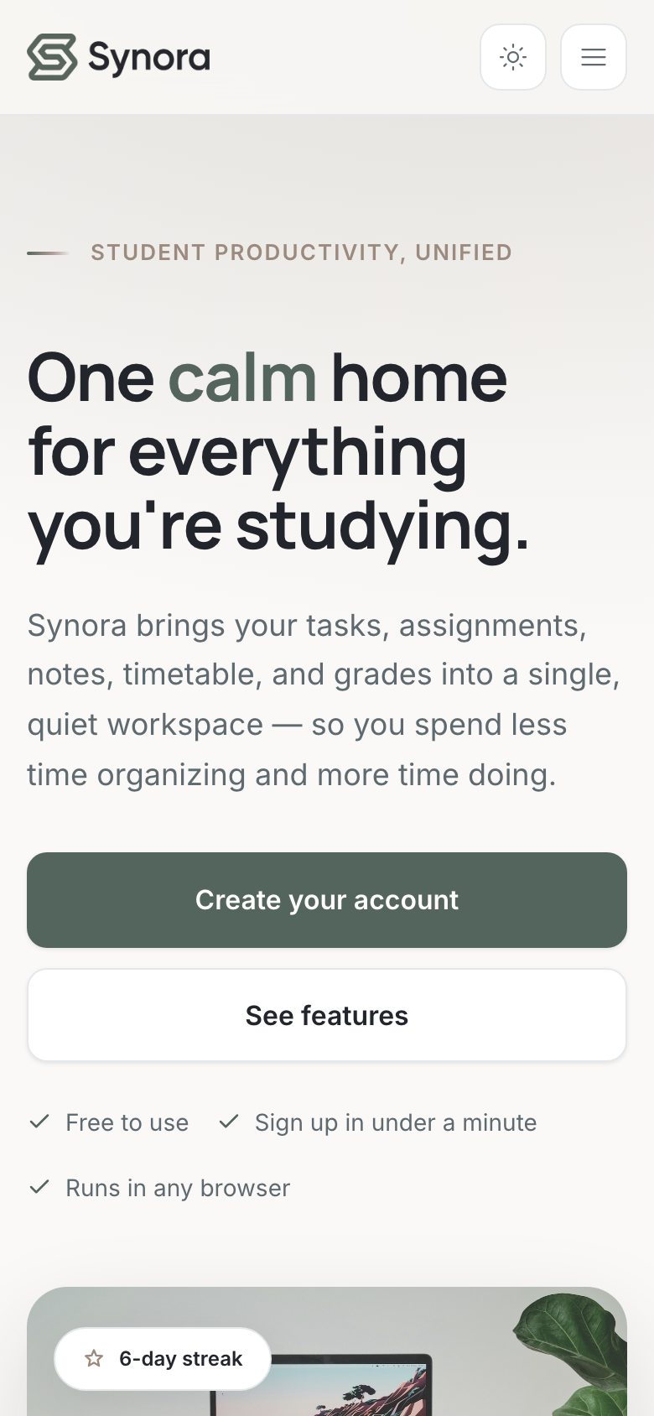
Figure 14. The landing page across desktop, tablet and mobile, adapting through Flexbox, Grid and media-query breakpoints.
The same adaptation applies in dark mode, confirming that the responsive strategy and the theme system are independent and compose cleanly: any breakpoint can be viewed in either theme, because the layout is decided by the grids and media queries while the appearance is decided entirely by the palette tokens.
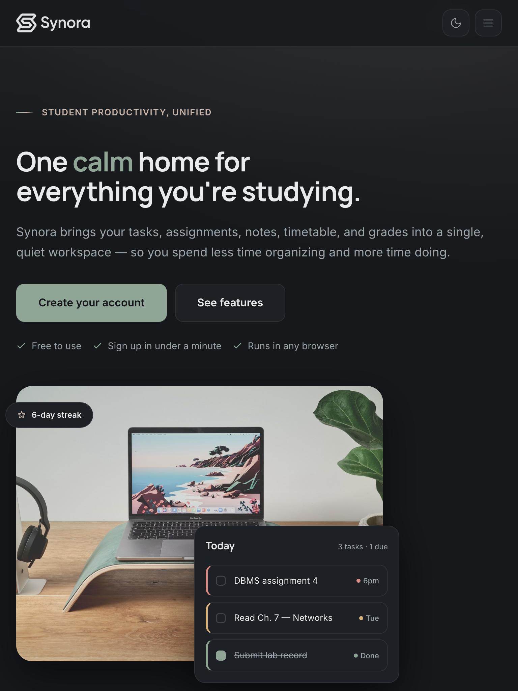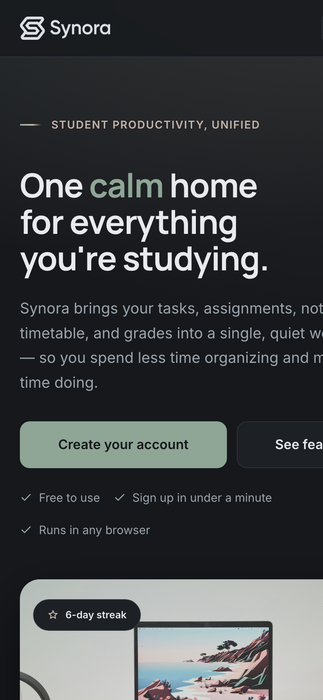
Figure 15. The dashboard in dark mode on tablet (left) and mobile (right); the responsive layout and the theme system compose independently.

7.1 Testing and Validation
Because Synora is client-side and has no backend, testing was performed manually and by inspection in the browser and its developer tools, exercising each feature’s workflow, its validation, its persistence and its behaviour across viewport sizes and both themes. The emphasis throughout was on the interactions a real student would perform and on the invariants the architecture is meant to guarantee — above all, that derived figures always agree with stored data, that removing a subject cleans up everything that referenced it, and that no two accounts on the same device can ever see each other’s data.
Representative cases verified during development are listed below. Persistence was confirmed by creating data, reloading and checking exact restoration from localStorage; isolation by using two accounts in the same browser and confirming neither could see the other’s data; and the calculations by working through attendance and CGPA examples by hand and comparing them against what the interface displayed. The responsive behaviour was checked at desktop, tablet and mobile widths in both themes, confirming that grids collapse to stacks, navigation adapts for touch, images stay within their containers and no content is clipped.

Table 7. Representative functional, calculation, persistence and responsive test cases and their outcomes.
Test case | Expected result | Outcome
Sign up — valid / bad email / mismatched passwords | Accept / field flagged / blocked. | Pass
Create, edit, complete, delete a task | List and dashboard update immediately. | Pass
Attendance increment / zero held / below target | Updates / “nothing recorded” / warning raised. | Pass
Attendance recovers above target | Warning reconciled away on refresh. | Pass
CGPA over mixed grades incl. a failure | Correct credit-weighted average; fail keeps credits. | Pass
Remove a subject | Attendance, CGPA and timetable references cascade. | Pass
Toggle theme; reload after edits | Palette switches and persists; data restored. | Pass
Two accounts, same browser | Data isolated per username. | Pass
Desktop / tablet / mobile widths | Grids collapse to stacks; no clipping. | Pass

7.2 Summary of Results
Functionally, the application delivers every module described in this report — authentication, guided onboarding, dashboard, tasks, calendar, quick notes, timetable, attendance, CGPA, achievements, notifications and settings — each backed by persistent per-account storage and a consistent, tokenised design system. The academic modules are correct and mutually consistent: removing a subject cascades through attendance, CGPA and the timetable; attendance percentages, the “can-miss” and “catch-up” figures and the credit-weighted CGPA are all derived from stored counts and grades; and warnings appear and are reconciled away as the underlying data changes.
Non-functionally, the product is responsive across desktop, tablet and mobile from a single codebase, themeable with a persisted light/dark preference, accessible in its fundamentals, and — most importantly — internally consistent by construction, because every figure shown to the student is computed on demand from a single source of truth rather than stored and risked going stale. The result is a workspace that is not merely a longer to-do list but a coherent academic companion for a semester.

8. Conclusion
Synora set out to replace a fragmented collection of single-purpose tools with one calm, personalised workspace for the operational side of a student’s semester. It does so by treating the student’s subjects as a single source of truth and deriving everything else — attendance percentages, CGPA, task statistics and warnings — from that authoritative record, so the interface is consistent by construction rather than by discipline. It was built deliberately from the fundamentals of the web platform: semantic HTML5 for structure, a token-driven CSS3 design system for a responsive and themeable interface, and vanilla JavaScript for all logic, DOM updates, events, validation and persistence through the Web Storage API.
The current implementation has clear, honest boundaries that follow from its client-only architecture: it is front-end only, its data lives in per-device browser storage without cross-device synchronisation or cloud backup, and its accounts are managed in the browser for demonstration rather than by secure server-side authentication. None of these limitations undermines the project’s goals; each is an explicit scope decision, and the architecture was chosen so that addressing them — chiefly by introducing a backend behind the existing store abstraction — would not require redesigning the interface. In that sense the boundaries mark where the project deliberately stops, not where it would have to be rebuilt to continue.

8.1 Future Scope
The following directions build on the current architecture rather than replacing it. Because every feature already goes through a single store abstraction, re-pointing that store at a backend API would leave the interface essentially unchanged, making these extensions incremental rather than a rewrite.
Server-side authentication with hashed credentials and sessions, combined with cloud storage, would replace the client-side account model and let a student’s workspace follow them across devices with automatic backup. Deadlines and timetable entries could be exported to, or synchronised with, external calendars such as Google or Outlook, and notifications could be delivered by push or email rather than only within the app. On top of the existing data model, an AI study assistant could summarise notes and answer questions about a subject, intelligent task prioritisation could rank work by deadline, weight and effort, and a syllabus import could bootstrap subjects and a study plan automatically. Academic analytics could surface trends in attendance and grades over time, and a packaged mobile application could offer offline use and native notifications while reusing the same data model.
Table 8. Current implementation versus realistic future scope, by area.
Area | Current implementation | Future direction
Storage | Browser localStorage, per device. | Backend database with cloud sync.
Accounts | Client-side, for demonstration. | Secure server-side authentication.
Calendar | In-app month view of tasks. | Two-way sync with Google/Outlook calendars.
Notifications | In-app, reconciled per refresh. | Push and email delivery.
Intelligence | Deterministic derivations. | AI study assistant and smart task prioritisation.
Reach | Responsive web app. | Packaged mobile app with offline use.

8.2 Learning Outcomes
Beyond the product itself, the project produced substantial learning outcomes. It required designing a coherent data model around a single source of truth; building a reusable, tokenised design system rather than styling pages one at a time; writing clean, framework-free JavaScript organised around a single namespace; handling events robustly through delegation so the interface stays correct as it re-renders; validating user input helpfully; and persisting and normalising data on the client. Just as importantly, it developed architectural judgement — the discipline to derive rather than duplicate, to centralise persistence behind one module, and to choose a structure that a future backend could slot into without a redesign.
In summary, Synora began with fundamental web-development concepts and was developed into a complete, responsive and personalized student productivity platform through thoughtful UI/UX design, structured frontend architecture, dynamic JavaScript behaviour, academic data modelling and persistent client-side data handling.

References
- MDN Web Docs — HTML, CSS and JavaScript reference and guides. Mozilla. https://developer.mozilla.org/
- MDN Web Docs — Web Storage API (localStorage). https://developer.mozilla.org/en-US/docs/Web/API/Web_Storage_API
- MDN Web Docs — Document Object Model (DOM). https://developer.mozilla.org/en-US/docs/Web/API/Document_Object_Model
- MDN Web Docs — CSS custom properties, Flexbox and Grid layout. https://developer.mozilla.org/en-US/docs/Web/CSS
- HTML Living Standard. WHATWG. https://html.spec.whatwg.org/
- CSS specifications. World Wide Web Consortium (W3C). https://www.w3.org/Style/CSS/
- Git and GitHub documentation. https://docs.github.com/
- DiceBear — “Lorelei” avatar style by Lisa Wischofsky, licensed CC0 1.0; used for the local avatars. https://www.dicebear.com/
- Google Fonts — the Inter and Manrope typefaces used by the application. https://fonts.google.com/

