SSL Installation step on linux Apache.
There are a lot of guides out there that deals with this topic (installing ssl certificate) but not much that are actually tailored for this pair, GoDaddy and Ubuntu. So hopefully this docuement will be helpful for you.

Elements
Basically in order to successfully install an SSL certificate you need the following things
- CSR file
- Private key
- Certificate key
- Certificate chain

Prepare Your Server
The first step to installing your certificate is to prepare your server directories to hold the final keys later on.
So ssh into your server and do the following:
into your server and do the following by terminal command:
- mkdir /etc/apache2/ssl
- chmod 700 /etc/apache2/ssl
- chown www-data:www-data /etc/apache2/ssl

Then to be sure, do the following to install openssl. Nothing will happen naturally if openssl is already installed.
- sudo apt-get install openssl

Then install the required ssl mods for your apache instance and activate them:
- sudo a2enmod ssl

Note: Above steps are only one time you have to do on Fresh server.

Generate the CSR
In order for GoDaddy to be able to issue our SSL certificate, we need to generate the CSR (Certificate Signing Request) key and our Private Key. In your home directory, do the following. You don’t need to do sudo at this point.

openssl req -newkey rsa:2048 -nodes -keyout website_ssl.key -out website_ssl.csr -sha256
After running the above command you will be required to answer some identity questions. Make sure you answer them as accurate as possible. The questions will look like something below:
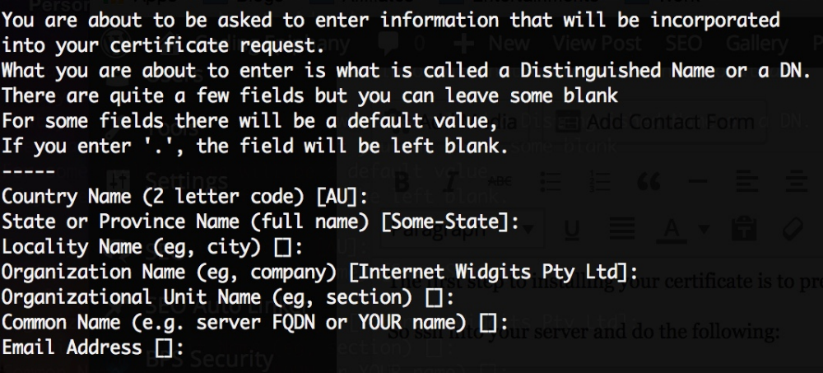
You don’t really need to use the challenge password with GoDaddy at the time of this writing.
Now that you have completed generating the private key and the CSR, it’s time to send it through to GoDaddy.

Generate the Secure Certificate
Open the website_ssl.csr that we generated before. You can use vim or you can simply cat it to the terminal. The CSR should look like this:
-----BEGIN CERTIFICATE REQUEST-----
MuzlucCfc6gnu+g4Bef95o1yE218AZQV1Pl
JooiHqsDycetfl/7KEw10hfRjV8TX+vDcBUkJ/BubyPYEf1j3dbDqlUGGXco1AB1
xJsRe7d/xyIKTKpp4uhl1J96CE8Qhqy7dezEht7Y7iluzJBJV8RRuHvBc1YKBFd+
Py5AVZwmgpdwi/hQ7AEUbaxnAX0u53HZBELJF41bW1eoInsaxnEMNMvfl/1
xoxmfaCZiKXZWDHB+7sw3YRyxbZ
-----END CERTIFICATE REQUEST-----
So copy the entire content from your CSR file, including the —–BEGIN and END.
Then login to GoDaddy, locate your secure certificate product and click launch. After that, click on setup and choose provide CSR. Then paste the content of the CSR file that you just copied previously.
When done, just wait until GoDaddy verifies your website’s identity and grant you access to download the certificate, in my case this happens very quick, at most within 10 minutes.

Installing the Certificate in Your Server
Once GoDaddy email you that your certificate has been generated, follow the link and download the certificate to you computer for now. Basically it’s a zip file containing 2 files, the one that looks like a randomly generated hash is your secure certificate (let’s call it 6eba0aa5c1b8.crt for this article), while the one that starts with gd_bundle_ is your certificate chain file.
So upload both files to your home directory in your Ubuntu server instance. You should now have the website_ssl.key, 7eca0vv8c1g.crt, gd_bundle-g2-g1.crt. Then move those 3 files to the ssl directory that you created previously.

Create the Apache Configuration
We are using the www.kindtraveler.com.conf file. This file is normally located in your /etc/apache2/sites-available/ folder.
Secondly, add the SSL rules at the beginning of the file, just after the opening tag. Please pay attention of the cipher suite rules as this is the combination that I found to be most acceptably secure at the moment.
<VirtualHost *:443>
SSLEngine On
SSLProtocol All -SSLv2 -SSLv3
SSLHonorCipherOrder on
# Prefer PFS, allow TLS, avoid SSL, for IE8 on XP still allow 3DES
SSLCipherSuite "EECDH+ECDSA+AESGCM EECDH+aRSA+AESGCM EECDH+ECDSA+SHA384 EECDH+ECDSA+SHA256 EECDH+aRSA+SHA384 EECDH+aRSA+SHA256 EECDH+AESGCM EECDH EDH+AESGCM EDH+aRSA HIGH !MEDIUM !LOW !aNULL !eNULL !LOW !RC4 !MD5 !EXP !PSK !SRP !DSS"
# Prevent CRIME/BREACH compression attacks
SSLCompression Off
# Commit to HTTPS only traffic for at least 180 days
Header add Strict-Transport-Security "max-age=15552000"
Now that you have added the rules for the SSL settings, you then need include the paths to the three keys that you setup before. So just after the rules above, add the following lines:
SSLCertificateFile /etc/apache2/ssl/7eca0vv8c1g.crt .crt
SSLCertificateKeyFile /etc/apache2/ssl/website_ssl.key
SSLCertificateChainFile /etc/apache2/ssl/gd_bundle-g2-g1.crt
Lastly restart your apache server just to be sure.
sudo /etc/init.d/apache2 restart

