* Consider the following set-up

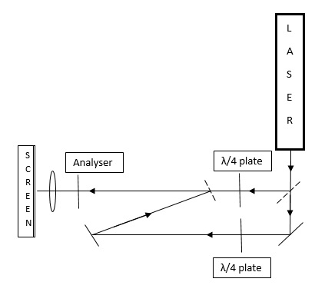

In the above experimental setup a laser beam which is linearly polarised is incident on two quarter wave plates (beam splitter helps in obtaining two beams of light). Both the Quarter-wave plates converts linearly polarised light circularly polarised light.

1. We observe an interference pattern when analyser is placed. What is the shape of the interference pattern?
2. When analyser is removed interference pattern disappears. List the possible reasons for this observation.
3. Now axis of analyser is rotated. Do we observe any shift in the fringes of the interference pattern? If yes then
4. What causes the fringe shift?
5. By what angle should the analyser be rotated to observe 1 fringe shift?

* You want to measure acceleration due to gravity. Which of the following experiments would you choose and why?

1. Free-fall
2. By measuring the time period of a pendulum
3. By using Millikan’s oil drop method

Apparatus

Stop watch which can measure time with a least count of 10 ms.

A metal bob of mass 50g, which will break upon falling from a distance of 2m

A string of length 1m, which breaks after completing two oscillations. You introduce a lot of error in measurement of length of string if you cut or fold the string.

Millikan setup from [PHYWE](http://www.phywe.com/index.php/fuseaction/download/lrn_file/versuchsanleitungen/P2510100/e/P2510100.pdf)

(Assume e is given to be equal to 1.6e-19 and assume the sample data as the data given to you.)

* A fabry-Perot interferometer is used to determine the specific expansion of a piezoelement using plane mirrors. The setup is shown as below:



You can find the whole experiment [here](http://www.photonics.ld-didactic.de/Manuals/4747103_EN%20Fabry%20Perot.pdf). If you are given that d= 1.5 cm and following output of the photo detector:

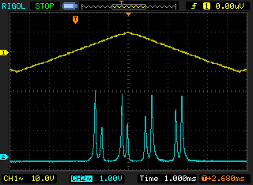

Find the specific expansion of piezoelement.

* From the following data given below find the relation between X and Y with error:

|  |  |
| --- | --- |
| X | Y |
| 1.43 | 3.39 |
| 2.69 | 13.46 |
| 4.62 | 43.82 |
| 7.17 | 152.93 |
| 15.49 | 880.07 |
| 24.05 | 2724.39 |
| 51.94 | 17676.65 |
|  |  |