ACTIVITY 1: Understanding Stack Operations
Subject: Data Structures
Topic: Stacks | Stack Implementation | Basic Stack Problems

Objective:
To help students understand the working of Stack data structure and practice Push, Pop, and Peek operations using step-by-step dry run.

Part A: Conceptual Questions
- Define Stack and explain LIFO principle.
Ans. A Stack is a linear data structure in which insertion and deletion happen only at one end called TOP.
It follows the LIFO (Last In First Out) principle:
- The element inserted last is removed first.
Example:
If we push 10, then 20, then 30 →
Pop will remove 30 first.

- What is Stack Overflow and Stack Underflow?
Ans. Stack Overflow → When we try to push an element into a full stack.
Stack Underflow → When we try to pop an element from an empty stack.

- Write real-life examples of Stack.
Ans. Stack of Plates, Browser Back button.

- What is the time complexity of Push and Pop operations?
Ans. Push -> O(1)
Pop -> O(1)

Part B: Dry Run Activity
Given a stack of size 5. Perform the following operations step-by-step and show the value of TOP after each operation.
Push(10)
Push(20)
Push(30)
Pop()
Push(40)
Peek()

Students must draw stack diagram after each operation.
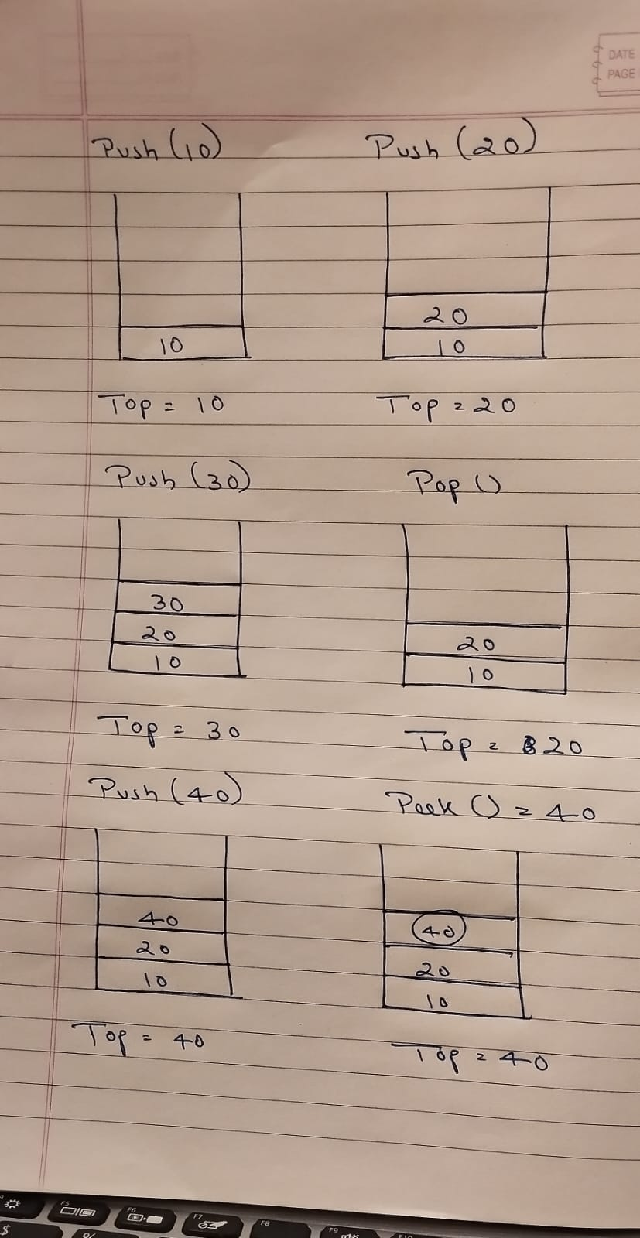

Part C: Coding Task
Write a Java program to implement Stack using Array. The program should allow user input and perform Push, Pop, and Peek operations.

import java.util.Scanner;

class StackArray {
int max = 5;
int stack[] = new int[max];
int top = -1;

void push(int value) {
if (top == max - 1) {
System.out.println("Stack Overflow");
} else {
stack[++top] = value;
System.out.println(value + " pushed into stack");
}
}

void pop() {
if (top == -1) {
System.out.println("Stack Underflow");
} else {
System.out.println(stack[top--] + " popped from stack");
}
}

void peek() {
if (top == -1) {
System.out.println("Stack is empty");
} else {
System.out.println("Top element is: " + stack[top]);
}
}

public static void main(String[] args) {
Scanner sc = new Scanner(System.in);
StackArray s = new StackArray();
int choice;

do {
System.out.println("\n1.Push\n2.Pop\n3.Peek\n4.Exit");
System.out.print("Enter choice: ");
choice = sc.nextInt();

switch(choice) {
case 1:
System.out.print("Enter value: ");
int value = sc.nextInt();
s.push(value);
break;
case 2:
s.pop();
break;
case 3:
s.peek();
break;
case 4:
System.out.println("Exiting...");
break;
default:
System.out.println("Invalid choice");
}
} while(choice != 4);
}
}

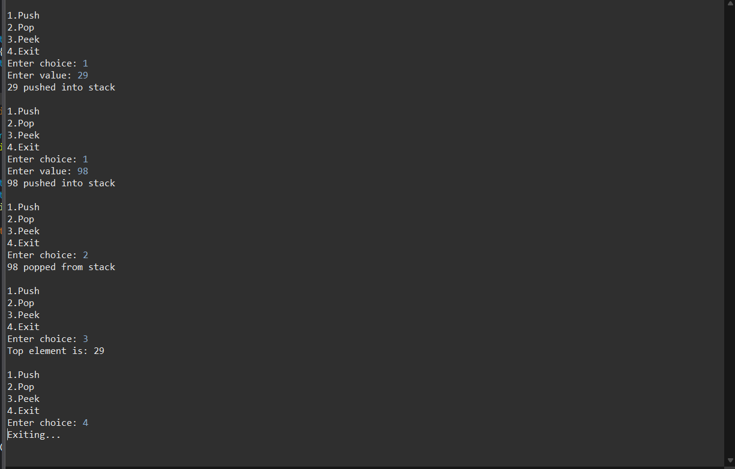

Part D: Problem Solving Task
Write a program to check whether the given parentheses expression is balanced or not using Stack.

import java.util.Stack;
import java.util.Scanner;

public class BalancedParentheses {

public static boolean isBalanced(String exp) {
Stack<Character> stack = new Stack<>();

for (int i = 0; i < exp.length(); i++) {
char ch = exp.charAt(i);

if (ch == '(' || ch == '{' || ch == '[') {
stack.push(ch);
} else if (ch == ')' || ch == '}' || ch == ']') {

if (stack.isEmpty())
return false;

char top = stack.pop();

if ((ch == ')' && top != '(') ||
(ch == '}' && top != '{') ||
(ch == ']' && top != '[')) {
return false;
}
}
}
return stack.isEmpty();
}

public static void main(String[] args) {
Scanner sc = new Scanner(System.in);
System.out.print("Enter expression: ");
String exp = sc.nextLine();

if (isBalanced(exp))
System.out.println("Balanced Expression");
else
System.out.println("Not Balanced Expression");
}
}

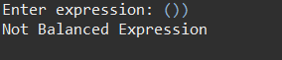

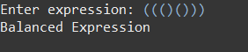

Conclusion
- Stack is a linear data structure following LIFO principle.
- Push and Pop operations work in constant time O(1).
- Stack Overflow and Underflow are important boundary conditions.
- Stacks are widely used in expression evaluation and recursion.
- Balanced parentheses problem is a classic application of Stack.

Submission Requirements:
• Handwritten dry run with stack diagram.
• Java program code printout.
• Output screenshot.
• Short conclusion (5 lines).

