1. Task Description
Build a reusable Shared Input component that supports Text, Textarea, Checkbox, and Radio inputs, styled with Tailwind CSS. Includes a simple demo form and a confirmation modal shown on submit.

2. Task Output Screenshot

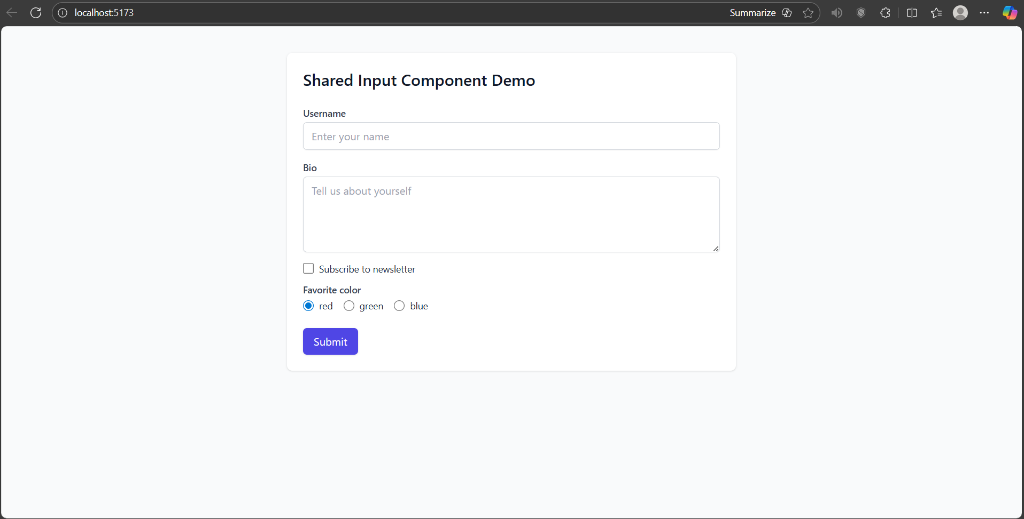

3. Widget/Algorithm Used in Task
- Text input used for Username.
- Textarea used for Bio.
- Checkbox used for Subscribe option.
- Radio Button Group used for selecting Favorite Color.
- Button used for Submit action.
- Modal dialog used for submission confirmation.
- Tailwind CSS utility classes used for layout and styling.

