1. Task Description
Create a validated form using Formik and Yup with reusable inputs, including a password field that shows a live checklist of rules with ticks as each rule is satisfied. Submission displays a confirmation modal.

2. Task Output Screenshot

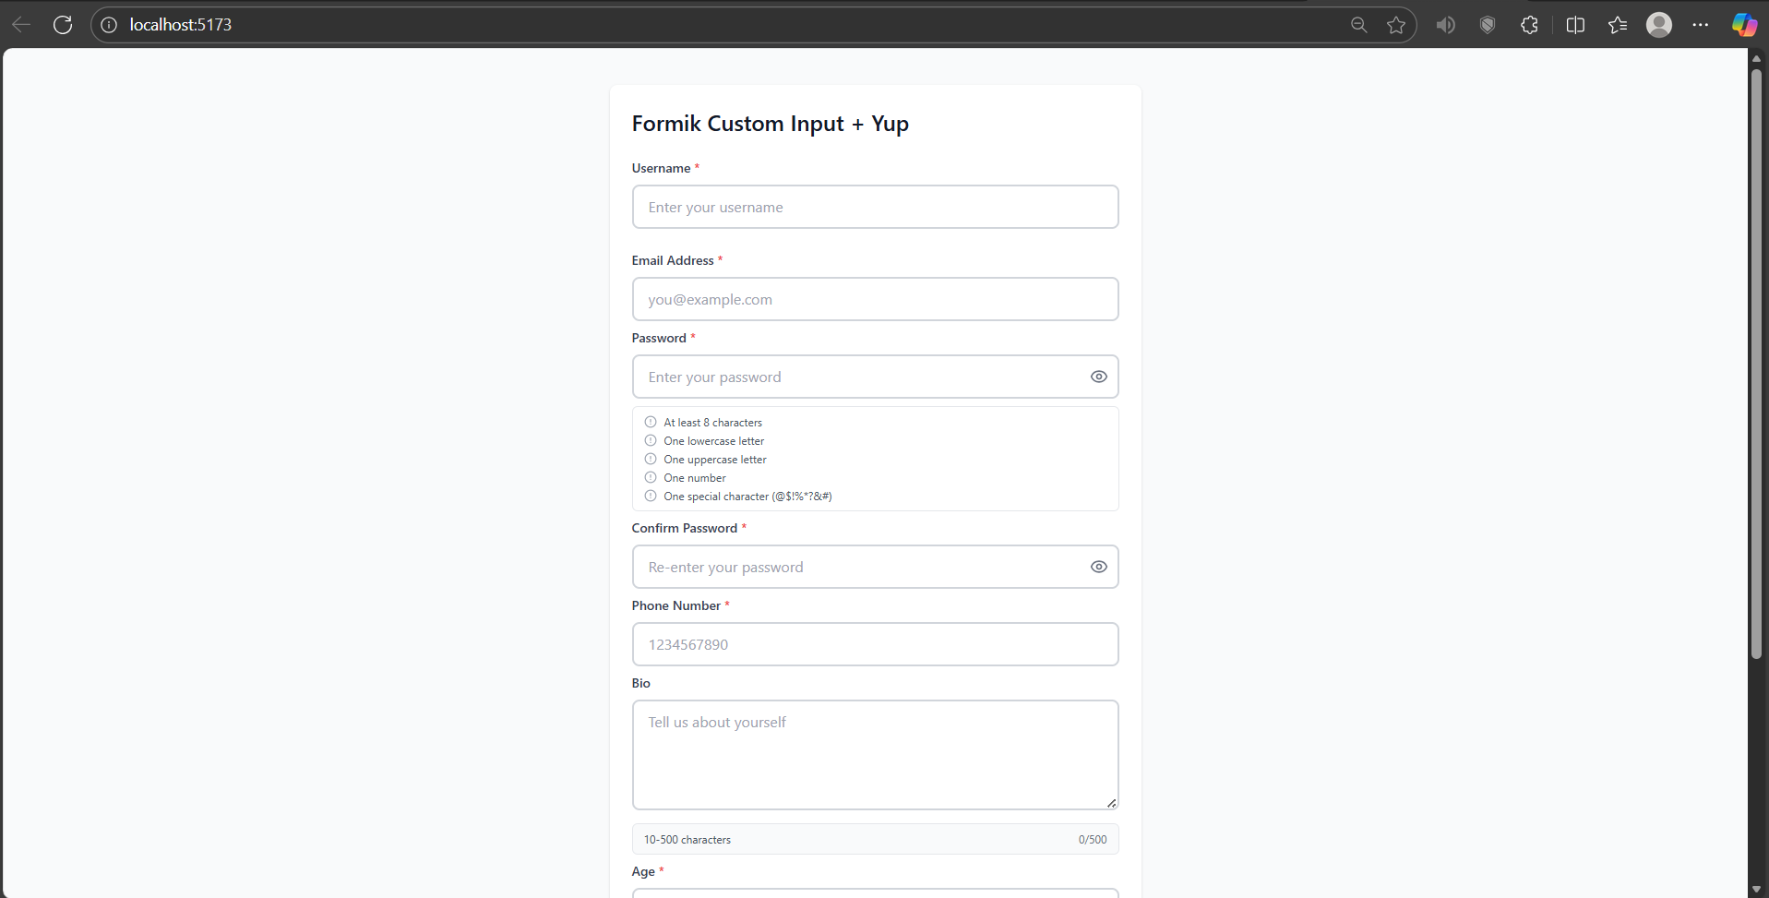
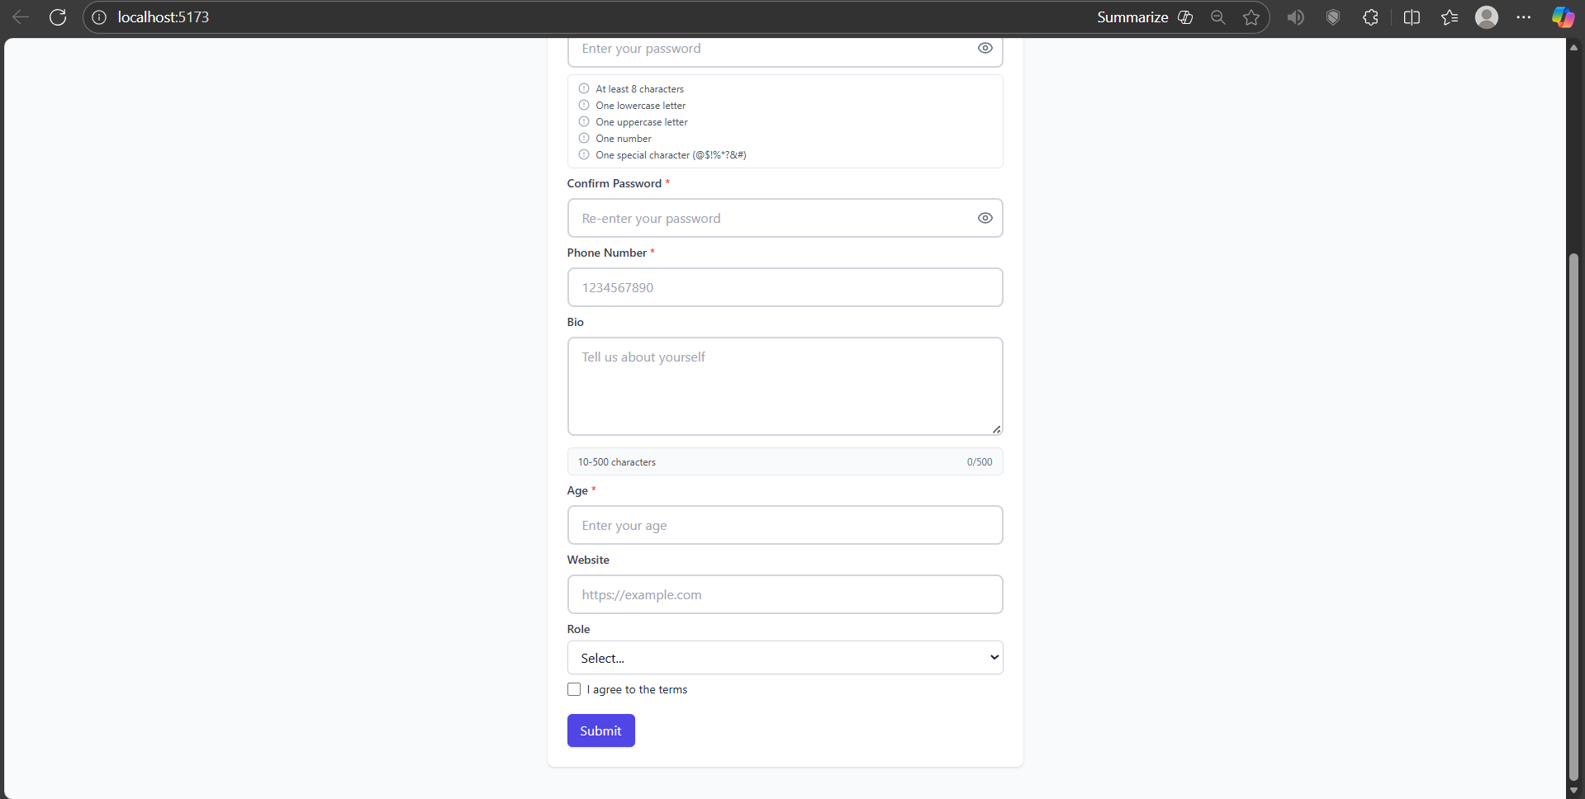

3. Widget/Algorithm Used In Task
• Text input used for Username, Email, and Age.
• Password input with visibility toggle and live rules (min length, lowercase, uppercase, number, special char) and tick indicators.
• Textarea used for Bio with character count.
• Select (Spinner) used for Role selection.
• Checkbox used for Terms agreement.
• Button used for Submit action.
• Formik used for form state and field binding.
• Yup used for validation schemas.
• Tailwind CSS used for styling; lucide-react used for icons.

