1. Task Description
Build an expenses sharing app that manages people and expenses, persists data locally, and computes net balances for each participant. UI polished with Tailwind components.

2. Task Output Screenshot
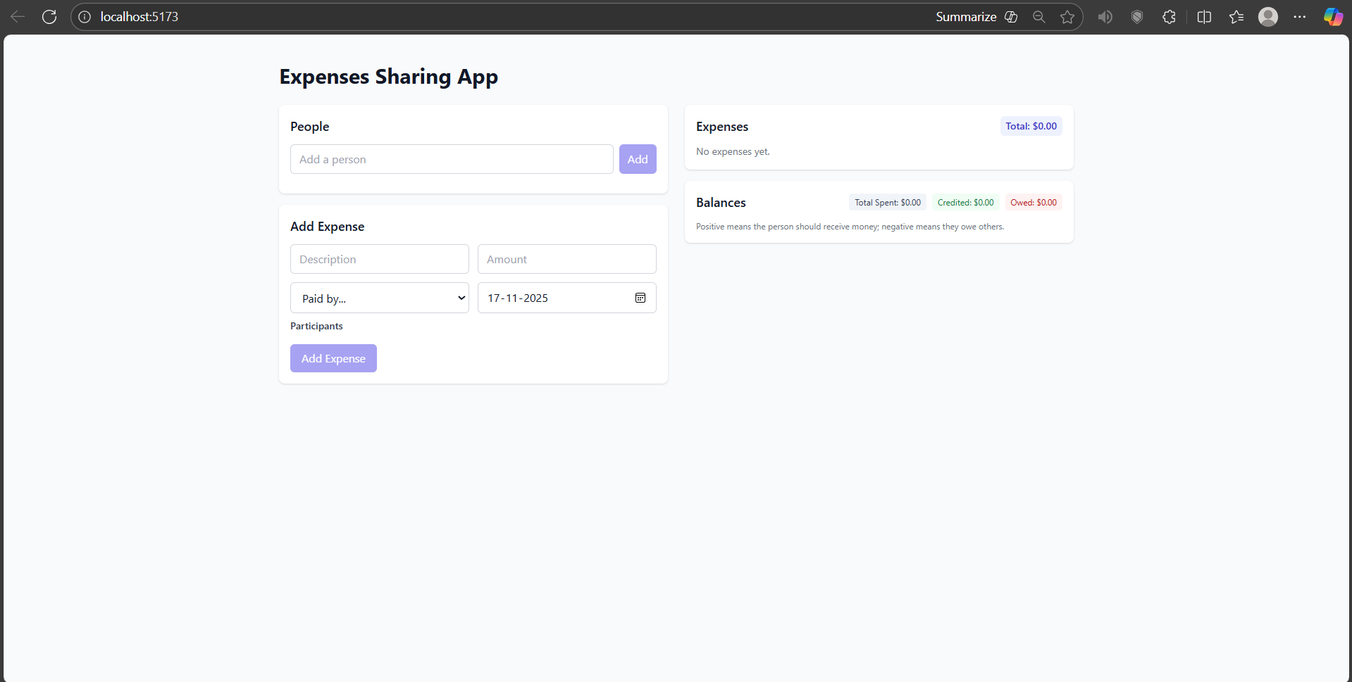

3. Widget/Algorithm Used In Task
• Text inputs used for Person name and Expense title/amount.
• Select/chooser used for selecting the Payer and Participants.
• Button widgets used for Add Person and Add Expense actions.
• List/table views used for displaying expenses and balances.
• Redux Toolkit used for state management with people and expenses slices.
• LocalStorage used for persistence.
• Balance computation algorithm to split amounts and calculate net owed/owed-to per person.
• Tailwind CSS used for layout, cards, chips, and visual balance bars.

