1. Task Description
Create a quotes generator that fetches a random quote from https://quotes.domiadi.com/api, normalizes fields, and allows copying to clipboard while saving as a local post. Includes loading, error states, and a top authors summary.

2. Task Output Screenshot

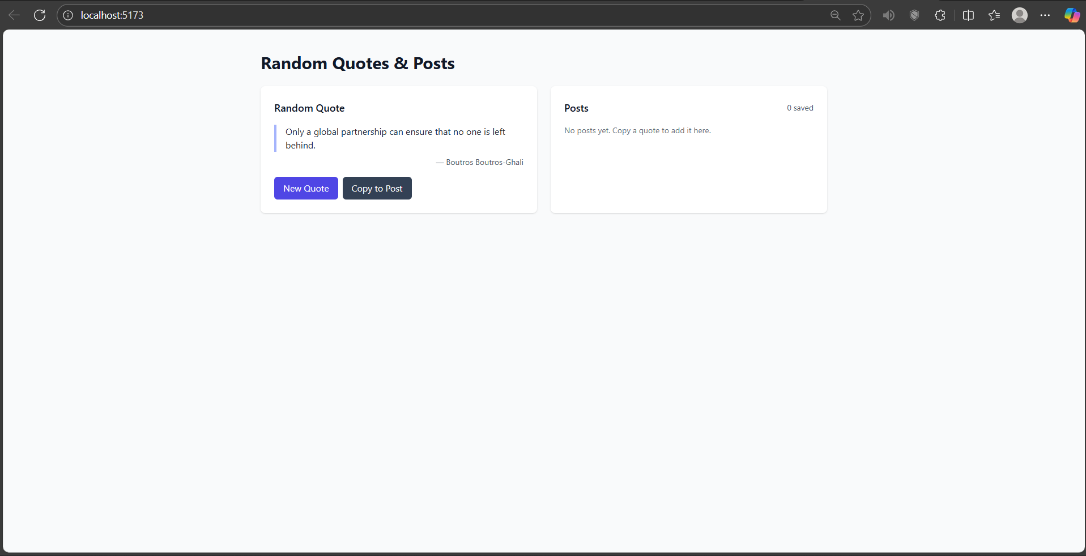

3. Widget/Algorithm Used In Task
• Button used for New Quote and Copy to Post actions.
• Card view used for displaying the current quote and author.
• Toast/Badge used to show feedback (loading, error, copied/saved).
• React Query used for data fetching and caching.
• Axios used for HTTP requests.
• Clipboard API used for copy functionality.
• Data normalization maps API fields (quote/from) to {content, author}.
• LocalStorage used to store saved posts and group by author.
• Tailwind CSS used for styling.

