1. Task Description
Create a paginated table of dummy data with Previous/Next, first/last buttons, ellipses, and exactly three middle page buttons centered around the current page. Page size is 10 and the shown range is indicated.

2. Task Output Screenshot

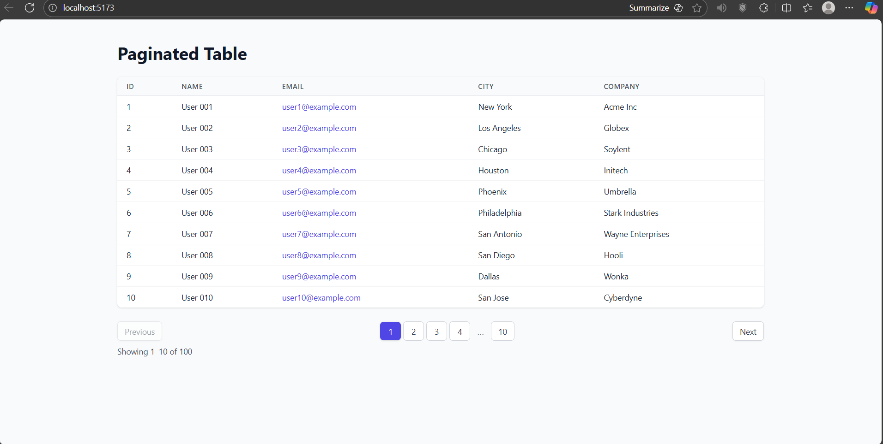

3. Widget/Algorithm Used In Task
• Table widget used for listing rows (ID, Name, Email, City, Company).
• Button widgets used for page navigation (First, Previous, page numbers, Next, Last).
• Ellipses logic used to condense page ranges.
• Pagination algorithm uses helper functions (getMiddlePages, range) to compute visible buttons.
• React useMemo used to slice data for the current page efficiently.
• Tailwind CSS used for the table and pagination styling.

