

PRACTICAL FILE

OF

PROGRAMMING IN C

COURSE CODE-CSEG1041

SCHOOL OF COMPUTER SCIENCE

# SUBMITTED BY: SUBMITTED TO:

***NAME: MANAN***

***SAP ID:590028349***

***COURSE: BSC CS***

***SEMSTER:01***

***BATCH=01***

***ACADEMIC YEAR=2025-2026***

***//Experiment 1: Installation, Environment Setup and starting with C language***

***1. Write a C program to print “ Hello World”***

*#include <stdio.h>*

*int main()*

*{*

*printf("Name - Manan\n");*

*printf("SAP ID:590028349\n");*

*printf("Course - bscCS\n");*

*printf("batch-01\n");*

*printf("\n------------------------\n");*

*printf("Hello World\n");*

*return 0;*

*}*

**OUTPUT:**

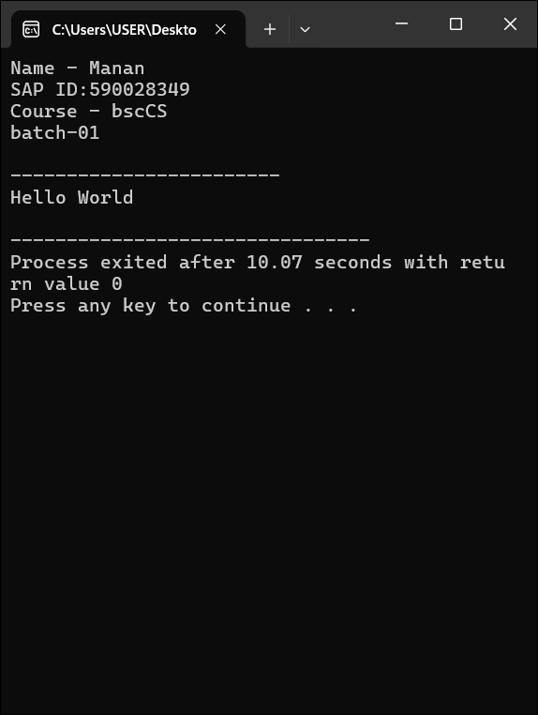

***2. Write a C Program to print the address in multiple lines (new line).***

*#include <stdio.h>*

*int main()*

*{*

*printf("Name of the student - Manan\n");*

*printf("SAPID:590028349\n");*

*printf("Course - bscCS\n");*

*printf("batch-01\n");*

*printf("\n------------------------\n");*

*printf("Name:Manan\n");*

*printf("House no:7/13\n");*

*printf("Street:Jwala Nagar\n");*

*printf("City:Delhi\n");*

*printf("Pincode:110032\n");*

*return 0;*

*}*

OUTPUT:

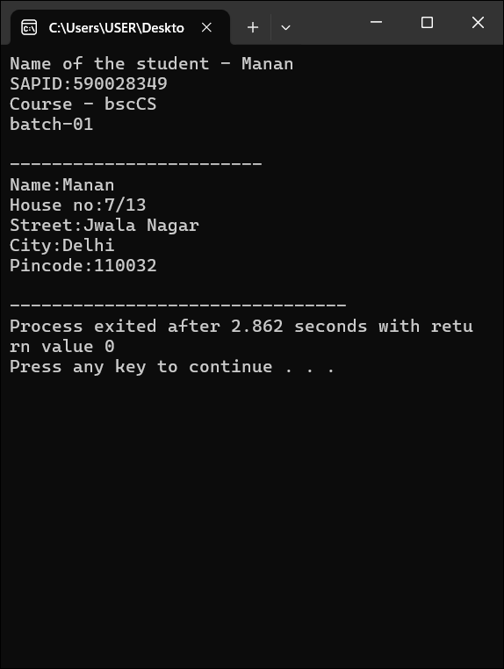

***3. ⁠Write a C program to add two numbers and take a number from the user***.

*#include <stdio.h>*

*int main(){int n1,n2,n3;*

*printf("Name of the student - Manan\n");*

*printf("SAPID:590028349\n");*

*printf("Course - bscCS\n");*

*printf("batch-01\n");*

*printf("\n------------------------\n");*

*printf("enter the first number:");*

*scanf("%d",&n1);*

*printf("enter the second number:");*

*scanf("%d",&n2);*

*n3=n1+n2;*

*printf("Sum=%d\n",n3);*

*return 0;*

*}*

Output:

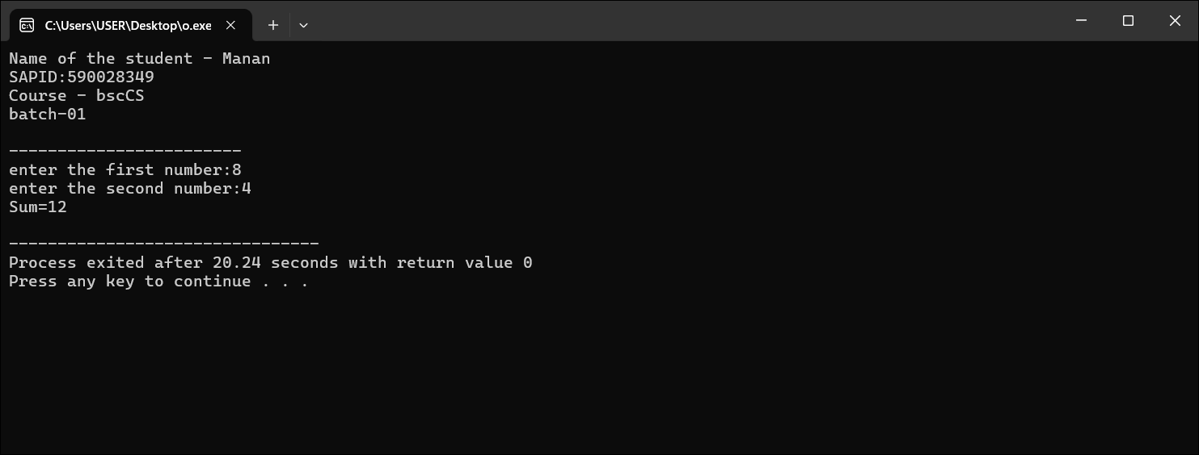

***4. ⁠Write a C program to perform four arithmetic operations on two variables.***

*#include <stdio.h>*

*int main() {*

*int a, b;*

*int sum, diff, prod;*

*float div;*

*printf("Name of the student - Manan\n");*

*printf("SAPID:590028349\n");*

*printf("Course - bscCS\n");*

*printf("batch-01\n");*

*printf("\n------------------------\n");*

*printf("Enter first number: ");*

*scanf("%d", &a);*

*printf("Enter second number: ");*

*scanf("%d", &b);*

*sum = a + b;*

*diff = a - b;*

*prod = a * b;*

*div = (float)a / b; // typecasting to get decimal value*

*printf("Addition = %d\n", sum);*

*printf("Subtraction = %d\n", diff);*

*printf("Multiplication = %d\n", prod);*

*printf("Division = %.2f\n", div);*

*return 0;*

*}*

Output:

