**SVKM’s NMIMS**

**Mukesh Patel School of Technology Management & Engineering**

**Computer Engineering Department**

Program: B.Tech Integrated Sem V

**Course: Basic Data Structures**

**2024-2025**

**Experiment No.01**

PART A

(PART A : TO BE REFFERED BY STUDENTS)

**A.1 Aim:**

Introduction to Data Structures and implementation of Arrays

**A.2 Prerequisite:**

1. Knowledge of different types of data structures.

2. Fundamental concepts of C\C++.

**A.3 Outcome:**

**After successful completion of this experiment students will be able to**

1. Identify the need of appropriate selection of data structure
2. Explore the effect of appropriate data structure selection.
3. Differentiate types of data structure based on their organization of data.
4. Enlist the applications of different data structure.
5. Implement arrays for the given problem

**A.4 Theory:**

**A.4.1. Introduction of Data structure**

* The data may be organized into many different ways. The logical and mathematical model of a particular organization of data is called data structure.
* A data structure helps you to understand relationship of one data element with the other and organize it within the memory.
* Data structure specified following:
  + Organization of data
  + Accessing methods
  + Degree of associativity
  + Processing alternatives for information
* Classification of data structure:

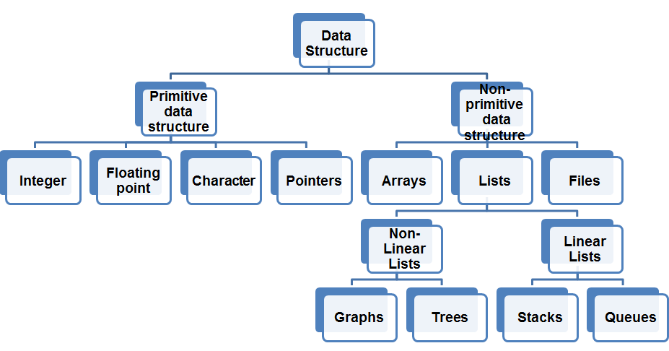

* Primitive data structure:
  + Basic structures
  + Directly operated upon by the machine instructions
* Non- Primitive data structures:
  + Derived from primitive data structure.
  + Emphasize on structuring of a group of homogenous or heterogeneous data structure.
  + Ex: Arrays, Lists, Files
* Various data structure:

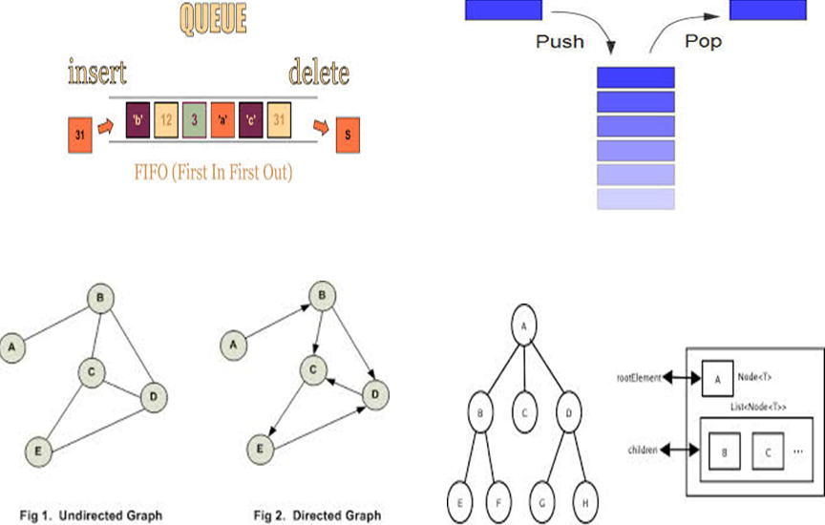

**A.5 Procedure/Algorithm:**

**A.5.1:**

**TASK 1:**

Write a C/C++ program of array to perform following **(1D Array)**

1. Find the sum and Average of all the elements in an array.
2. Find highest and lowest element in an array.
3. Write a function that takes an array as input and returns a new array that is the reverse of the original array.

**TASK 2:**

Identify suitable data structure for given scenarios. Specify the reason for it.

1. To implement a system for reversing a word.
2. To implement a printer spooler so that jobs can be printed in the order of the arrival.
3. To represent an image in a form of bitmap.
4. For representing a city region telephone network.
5. To store information about the directories and files in a system.
6. To implement a system for parsing syntax.
7. To implement back functionality in web browsers.
8. To record the sequence of all the pages browsed in one session.
9. To process network packets coming to the router.
10. To represent machines on the internet and to find optimal paths between source machine and destination machine to send data.
11. To represent connections\relations in social networking sites.
12. Google maps to travel from your home to office in minimum time.

**********************

PART B

(PART B : TO BE COMPLETED BY STUDENTS)

***(Students must submit the soft copy as per following segments within two hours of the practical. The soft copy must be uploaded on the Blackboard or emailed to the concerned lab in charge faculties at the end of the practical in case the there is no Black board access available)***

|  |  |
| --- | --- |
| Roll No. C146 | Name: Manan Gandhi |
| Class : D | Batch : D1 |
| Date of Experiment: 19/07/2024 | Date of Submission |
| Grade : | Time of Submission: |
| Date of Grading: |  |

**B.1 Software Code written by student:**

***(Paste your code completed during the 2 hours of practical in the lab here)***

**Task 1:**

// Write a C/C++ program of array to perform following (1D Array)

// i. Find the sum and Average of all the elements in an array.

// ii. Find highest and lowest element in an array.

// iii. Write a function that takes an array as input and returns a new array that is the reverse of the original array.

#include <iostream>

using namespace std;

int calculate_sum(int arr[], int len)

{

int sum = 0;

for (int i = 0; i < len; i++)

{

sum += arr[i];

}

return sum;

}

int calculate_highest(int arr[], int len)

{

int highest = arr[0];

for (int i = 0; i < len; i++)

{

if (arr[i] > highest)

{

highest = arr[i];

}

}

return highest;

}

int calculate_lowest(int arr[], int len)

{

int lowest = arr[0];

for (int i = 0; i < len; i++)

{

if (arr[i] < lowest)

{

lowest = arr[i];

}

}

return lowest;

}

void reverse_arr(int arr[], int len, int *reverse)

{

for (int i = 0; i < len; i++)

{

reverse[i] = arr[len - i - 1];

}

}

int main()

{

int arr[] = {};

double sum = 0, highest, lowest;

int reverse[] = {};

double average = 0;

int len = 0;

cout << "Enter length of array: ";

cin >> len;

for (int i = 0; i < len; i++)

{

cout << "Enter element at index " << i << ": ";

cin >> arr[i];

}

sum = calculate_sum(arr, len);

average = sum / len;

cout << "Sum: " << sum << endl;

cout << "Average: " << average << endl;

highest = calculate_highest(arr, len);

lowest = calculate_lowest(arr, len);

cout << "Highest: " << highest << endl;

cout << "Lowest: " << lowest << endl;

reverse_arr(arr, len, reverse);

cout << "Reverse: " << endl;

for (int i = 0; i < len; i++)

{

cout << reverse[i] << endl;

}

return 0;

}

**Task 2:**

1. Stack
2. Queue
3. Array
4. Graph
5. Tree
6. Tree
7. Stack
8. Linked List
9. Queue
10. Graph
11. Graph
12. Graph

**Extra Practice Questions:**

**1.**

#include <iostream>

using namespace std;

int main()

{

int a, b, sum;

cout << "Enter a: ";

cin >> a;

cout << "Enter b: ";

cin >> b;

sum = a + b;

cout << "Sum: " << sum << endl;

return 0;

}

**2.**

#include <iostream>

using namespace std;

int main()

{

int nums[] = {};

int len = 0;

cout << "Enter length of array: ";

cin >> len;

for (int i = 0; i < len; i++)

{

cout << "Enter element at index " << i << ": ";

cin >> nums[i];

}

for (int i = 0; i < len; i++)

{

cout << i << ": " << nums[i] << endl;

}

return 0;

}

**3.**

#include <iostream>

#include <unordered_map>

using namespace std;

int main()

{

int nums[] = {};

int len = 0;

unordered_map<int, int> frequency;

cout << "Enter length of array: ";

cin >> len;

for (int i = 0; i < len; i++)

{

cout << "Enter element at index " << i << ": ";

cin >> nums[i];

}

for (int i = 0; i < len; i++)

{

frequency[nums[i]] += 1;

}

for (auto x : frequency)

{

cout << x.first << ": " << x.second << endl;

}

return 0;

}

**4.**

#include <iostream>

using namespace std;

int main()

{

int arr[] = {};

int len = 0, num = 0;

cout << "Enter length of array: ";

cin >> len;

for (int i = 0; i < len; i++)

{

cout << "Enter element at index " << i << ": ";

cin >> arr[i];

}

for (int i = 0; i < len; i++)

{

num = (num * 10) + arr[i];

}

cout << num << endl;

return 0;

}

**B.2 Input and Output:**

***(Paste your program input and output in following format, If there is error then paste the specific error in the output part. In case of error with due permission of the faculty extension can be given to submit the error free code with output in due course of time. Students will be graded accordingly.)***

**Task 1:**

**B.3 Conclusion:**

*(****Students must write the conclusion as per the attainment of individual outcome listed above and learning/observation noted in section B.3)***

We learned about different data structures

**B.4 Question of Curiosity**

***(To be answered by student based on the practical performed and learning/observations)***

Q1. Why appropriate selection of data structure is important in computer programming?

For optimized time of execution and space occupancy of the software.

************************