Manan Gaur

Reg No: 220929232

BTech Mechatronics

Basic Electronics, Microcontrollers & Arduino

Microprocessors are the central part of a computer. They process information and do arithmetic operations at a very high speed(GHz) to perform various actions. Microprocessors are silicon chips made of billions of transistors. They cannot be used alone and require other components like RAM to perform actions.

Microcontrollers(MCU) are a compact integrated circuits capable of performing low-level actions like a mini computer. Unlike microprocessors, they do not require any other components to function and are a complete standalone device. Microcontrollers, as the name suggests, are used to perform small actions and control specific parts of a device/machine efficiently and in a simple manner. Arduinos and all circuit boards have MCUs at its heart. Transistors are the backbone of modern day technology. Microprocessors are made of billions of transistors and microcontrollers are standalone devices contain processing power, RAM, flash memory and other components necessary to function.

Arduinos are an open-source electronic boards that can be used by anyone to do projects industrially or just as an hobby. They are developed by a community of thousands of individuals and contain many circuit boards with numerous applications. Arduino UNO is the flagship product of Arduino and is widely used by students and professionals alike. UNO is also useful for educational purposes and is the starting point for a novice. Below is the image of an Arduino UNO:

All Arduinos have the following common components:

* Reset Switch: Reruns the program given to the MCU from the beginning. Very useful for testing purposes.
* USB Connector: Used to connect laptop to the board to feed programs. It can also power the circuit board.
* Crystal Oscillator: Vibrates 16-20 million times per second(based on the reverse piezoelectric effect). This means that the MCU can perform at a speed of 16MHz.
* Power Port: Used to power the board with 2.1mm plug.
* Voltage Regulator: The built-in voltage regulator ensures a stable supply of voltage to the MCU.
* TX RX LEDs: These LEDs are mostly used in testing purposes.

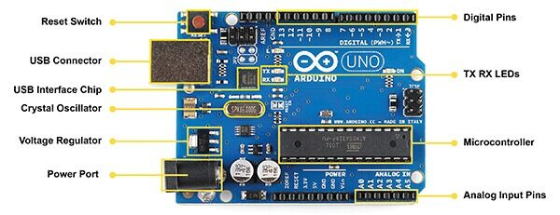

Arduino UNO components

* Analog Input Pins: These pins are capable of reading analog signals(temperature change, etc) and converting them to a digital signal. They can also output 1 or 0 based on specific conditions. These pins have very high resistance; they only measure voltage as the current flow is negligible.
* Digital Pins: These pins are I/O pins which can also power devices connected to them. They are used to read digital signals from connected components.
* USB Interface Chip: This chip converts the USB signal received from a device to a level at the MCU can understand. It is necessary for communicating with the MCU.
* Microcontroller(MCU): This is the heart of the board. It has memory of 32kb and the program uploaded from the Arduino IDE is stored here. It consists of a CPU, flash memory and 2kb RAM. MCU is responsible for performing all the actions given to the Arduino.

Arduinos come in various sizes and shapes. The two most widely used arduinos are Arduino UNO and Arduino MEGA. MEGA is a size upgradation of the UNO and is capable of performing more tasks and offers more processing capability. It is very popular in the open-source community and the 3D printing community.

A major feature of Arduino and all other circuit boards is PWM: Pulse Width Modulation. PWM is a concept used in the electronic industry to digitally control the flow of voltage and obtain analog results. PWM controls the amplitude of digital signals to control devices requiring power. By using an on-and-off process, it controls the amount of power received by the device. PWM is widely used as it is very useful for preventing power loss. Potentiometer control the incoming digital signal by preventing it from going further. This causes power loss. But, PWM simply shut down the power supply at a very high speed, preventing loss of power. PWM have the concept of a Duty Cycle, which is the ratio of the time the signal was high to the total time of the cycle. Duty Cycle is usually measured in percentage.

Analog pins, in an Arduino, are used to read signals, control devices or provide output based on given conditions. When controlling devices, these pins can control the power output of a device using PWM. For example, the brightness of an LED can be controlled by analog pins using the PWM.

Digital pins are default used as input pins, collecting digital signals from connected devices. If used in output mode, these pins will provide 5V voltage to the component when high and 0V when low. These pins are mostly used to read digital signals.