A

Project Report

On

“**EcoFinds – Sustainable Second-Hand Marketplace**”

“Buy & Sell Sustainably, One Click at a Time.”

Odoo Hackathon 2025

Team :

**Extrabit**

September 6, 2025

Submitted By:

Manan Hiran

Sanket Hiran

Vatsal Kotadiya

Diksha Puitandi

**ACKNOWLEDGEMENT**

We would like to express our sincere gratitude to **Odoo Hackathon 2025** organizers for providing us with this opportunity to participate and showcase our ideas. This hackathon has been an invaluable platform for us to learn, innovate, and collaborate.

We are especially thankful to our mentors and guides for their constant support, encouragement, and constructive feedback throughout the development of **EcoFinds – Sustainable Second-Hand Marketplace**.

We also extend our heartfelt thanks to our teammates, whose dedication, hard work, and teamwork made this project possible within the limited timeframe.

Finally, we are grateful to our families, friends, and peers for their continuous motivation and moral support during this journey.

With Sincere Regards,

Manan Hiran

Sanket Hiran

Vatsal Kotadiya

Diksha Puitandi

**INDEX**

|  |  |  |
| --- | --- | --- |
| SR NO | DESCRIPTION | PAGE NO |
| 1. | Introduction | 1 |
| 2. | Project Profile | 3 |
| 3. | Objectives | 5 |
| 4. | Project Category | 7 |
| 5. | Environment Description | 9 |
| 6. | Analysis Report | 11 |
|  | 6.1 Current System | 12 |
|  | 6.2 Limitations of Current System | 13 |
|  | 6.3 Requirement Specification | 14 |
|  | 6.4 Proposed System | 16 |
|  | 6.5 Data Flow Diagram | 17 |
| 7. | Design View | 20 |
| 8. | Future Enhancement |  |
| 9. | References |  |

**1.**

**INTRODUCTION**



Sustainability is one of the biggest challenges of today’s world. Every year, millions of perfectly usable goods are discarded, creating huge amounts of waste and harming the environment. At the same time, many people are looking for affordable, unique, and eco-friendly alternatives to buying new products.

**EcoFinds – Sustainable Second-Hand Marketplace** addresses this problem by creating a trusted platform where people can easily buy and sell pre-owned items. By extending the lifecycle of products, the app helps reduce waste and supports the idea of a circular economy.

**Why EcoFind here?**

* **Promotes Sustainability**: Encourages reuse of products, reducing environmental impact.
* **Affordable Shopping**: Helps users find quality products at lower prices.
* **Convenience**: Provides an easy-to-use platform for creating, browsing, and managing product listings.
* **Community Building**: Connects like-minded individuals who believe in sustainable living.
* **Transparency & Trust**: Secure login, user profiles, and clear product details build user confidence.

**2.**

**PROJECT PROFILE**

| **Title** | **Details** |
| --- | --- |
| **Frontend Tools** | Next.js 14 (App Router), Tailwind CSS, Shadcn/ui, React Hook Form |
| **Backend Tools** | Next.js API Routes |
| **Database** | SQLite with Prisma ORM |
| **Authentication** | NextAuth.js |
| **File Storage** | Local File Storage (for images) |
| **Submitted To** | Odoo Hackathon 2025 |
| **Developed By** | Manan Hiran  Sanket Hiran  Vatsal Kotadiya  Diksha Puitandi |

**3.**

**OBJECTIVES**



The objective of **EcoFinds – Sustainable Second-Hand Marketplace** is to provide a simple and effective platform where users can buy and sell second-hand goods. By creating this marketplace, the project promotes sustainability by extending the life of products and reducing waste.

Another objective is to deliver a **secure and user-friendly experience** through features like user registration, login, and profile management. This ensures trust among users and creates a personalized environment for smooth interaction.

The project also focuses on **efficient product management** by enabling users to add, edit, delete, and browse product listings. With keyword search and category filters, buyers can quickly find the products they are looking for, while sellers can showcase their items effectively.

Lastly, the aim is to lay the foundation for a scalable marketplace that can grow with advanced features such as a shopping cart, purchase history, and future enhancements like payment integration. This ensures EcoFinds not only works as a prototype but can evolve into a complete sustainable shopping platform.

**4.**

**PROJECT CATEGORY**



The **EcoFinds – Sustainable Second-Hand Marketplace** is categorized as a **Web and Mobile Application**, meaning it is developed using **Next.js** with integrated backend API routes and database connectivity through **Prisma ORM with SQLite**. As a web-based system, EcoFinds can be deployed on a server and accessed from both desktop browsers and mobile devices with an active internet connection.

All marketplace-related data, including user accounts, product listings, images, and purchase history, are stored securely in the database. Any operations such as authentication, product management, search, or filtering are handled by the backend before the results are displayed to the user. This ensures both accuracy and reliability of the system.

In a web-based application, the workload on the server is slightly higher since it handles user authentication, product uploads, searches, and cart management. But, web applications are highly scalable, allowing multiple users to interact with the system at the same time without performance issues.

The development of a web and mobile marketplace system like EcoFinds is highly beneficial because it ensures better security, centralized data storage, and easy accessibility. Unlike standalone applications, a web-based solution is easier to maintain and update, making it a suitable choice for long-term scalability and user growth.

**5.**

**ENVIRONMENT DESCRIPTION**



**Development Environment**

* **Hardware Requirements**
  + Processor: Intel i5 or above (or equivalent)
  + RAM: Minimum 8 GB (16 GB recommended)
  + Storage: At least 20 GB free space
  + Operating System: Windows / Linux / macOS
* **Software Requirements**
  + IDE: Visual Studio Code (for coding), Android Studio (for mobile testing)
  + Runtime: Node.js 20+
  + Database: SQLite (lightweight and zero setup)
  + ORM: Prisma ORM for database modeling and queries
  + Authentication: NextAuth.js
  + Design Tool: Figma (UI/UX wireframes and prototypes)
  + Version Control: GitHub

**Execution / Deployment Environment**

* **Frontend + Backend**: Next.js + Next.js API Routes
* **Database**: SQLite (prototype), with option to upgrade to PostgreSQL for production
* **Authentication**: NextAuth.js with secure session handling
* **File Storage**: Local storage for images (public folder)
* **Access Requirements**:
  + Stable internet connection
  + Modern browsers (Chrome, Firefox, Edge)

**6.**

**ANALYSIS REPORT**



**6.1 Current System in market**

Based on the current practices for buying and selling second-hand goods, the existing system involves the following components:

**User Accounts**

* Buyers and sellers create accounts on general platforms such as OLX, Facebook Marketplace, or WhatsApp groups.
* Limited profile features are available, with no proper verification or trust mechanism.

**Product Listing and Management**

* Sellers upload product details such as title, description, price, and images.
* Listings are often unstructured, with no standardized categories or formatting.
* Buyers have limited options to track or manage purchased items.

**Search and Filtering Options**

* Users can search products by keywords only.
* Filtering options are basic or missing, making it difficult to narrow down results by category or price.

**Communication and Transactions**

* Buyers and sellers communicate directly via phone calls or messaging apps.
* Payments usually happen outside the platform, making them less secure.

**Lack of Purchase History**

* There is no system to track previous purchases.
* Users cannot view their transaction history or maintain records of items bought or sold.

**Sustainability Perspective**

* Current platforms do not emphasize eco-friendliness or product lifecycle extension.
* Resale is treated as a casual exchange rather than a conscious effort to reduce waste.

**6.2 Limitations of Current System**

1. **Lack of Trust & Verification**

* **Issue:** Current platforms do not verify buyer or seller identities, which can lead to scams, fake listings, or fraud.
* **Potential Fix:** Implement secure authentication, verified profiles, and user ratings/reviews.

1. **Unstructured Product Listings**

* **Issue:** Product details are inconsistent, with no standardized categories, limited descriptions, and poor-quality images.
* **Potential Fix:** Provide structured listing forms with mandatory fields (title, description, price, category, and image upload).

1. **Weak Search & Filtering Options**

* **Issue:** Users can only search by keywords, making it hard to find relevant products among large numbers of listings.
* **Potential Fix:** Introduce advanced filters such as category, price range, location, and keyword relevance.

1. **No Purchase Tracking**

* **Issue:** Existing systems do not maintain records of past purchases, leaving users with no history of transactions.
* **Potential Fix:** Add a purchase history module where buyers can view all previously bought items.

1. **Lack of Sustainability Focus**

* **Issue:** Current resale platforms treat second-hand selling as casual exchange, without promoting eco-friendly consumption.
* **Potential Fix:** Highlight sustainability metrics (e.g., waste reduced, items reused) and encourage users to contribute to a circular economy.

1. **Insecure Transactions**

* **Issue:** Payments and communications often occur outside the platform, leading to risk of disputes or fraud.
* **Potential Fix:** Enable secure, in-app payment options and maintain chat records for buyer-seller communication.

**6.3 Requirement Specification**

**Functional Requirements**

**User Registration & Authentication**

* Users can sign up using email and password.
* Secure login with encrypted credentials and session management (via NextAuth.js).

**User Profile Management**

* Create and update user profiles with username and basic details.
* Edit profile fields such as name, email, and profile image.

**Product Listing Management (CRUD)**

* Users can create, edit, view, and delete product listings.
* Listings must include title, description, category, price, and at least one image.
* Categories are predefined for easier browsing.

**Product Browsing & Discovery**

* Users can browse all available product listings in a feed.
* Keyword search to quickly find items by title.
* Filter listings by categories and price range.

**Product Detail View**

* Show complete product details including title, description, price, category, and image.
* Provide a “Contact Seller” or “Add to Cart” option.

**Cart & Purchase History**

* Users can add products to a cart for review before purchase.
* Maintain purchase history showing all previously bought products.

**Non-Functional Requirements**

**Performance**

* Fast response time for product browsing and searches.
* Optimized handling of product images for quick loading.

**Security**

* Secure authentication with encrypted passwords and session tokens.
* Prevent unauthorized access to user accounts or product data.

**Usability**

* Simple and intuitive UI for buyers and sellers.
* Responsive design for both desktop and mobile use.

**Scalability**

* Ability to support a growing number of users and product listings.
* Easy migration from SQLite to PostgreSQL for production.

**Availability & Reliability**

* High availability with minimal downtime during usage.
* Stable database connections to ensure no data loss in listings or purchases.

**6.4 Proposed System**

The proposed system is an online **second-hand marketplace** that is designed for a single entity:

**User (Buyer / Seller)**

* **Login / Logout** – Secure authentication for accessing the app.
* **Manage Profile** – Update personal details, username, and profile photo.
* **Product Listing** – Create, edit, view, and delete listings with title, description, category, price, and image.
* **Browse Products** – View all available listings in a feed.
* **Search & Filter** – Find products using keywords and predefined categories.
* **Product Detail View** – View complete details of selected items (title, price, description, category, image).
* **Manage Cart** – Add items to cart, update, or remove before purchase.
* **Purchase History** – View all previously purchased products.
* **Feedback** – Option to provide reviews or ratings for purchased items (future enhancement).

**6.5 Data Flow Diagram**

**LEVEL 0**

**LEVEL 1**

**LEVEL 2**

**7.**

**DESIGN VIEW**



**USER**

**Sign up Page :**

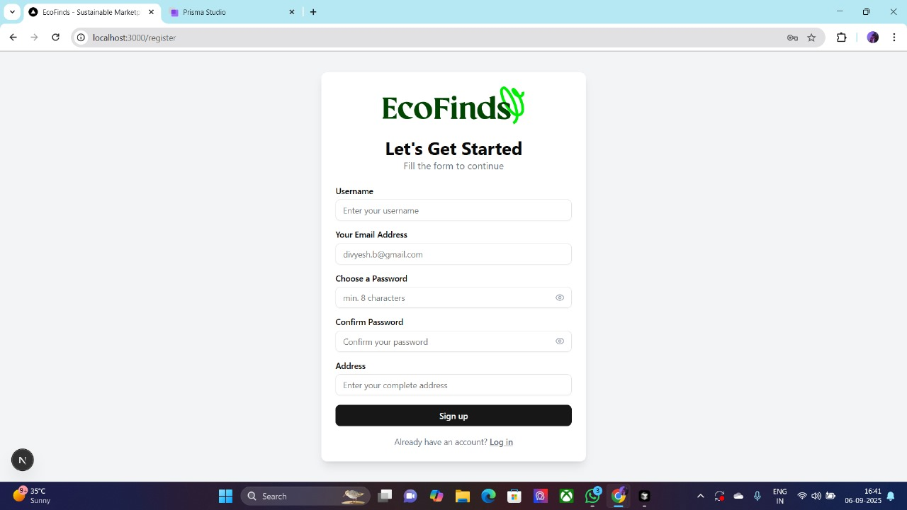

**Log in Page :**

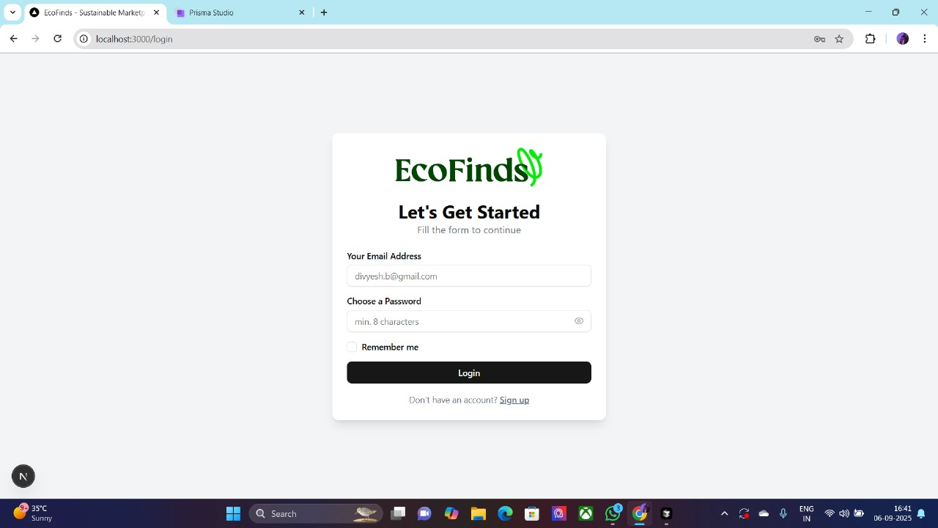

**Home Page :**

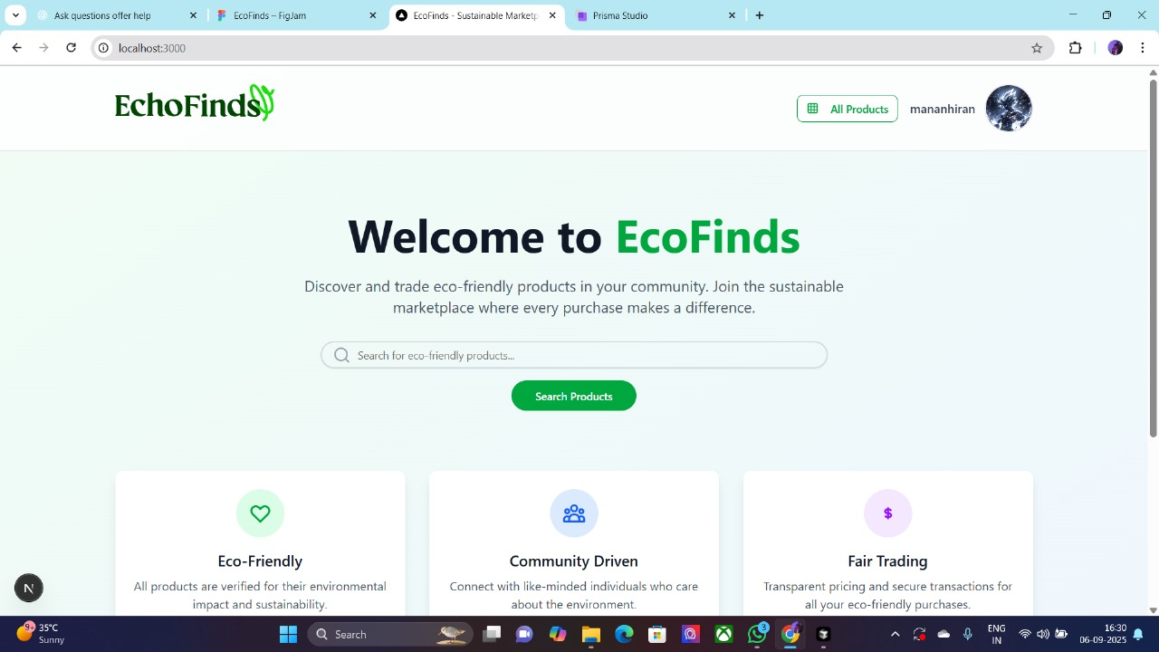

**Dashboard Page :**

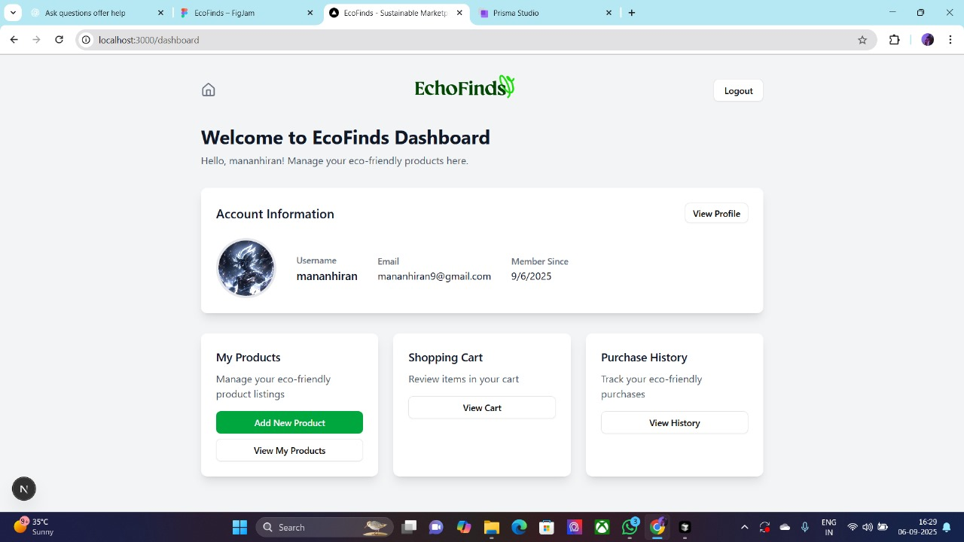

**Profile Page :**

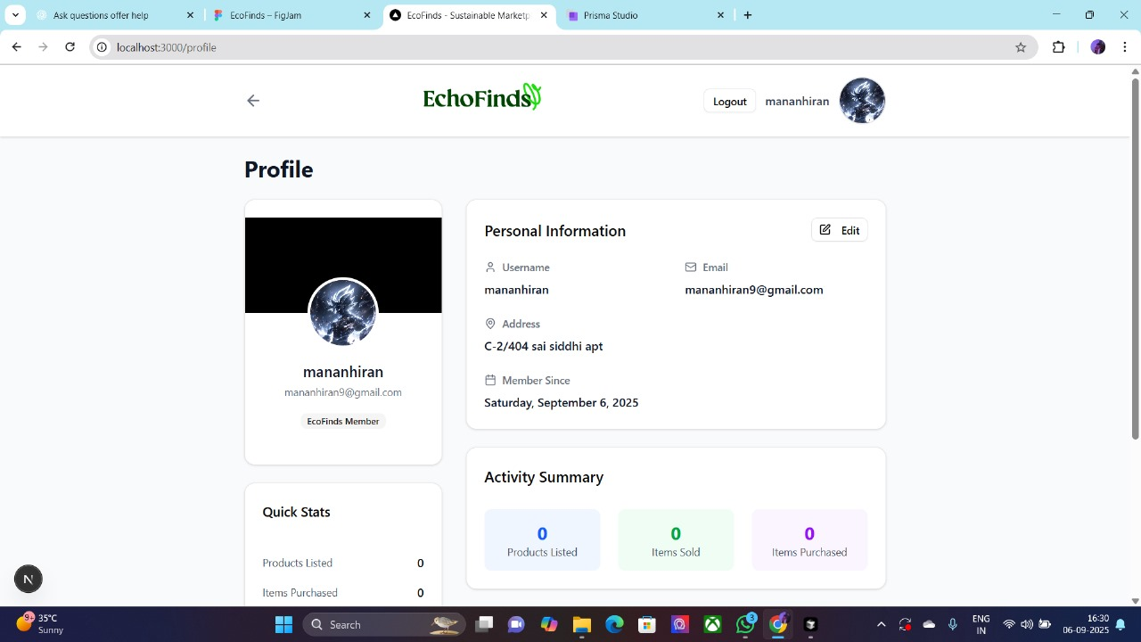

**Edit Page :**

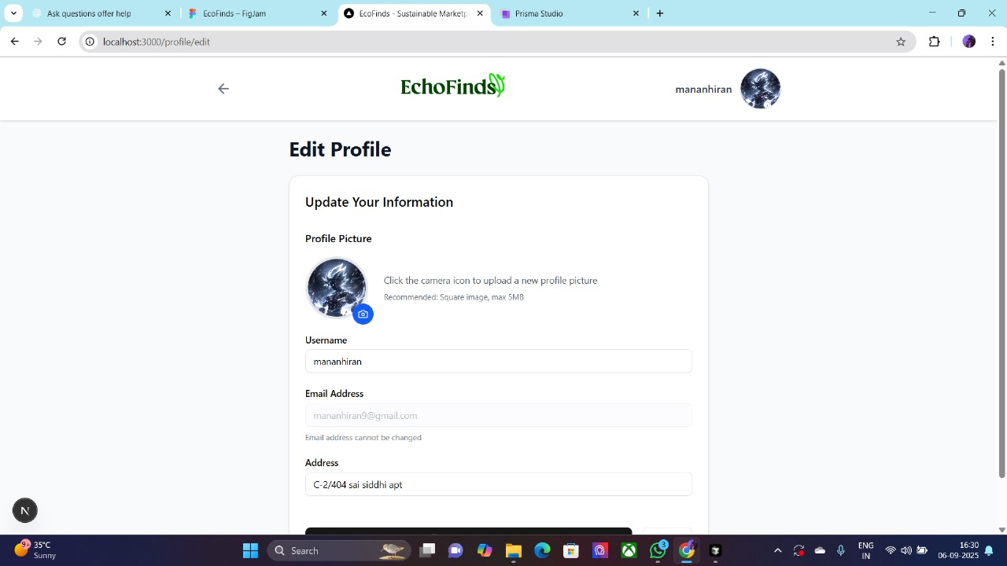

**Products Page :**

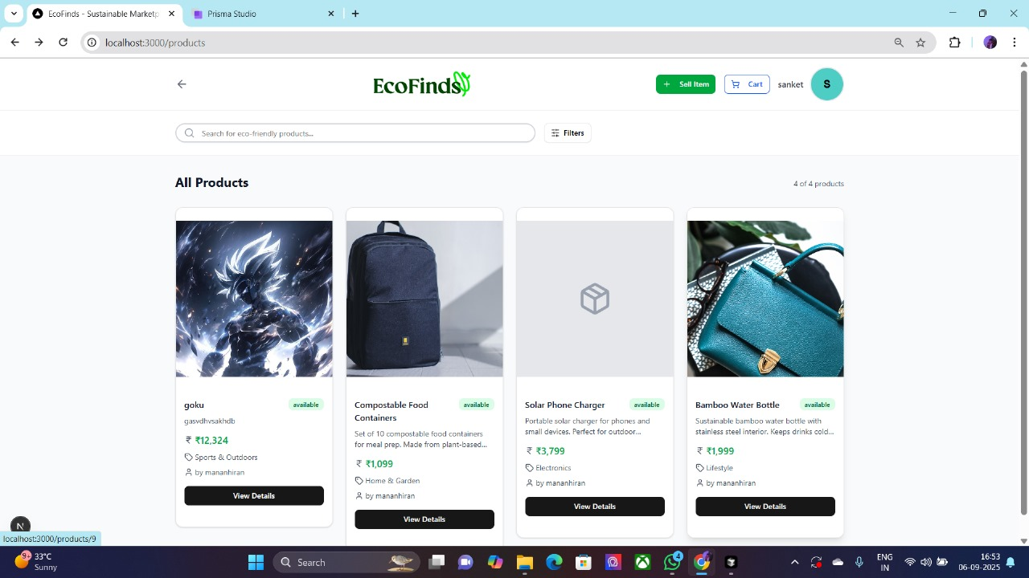

**8.**

**FUTURE ENHANCEMENT**



**Payment Gateway Integration**

* Add secure online payment methods (Stripe, PayPal, Razorpay) to complete transactions within the app.

**Reviews & Ratings**

* Allow buyers to rate products and leave feedback for sellers, improving trust and transparency.

**AI-Powered Recommendations**

* Implement machine learning models to suggest products based on user interests, search history, and purchase behavior.

**Location-Based Listings**

* Enable users to search for products available nearby using geolocation services.

**Chat & Negotiation System**

* Add in-app chat for buyers and sellers to communicate, negotiate prices, and finalize deals securely.

**Sustainability Impact Dashboard**

* Provide users with insights on how much waste they have reduced by reusing and buying second-hand items.

**Cloud Storage for Images**

* Replace local file storage with cloud storage (e.g., AWS S3, Firebase) for scalability and reliability.

**Mobile App Deployment**

* Expand from web app to full-featured native Android and iOS apps for wider accessibility.

**9.**

**REFERENCES**



<https://openai.com/index/chatgpt/>

<https://www.google.co.in/>

<https://www.youtube.com/>

<https://cursor.com/>