Manan Patel

3/22/2016

Activity 16

CMPSC 302

1. 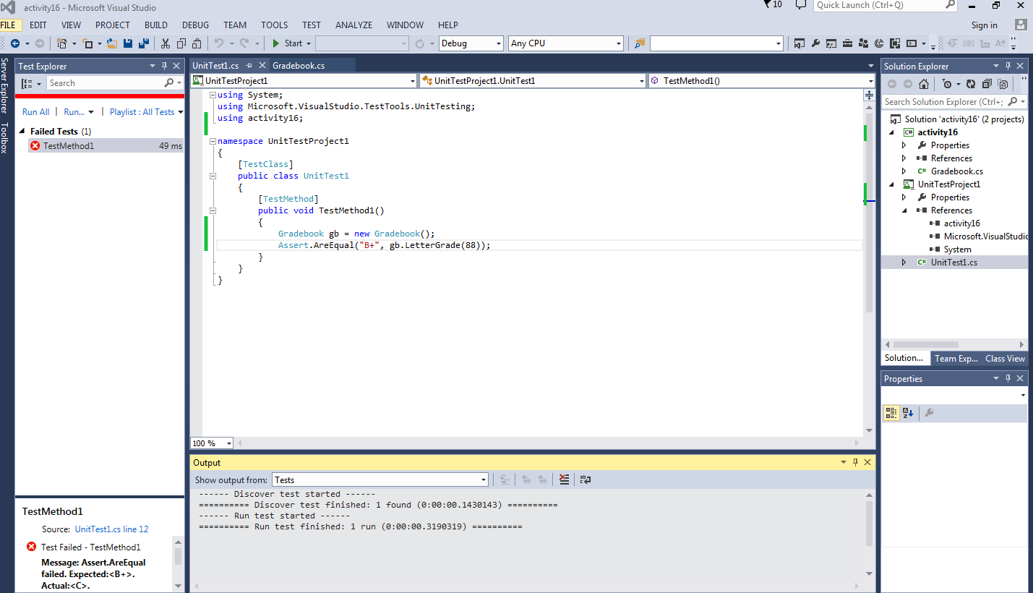Failed test

2) Passed test

