## Joshua Manansala

## CS 340

## Module 4: README

## About the Project/Project Title

The project is called “Create and Read in Python”. The project is about using MongoDB and python with

each other to create a program that is both efficient and simple to use by anyone.

## Motivation

The motivation behind this project is to learn how to create, read, update, and manage a mongo database. After learning how to do that, the motivation is to learn how to incorporate that aspect of the project into a python project to make an even more efficient program that can me used to access and update a database.

## Getting Started

The best way to simulate this project locally is to first create a database within mongo. This can be done manually or by importing a list of data that has already been created and structured.

From there, the creator would then need to organize the data, structure access to the project, and decide what details of the project are to be made.

## Installation

The tools needed for this software are terminal/command line and jupyter notebook. Within the terminal/command line, MongoDB was used for the library of information and to control access to the project. These would either be built into the computer software or could be downloaded from online.

## Usage

The usage for this project is mainly for updating the database within this particular library. Information can be taken from the database or added to the database depending on who the user is and what permissions they are granted. The main subject of this particular database being used is animal shelter information.

### Code Example

The library can be accessed to see the current information that is available in relation to the animal shelter. Along with that, the database can be changed depending on user roles.

### Tests

Tests can be run by entering new information or looking up current information within the database. This allows people to enter new information or retrieve information that has been added by someone else at an earlier time.

### Screenshots

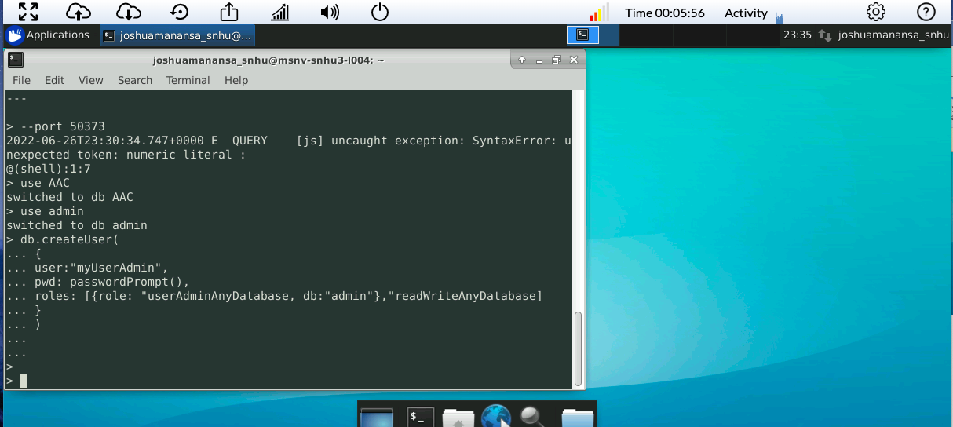

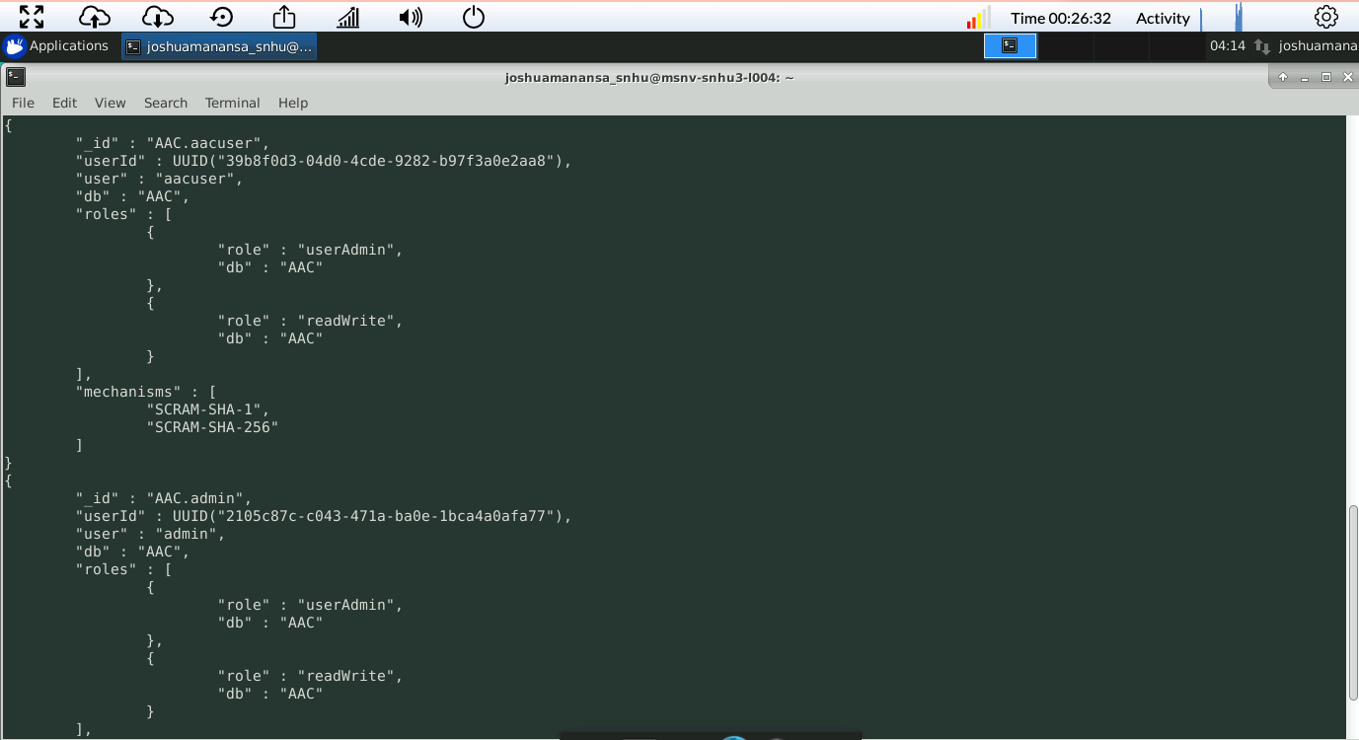

## Contact

Your name: Joshua Manansala