Task 6

BSA squad

Using image recognition to determine the health of a coral colony

Squad members: Manar Adel

Zeina Mohammed

Habiba Ahmed

Mohamed Maghraby

Companies may develop image recognition software to identify and display the areas of change on the coral colony to the station judge. On a video screen, the company’s program should outline areas where the coral has changed. The following parameters must be used:

• Areas of growth should be outlined with a green overlay or a marked with a green rectangle/circle around the affected area.

• Areas of damage or death should be outlined with a yellow overlay or marked with a yellow rectangle/circle around the affected area.

• Areas of bleaching/blotching should be outlined with a red overlay or marked with a red rectangle/circle around the affected area.

• Areas that have recovered from bleaching/blotching should be outlined with a blue overlay or marked with a blue rectangle/circle around the affected area

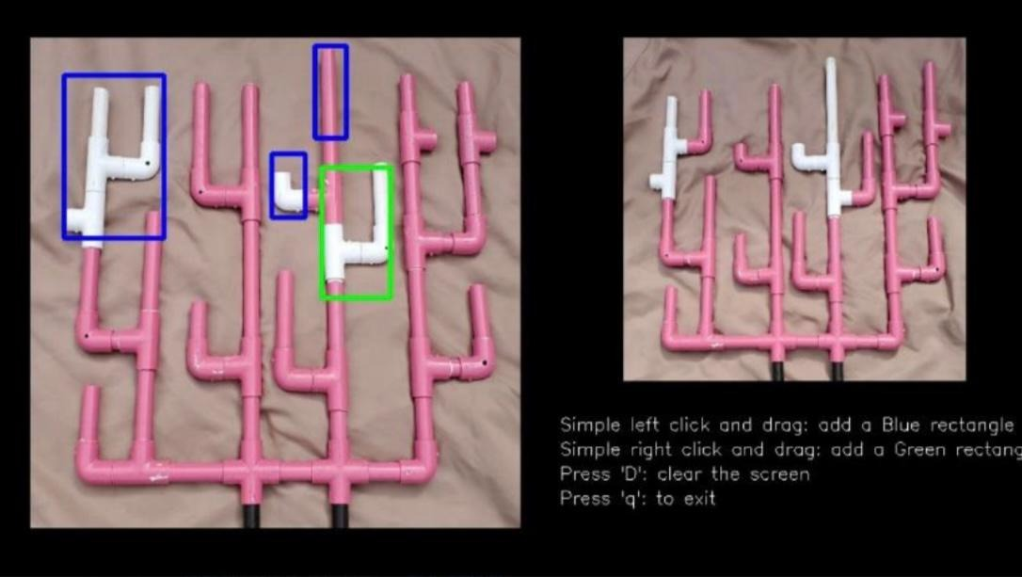

The program was coded using the Python openCV library. Each of us helped with the code. It is commented in the code who did what exactly who did what.