**Name: Manar Hussein Sayed Khalil**

**B.N: 950**

**Topic: Programming language**

**GitHub link:** <https://github.com/Manar-hussien/ECE001>

**GitHub pages:** <https://manar-hussien.github.io/ECE001/>

**Programming language:**

A programming language is a proper language containing a lot of directions that produce different sorts of yield. Programming languages are used in computer programming to implement algorithms. Most programming languages comprise of directions for PCs. There are programmable machines that use a set of specific instructions, rather than general programming languages.

The types of programming languages are: Procedural, Functional, Object-oriented, Scripting and Logic Programming Language. Programming is definitely important because it helps us to: interact with machines and computers, harness the power of computing in all human endeavor, automate tasks and create intelligent machines and it helps me do my work better, faster and in a more efficient manner.

**Source code:**

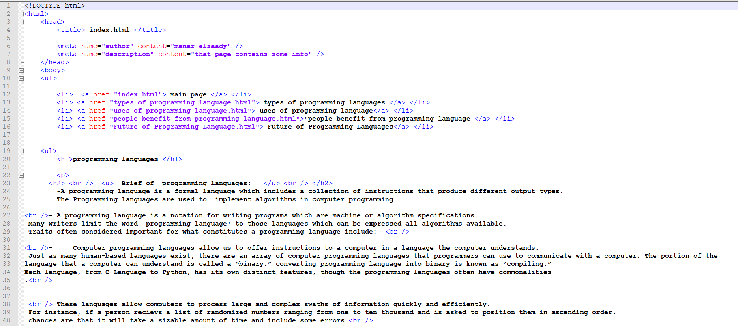

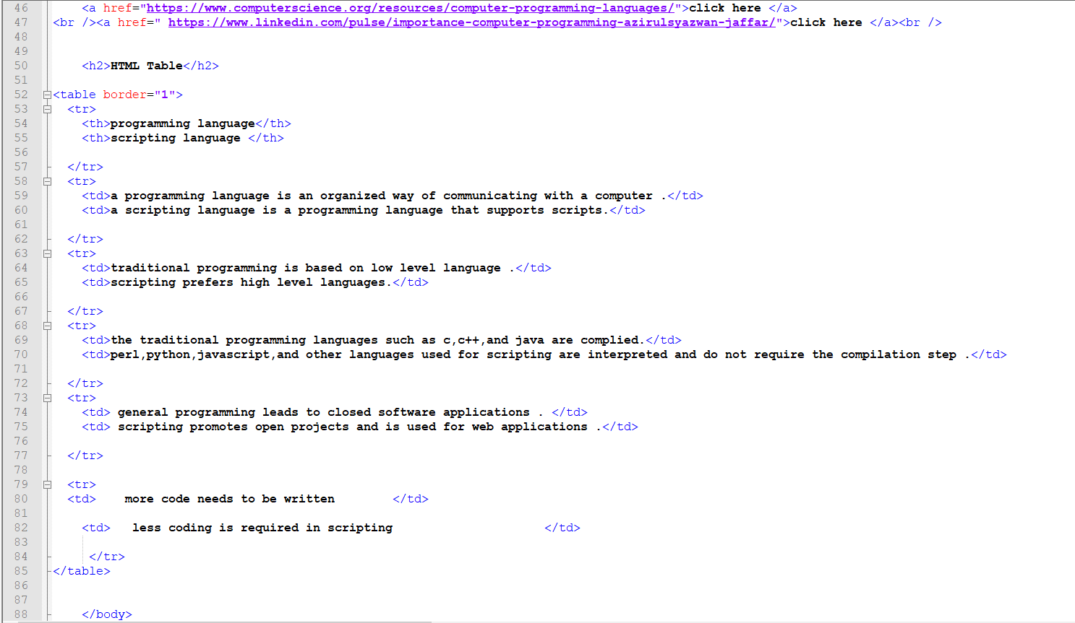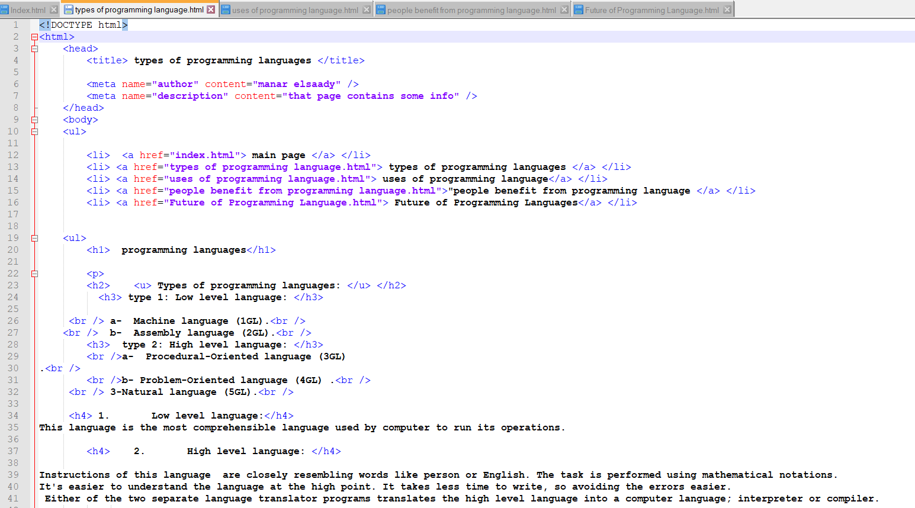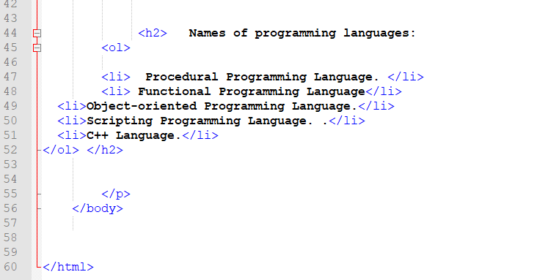

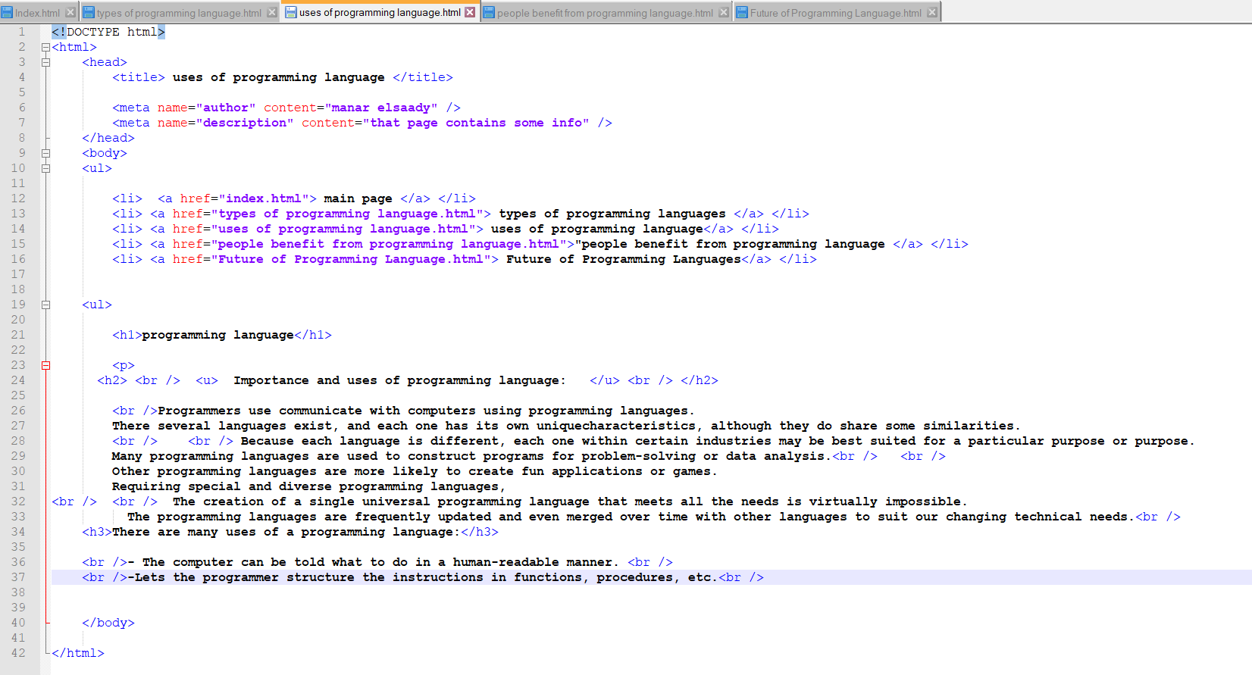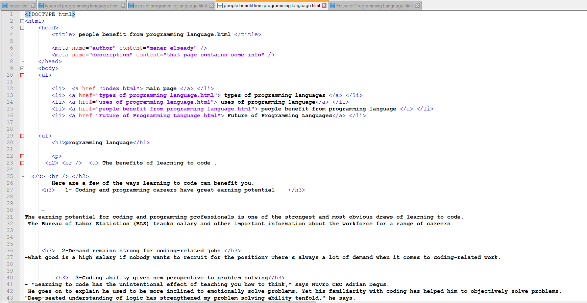

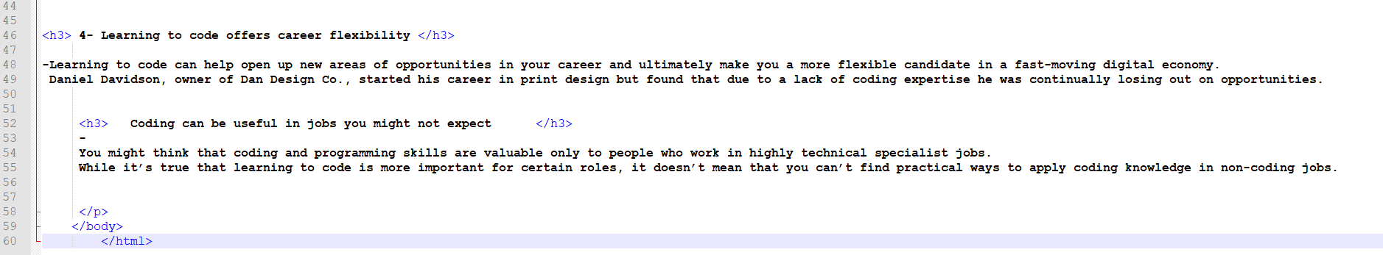

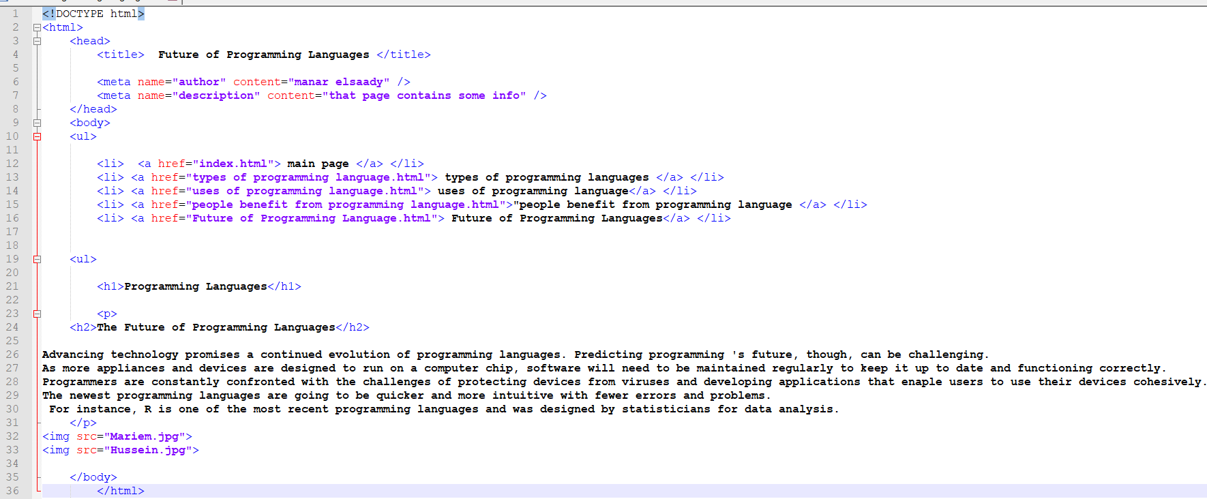

**Screenshots:**

