Manar Mohamad 11924677

Rahaf Nasrallah 11923488

The generated output:

This is our URL for each server

orderServiceUrls = ['http://localhost:3007', 'http://localhost:3011']

catalogServiceUrls = ['http://localhost:3004', 'http://localhost:3010']

After running multiple requests

1. Get book information for book 7, we can see it sent the query to catalog server with url http://localhost:3004

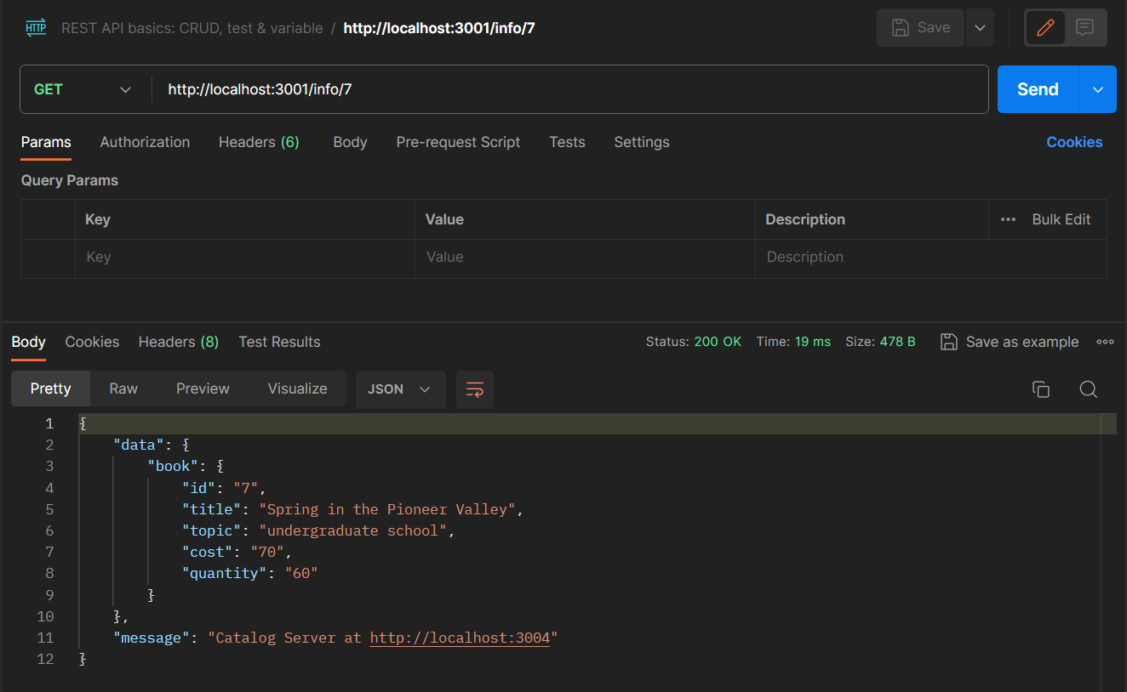

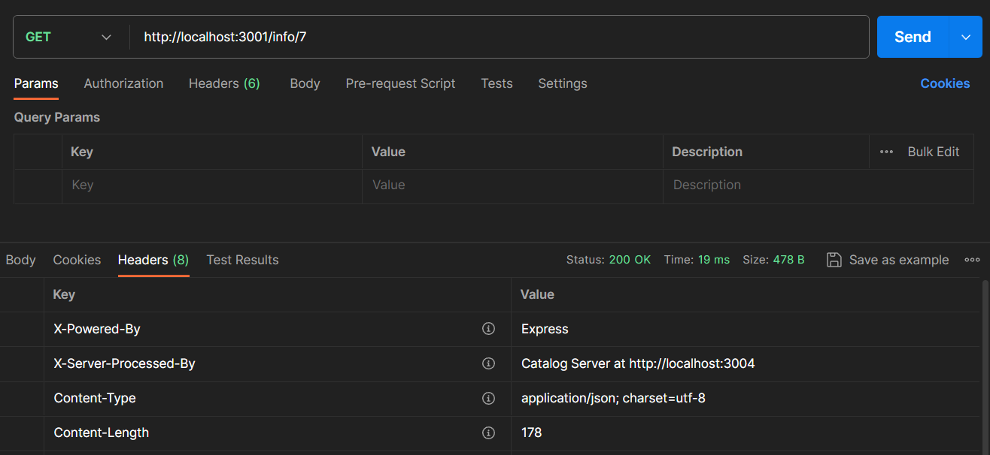

We can see here each Queries are executed on different servers each time the server is deemed busy

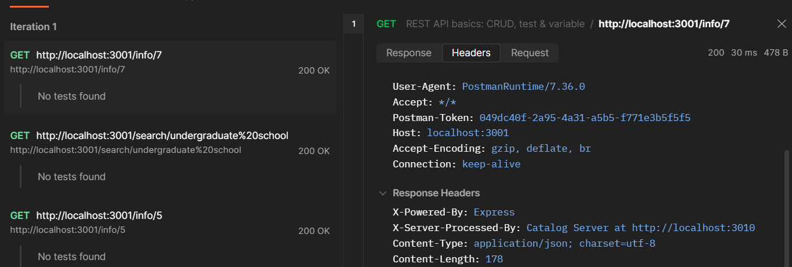

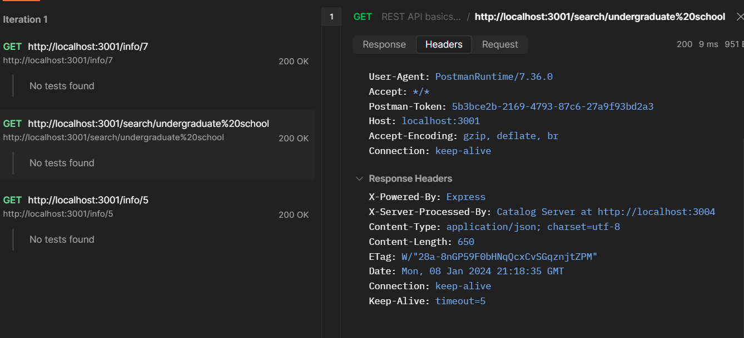

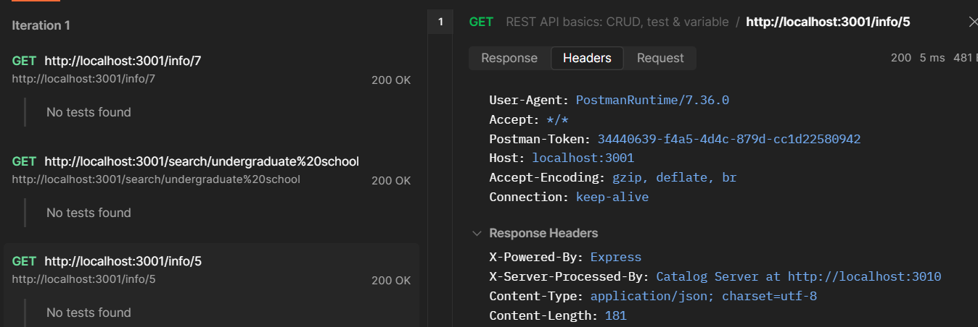

The result for second API request

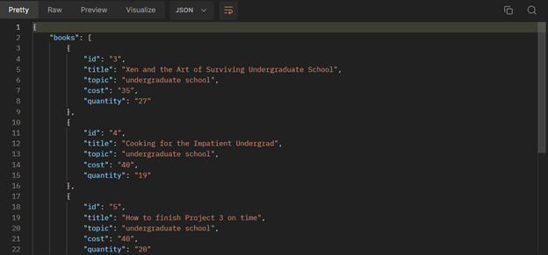

Here for purchase requests :

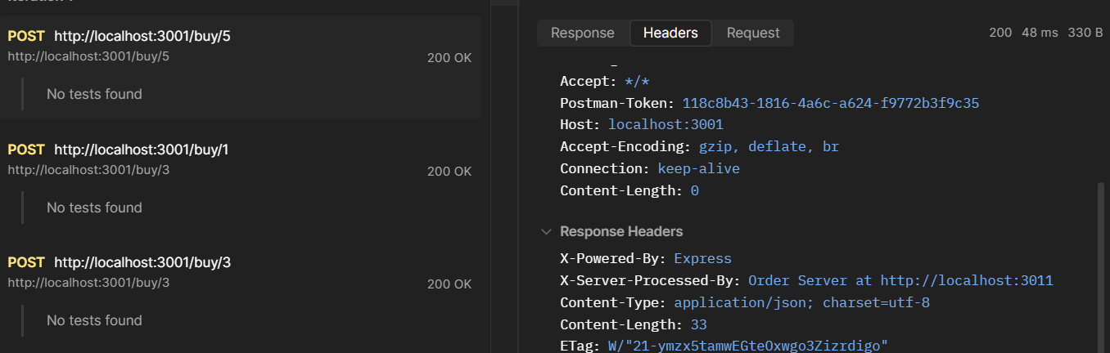

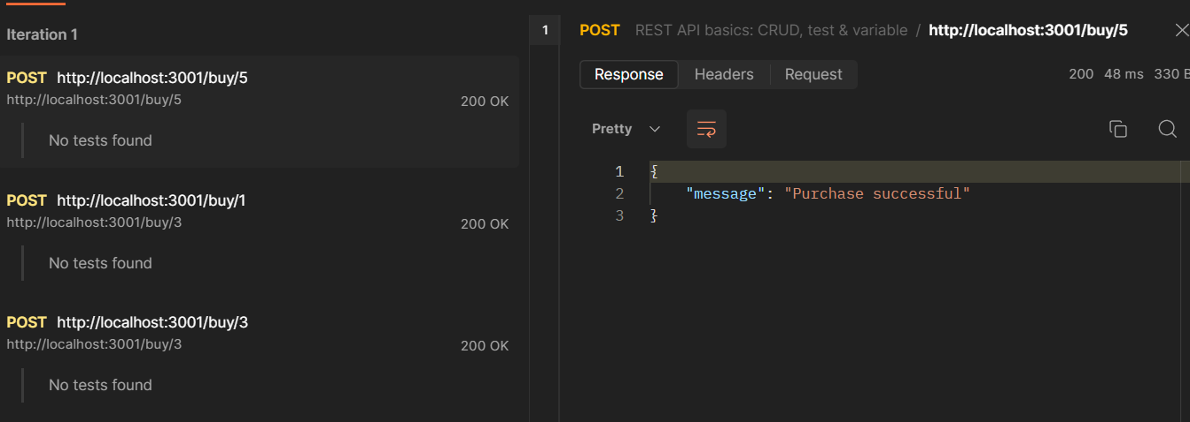

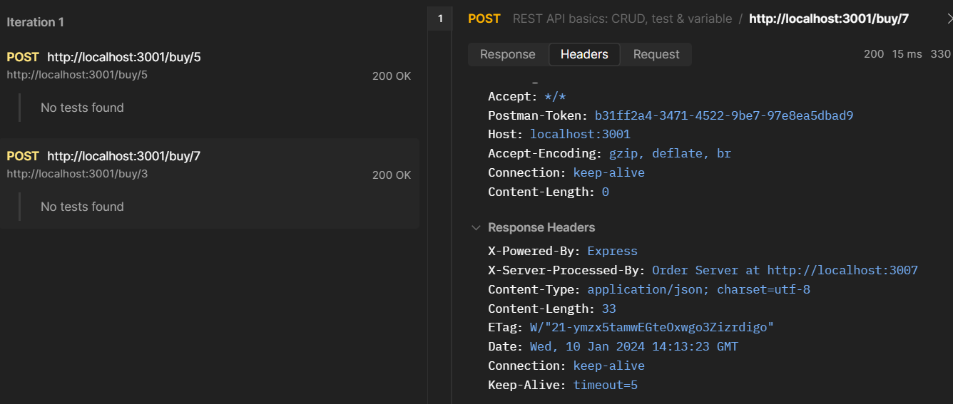

For cache we can see here that first Request is a cache miss because the server will get it for the first time from the database and second time from cache - cache hit , the time will be less than the first time

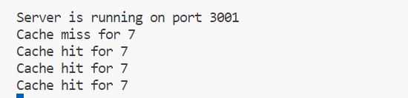

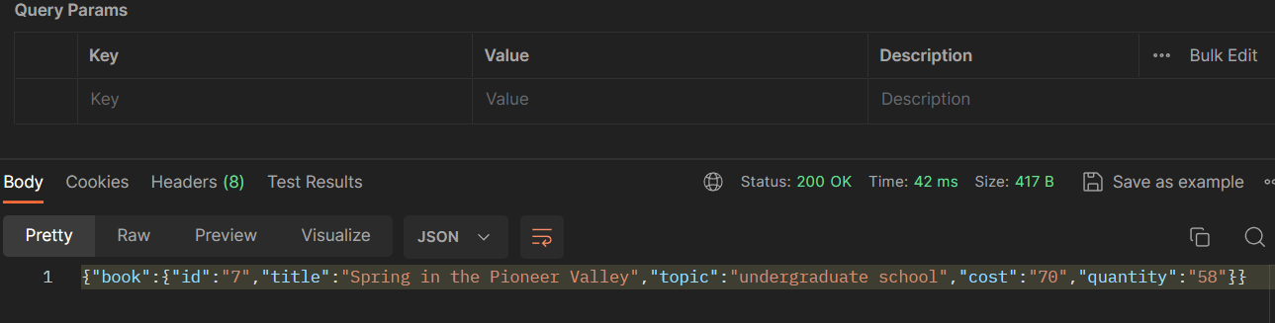

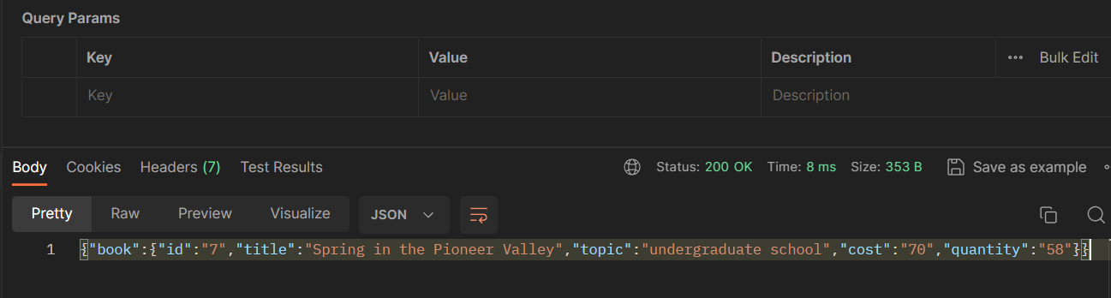

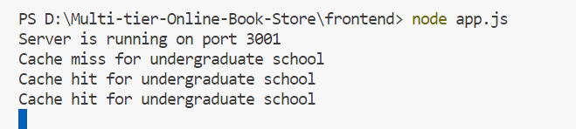

**This is the table and the graph that show the performance improvement with cache :**

