

A Guide to Preparing

Sprint-0 Report

Product Release-1 (IT 496: Project-1)

A document prepared by

Dr. Maha Al-Yahya, Dr. Rana Al-Kadhi, and Dr. Hend Al-Rasheed.

Reviewed by the IT Department GP Agile Transformation Team.

Version1.0 September, 2021



<Project Title>

Sprint-0 Report

Prepared by

<Student1, ID>

<Student2, ID>

<Student3, ID>

<Student4, ID>

Supervised by

<Supervisor’s name>

Table of Contents

1 Introduction 4

1.1 The Problem 4

1.2 The Solution 4

1.3 Product 4

1.3.1 Product Vision 4

1.3.2 Product Roadmap 4

1.3.3 Objectives 4

1.3.4 Scope 4

1.3.5 Hardware/Software Tools and Cost 4

1.4 Scrum Team 4

1.4.1 Skill Set Requirements 4

1.4.2 Roles and Responsibilities 4

2 Background 4

3 Literature Review 4

3.1 Competitive Product Analysis 5

4 System Description 5

4.1 Users 5

4.2 Architecture 5

4.3 Use Case Diagram 5

5 Product Backlog 5

5.1 Product Backlog Items 6

5.1.1 Product Backlog Table 7

6 References 7

# Introduction

An introduction should transfer your reader from the outside world into your project. You may include the project proposal you presented in the initial stages of your project, however, you need to include any modifications suggested by the committee. The introduction should include the following subsections.

## The Problem

## The Solution

## Product

### Product Vision

### Product Roadmap

### Objectives

### Scope

### Hardware/Software Tools and Cost

Describe installed HW and SW

## Scrum Team

### Skill Set Requirements

#### Learning

This is a new section in the report, explain here what steps have been undertaken to achieve the learning required, and the current stage of your learning.

### Roles and Responsibilities

# Background

The background chapter of your report should include a detailed description of necessary domain knowledge and theoretical background required for understanding the project. Include background information in areas that are relevant to your product, including the problem domain and solution domain.

For example, present to the reader the hardware in your project (such as sensors) and any necessary external software (such as GoogleMaps API). Furthermore, the background chapter should include any important definitions related to your topic (such as the definition of recommender systems) and types (such as what are the main types of recommendation algorithms).

The “Background” section of your report may be in a separate chapter, or it may be included as an introductory section in the “Literature Review” chapter. Please consult your project advisor which is more appropriate for your project.

# Literature Review

The goal of the literature review is to help determine the requirements of the project. A literature review describes published information in a particular subject area. It should include a synthesis of similar or related work in your field of study. It should position your project in relation to other efforts. The literature review within the project report needs to be focused on providing explanation and justification for all aspects of the problem to be tackled and the approaches to be considered, and support for the work to be done in the project. There is no obligation for your project to have more features than other reviewed projects.

“A literature review usually has an organizational pattern and combines both summary and

synthesis. A summary is a recap of the important information of the source, but a synthesis is a re-organization, or a reshuffling, of that information.” (Literature Reviews)

## Competitive Product Analysis

Before you build your product, you need to research the market to learn about the strengths and weaknesses of existing similar products.

* Identify competitors
* Identify important features that differentiate each competitor
* Compare your product to the others in the market

# System Description

## Users

This subsection should describe general characteristics of the users of the product including educational level, experience, and technical expertise.

## Architecture

System architecture describes your system’s organizational style showing the major subsystems and data repositories and their inter-connections. Include the system architecture and supplement your architecture with text as needed. Provide a high-level overview of how the functionality and responsibilities of the system were partitioned and then assigned to subsystems or components. Do not go into too much detail about the individual components themselves at this stage.

The main purpose here is to gain a general understanding of how and why the system was

decomposed, and how the individual parts work together to provide the desired functionality.

You may use one of the design patterns, either in describing parts of the architecture, or for

referring to elements of the architecture that employ them.

Describe the system architecture by providing a high-level view of the system showing input and output, system users, external programs and devices, major components and their interactions.

## Use Case Diagram

Include the use case diagram to show how your system interacts with actors.

# Product Backlog

“The product backlog is a prioritized list of desired product functionality (release-1 and release-2). It provides a centralized and shared understanding of what to build and the order in which to build it. It is a highly visible artifact at the heart of the Scrum framework that is accessible to all project participants.” (Rubin, 2017).

The product backlog is composed of backlog items (PBIs). The product backlog usually takes the form of a table with two columns, the PBI and its size. The building blocks of the product backlog are **user stories**. User stories are a “a common format for representing items of business value”. For more information on user stories and requirements, refer to chapter 5 in (Rubin, 2017).

## Product Backlog Items

The product backlog is composed of backlog items (PBIs). “PBIs are features, items of functionality that will have tangible value to the user or customer. These are often written as user stories. Examples of features include something brand-new (a login screen for a new website), or a change to an existing feature (a more user-friendly login screen for an existing website). Other PBIs include defects needing repair, technical improvements, knowledge-acquisition work, and any other work the product owner deems valuable. See Figure 1 and Table below for examples of the different types of PBIs. “(Rubin, 2017)

As the product backlog is an ordered list of everything that is known to be needed in the product, non-functional requirements such as performance, security, system availability, and usability should be part of the product backlog.

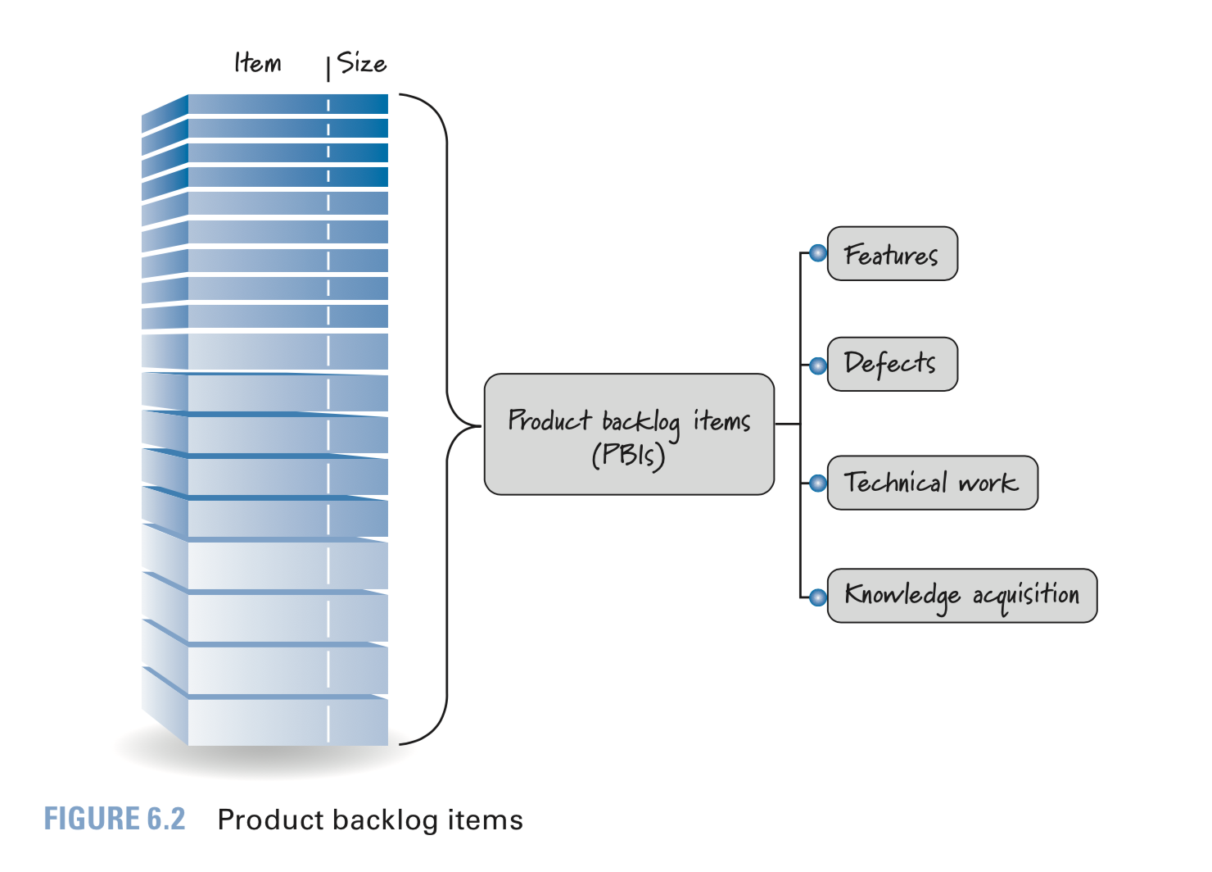

Figure : PBI Types

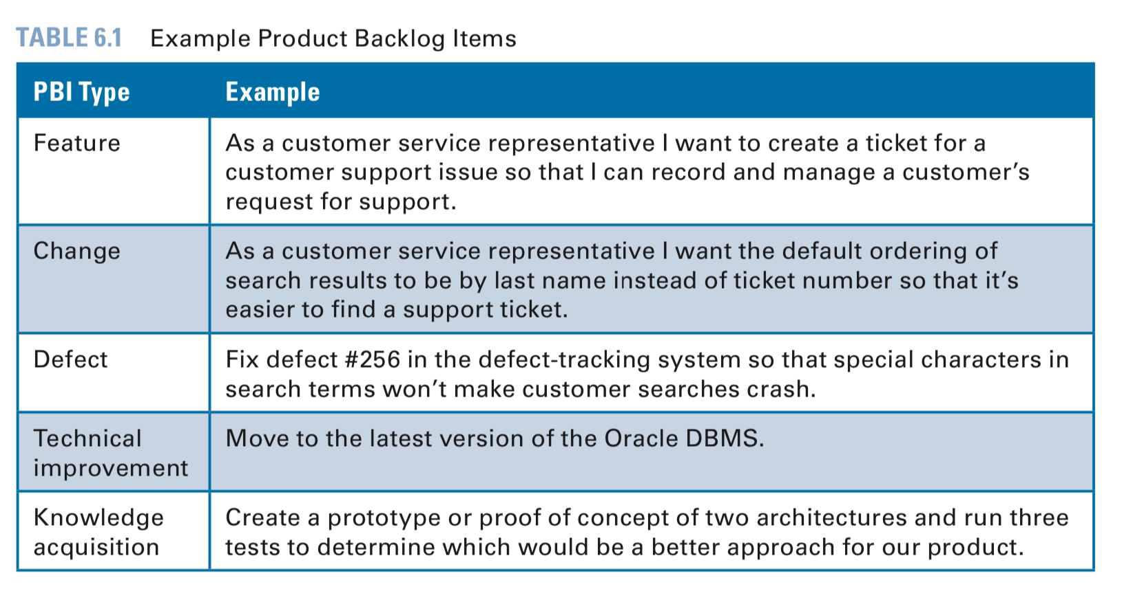

The PBIs presented in this report should reflect the PBIs created in your **Jira project**.

The items at the top of the backlog should be **ready** to be moved into a sprint. Example definition of ready (Rubin, 2017).:

|  |  |
| --- | --- |
| **Example Definition of Ready** | |
| ☐ | Business value is clearly articulated |
| ☐ | Details are sufficiently understood |
| ☐ | Dependencies are identified; no blocking dependencies exist |
| ☐ | Team is appropriately staffed relative to the PBI |
| ☐ | Estimated and small enough to be completed during sprint |
| ☐ | Acceptance criteria are clear and testable |
| ☐ | Performance criteria, if any, are defined and testable |
| ☐ | Team understands how to demo the completed PBI |

For more information on the product backlog, please refer to chapter 6 (Rubin, 2017).

### Product Backlog Table

In this PB table list all system requirements, the highest items (the ones you will start implementing in the next sprint) should be defined in sufficient details (size, type, and acceptance criteria)

|  |  |  |  |
| --- | --- | --- | --- |
| PBI  (user story) | Size  (Story points) | Type  (Feature, defect, technical work, knowledge acquisition) | Acceptance Criteria  The conditions of satisfaction that must be met for that item to be accepted. |
|  |  |  |  |
|  |  |  |  |
|  |  |  |  |

# References

Any references in the report should be included in this section. Always give complete citations for references cited in your report. A proper reference involves two components: the citation in the text and the complete bibliographic entry in the References section. It is recommended to generate the references automatically (use “References” menu in Word, “Insert Citation”), or external plugin like Zotero. Use the Institute of Electrical and Electronics Engineers (IEEE) style for referencing. For more information see:

http://wwwlib.murdoch.edu.au/find/citation/ieee.html

**References for this guide**

Rubin, K. S. (2017). *Essential Scrum: A practical guide to the most popular agile process*. Upper Saddle River, NJ: Addison-Wesley.