

Project Report (Part I)
on

Integrated Worker Safety and Health Monitoring System for Mining Operations
Submitted in partial fulfillment for the award of the degree of

BACHELOR OF ENGINEERING
In

MECHANICAL AND MECHATRONICS ENGINEERING
Submitted by
Manas Amit Pednekar (36)
Amey Anant Satale (46)
Aaryaa Rakesh Kanojia (18)

Under the Guidance of

Mr. Dipesh Tare

Assistant Professor

Department of Mechanical and Mechatronics Engineering (Academic Year 2026-27)




CERTIFICATE

This is to certify that the project entitled “Integrated Worker Safety and Health Monitoring System for Mining Operations” is a bonafide work of Manas Amit Pednekar (36), Amey Anant Satale (46) and Aaryaa Rakesh Kanojia (18) submitted to the Thakur College of Engineering and Technology, Mumbai (An Autonomous College affiliated to University of Mumbai) in partial fulfillment of the requirement for the Project-I for award of the degree of “Bachelor of Engineering” in “Mechanical and Mechatronics Engineering”.

Signature with Date: ----------------- Name of Guide:  Designation: Assistant Professor | Signature with Date: -------------------- Name of HOD:  Name of Department: Mechanical and Mechatronics Engineering

PROJECT APPROVAL CERTIFICATE

This project report entitled “Integrated Worker Safety and Health Monitoring System for Mining Operations” by Manas Amit Pednekar (36), Amey Anant Satale (46) and Aaryaa Rakesh Kanojia (18) is approved for the degree of “Bachelor of Engineering” in “Mechanical and Mechatronics Engineering”.

Internal Examiner: External Examiner:
Signature: Signature:

Name: Name:
Date:
Place:

ACKNOWLEDGEMENT

Working on this project taught us a lot, and it would not have been possible without the people around us. We would like to thank them here.
We sincerely thank our guide, Mr. Dipesh Tare, for his guidance, his patience with our many questions and his constant support at every stage of the project.
We also thank the project coordinators for arranging the facilities we needed to carry out the project work.

We thank the HOD, [Name of HOD], the Principal, Dr. B. K. Mishra, and the college management for their support. We are also thankful to the laboratory staff of the department, and to our friends and families who encouraged us throughout.

1.

2.

3.

1. Manas Amit Pednekar (36)
2. Amey Anant Satale (46)
3. Aaryaa Rakesh Kanojia (18)

Plagiarisms Report

INDEX

Chapter No. | Topic
 | List of Figures |  | I
 | List of Tables |  | II
 | Abstract |  | III
Chapter 1 | Introduction |  | 1
 | 1.1 | Overview of the Project | 1
 | 1.2 | Motivation & Application | 2
 | 1.3 | Problem Definition | 2
 | 1.4 | Objective & Scope | 3
 | 1.5 | Expected outcome | 4
 | 1.6 | Organization of the Report | 4
Chapter 2 | Literature Survey & Proposed System |  | 5
 | 2.1 | Literature review of Existing System | 5
 | 2.2 | Limitations of Existing System & Gap Analysis | 7
 | 2.3 | Proposed System | 8
Chapter 3 | Requirement Gathering, Analysis and Planning |  | 10
 | 3.1 | Requirement Specification | 10
 | 3.2 | Feasibility Study | 12
 | 3.3 | Methodology | 13
 | 3.4 | Technology Stack | 14
 | 3.5 | Gantt Chart and Process Model | 14
 | 3.6 | System Analysis (Functional, Structural, and Behavioral Models) | 16
Chapter 4 | System Design and Experimental Set up |  | 20
 | 4.1 | System Architecture & Diagrams (DFD/UML/ Block Diagram/Physical Layout) | 20
 | 4.2 | Algorithm & Process flow design (Flowchart/Pseudo Code) | 23
 | 4.3 | User Interface & Input Data Design (Snapshots/ circuits/Structure) | 27
 | 4.4 | Experimental Setup and Tools (Software & Hardware) | 32
 | 4.5 | Implementation, Deployment and Testing | 33
 | 4.6 | Performance Evaluation. | 35
 | 4.7 | Summary | 36
Chapter 5 | Results & Discussion |  | 37
 | 5.1 | Outputs & Outcomes | 37
 | 5.2 | Analysis of Results & Interpretation of data | 38
 | 5.3 | Discussion of Results & Limitations of the System | 39
Chapter 6 | Conclusion & Future Scope |  | 40
 | 6.1 | Summary of work completed | 40
 | 6.2 | Future Scope | 40

References
Research Paper
Appendix A
- Abbreviation and symbols

Appendix B
  - Definitions

Appendix C
  - List of Publications

List of Figures

Figure No. and Title Page No.
Figure 1: Overall block diagram of the proposed system 8
Figure 2: Gantt chart of the project 15
Figure 3: Iterative and incremental process model followed in the project 15
Figure 4: Use case diagram 16
Figure 5: Data flow diagram, level 0 17
Figure 6: Data flow diagram, level 1 17
Figure 7: State diagram of a worker's status 19
Figure 8: Sequence diagram of an alarm 19
Figure 9: Physical architecture of MineSafe 20
Figure 10: Circuit diagram of the body unit 21
Figure 11: Circuit diagram of a repeater node 22
Figure 12: Circuit diagram of the entry station 22
Figure 13: Flowchart of status evaluation on the hub 25
Figure 14: Flowchart of the entry check 27
Figure 15: Register workers tab 29
Figure 16: Entry check tab 29
Figure 17: Kit check (AI) result 30
Figure 18: Live tab during an alarm 30
Figure 19: Map tab with tunnels, repeaters and workers 31
Figure 20: Air panels on the Gas and air tab 31
Figure 21: Network tab 32
Figure 22: Incident log 32
Figure 23: Experimental bench set-up 33
Figure 24: Live tab during a bench run with real hardware 37

List of Tables

Table No. and Title Page No.
Table 1: Summary of literature survey 6
Table 2: Gap analysis: existing approaches compared with MineSafe 7
Table 3: Functional requirements 10
Table 4: Non-functional requirements 11
Table 5: Hardware requirements 11
Table 6: Software requirements 12
Table 7: Approximate cost of the prototype 13
Table 8: Technology stack 14
Table 9: Body unit pin connections (ESP32-S3) 21
Table 10: Repeater and entry station connections 23
Table 11: Default warning and danger limits 25
Table 12: Structure of the body unit packet (54 bytes) 28
Table 13: Flag bits in the body unit packet 28
Table 14: Main hub interfaces (HTTP) 28
Table 15: Test cases 35
Table 16: Network timing and routing settings 36
Table 17: Bench test observations 38
Table 18: Proposed sensors to detect kit removed underground 41

Abstract
Once a miner goes underground, the people in the control room lose track of three simple things. They do not know if the worker is still wearing the helmet and vest, they do not know how the worker's body is coping with heat and hard work, and they do not know where the worker is. In most small and medium mines in India, the only tools at hand are a muster roll, a few fixed gas monitors and a telephone line.
In this project we built MineSafe, a low-cost system that tries to fill all three gaps at once. At the gate, an entry station made with a XIAO ESP32-S3 Sense reads NFC tags stuck inside the helmet, vest, trousers and shoes and takes a full-body photo. A YOLOv8 model on the laptop checks the photo to see whether the kit is actually worn. Only after the supervisor approves is a body unit handed to the worker. The body unit is an ESP32-S3 worn on the chest with an MPU6050, a BMP180, a DS18B20 skin probe and a pulse sensor. It sends one small packet every second. Repeaters built on the XIAO ESP32-C6 are placed along the tunnel. They link up on their own into a chain over ESP-NOW, and each one also carries an MQ gas sensor, an AHT20 air temperature and humidity sensor and a buzzer.
A Python Flask program on the supervisor's laptop collects everything. It works out each worker's position without GPS, using step counting, gyroscope heading, the tunnel map and the repeaters as check-points. It also marks every worker and every repeater location as SAFE, WARNING or DANGER, and keeps a medical card for each worker. When the supervisor presses ALERT, the alarm travels back down the same chain. Every repeater buzzes, every body unit lights its red LED, and the dashboard counts how many have confirmed. Bench tests showed the full data path working, the alarm coming back to the worker, wrong gear tags being rejected and unplugged sensors being reported. The demo set costs about Rs. 8,100 without the laptop. Range, alarm delay and position error in a real tunnel are still to be measured in Part II.
Keywords: Mine safety, wearable sensors, ESP-NOW, PPE compliance, RFID, YOLOv8, dead reckoning, gas monitoring, heat stress, IoT

Chapter 1
Introduction
1.1 Overview of the Project
Mining gives the country its coal, iron ore, limestone and many other raw materials, but the work itself is still dangerous. A miner spends the shift in a place with no daylight, no mobile signal and no GPS. If something goes wrong, such as a fall of roof, a gas build-up or a person collapsing from heat, the people on the surface often find out late. In Parliament in 2025, the government reported 226 deaths in coal and lignite mines between 2020 and 2024, with 53 of them in 2024 alone [1]. Behind most of these numbers is a short delay between the accident and the moment anyone knew about it.
Our project, which we call MineSafe, is an attempt to shorten that delay using parts that a college lab can buy online. The idea is simple. Before a worker goes down, the system checks that the safety kit is really there and really worn. While the worker is underground, a small unit on the chest keeps sending health and movement readings. A chain of small radio boxes along the tunnel carries these readings to a laptop in the control room. The laptop shows every worker as a dot on the tunnel map, raises a warning when something looks wrong, and lets the supervisor send an alarm back to every worker with one click.
The system has four main blocks:
• Entry station at the gate, with an RFID (NFC) reader and a camera, to check the safety kit.
• Body unit worn by each miner, with motion, temperature, pulse and pressure sensors, an SOS button and a red alert LED.
• Repeater chain along the tunnel, which passes data hop by hop and also measures gas, air temperature and humidity.
• Admin hub, a Flask web application on a laptop that runs fully offline and shows everything on a browser dashboard.
Everything talks over ESP-NOW underground and over the laptop's Wi-Fi hotspot on the surface. No router, internet connection or cable laying is needed, which is what makes the system practical for a small mine or a tunnelling site.
1.2 Motivation & Application
When we started reading accident reports for this project, the same three problems kept coming up. The first was late discovery. A worker who falls in a far-off heading may lie there until someone happens to walk past. The second was not knowing where people were. After a collapse or a fire, the rescue team knows from the roll who went down, but not where each person was last seen. The third was the slow slide away from safety rules. A helmet that was checked at 7 a.m. may be lying on a ledge by 11 a.m. because the working place is hot.
Heat makes all three problems worse. Deep workings are often hot and humid, and it is the mix of temperature and humidity, not temperature alone, that decides whether the body can cool itself. A single gas and temperature monitor near the shaft cannot show that one particular drive is getting too hot. Measuring the air at many points along the tunnel can.
Large mines abroad already use dedicated tracking and communication systems. In the USA, the MINER Act of 2006 made such systems compulsory after the Sago disaster, and MSHA now tests and approves them [2]. These systems cost a lot and need trained staff, so they are mostly out of reach for the smaller mines that employ a big share of India's mine workers. As mechatronics students, we wanted to see how much of that safety net we could rebuild with low-cost microcontrollers and open-source software.
Applications of the system include:
• Underground coal and metal mines, especially small and medium operators.
• Tunnelling work for metro rail, roads and hydro projects.
• Confined-space work such as sewers, tanks and large pipelines.
• Any site where workers must wear PPE and are out of sight of supervisors, for example large warehouses or plants with hot zones.
1.3 Problem Definition
In a typical small mine, the control room cannot answer three questions about a worker during a shift: Is the worker still wearing the required kit? Is the worker's body under stress, or has the worker fallen? Where exactly is the worker right now? Existing tools answer at most one of these questions, need costly fixed infrastructure, or depend on GPS and mobile networks that do not work underground.
The problem we set out to solve can be stated as follows:
To design and build a low-cost, offline system that checks a miner's safety kit at the gate, keeps track of the miner's health, movement and position underground without GPS, watches gas and heat along the tunnel, and lets the control room warn each worker within seconds, with confirmation that the warning was received.
1.4 Objective & Scope
1.4.1 Objectives
1. To check four items of protective equipment (helmet, vest, trousers and shoes) at the entry gate using RFID tags, and to confirm with a camera photo and an AI model that the kit is actually worn.
2. To build a chest-worn body unit that measures motion, skin temperature, pulse and air pressure and sends a data packet every second.
3. To build repeater nodes that form a multi-hop wireless chain on their own and also measure gas, air temperature and humidity at their location.
4. To estimate each worker's position on a tunnel map without GPS.
5. To classify each worker and each repeater location as SAFE, WARNING or DANGER, and to send alarms back to the workers with confirmation.
6. To keep the medical details that a rescue team needs, such as blood group, allergies and emergency contact.
7. To keep the total hardware cost low enough for a small mine to try the system.
1.4.2 Scope
Part I of the project covers the design, building and bench testing of a working prototype: one body unit, two to three repeaters, one entry station and the laptop hub software. Testing so far has been done in the college lab, using both real hardware and a simulator that we wrote to stand in for extra repeaters and workers. Field trials in a real or mock tunnel, a proper enclosure and battery for the body unit, and accuracy measurements are planned for Part II.
The following are outside the scope of this project: certification for use in explosive (gassy) atmospheres, voice communication, and medical-grade measurement of heart rate and oxygen level. The SpO2 value shown on the dashboard is only an estimate.
1.5 Expected outcome
• A working entry station that rejects missing or copied gear tags and gives an AI verdict on a full-body photo.
• A body unit that reports falls, no-movement, SOS presses, high body temperature and abnormal pulse to the hub within a few seconds.
• A repeater chain that sets itself up with no manual routing and heals itself if a node is moved or switched off.
• A live dashboard with worker cards, tunnel map, gas and air readings, network health and an incident log.
• A one-click alarm that reaches every buzzer and every worker's LED, with a count of confirmations on screen.
• A complete demo kit costing around Rs. 8,000 to 8,500, excluding the laptop.
1.6 Organization of the Report
Chapter 1 introduces the project, the reasons behind it and its objectives. Chapter 2 reviews existing work on mine communication, tracking, smart helmets and PPE detection, points out the gap and describes the proposed system. Chapter 3 covers requirements, feasibility, methodology, technology stack, schedule and the analysis models. Chapter 4 explains the system design in detail, including circuits, algorithms, user interface, experimental set-up, implementation and testing. Chapter 5 presents the results and discusses the limits of the system. Chapter 6 concludes the report and lists future work. References, the research paper and the appendices follow.
Chapter 2
Literature Survey & Proposed System
2.1 Literature review of Existing System
We grouped the work we read into five areas: wireless communication and tracking in mines, precise indoor positioning, smart helmets and wearables, camera-based PPE detection, and walking-based (dead reckoning) navigation. A short summary of each important source is given below and in Table 1.
2.1.1 Wireless information systems for mines
CSIR-CIMFR in Dhanbad developed one of the best-known Indian systems for this purpose. Bandopadhyay, Chaulya and Mishra [3] placed ZigBee routers every 50 to 80 m in the mine and gave each miner an active RFID tag. The tags talk to the nearest router, and the mesh carries the data to a coordinator linked to the surface. The work proved that low-power 2.4 GHz radios can carry tracking and environmental data underground. However, the position was only known as "near reader number so-and-so", and the system did not look at the worker's health.
Moridi et al. [15] combined a ZigBee sensor network with a GIS map for an underground mine. Gas, temperature and humidity readings and miner tags were shown on a map in the control room. This is close to what we wanted for the environment side, but positions were again limited to the zone of each node, and no alarm went back to the individual worker.
2.1.2 Ultra-wideband positioning
Ultra-wideband (UWB) radio can measure distance very accurately. Clausen et al. [4] built and tested a UWB positioning system in an underground mine setting and reached sub-metre accuracy. The drawback is cost: UWB needs many fixed anchors and a special tag for each worker, so the cost per metre of tunnel is high.
2.1.3 Smart helmets
Many student and conference projects put gas, temperature and impact sensors on a helmet and send the readings over Wi-Fi, ZigBee or LoRa. Kartik [5] reviews this group of IoT smart helmets for mining and lists the common difficulties: radio signals die quickly in rock, sensors need calibration, batteries run out and data security is weak. Most of these helmets give a local beep or a cloud dashboard. Very few of them check the kit at the gate, track position, or send an alarm back to the worker.
2.1.4 Camera-based PPE detection
Object detectors from the YOLO family [6] made it possible to detect objects in real time on normal hardware. Ferdous and Ahsan [7] trained YOLO-based models on construction-site photos of hard hats, vests and goggles and reported a mean average precision of about 90 % for their best model. Ultralytics YOLOv8 [8] made such models easy to use from Python. These systems usually run on CCTV cameras over a network. They tell you that someone is not wearing a helmet, but not who that person is, and they do not work in places without cameras.
2.1.5 Pedestrian dead reckoning
If GPS is not available, a person's position can be estimated by counting steps and following the direction of walking. This is called pedestrian dead reckoning (PDR). Foxlin [9] showed that a sensor on the shoe can keep the error small by resetting the speed to zero each time the foot is flat on the ground. Weinberg [10] gave a simple way to estimate step length from an accelerometer. A unit worn on the chest cannot use the foot-flat trick, so its drift must be corrected in other ways. We use the tunnel map and the repeaters for this.
Table 1: Summary of literature survey
Ref. | Work | Method | What it does well | What is missing
[3] | Bandopadhyay et al., 2009 | Active RFID + ZigBee mesh | Proved low-power mesh works underground | Zone-level position only, no health data
[15] | Moridi et al., 2015 | ZigBee sensors + GIS map | Gas and climate shown on a mine map | No alarm back to worker, no kit check
[4] | Clausen et al., 2024 | UWB anchors and tags | Sub-metre position accuracy | Costly, many anchors needed
[5] | Kartik, 2023 | Review of IoT smart helmets | Lists real problems in mines | Helmets rarely track position or kit
[7] | Ferdous and Ahsan, 2022 | YOLO PPE detection | About 90 % mAP on site photos | Needs cameras and network; no identity
[9] | Foxlin, 2005 | Shoe-mounted inertial PDR | Low drift over long walks | Needs foot mounting

2.2 Limitations of Existing System & Gap Analysis
From the survey we found that each existing approach solves one part of the problem quite well, but none of them solves all of it. The main limitations are:
• Kit compliance is checked by eye. There is no record of who entered wearing what, and no check that the kit is worn rather than just carried.
• Health is not watched. Fixed gas monitors say nothing about the person. Smart helmets measure a few values but rarely heart rate or falls.
• Position is coarse or expensive. RFID and ZigBee systems only give the zone of the nearest reader. UWB is accurate but costly. GPS does not work at all.
• Alarms are one-way. Most systems sound a local beep or show a message in the control room, but cannot tell a particular worker to get out, and cannot confirm the worker got the message.
• Infrastructure is heavy. Many systems need cables, routers, servers or internet access, which small mines do not have.
Table 2 compares the main approaches with MineSafe on these points.
Table 2: Gap analysis: existing approaches compared with MineSafe
Feature | Gas detector | RFID / ZigBee mesh | Smart helmet | CCTV + AI | MineSafe
Kit check at entry | No | Gate tag only | No | At camera only | Tags + AI photo
Live vitals | No | No | Partial | No | Temp, pulse, SpO2 est., falls
Position underground | No | Reader zone | Usually GPS | No | Map with steps + check-points
Gas and heat along tunnel | One point | Some nodes | On helmet | No | Every repeater
Alarm back to worker | Local beep | Limited | Some | No | Every buzzer + worker LED
Medical card for rescue | No | No | No | No | Yes
Needs | Nothing | Readers, cables | Network | Cameras, network | Battery nodes, laptop

The gap is clear: no single low-cost system checks the kit before entry, follows the worker's health and movement afterwards, places the worker on a map without GPS, and sends a confirmed alarm back to that worker. Filling this gap is the aim of our work.
2.3 Proposed System
The proposed system, MineSafe, joins kit checking, health monitoring, tracking and two-way alarms into one offline system. Figure 1 shows the overall block diagram, split into five stages from sensing to the users.
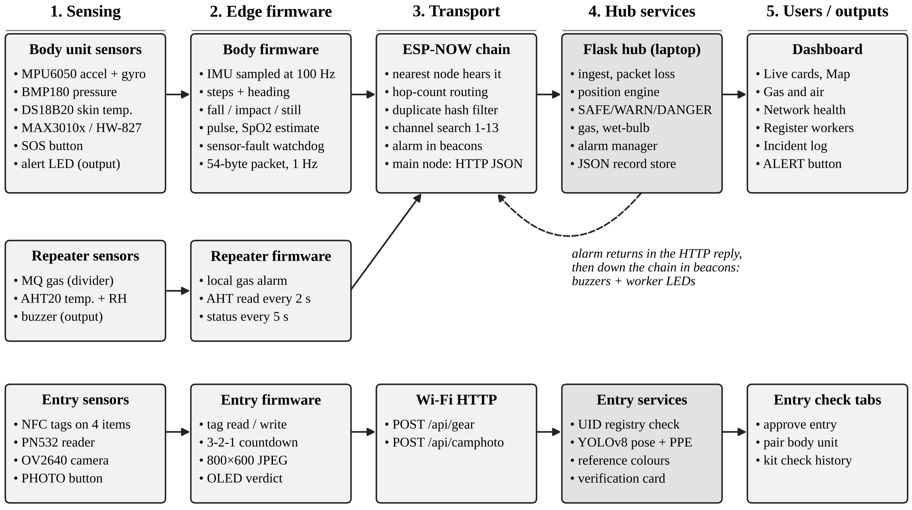
Figure 1: Overall block diagram of the proposed system
Sensing. The body unit has an MPU6050 (acceleration and rotation), a BMP180 (air pressure), a DS18B20 probe (skin temperature) and a MAX30102 or HW-827 pulse sensor. Each repeater has an MQ gas sensor and an AHT20 temperature and humidity sensor. The entry station has a PN532 NFC reader and an OV2640 camera.
Edge processing. Firmware on each ESP32 makes the decisions that must work even when the network is down. The body unit detects a fall by itself and the repeater beeps by itself on a sharp gas rise. Everything else is packed into small binary packets.
Transport. Underground, ESP-NOW carries the packets from repeater to repeater. On the surface, the main repeater and the entry station send JSON over HTTP to the laptop through the phone's Wi-Fi hotspot.
Hub. The Flask program on the laptop counts lost packets, estimates position, classifies each worker, converts gas readings to ppm, runs the AI kit check, manages alarms and stores records.
Users. The supervisor uses a browser dashboard. Workers underground get the alarm through the repeater buzzers and their own red LED.
A worker's shift with MineSafe goes through six steps: (1) one-time registration with name, blood group and medical notes; (2) scanning of the tagged helmet, vest, trousers and shoes at the gate; (3) a photo for the AI kit check; (4) approval by the supervisor, which pairs a body unit with the worker; (5) live monitoring of vitals, motion and position; and (6) an alarm with location and medical card if a fall, SOS, gas or heat problem occurs.
Chapter 3
Requirement Gathering, Analysis and Planning
3.1 Requirement Specification
We gathered requirements by reading DGMS guidance and accident summaries, going through research papers and product brochures, and discussing the idea with our guide. We then split the requirements into functional and non-functional ones, followed by the hardware and software needed.
3.1.1 Functional requirements
Table 3: Functional requirements
ID | Requirement
FR1 | The supervisor shall be able to register a worker with name, employee ID, blood group, medical notes, emergency contact and body unit ID.
FR2 | The entry station shall read the NFC tag of each kit item and the hub shall reply OK, MISMATCH or UNKNOWN TAG.
FR3 | The entry station shall take a full-body photo and the hub shall give an AI verdict on helmet, vest and shoes.
FR4 | The supervisor shall approve entry and pair a body unit with the worker.
FR5 | The body unit shall send temperature, pulse, motion, step count, heading, height and flags once per second, and at once when SOS is pressed.
FR6 | The body unit shall detect a fall, no movement and a hard impact on its own.
FR7 | Repeaters shall form a chain by themselves and forward packets to the main repeater.
FR8 | Each repeater shall measure gas, air temperature and humidity and report them to the hub.
FR9 | The hub shall show each worker on a tunnel map without GPS.
FR10 | The hub shall classify each worker and repeater location as SAFE, WARNING or DANGER and log every change.
FR11 | The supervisor shall be able to raise and clear an alarm for one worker or for everyone; gas at danger level shall raise it automatically.
FR12 | The dashboard shall show how many repeaters are buzzing and how many workers have confirmed the alarm LED.

3.1.2 Non-functional requirements
Table 4: Non-functional requirements
Type | Requirement
Offline operation | The whole system must work with no internet connection.
Low cost | A body unit should cost about Rs. 2,000 and a repeater about Rs. 1,500.
Ease of set-up | A repeater should need nothing more than a number and a main/tunnel setting.
Response time | A danger event should appear on the dashboard within a few seconds.
Reliability | A missing or loose sensor must not stop the rest of the unit; it should be reported as a fault.
Usability | A shift supervisor should be able to use the dashboard without training.
Security | Gear tags are checked by their factory UID, so a copied label is rejected; Wi-Fi details are kept out of the public code.
Scalability | More workers and more tunnel length should only need more body units and repeaters.

3.1.3 Hardware requirements
Table 5: Hardware requirements
Unit | Component | Purpose
Body unit | ESP32-S3 N16R8 board | Main controller with 2.4 GHz radio
 | MPU6050 (GY-521) | Acceleration and rotation for falls, steps, heading
 | BMP180 | Air pressure for height (level)
 | DS18B20 probe + 4.7 kOhm | Skin temperature
 | MAX30102 / HW-827 | Pulse and SpO2 estimate
 | Push button, red LED + 220 Ohm, Li-ion cell | SOS, alarm indication, power
Repeater | Seeed XIAO ESP32-C6 | Controller with external antenna socket
 | MQ-2 gas module + 10k/20k divider | Gas sensing
 | AHT20 | Air temperature and humidity
 | Active buzzer, power bank | Alarm sound, power
Entry station | Seeed XIAO ESP32-S3 Sense | Controller with OV2640 camera
 | PN532 NFC reader, NTAG215 tags | Reading gear tags
 | SSD1306 OLED, three buttons | Display and READ / WRITE / PHOTO modes
Hub | Laptop with Wi-Fi, phone hotspot | Runs the Flask server and dashboard

3.1.4 Software requirements
Table 6: Software requirements
Item | Version / detail | Use
Arduino IDE + ESP32 core | Core 3.x | Firmware for all ESP32 boards
Python | 3.10 or newer | Hub program
Flask | 3.x | Web server and REST API
Ultralytics YOLOv8 | Pose + PPE models | AI kit check
OpenCV, NumPy, Pillow | Latest | Image handling
Web browser | Chrome / Edge / Firefox | Dashboard
Git and GitHub | - | Version control
Operating system | Windows 10/11 or Linux | Laptop running the hub

3.2 Feasibility Study
3.2.1 Technical feasibility
All the parts we need are common modules with good documentation, and all of them work with the Arduino ESP32 core. ESP-NOW is built into every ESP32 and needs no extra hardware [11]. Our first plan was to use ZigBee, as many earlier systems did. We dropped it when we found that the ESP32-S3 has no 802.15.4 radio. ESP-NOW works on both the S3 and the C6, needs no pairing and shares the same 2.4 GHz band as the hotspot, so this change actually made the system simpler. YOLOv8 runs on a normal laptop CPU fast enough for one photo per worker. So the project is technically feasible with the skills and tools available to us.
3.2.2 Economic feasibility
Table 7 gives the approximate cost of the demo kit, based on online prices in October 2026. The laptop and phone already belong to the team, and all software is free and open source. A complete demo set of one body unit, two repeaters and one entry station costs about Rs. 8,130. For comparison, a single commercial tracking tag or a certified gas detector can cost more than this. Each extra worker adds about Rs. 2,040, and each extra stretch of tunnel adds one repeater at about Rs. 1,585.
Table 7: Approximate cost of the prototype
Unit | Main parts | Cost (Rs.)
Body unit | ESP32-S3, MPU6050, BMP180, DS18B20, MAX30102, HW-827, Li-ion cell and charger, button, LED, strap | 2,040
Repeater x 2 | XIAO ESP32-C6, MQ module, AHT20, buzzer, resistors, power bank, enclosure (1,585 each) | 3,170
Entry station | XIAO ESP32-S3 Sense, PN532, OLED, buttons, four NTAG215 tags | 2,420
Miscellaneous | Jumper wires, headers, breadboards | 500
Hub | Existing laptop and phone hotspot | 0
Total |  | 8,130

3.2.3 Operational feasibility
The supervisor only needs a laptop and a browser. Registration, approval and alarms are a few clicks each. Repeaters are set by changing one number in the code before flashing, and after that they join the chain on their own. Workers only have to wear the unit and press one button for SOS or for "I am OK" after a false fall alarm. We therefore expect the system to be easy to run on site.
3.2.4 Schedule feasibility
The work was split into small parts that could be built and tested one by one (see Figure 2). The body unit, repeaters and hub were developed in parallel by the three team members. A working bench prototype was ready within the Part I timeline, leaving Part II for field trials and improvements.
3.3 Methodology
We followed a step-by-step method in which each part was built, tested on the bench and then joined to the rest:
1. Study and planning. Read papers and DGMS material, listed the hazards, fixed the requirements and drew the first block diagram.
2. Component selection. Chose sensors and boards on the basis of cost, availability, power use and library support, and bought them.
3. Body unit. Wrote our own drivers for each sensor, so that a missing sensor would not stop the unit, and added fall, step and pulse logic.
4. Repeater chain. Wrote the beacon and parent-selection logic, the uplink with duplicate filtering, and the alarm carried in beacons.
5. Hub software. Built the Flask server, the JSON storage, the dashboard tabs, the position engine and the classification rules.
6. Entry station and AI check. Added NFC tag reading and writing, the camera photo upload and the YOLOv8 kit check.
7. Environment sensing. Added the MQ gas sensor with ppm conversion and the AHT20 air sensor with wet-bulb calculation on each repeater.
8. Integration and testing. Tested with a phone acting as a worker, then with the real body unit, then with a simulator for a longer chain.
9. Documentation. Wrote the wiring guide, the report, the research paper and the presentation.
3.4 Technology Stack
Table 8: Technology stack
Layer | Technology | Why we chose it
Microcontrollers | ESP32-S3, XIAO ESP32-C6, XIAO ESP32-S3 Sense | Cheap, built-in 2.4 GHz radio, Arduino support
Firmware | C++ on Arduino ESP32 core 3.x | Familiar, large community, fast to test
Underground radio | ESP-NOW | No router or pairing, low delay, works on S3 and C6
Surface link | Wi-Fi hotspot, HTTP + JSON | Simple and works with any laptop
Hub server | Python 3, Flask | Small, easy to write REST APIs
Storage | JSON files | No database server needed, easy to back up
AI model | Ultralytics YOLOv8 (pose + PPE) | Accurate and runs on a CPU
Dashboard | HTML, CSS, JavaScript | Runs in any browser, no installation
Tools | Git, GitHub, Notion, VS Code | Version control and team notes

3.5 Gantt Chart and Process Model
Figure 2 shows the schedule of the project for the academic year 2026-27. Part I ran from July to October 2026. The grey bars are the work planned for Part II.
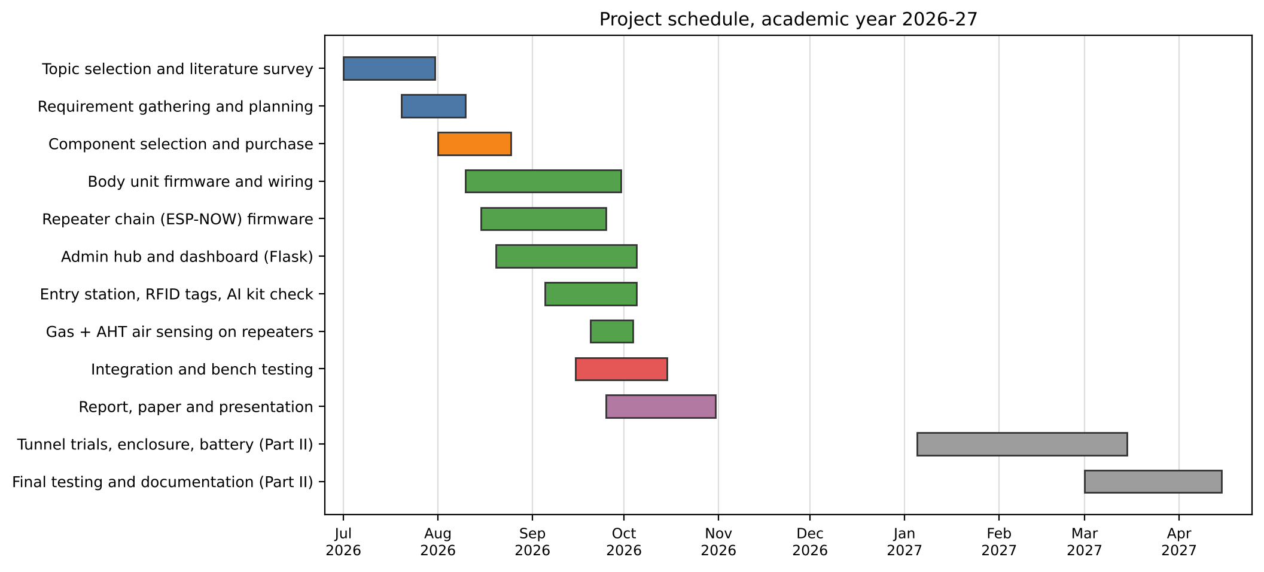
Figure 2: Gantt chart of the project
We used an iterative and incremental process model (Figure 3). Instead of building everything at once, we released the system in three versions. Version 1 had only the body unit and the hub, with a phone acting as a test worker. Version 2 added the repeater chain, the tunnel map, the alarm path and the entry tags. Version 3 added the camera entry station with the AI kit check, the gas and air sensing on repeaters, and the medical card. Each version went through planning, design, building, testing and review, and what we learned in the review went into the next version. This model suited us because hardware problems often showed up only during testing.
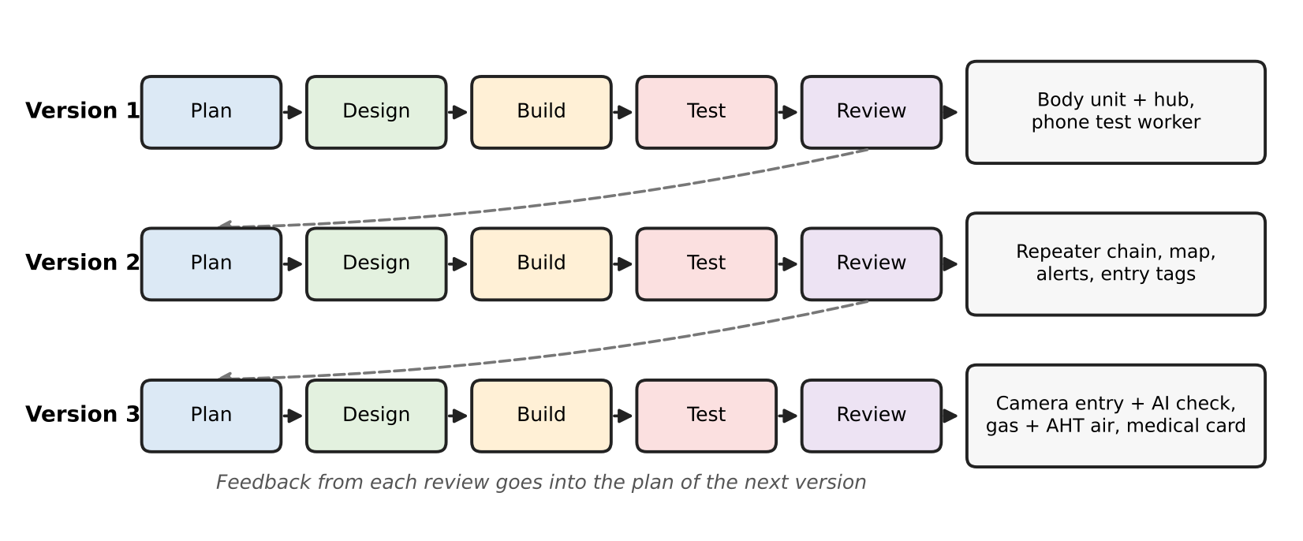
Figure 3: Iterative and incremental process model followed in the project
3.6 System Analysis (Functional, Structural, and Behavioral Models)
3.6.1 Functional model
The use case diagram in Figure 4 shows who uses the system and for what. The miner scans the gear, stands for the photo and can press SOS or "I am OK". The supervisor registers workers, approves entry, watches the dashboard and raises or clears alarms. The rescue team uses the live view to find the last known position and the medical card of a worker in trouble.
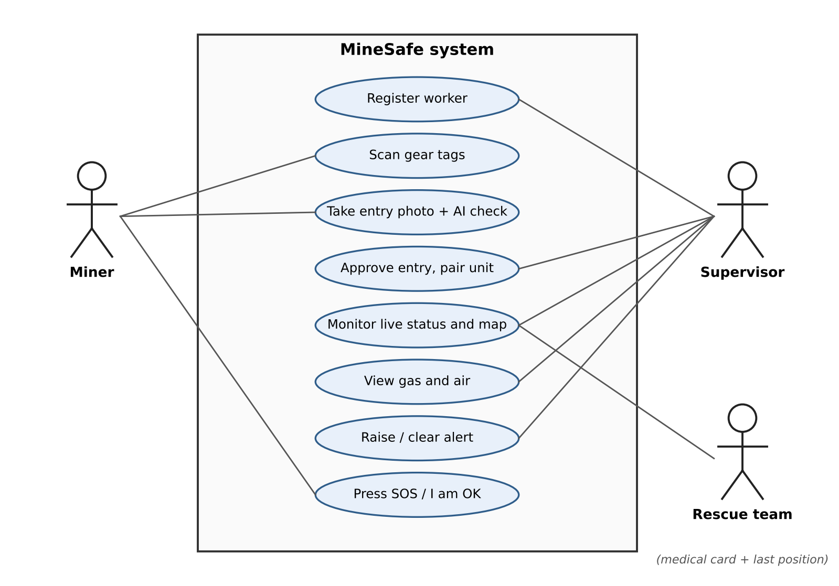
Figure 4: Use case diagram
The level 0 data flow diagram (Figure 5) treats the whole system as a single process and shows the data that flows to and from the outside: readings and SOS from the miner, tag UIDs and photos from the entry station, gas and air readings from the repeaters, and commands from the supervisor. Going back out are the alert LED to the miner, the tag results to the entry station, the alarm in beacons to the repeaters and the dashboard to the supervisor.
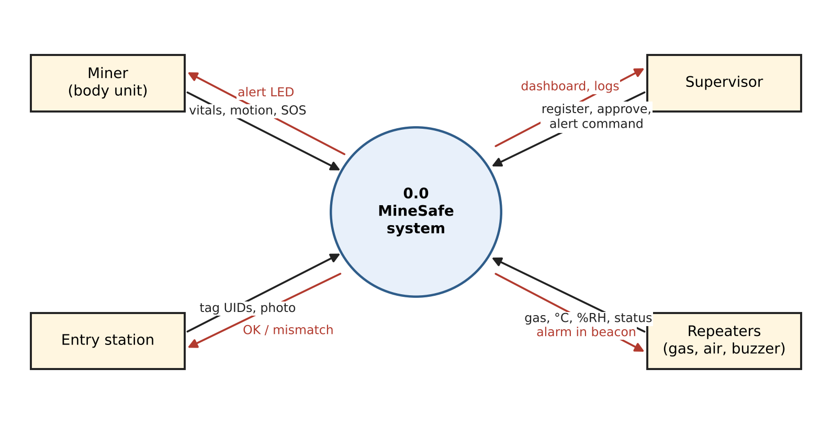
Figure 5: Data flow diagram, level 0
The level 1 DFD (Figure 6) breaks the system into six processes: entry verification, telemetry collection, status evaluation, position estimation, alarm management and the dashboard. It also shows the four data stores: worker records, the map with repeaters, the incident log and the tag registry.
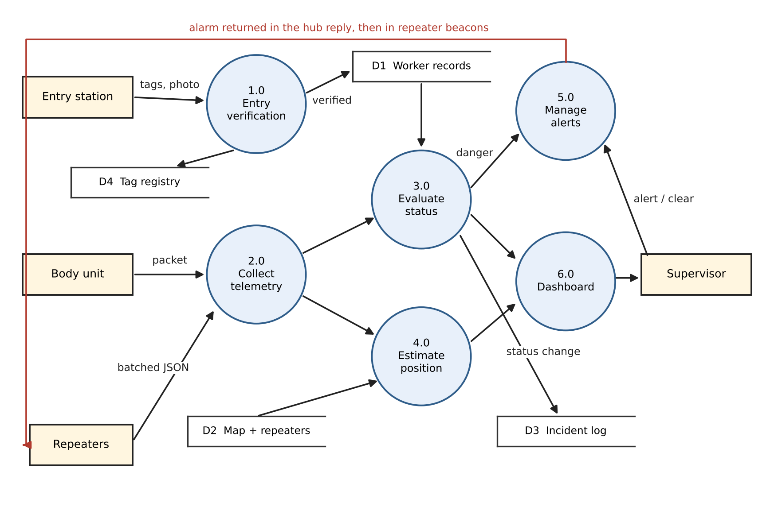
Figure 6: Data flow diagram, level 1
3.6.2 Structural model
Structurally, the system is made of three kinds of firmware and one server program. Each firmware is a single Arduino sketch made of small modules: sensor drivers, radio handling, local logic and serial diagnostics. The hub is one Python program with these main parts:
• Ingest: receives batches from the main repeater, checks each packet, counts losses and spots restarted units.
• Position engine: turns steps, heading and height into map coordinates and snaps them to tunnels.
• Evaluator: compares readings with the limits and decides SAFE, WARNING or DANGER.
• Gas and air module: converts sensor voltage to ppm and air readings to wet-bulb temperature.
• Entry module: checks tags against the registry and runs the YOLOv8 kit check.
• Alarm manager: stores the current alarm and counts confirmations.
• Storage and API: keeps workers, tags, map and settings in JSON files and serves the dashboard.
3.6.3 Behavioral model
Each worker moves between three states, shown in Figure 7. A move up to WARNING, or back down, must hold for 3 seconds before it is logged, so a reading sitting right on a limit does not flood the log. A move to DANGER, for example after a fall or an SOS press, is logged at once.
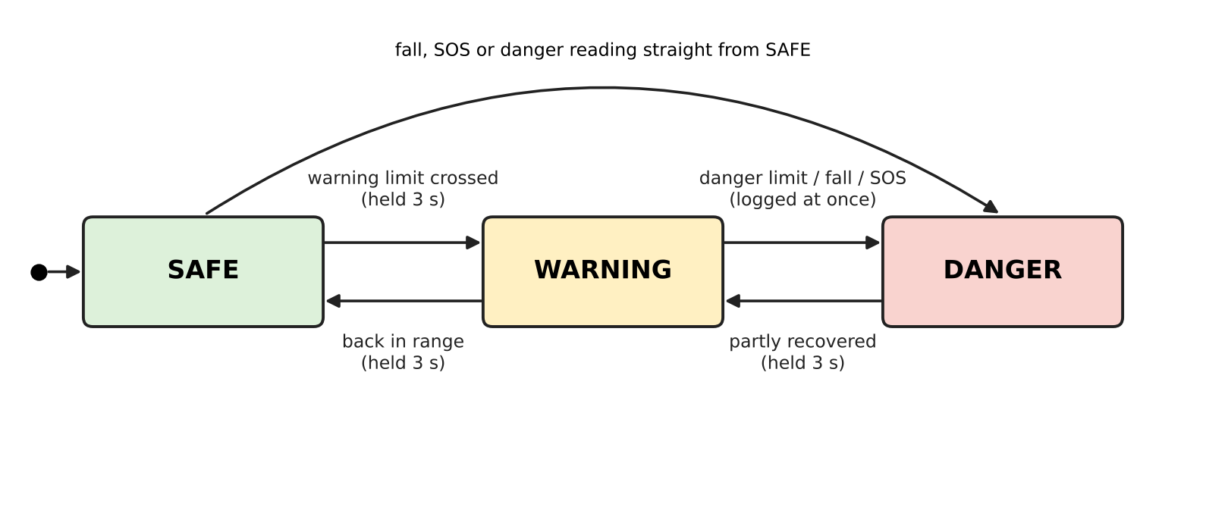
Figure 7: State diagram of a worker's status
The sequence diagram in Figure 8 shows what happens when the supervisor raises an alarm. The hub stores the alarm, the main repeater picks it up in the reply to its next post, and each repeater copies it into its beacon. The body unit lights its LED and reports this back in its next packet, and the dashboard counts the confirmations.
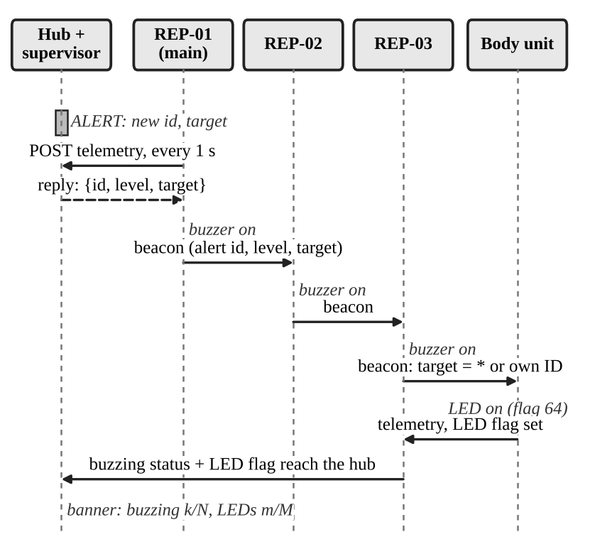
Figure 8: Sequence diagram of an alarm
Chapter 4
System Design and Experimental Set up
4.1 System Architecture & Diagrams (DFD/UML/ Block Diagram/Physical Layout)
Figure 9 shows the physical layout of the system. There are three layers. In the wearable layer, each miner carries a body unit. A body unit is not tied to any one repeater: it simply broadcasts, and whichever repeater is nearest picks up the packet. In the network layer, repeaters are placed along the tunnel. One of them, the main repeater (REP-01), also joins the surface Wi-Fi hotspot and posts everything to the hub once a second. In the surface layer, the laptop hub serves the dashboard and also receives tag scans and photos from the entry station.
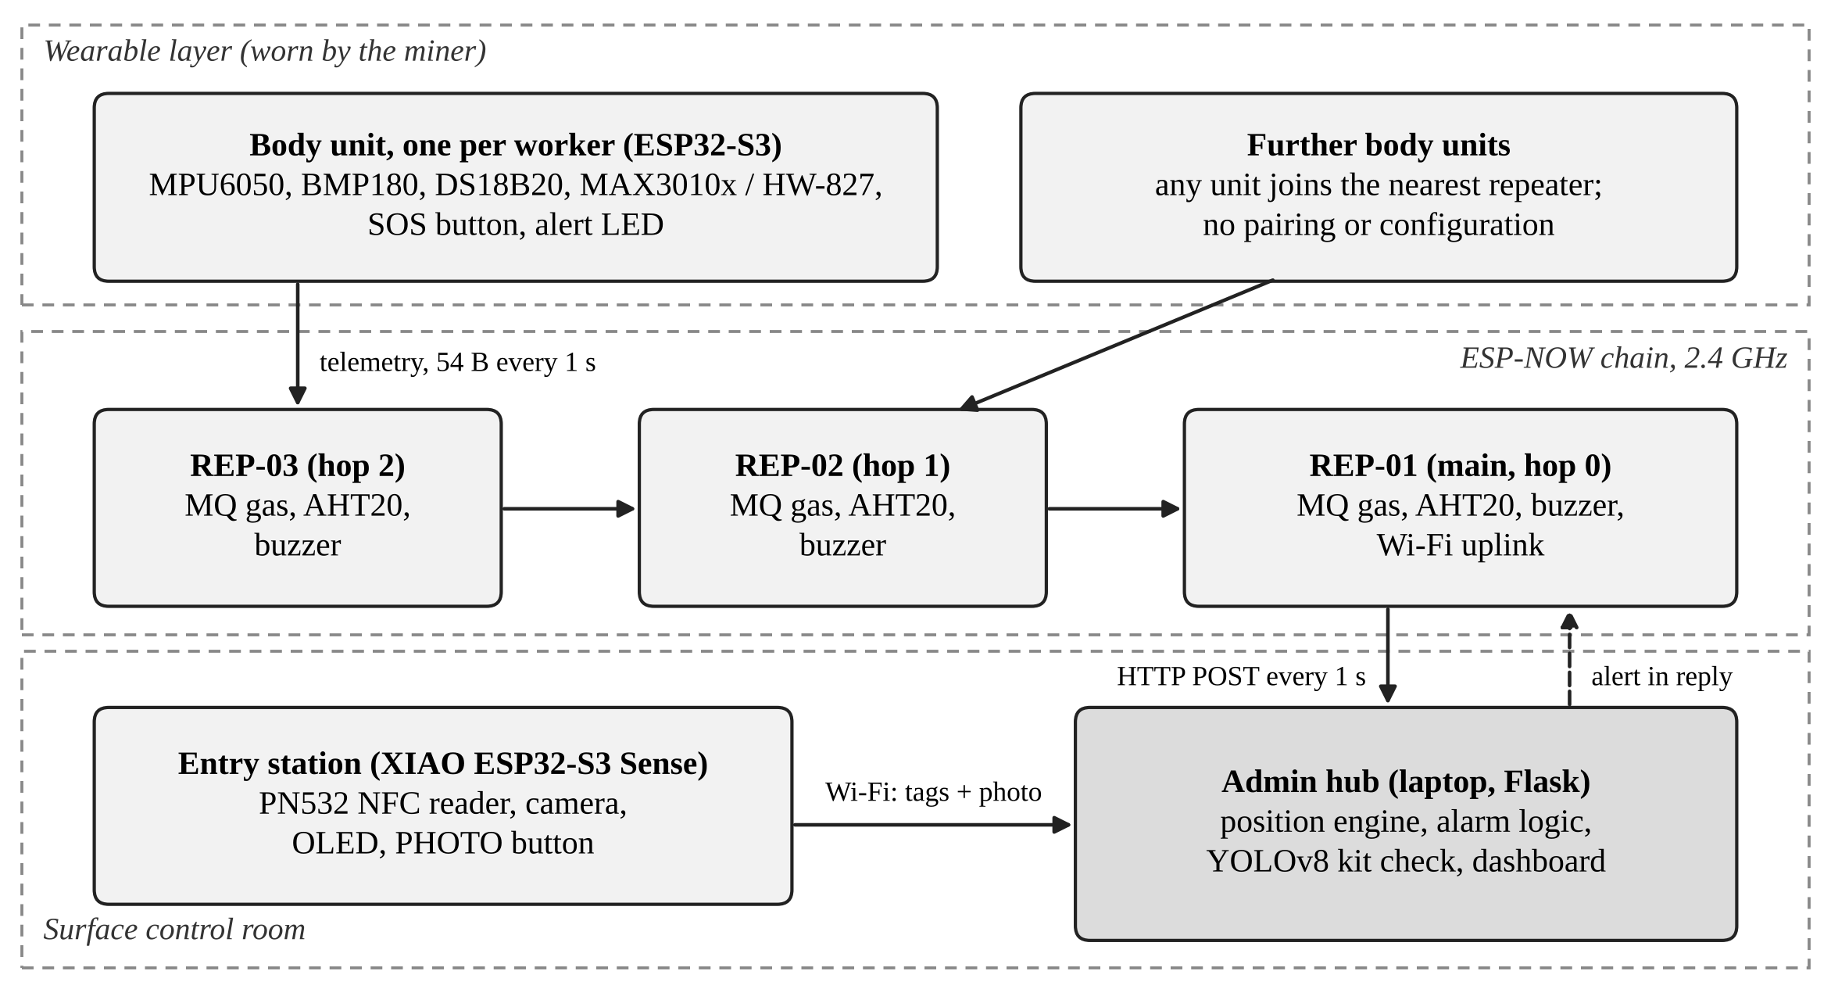
Figure 9: Physical architecture of MineSafe
Data moves both ways. Readings travel up the chain toward the main repeater. The hub's reply to each post carries the current alarm. Repeaters copy the alarm into their beacons, so it spreads down the chain, and every body unit that hears it turns on its LED. This means we did not need a separate downlink, which kept the firmware simple.
4.1.1 Body unit circuit
The body unit circuit is shown in Figure 10 and the pin connections in Table 9. The MPU6050, BMP180 and MAX30102 share one I2C bus on GPIO8 (SDA) and GPIO9 (SCL), each at its own address, so no multiplexer is needed. The DS18B20 uses 1-Wire on GPIO7 with a 4.7 kOhm pull-up resistor. The HW-827 analog pulse sensor is on GPIO4, which is an ADC1 pin. We had to learn this the hard way: ADC2 pins stop working while the radio is on. At one point we had both the LED and the pulse sensor on GPIO4, which we found during testing and fixed by moving the LED to GPIO6.
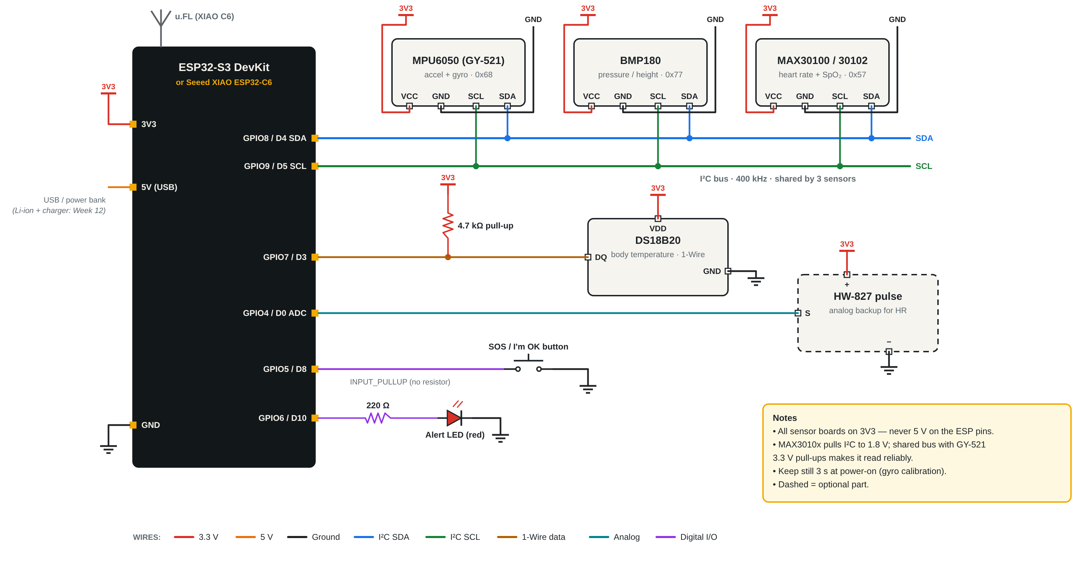
Figure 10: Circuit diagram of the body unit
Table 9: Body unit pin connections (ESP32-S3)
Part | Measures | Connection
MPU6050 | Acceleration and rotation, 100 Hz | SDA GPIO8, SCL GPIO9, address 0x68
BMP180 | Air pressure, temperature | Same I2C bus, address 0x77
MAX30100/02 | Red and IR reflection | Same I2C bus, address 0x57
DS18B20 | Skin temperature | GPIO7, 4.7 kOhm to 3V3
HW-827 | Analog pulse | Signal to GPIO4 (ADC1)
SOS button | Press | GPIO5 to GND, internal pull-up
Red LED | Shows alarm | GPIO6 through 220 Ohm

4.1.2 Repeater circuit
Repeaters use the Seeed XIAO ESP32-C6 (Figure 11). The MQ gas module runs on 5 V, so its analog output goes through a 10 kOhm / 20 kOhm divider before reaching the 3.3 V ADC pin D2. The firmware multiplies the reading by 1.5 to get the real sensor voltage. The AHT20 sits on the I2C pins D4 (SDA) and D5 (SCL), and the buzzer is on D10. We put the gas and air sensors on the repeaters instead of on the worker on purpose. The MQ heater draws about 150 mA and gets hot, which suits a fixed box on a power bank much better than a chest-worn unit.
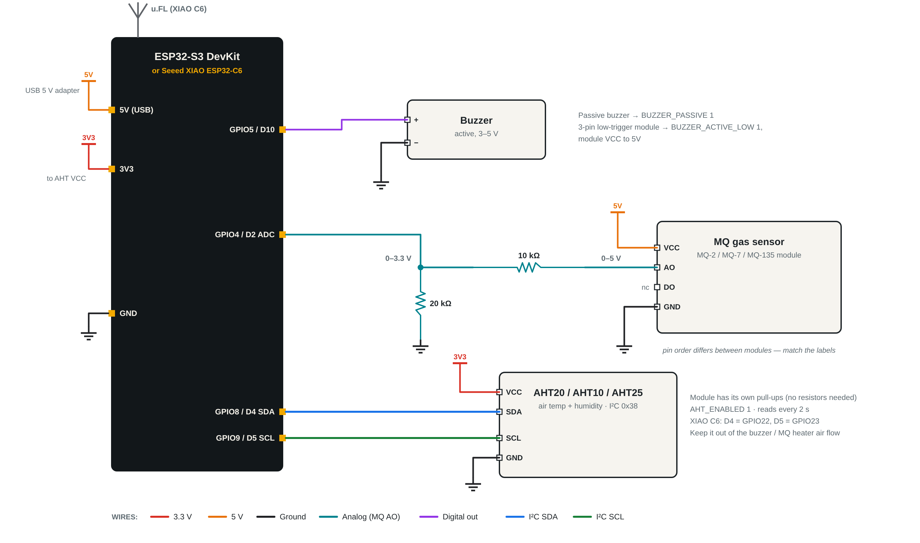
Figure 11: Circuit diagram of a repeater node
4.1.3 Entry station circuit
The entry station (Figure 12) uses the XIAO ESP32-S3 Sense, which comes with an OV2640 camera on its expansion board. The PN532 NFC reader and the SSD1306 OLED share one I2C bus. Three buttons select WRITE (store the item name on a new tag), READ (check tags at the gate) and PHOTO (take a photo after a three-second countdown and send it to the hub with the tags read so far).
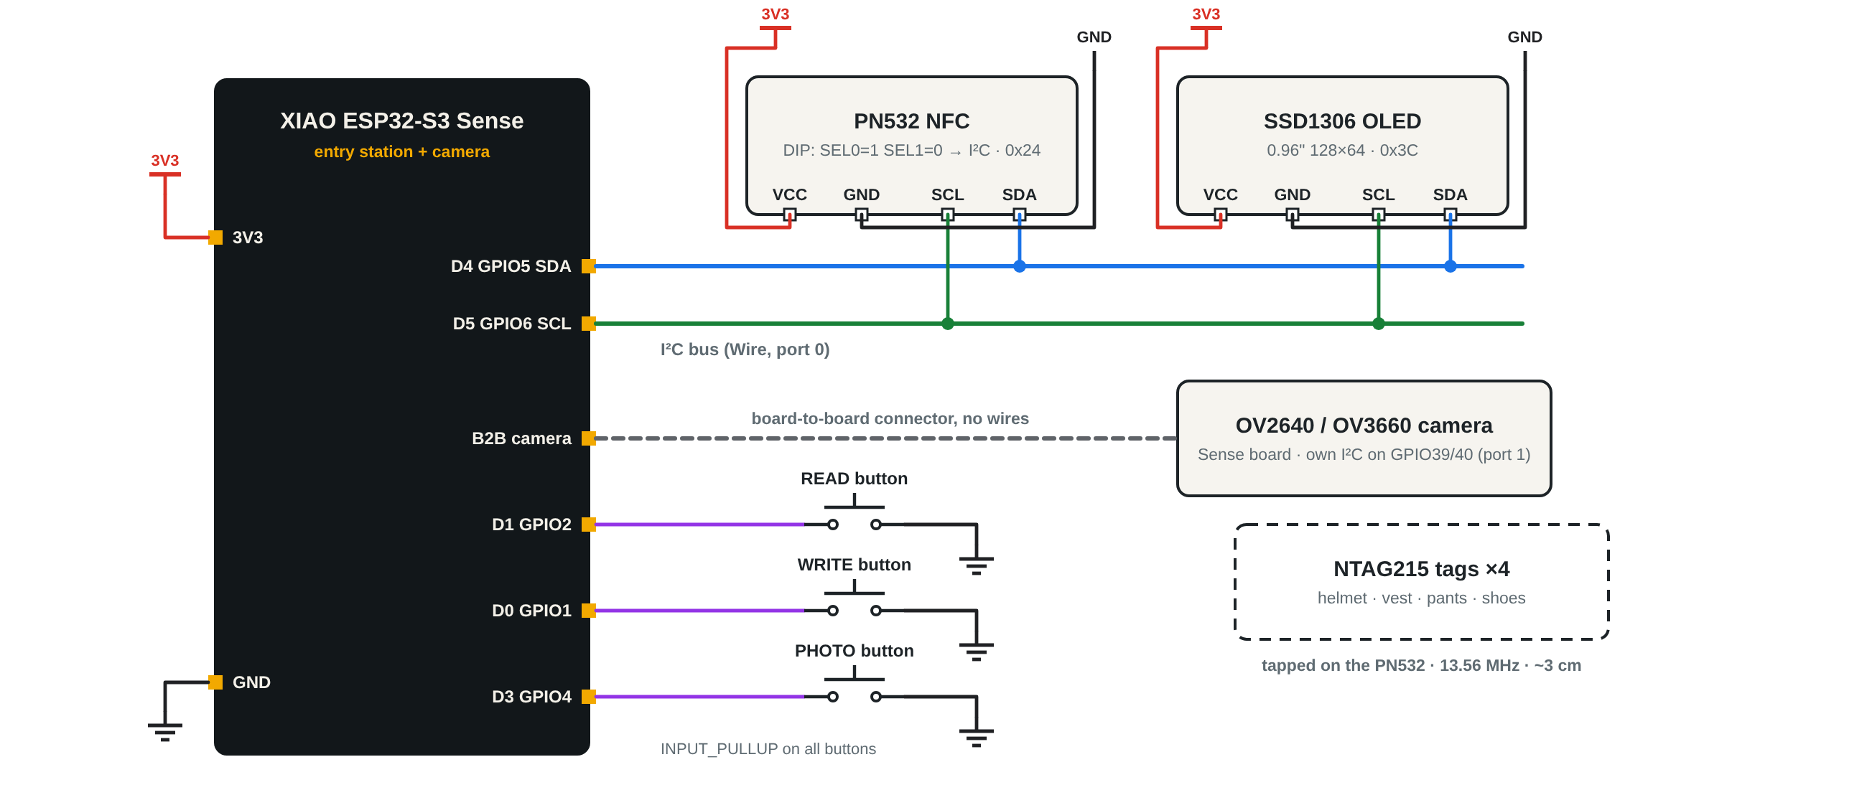
Figure 12: Circuit diagram of the entry station
Table 10: Repeater and entry station connections
Unit | Part | Connection
Repeater (XIAO C6) | Buzzer | D10
 | MQ gas sensor AO | 10k / 20k divider to D2
 | AHT20 | SDA D4, SCL D5, 3V3, GND
Entry (XIAO S3 Sense) | PN532 + OLED | Shared I2C bus
 | Camera OV2640 | Board-to-board connector
 | READ / WRITE / PHOTO buttons | Digital inputs with pull-ups

4.2 Algorithm & Process flow design (Flowchart/Pseudo Code)
4.2.1 Fall and no-movement detection
The body unit reads the MPU6050 every 10 ms and works out the size of the acceleration vector:
|a| = sqrt(ax^2 + ay^2 + az^2)
If |a| stays below 0.4 g for more than 80 ms, we call it a free fall. If it goes above 3 g, we call it an impact. Two seconds later we check the tilt from the upright direction learned at power-on. If the tilt is more than 55 degrees, the worker is taken to be lying down and the FALL flag is set. The pseudo code is:
every 10 ms:
read accel (ax, ay, az) in g
mag = sqrt(ax*ax + ay*ay + az*az)
if mag < 0.4 for more than 80 ms: event = FREE_FALL, t_event = now
if mag > 3.0: event = IMPACT, t_event = now, set IMPACT flag
if event and now - t_event >= 2 s:
tilt = angle between gravity now and upright at start
if tilt > 55 deg: set FALL flag
event = none
if FALL and (upright and moving for 3 s, and 15 s since fall)
or button pressed: clear FALL
if no motion for 30 s: set NO_MOVEMENT flag

The 30-second no-movement time is a demo value. In a real mine it would be longer. The button doubles as an "I am OK" cancel, so a worker who drops the unit can clear a false alarm.
4.2.2 Step counting and position
Integrating acceleration twice to get position does not work with a cheap sensor. A tiny bias of 0.01 g grows as e = 0.5 b t^2, which is about 176 m of error after only one minute. So we count steps instead. A step is counted when a fast-filtered |a| rises 0.11 g above a slow baseline, at most once every 280 ms. Heading comes from integrating the gyroscope rotation about the gravity direction, so the unit can be worn in any orientation. For each step, the hub moves the worker by the step length L in the direction of heading theta:
x(k) = x(k-1) + L sin(theta), y(k) = y(k-1) + L cos(theta)
Height comes from the BMP180 pressure p, compared with the pressure p0 at start:
h = 44330 [1 - (p / p0)^0.1903]
Two corrections stop the error from growing. First, the position is snapped to the tunnel that best matches both the location and the walking direction, and the tunnel direction slowly corrects the gyro heading. Second, when a body unit hears a repeater stronger than -55 dBm, the worker must be within a few metres of it, so the position is reset to that repeater. The dashboard draws a circle around each dot that grows with the distance walked since the last check-point.
4.2.3 Repeater chain building
every 1 s (+ random 0-200 ms):
broadcast beacon {my number, my hops, channel, alarm id, level, target}

on beacon from neighbour n:
if rssi(n) < -92 dBm: ignore
table[n] = {hops, rssi, time = now}
drop neighbours not heard for 6 s
parent = neighbour with fewest hops (best rssi on a tie)
my hops = parent.hops + 1 (main repeater is always 0)
if beacon alarm id > my alarm id: copy alarm, set buzzer

if nothing heard for 8 s:
scan channels 1..13, 1.3 s each, until a beacon is found

A packet from a body unit may be heard by more than one repeater. Each repeater forwards it only if it is closer to the main repeater than the node it came from, and keeps a short-lived hash of recent packets so the same packet is never sent twice.
4.2.4 Status evaluation
Every packet that reaches the hub is evaluated as shown in the flowchart in Figure 13, using the limits in Table 11. Any danger condition makes the worker DANGER. Otherwise, any warning condition makes the worker WARNING.
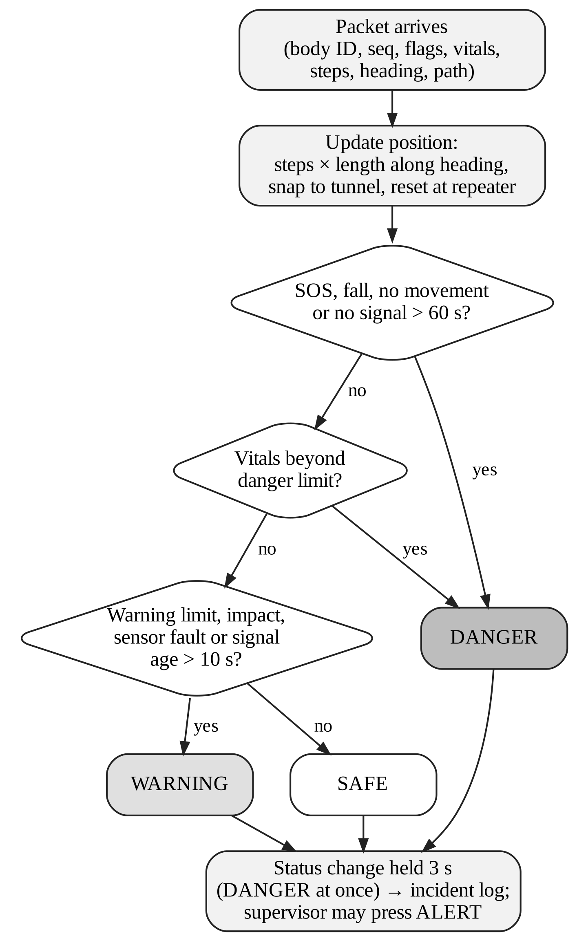
Figure 13: Flowchart of status evaluation on the hub
Table 11: Default warning and danger limits
Quantity | Warning | Danger
Body temperature | >= 38.0 C or <= 32.0 C | >= 39.5 C
Heart rate | < 50 or > 120 bpm | < 40 or > 150 bpm
SpO2 (estimate) | <= 92 % | <= 88 %
Motion | Impact > 3 g | Fall, or still for 30 s
Signal age | > 10 s | > 60 s
Wet-bulb temperature | >= 30.5 C | >= 33.5 C
Air temperature / humidity | >= 35 C / >= 90 % | >= 40 C
Gas (LPG / propane, MQ-2) | 1000 ppm | 2100 ppm

4.2.5 Gas and heat calculation
The MQ sensor resistance Rs is found from the measured voltage Vout, the supply Vc and the load resistor RL:
Rs = RL (Vc - Vout) / Vout
The clean-air value R0 is learned after the one-minute heater warm-up. The gas level then follows the datasheet curve ppm = a (Rs/R0)^b [13]. For example, for LPG on the MQ-2 we use a = 574.25 and b = -2.222. An MQ sensor reacts to several gases at once, so only the gases it is designed for can trigger the automatic alarm, and the others are shown as side readings. Each repeater also has its own safety net: if the voltage rises 1 V above its clean-air level, it beeps by itself even if the link to the surface is lost.
For heat, the AHT20 gives air temperature T and relative humidity RH [14]. The hub turns them into a wet-bulb temperature using Stull's formula [12]:
Tw = T atan[0.151977 (RH + 8.313659)^0.5] + atan(T + RH) - atan(RH - 1.676331) + 0.00391838 RH^1.5 atan(0.023101 RH) - 4.686035
Heat changes are logged and shown, but they do not sound the automatic alarm. Heat builds up slowly, and the supervisor is better placed to decide whether to improve ventilation or pull workers out.
4.2.6 Entry check flow
Figure 14 shows the gate procedure. The worker taps each tagged item on the reader. The hub looks up the tag's factory UID, not the text written on it, so a copied tag is rejected. When the photo arrives, the YOLOv8 pose model first finds the person and marks the head, body and feet areas. The PPE model then looks for helmets, vests and shoes. A detection only counts if it is in the right area; a helmet found at waist height is treated as carried, not worn. Helmet, vest and shoes must all be found for KIT COMPLETE. The confidence threshold is 0.30.
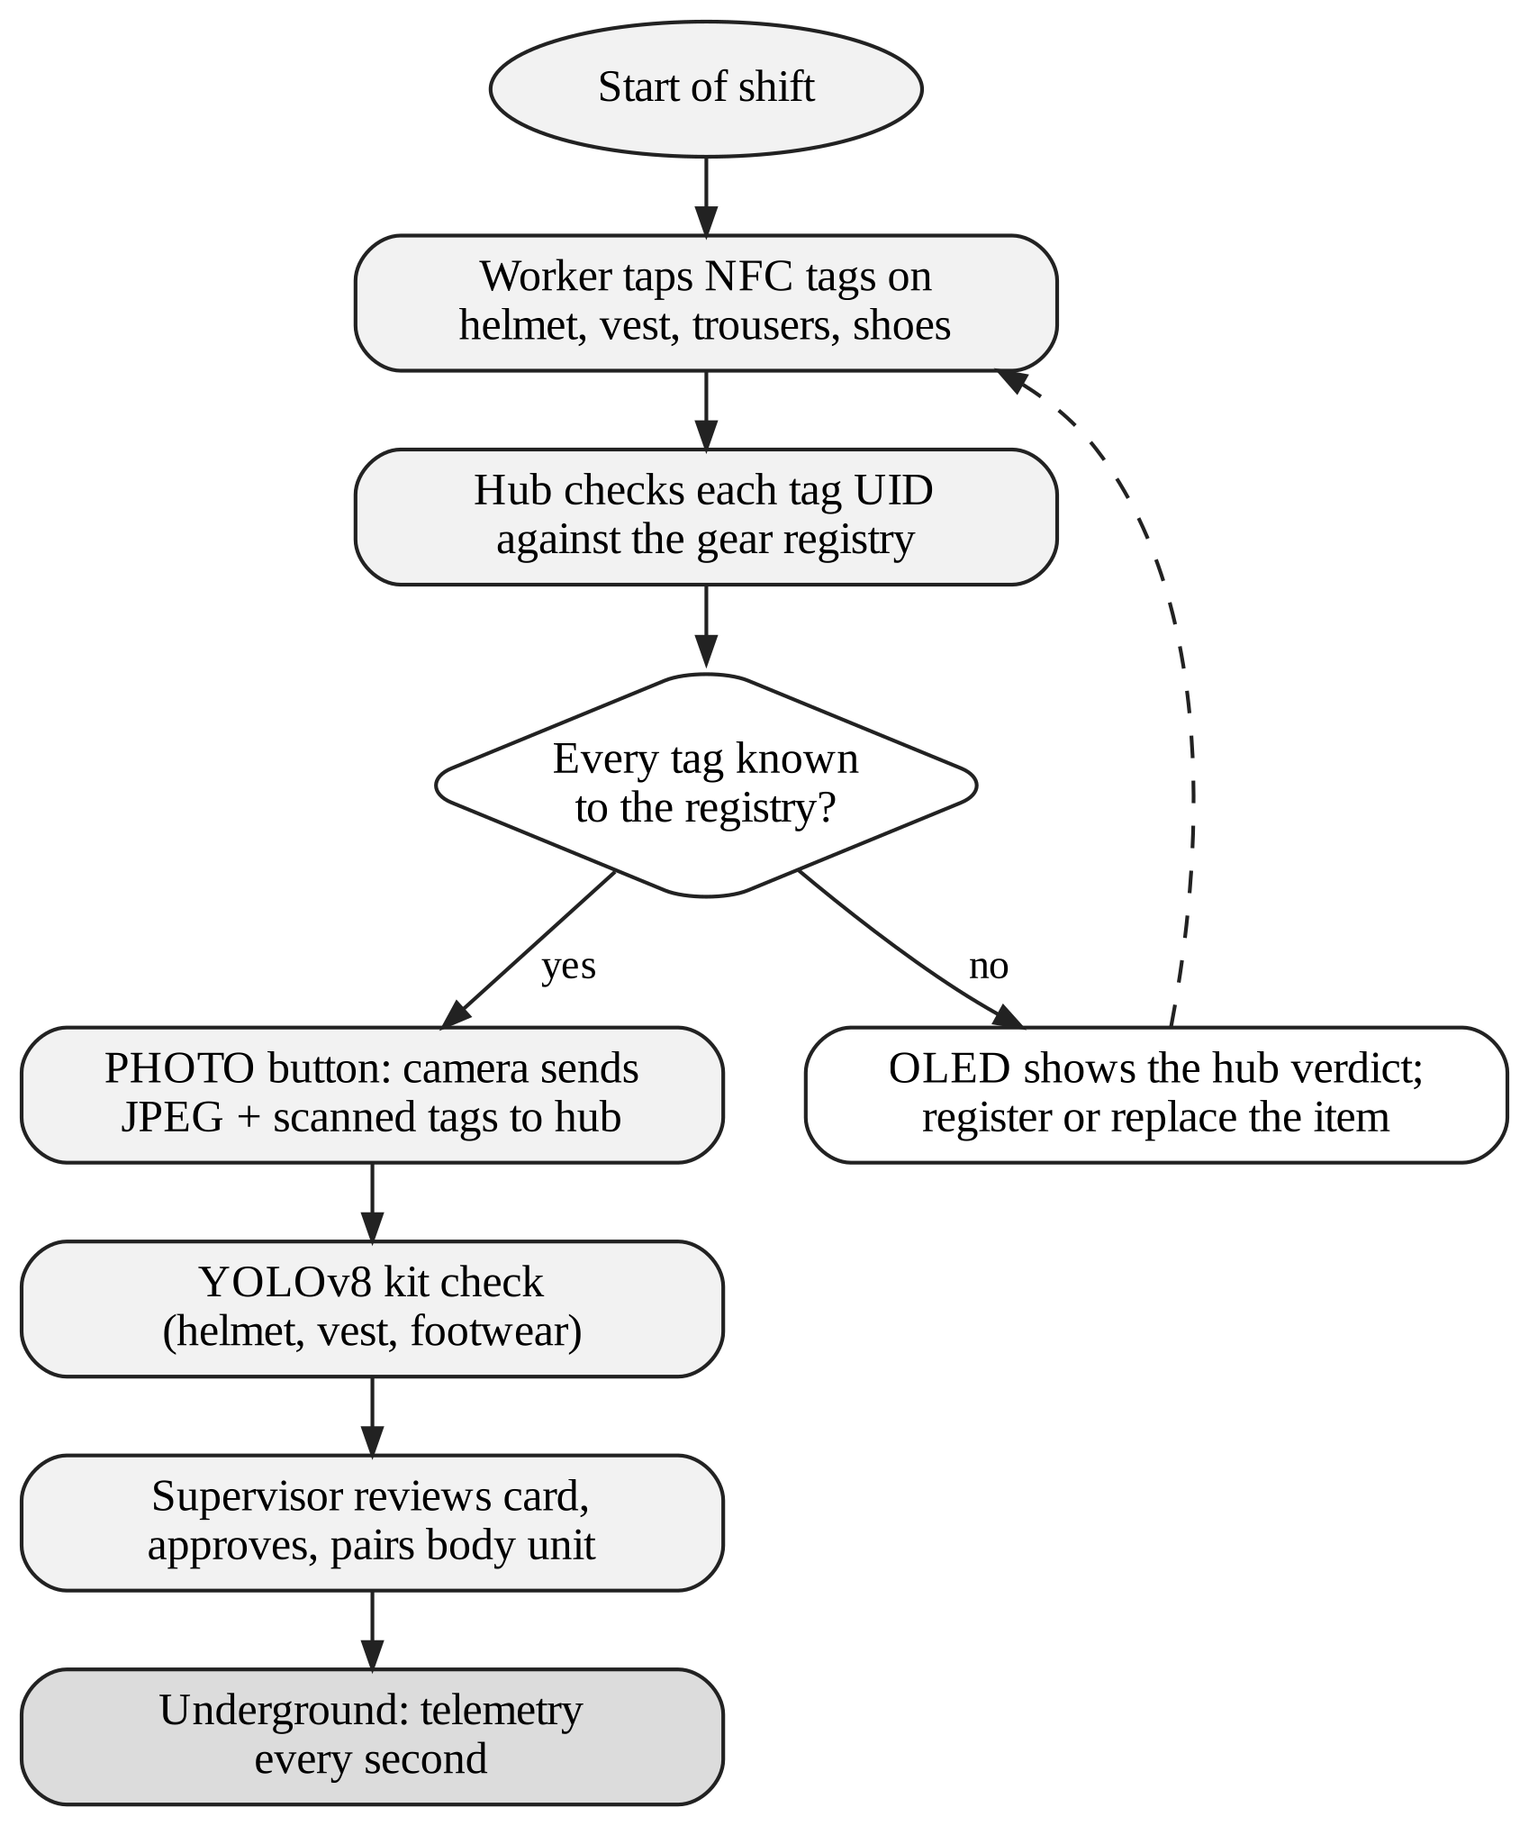
Figure 14: Flowchart of the entry check
4.3 User Interface & Input Data Design (Snapshots/ circuits/Structure)
4.3.1 Input data design
Each body unit sends one fixed 54-byte binary packet every second (Table 12). A fixed binary layout is much smaller than text and easy to check. The serial number lets the hub work out packet loss per worker, and the boot ID, chosen at random at each power-on, shows at once if a unit has restarted. The flag bits are listed in Table 13. The main repeater turns the packets into JSON before posting them to the hub.
Table 12: Structure of the body unit packet (54 bytes)
Field | Size | Meaning
magic, version, type | 4 B | "MS", version 3, packet type
node | 10 B | Body ID, for example BODY-01
boot, seq | 2 B + 4 B | Restart detection, packet loss
tObj, tAmb | 2 B x 2 | Body and air temperature (0.01 C)
ax, ay, az, gx, gy, gz | 2 B x 6 | Acceleration (mg) and rotation (0.1 deg/s)
flags | 2 B | Event and fault bits
uptime | 4 B | Seconds since power-on
nearRep, nearRssi | 1 B + 1 B | Strongest repeater heard
hum, steps | 2 B x 2 | Humidity, step count
head, alt | 2 B x 2 | Heading (0.1 deg), height (dm)
hr, spo2 | 1 B x 2 | Heart rate, SpO2 (0 = none)

Table 13: Flag bits in the body unit packet
Value | Name | Set when
1 | FALL | Free fall or impact, then lying > 55 deg
2 | NO MOVEMENT | Still for 30 s
4 | IMPACT | Acceleration above 3 g
8 | SOS | Button pressed (toggles)
16 | MOTION FAULT | MPU6050 not answering
32 | TEMP FAULT | No DS18B20 reading for 5 s
64 | ALERT LED | Control-room alarm shown on unit
128 | TEST | Packet from a phone test page

Table 14: Main hub interfaces (HTTP)
Endpoint | Sent by | Use
POST /api/telemetry | Main repeater | Packets and repeater status; reply carries the alarm
POST /api/gear | Entry station | Tag read / write, UID check
POST /api/camphoto | Entry station | Photo and tags for the kit check
POST /api/verify/<id> | Dashboard | Approve entry and pair unit
POST /api/workers | Dashboard | Register or edit a worker
POST /api/alert, /api/alert/clear | Dashboard | Raise or clear an alarm
POST /api/map, /api/gas | Dashboard | Map and gas sensor settings
GET /api/state | Dashboard | Full state, every second

4.3.2 Dashboard snapshots
The dashboard is a single web page that refreshes every second. It has tabs for Live, Register workers, Entry check, Kit check, Map, Gas and air, Network and Incident log, plus an ALERT button that is always visible. The snapshots below were taken during a test run with simulated workers. The names shown are made up.
Register workers (Figure 15). For each body unit the supervisor enters the worker's name, employee ID, blood group, work and zone, allergies, medical conditions, regular medicines, emergency contact, notes for rescuers and the worker's own step length.
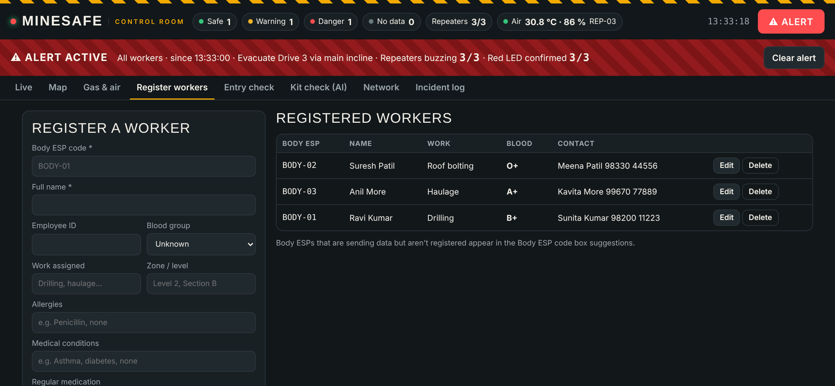
Figure 15: Register workers tab
Entry check (Figure 16). This tab shows the photo verifications waiting for approval, the body units already cleared and the list of tag events. In the snapshot, four issued tags were read as OK and one unknown tag was rejected.
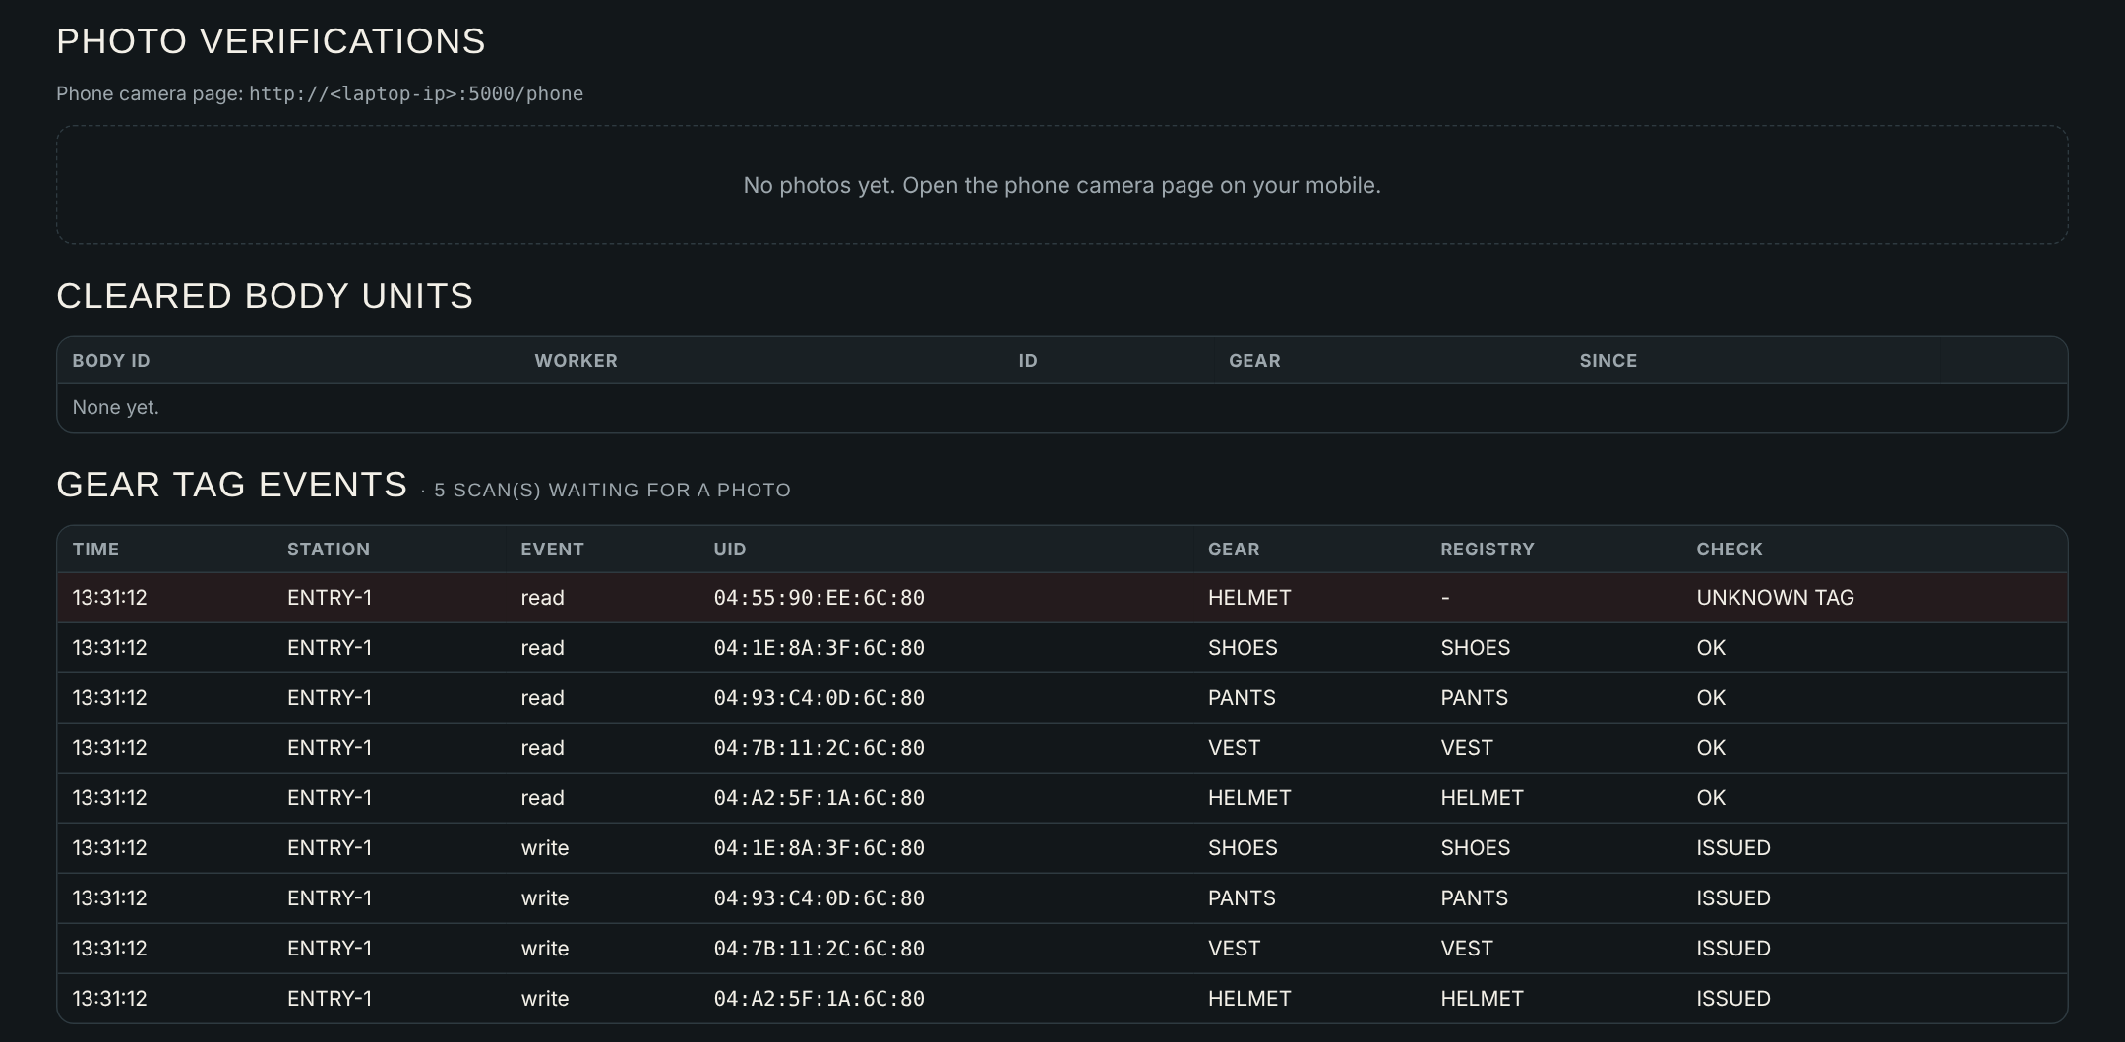
Figure 16: Entry check tab
Kit check (Figure 17). This shows the AI verdict on the gate photo with boxes drawn on the detected items.
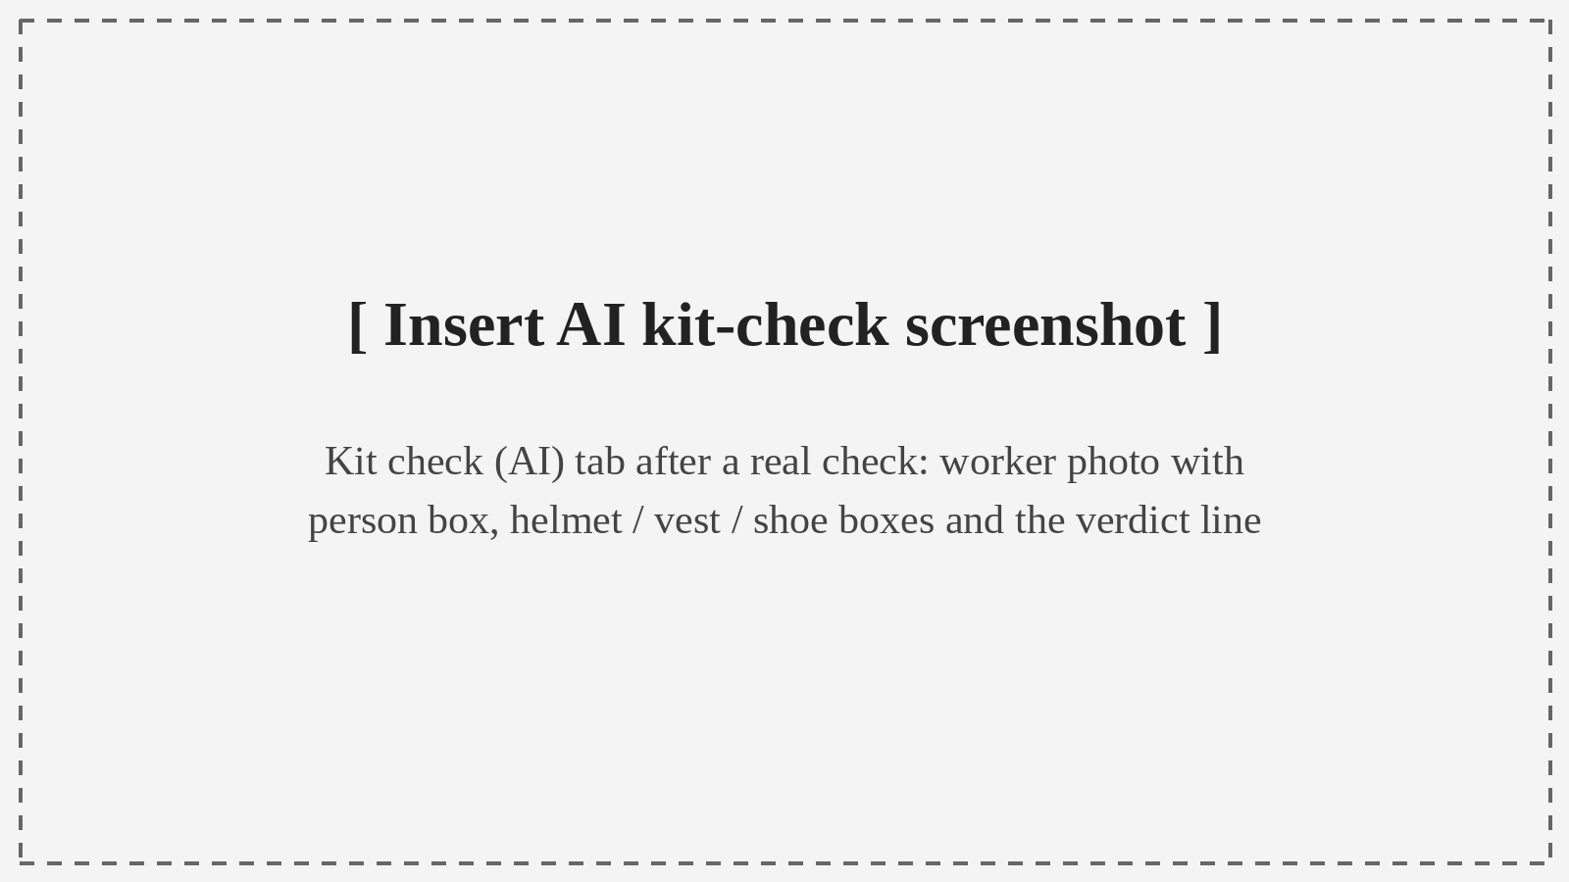
Figure 17: Kit check (AI) result [insert screenshot from a real check]
Live (Figure 18). There is one card per worker, with DANGER cards on top. Each card shows body temperature, heart rate, signal age, the reason for the current state, whether entry was verified, blood group, nearest repeater and distance from the hub. While an alarm is active, a banner at the top shows the message and the two confirmation counts.
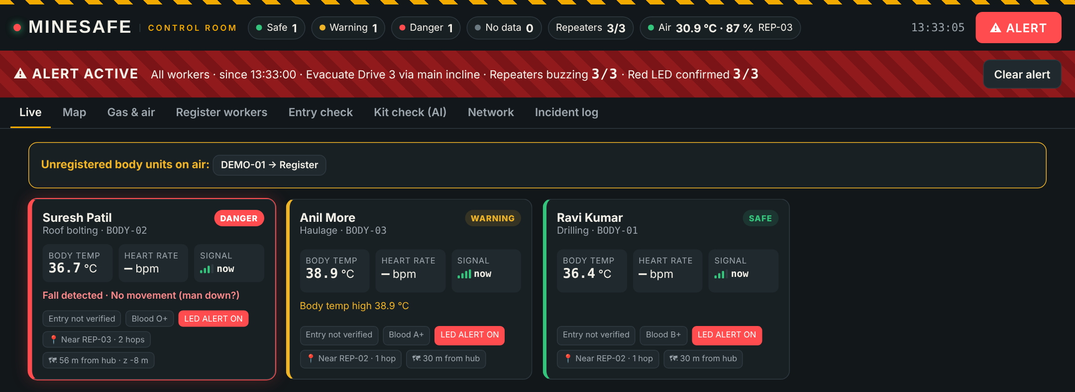
Figure 18: Live tab during an alarm
Map (Figure 19). The supervisor uploads a picture of the mine plan, marks the hub as (0, 0, 0), sets the scale, draws the tunnels and places the repeaters. Workers appear as coloured dots with a trail and an uncertainty circle.
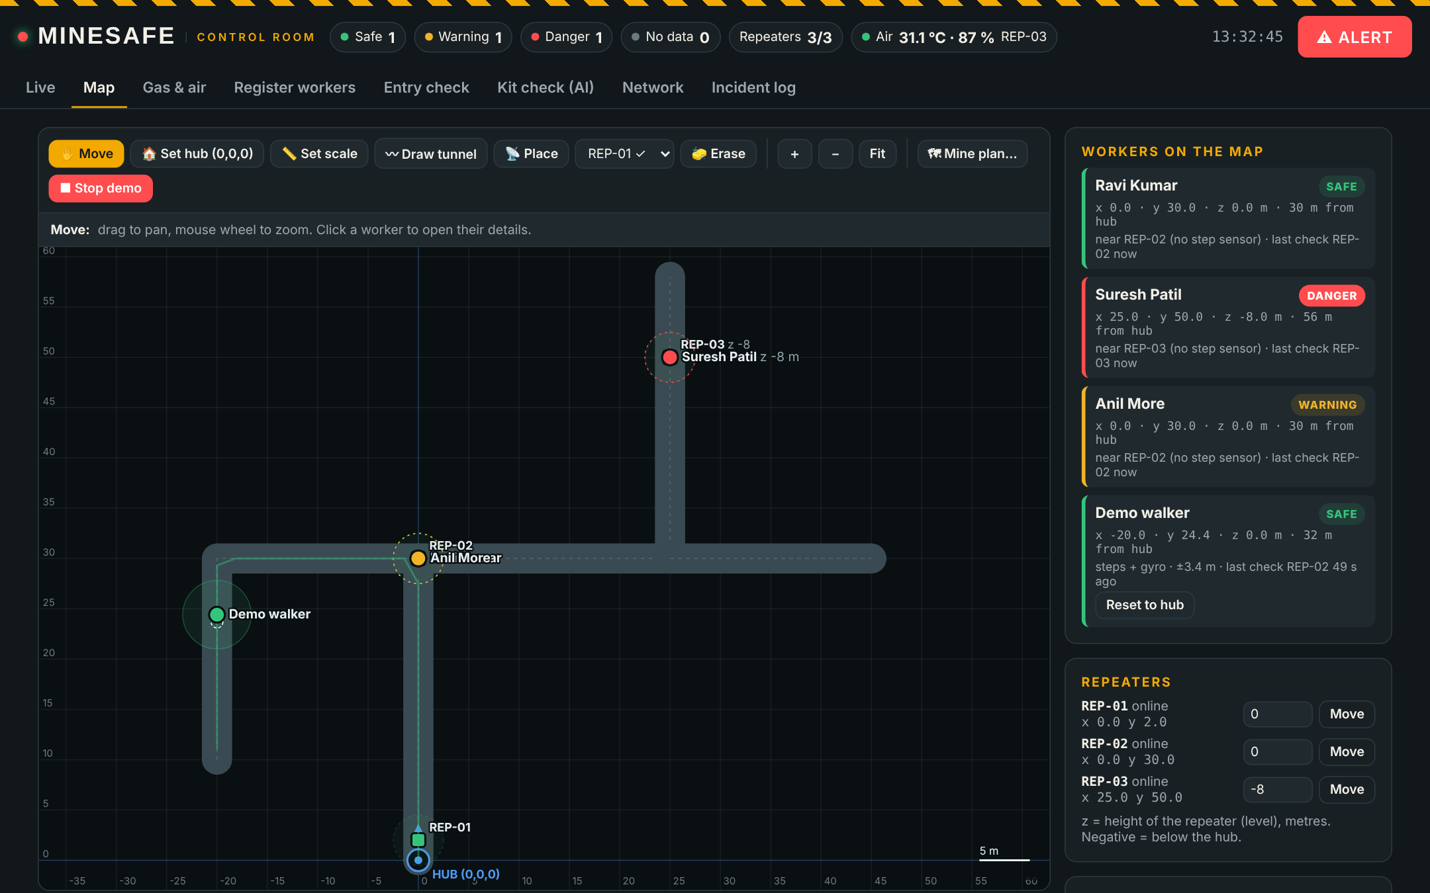
Figure 19: Map tab with tunnels, repeaters and workers
Gas and air (Figure 20). One card per repeater shows the estimated ppm of each gas, the raw voltage, Rs/R0 and a trend line, followed by an air panel with temperature, humidity and wet-bulb temperature.
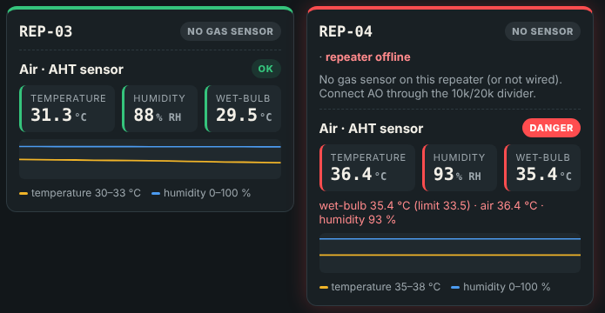
Figure 20: Air panels on the Gas and air tab
Network (Figure 21). This tab draws the repeater chain hop by hop with signal strength and air readings, and lists each body unit with its packet loss and full route to the hub, for example REP-03 to REP-02 to REP-01 to hub.
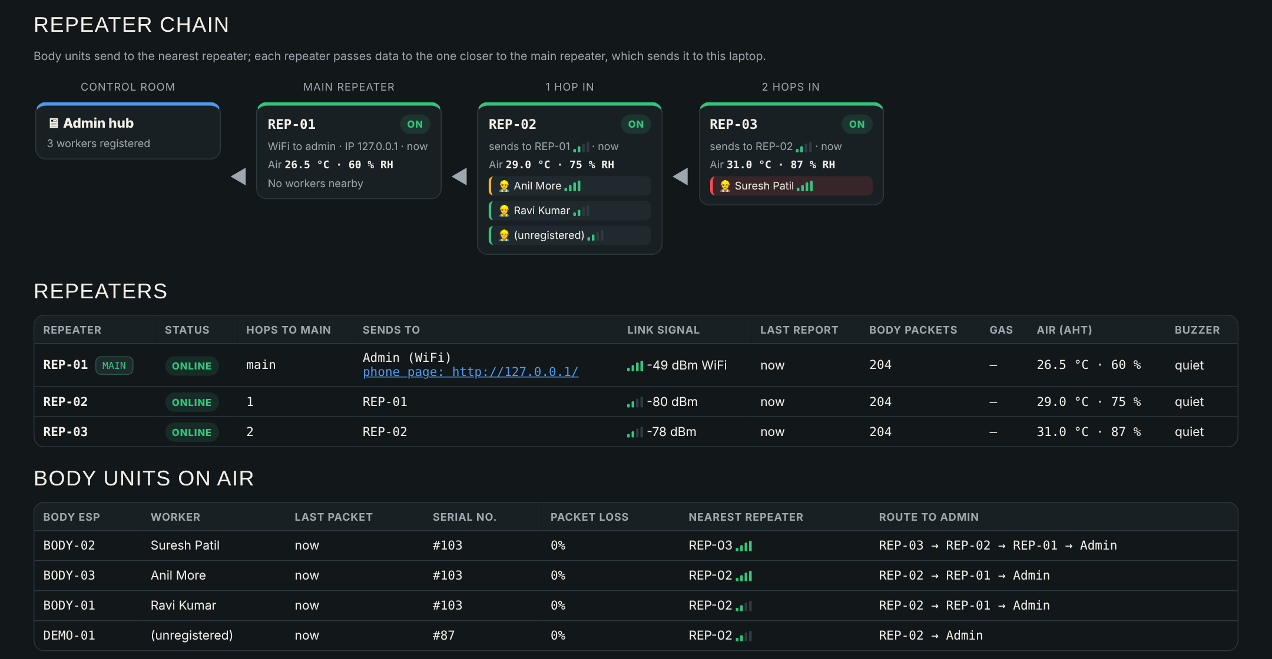
Figure 21: Network tab
Incident log (Figure 22). Every status change is recorded with its time and reason, along with every alarm sent or cleared.
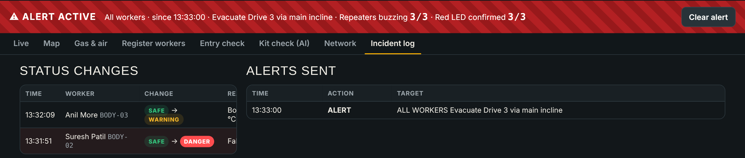
Figure 22: Incident log
4.4 Experimental Setup and Tools (Software & Hardware)
All testing in Part I was done on a lab bench. The set-up (Figure 23) had the following parts:
• A laptop running the hub, connected to a phone hotspot named for the project.
• REP-01 (main repeater) on the hotspot, with the MQ-2 sensor, AHT20 and buzzer, powered from USB.
• One or two tunnel repeaters placed a few metres away, also on USB power banks.
• BODY-01 on the ESP32-S3 with its sensors on a breadboard, plus a second test body unit (BODY-02) on an ESP32-C6 board with an MPU6050 and a pulse sensor.
• The entry station with the PN532 reader, OLED and camera, and five NTAG215 tags (four issued, one unknown).
• A phone opening the repeater's test page to act as an extra worker, with sliders for temperature, humidity and pulse and buttons for fall, SOS and walking.
• A simulator script on the laptop that stands in for a longer chain of three repeaters and three workers.
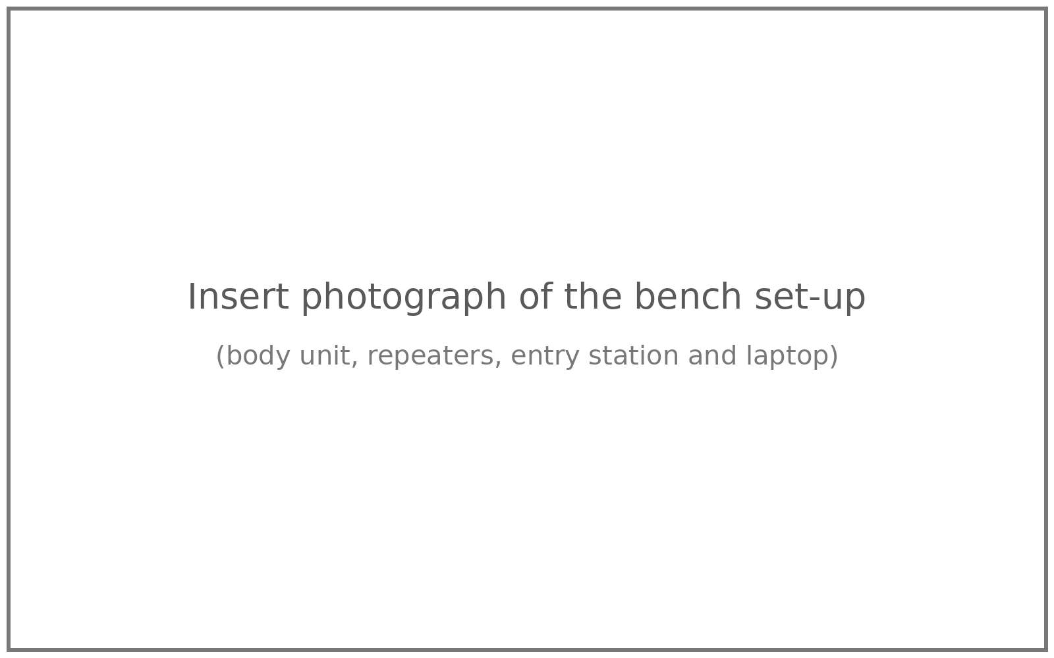
Figure 23: Experimental bench set-up [insert photograph]
Tools used: Arduino IDE with the ESP32 core 3.x and its serial monitor for firmware and debugging, a digital multimeter for checking supply and divider voltages, Python 3 with Flask and Ultralytics for the hub, a web browser for the dashboard, and Git with GitHub for sharing code between team members.
4.5 Implementation, Deployment and Testing
4.5.1 Implementation
We wrote all the sensor drivers ourselves inside the sketches instead of using libraries. This gave us control over timing and, more importantly, let the unit carry on when a sensor is missing or comes loose. A sensor that stops answering is reported once by name, is no longer polled, and is searched for again every 3 seconds after the I2C bus is restarted. Early on, a loose wire made the ESP32 core print hundreds of I2C error lines a second, which buried our own messages in the serial monitor. We fixed this by silencing the core's I2C log and adding our own short status line every 5 seconds.
Another issue we hit was a blank serial monitor on the ESP32-C6 and S3 boards. The cause was the "USB CDC On Boot" setting in the Arduino IDE: it must be enabled when the cable is in the native USB socket and disabled when it is in the UART socket. We noted this in our wiring guide so others do not lose time on it.
4.5.2 Deployment
1. Start the phone hotspot and connect the laptop to it.
2. Run the hub program on the laptop and open the dashboard in a browser.
3. Flash each repeater with its number; set REP-01 as main. Place repeaters along the tunnel with the main one near the surface.
4. Write the gear tags at the entry station using WRITE mode and register them on the hub.
5. Register each worker and assign a body unit.
6. Upload the mine plan on the Map tab, set the scale, draw tunnels and place the repeaters.
7. At the start of the shift, each worker scans the gear, stands for the photo and is approved. The worker stands still for three seconds after switching on the body unit so the gyro can calibrate.
The Wi-Fi name, password and the laptop's address are kept in a separate secrets file that is not uploaded to the public GitHub repository. If the laptop's address changes, the main repeater and the entry station search the hotspot network and find the hub again by themselves.
4.5.3 Testing
Table 15: Test cases
No. | Test case | Expected result | Status
1 | Body unit packet reaches hub through REP-01 | Card appears on Live tab, values update every second | Pass
2 | Press ALERT on dashboard | Repeater buzzer on, body LED on | Pass
3 | Alarm to all with 3 repeaters, 3 workers (simulator) | Banner shows buzzing 3/3 and LED 3/3 | Pass
4 | Unplug MPU6050 and DS18B20 | Flags 0x30, card shows both faults, unit keeps running | Pass
5 | Scan 4 issued tags and 1 unknown tag | 4 x OK, 1 x UNKNOWN TAG | Pass
6 | Read AHT20 on REP-01 | Temperature and humidity on Gas and air tab | Pass
7 | Inject hot and humid air reading | Wet-bulb computed, DANGER logged | Pass
8 | Simulated walker on map | Dot follows tunnels, resets at repeaters | Pass
9 | Fall at deepest repeater (simulator) | DANGER card and incident log entry | Pass

4.6 Performance Evaluation.
In Part I we evaluated the system mainly on whether each function worked correctly and how quickly the system reacted on the bench. The timing settings that decide the speed of the network are listed in Table 16. With a beacon every second, an alarm needs about one second to reach the main repeater and about one more second per hop to reach the rest of the chain. In our bench runs with the simulator, all three repeaters and all three LEDs confirmed the alarm within a few seconds.
Table 16: Network timing and routing settings
Parameter | Value | Purpose
Body packet interval | 1 s | Data rate per worker
Beacon interval | 1 s + 0-200 ms jitter | Routing, channel and alarm
Main repeater post | 1 s | JSON batch to hub
Tunnel status report | 5 s or on event | Repeater health, gas, air
Neighbour lifetime | 6 s | Drop silent neighbours
Lost-link timeout | 8 s | Start channel search
Weakest usable link | -92 dBm | Ignore poor parents
Check-point threshold | -55 dBm | Position reset at repeater
Hop limit / buffer | 15 hops / 30 packets | Avoid loops and memory overflow

On the bench, the body unit's signal at REP-01 was between -39 and -67 dBm, which is far above the -92 dBm limit. The log showed consecutive packet numbers, meaning no packets were lost over those runs. Range in rock, real alarm delay, position error over a known walk and the accuracy of the AI kit check could not be measured in the lab. These are the main measurements planned for Part II.
4.7 Summary
This chapter described the physical architecture of MineSafe, the circuits of the body unit, repeater and entry station, and the main algorithms for falls, steps, position, chain building, status, gas and heat. It also covered the packet and API design, the dashboard screens, the bench set-up and the tests carried out. All planned functions worked on the bench. Field measurements remain to be done.
Chapter 5
Results & Discussion
5.1 Outputs & Outcomes
The main outcome of Part I is a working prototype in which all four blocks talk to each other. Figure 24 is a screenshot from a bench session with real hardware. At that moment we had unplugged the body unit's sensors for rewiring, and the hub correctly showed both the motion sensor and the temperature sensor as not responding (flag value 0x30). The phone test worker on the same screen stayed SAFE.
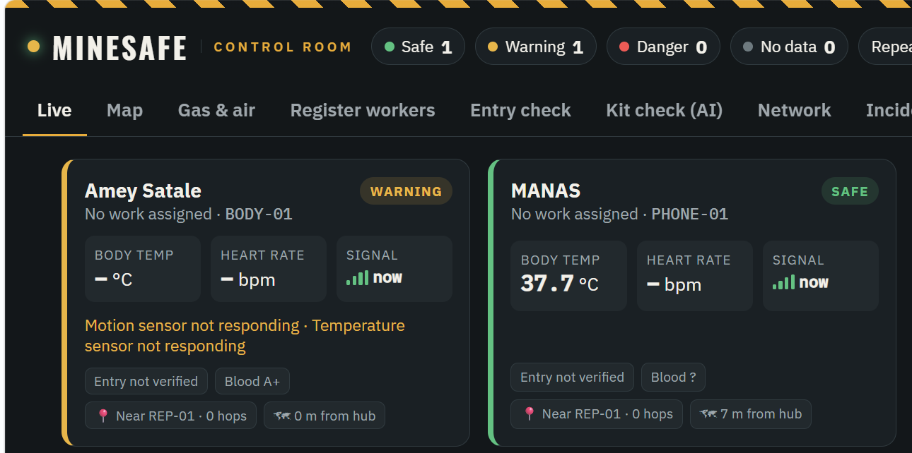
Figure 24: Live tab during a bench run with real hardware
The outputs we obtained were:
• Live worker cards with temperature, pulse, motion, signal and status, updated every second.
• Self-forming repeater chain with the route of each packet shown on the Network tab.
• Alarm from the dashboard reaching the repeater buzzer and the body unit LED, with confirmation counts.
• Gear tag check at the gate with OK, MISMATCH and UNKNOWN TAG results.
• Gas readings in ppm and air temperature, humidity and wet-bulb temperature for each repeater.
• Tunnel map with moving worker dots and uncertainty circles.
• Incident log of every status change and alarm.
5.2 Analysis of Results & Interpretation of data
Table 17 lists what we observed in each bench test.
Table 17: Bench test observations
Test | Set-up | Observation
Chain to hub | Body unit, phone worker, REP-01, laptop | Packets shown live; no gaps in sequence numbers
Link strength | Body unit near REP-01 | RSSI -39 to -67 dBm
Alarm return | ALERT from hub | Buzzer on, body LED on
Alarm confirmation | Simulated 3 repeaters, 3 workers | Buzzing 3/3, LED confirmed 3/3
Sensor fault | BODY-01 with sensors unplugged | Flags 0x30, both faults shown
Gate tags | 4 issued + 1 unknown tag | 4 x OK, 1 x UNKNOWN TAG
Air sensing | AHT20 on REP-01, lab | 31.3 C, 62 % RH
Heat logic | Simulated 36.4 C, 93 % RH | Wet-bulb 35.4 C, DANGER
Gas reading | MQ-2 on REP-01, clean air | Sensor output about 1836 mV, shown on Gas and air tab
Map tracking | Simulated walker + phone worker | Dots stay on tunnels, reset at repeaters
Range per hop | Tunnel trial | To be measured in Part II
Alarm delay | Hub to last LED, real hardware | To be measured in Part II
Position error | Walk of known length | To be measured in Part II
Kit-check accuracy | Labelled gate photos | To be measured in Part II

A few points stand out from these results. The signal levels show that, in open air, one hop can easily cover the bench distances, so the limit in a real mine will be the rock and the shape of the tunnel, not the radio itself. The AHT20 reading of 31.3 C and 62 % RH matched the conditions in the lab that afternoon, and the wet-bulb value for these numbers is about 25 C, which the hub correctly showed as SAFE. When we fed in 36.4 C and 93 % RH, the wet-bulb temperature came out at 35.4 C, above the 33.5 C danger limit, and the hub marked that location as DANGER. This shows why humidity matters: the dry temperature alone would only have given a warning.
The fault test was useful. Because each driver checks its own sensor, the body unit kept sending packets and the dashboard named the exact sensor that had failed. In a mine, this tells the supervisor that a worker's unit needs attention, instead of quietly showing a normal temperature that is actually stale.
5.3 Discussion of Results & Limitations of the System
The bench results show that the parts of MineSafe work together as designed: kit check, live monitoring, tracking, gas and air sensing, and a two-way alarm with confirmation, all running offline on one laptop. Putting gas and air sensing on the repeaters kept the body unit light, and carrying the alarm inside the routing beacons meant we did not need a separate downlink.
There are also clear limits that we want to state honestly:
• Radio range at 2.4 GHz in rock and coal is short and depends on the tunnel shape, so repeater spacing has to be found by trial.
• The fall and no-movement limits were set on the bench and have not been tested on many people.
• The SpO2 value is an uncalibrated estimate and must not be treated as a medical reading.
• MQ sensors react to more than one gas and drift with temperature and humidity, so the ppm values are only indicative.
• The hub is a single laptop, which is a single point of failure.
• The kit is checked only at the gate; the system does not yet know if a helmet is taken off underground.
• None of the hardware is certified for explosive atmospheres. A real gassy mine would need intrinsically safe enclosures and approvals.
Chapter 6
Conclusion & Future Scope
6.1 Summary of work completed
In Part I we designed, built and tested MineSafe, an integrated worker safety and health monitoring system for mining operations. The entry station checks four tagged kit items and takes a photo for an AI kit check. The body unit measures motion, skin temperature, pulse and pressure and detects falls, no movement and SOS presses on its own. The repeaters form a chain by themselves over ESP-NOW and also measure gas, air temperature and humidity. The Flask hub tracks workers on a tunnel map without GPS, classifies their status, keeps their medical cards and sends alarms back to every buzzer and LED with confirmation.
The whole demo kit costs about Rs. 8,100 excluding the laptop, needs no internet or cabling, and can be set up by giving each repeater a number. Our bench tests confirmed that all the pieces work together. What they do not yet show is how well the system works underground, which is the focus of Part II.
6.2 Future Scope
• Field trials in a real or mock tunnel to measure range per hop, alarm delay and position error over known distances.
• Kit-check accuracy measured on a labelled set of gate photos, and the model fine-tuned on photos of our own kit.
• Enclosure and battery for the body unit, with a proper strap and a charging dock.
• Kit-removal detection underground, using the low-cost sensors in Table 18. A new KIT-OFF flag would show WARNING and turn into DANGER with the buzzer if the item is not put back within 60 seconds.
• Better gas sensing with methane-specific and electrochemical CO sensors.
• Short text messages to workers on a small display, such as an evacuation route.
• Shift reports and heat-stress trends for management and DGMS records.
• Long-range tracking network for deeper and longer workings, with UWB anchors at key junctions where a tighter position is needed.
Table 18: Proposed sensors to detect kit removed underground
Kit item | How it is sensed | Added part (approx. Rs.)
Helmet | IR proximity sensor sees the head, or chin-strap micro switch | TCRT5000 / VL53L0X (40-300)
Vest | Reed switch in the buckle; open means vest off | Reed switch + magnet (30)
Shoes, gloves | BLE tag in each item; signal lost means item left behind | BLE tag (300 each)
All kit | Kit check repeated by cameras at junctions | ESP32-CAM (600)

References
[1] “226 deaths reported in coal and lignite mines across India in last five years: Minister,” ETV Bharat, Mar. 17, 2025. [Online]. Available: https://www.etvbharat.com/en/!bharat/parliament-coal-and-mines-deaths-lignite-rajya-sabha-enn25031704125
[2] U.S. Mine Safety and Health Administration, “Communications and tracking in underground mines.” [Online]. Available: https://www.msha.gov/compliance-and-enforcement/equipment-approval-certification/communications-and-tracking-underground-mines
[3] L. K. Bandopadhyay, S. K. Chaulya, and P. K. Mishra, “Wireless information and safety system for mines,” J. Sci. Ind. Res., vol. 68, no. 2, pp. 107–117, Feb. 2009.
[4] E. Clausen, T. Hartmann, A. E. Kianfar, and M. Ziegler, “Development and evaluation of a UWB-based indoor positioning system for underground mine environments,” Mining, Metall. Explor., 2024, doi: 10.1007/s42461-023-00797-z.
[5] B. Kartik, “IoT-based smart helmet for hazard detection in mining industry,” arXiv:2304.10156, 2023.
[6] J. Redmon, S. Divvala, R. Girshick, and A. Farhadi, “You only look once: Unified, real-time object detection,” in Proc. IEEE Conf. Comput. Vis. Pattern Recognit. (CVPR), 2016, pp. 779–788.
[7] M. Ferdous and S. M. M. Ahsan, “PPE detector: A YOLO-based architecture to detect personal protective equipment (PPE) for construction sites,” PeerJ Comput. Sci., vol. 8, Art. no. e999, 2022, doi: 10.7717/peerj-cs.999.
[8] G. Jocher, A. Chaurasia, and J. Qiu, “Ultralytics YOLOv8,” 2023. [Online]. Available: https://github.com/ultralytics/ultralytics
[9] E. Foxlin, “Pedestrian tracking with shoe-mounted inertial sensors,” IEEE Comput. Graph. Appl., vol. 25, no. 6, pp. 38–46, Nov./Dec. 2005.
[10] H. Weinberg, “Using the ADXL202 in pedometer and personal navigation applications,” Analog Devices, Norwood, MA, USA, Appl. Note AN-602, 2002.
[11] Espressif Systems, “ESP-NOW,” ESP-IDF Programming Guide. [Online]. Available: https://docs.espressif.com/projects/esp-idf/en/latest/esp32/api-reference/network/esp_now.html
[12] R. Stull, “Wet-bulb temperature from relative humidity and air temperature,” J. Appl. Meteorol. Climatol., vol. 50, no. 11, pp. 2267–2269, Nov. 2011.
[13] Hanwei Electronics, “Technical data: MQ-2 gas sensor,” datasheet.
[14] Aosong Electronics, “AHT20 integrated temperature and humidity sensor,” datasheet.
[15] M. A. Moridi, Y. Kawamura, M. Sharifzadeh, E. K. Chanda, M. Wagner, H. Jang, and H. Okawa, “Development of underground mine monitoring and communication system integrated ZigBee and GIS,” Int. J. Min. Sci. Technol., vol. 25, no. 5, pp. 811–818, 2015.
Research Paper
The research paper prepared from this project, titled “Integrated Worker Safety and Health Monitoring System for Mining Operations”, by Manas Amit Pednekar, Amey Anant Satale, Aaryaa Rakesh Kanojia and Dipesh Tare, written in the IEEE conference format, is attached on the following pages.
Appendix A
Abbreviation and Symbols
1. ADC: Analog to Digital Converter
2. AI: Artificial Intelligence
3. API: Application Programming Interface
4. BLE: Bluetooth Low Energy
5. BOM: Bill of Materials
6. CO: Carbon Monoxide
7. DFD: Data Flow Diagram
8. DGMS: Directorate General of Mines Safety
9. ESP-NOW: Connectionless Wi-Fi protocol by Espressif
10. GPIO: General Purpose Input Output
11. GPS: Global Positioning System
12. HR: Heart Rate
13. HTTP: Hypertext Transfer Protocol
14. I2C: Inter-Integrated Circuit (two-wire bus)
15. IMU: Inertial Measurement Unit
16. IoT: Internet of Things
17. JSON: JavaScript Object Notation
18. LED: Light Emitting Diode
19. LPG: Liquefied Petroleum Gas
20. MSHA: Mine Safety and Health Administration (USA)
21. NFC: Near Field Communication
22. PDR: Pedestrian Dead Reckoning
23. PPE: Personal Protective Equipment
24. ppm: Parts per million
25. RFID: Radio Frequency Identification
26. RH: Relative Humidity
27. RSSI: Received Signal Strength Indicator
28. SOS: Distress call from the worker
29. SpO2: Blood oxygen saturation
30. UID: Unique Identifier
31. UWB: Ultra-Wideband
32. YOLO: You Only Look Once (object detection model)
33. g: Acceleration due to gravity, 9.81 m/s²
34. Rs / R0: Sensor resistance / clean-air resistance
35. Tw: Wet-bulb temperature
36. dBm: Power level in decibels relative to 1 mW
Appendix B
Definitions
1. Body unit: The small device worn on the miner's chest that measures health and motion and sends a packet every second.
2. Repeater: A fixed node placed along the tunnel that passes packets on toward the surface and carries gas and air sensors and a buzzer.
3. Main repeater: The repeater nearest the surface (REP-01) that is joined to both the ESP-NOW chain and the Wi-Fi hotspot.
4. Hop: One step of a packet from one repeater to the next.
5. Beacon: A short message each repeater broadcasts every second with its number, hop count, channel and the current alarm.
6. Dead reckoning: Working out position from a known start point using the distance moved and the direction of movement.
7. Check-point: A repeater used to reset a worker's position when the worker passes close to it.
8. Wet-bulb temperature: The lowest temperature air can be cooled to by evaporating water into it; a common measure of heat stress.
9. Kit check: The AI check on the gate photo that confirms the helmet, vest and shoes are worn.
10. Incident log: A time-stamped record of every status change and every alarm on the hub.
11. Free fall: A short period in which the measured acceleration drops close to zero because the body is falling.
12. Intrinsically safe: Designed so that it cannot release enough energy to ignite a gas mixture.
Appendix C
List of Publications
Publications (IEEE Format):
[1] M. A. Pednekar, A. A. Satale, A. R. Kanojia, and D. Tare, “Integrated Worker Safety and Health Monitoring System for Mining Operations,” manuscript prepared for submission, Thakur College of Engineering and Technology, Mumbai, India, 2026.

