Hardware Architecture & Bill of Materials
Intelligent Safety Gear Compliance, Health Monitoring, and Navigation System for Miners
Full system architecture from worker identity and PPE tagging through the entry-chamber verification checkpoint, the wearable hub, the underground repeater chain, and the surface server/dashboard — with a consolidated component list and approximate cost estimates.
Prepared for: Manas | Final-Year B.E. Mechatronics Engineering, TCET Mumbai
Compiled July 2026

1. System Overview
The system is organized into seven functional layers, from worker/PPE identity at the point of issuance through to the supervisor-facing dashboard. Data flows one direction (worker to surface) for telemetry and alerts, and a lighter configuration/acknowledgement flow runs the other way (surface to chamber/hub) for shift assignment and remote commands.
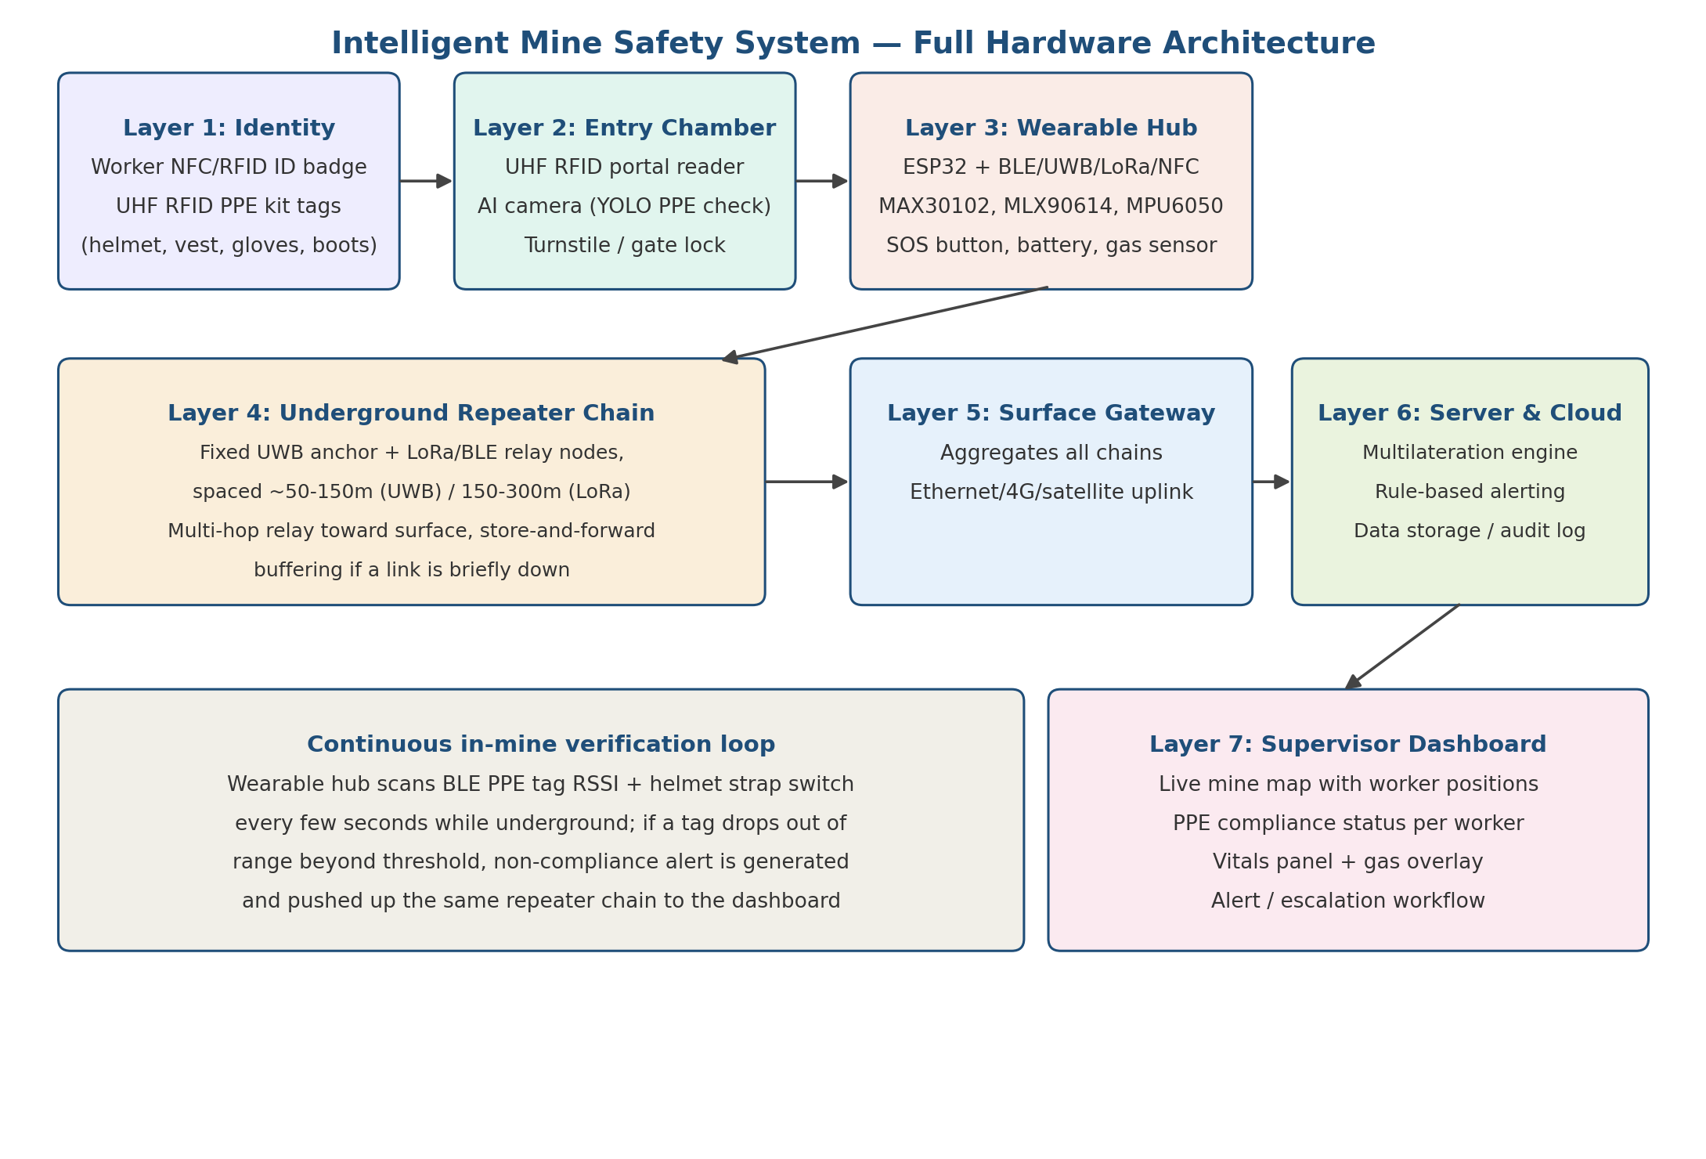
The diagram above shows the full chain. Each layer is detailed in Section 2, with its own component list and design logic.

2. Layer-by-Layer Architecture

2.1 Layer 1 — Worker and PPE Identity
Two separate tag types exist at this layer, deliberately kept simple and low-cost since they are the most numerous and most exposed to loss/damage:
- Worker ID badge: passive NFC/HF tag (13.56 MHz, NTAG213/215 or Mifare Classic) embedded in a wristband or badge. Carries only a unique Worker ID — all personal, medical, and shift data is stored server-side against that ID, so a lost or damaged badge does not expose sensitive data.
- PPE kit tags: passive UHF RFID tags (860–960 MHz, e.g. Alien Higgs-3 inlay) embedded in helmet shell, vest lining, glove cuffs, and boots. UHF is chosen over NFC/HF specifically because the entry chamber must read several tags at once across a portal gate — HF read range is too short for a walk-through checkpoint.

2.2 Layer 2 — Entry Chamber (Assignment + Verification)
The chamber performs two distinct functions that should not be conflated in the design: association (matching a PPE tag set to a Worker ID) and verification (confirming the items are actually worn, not just present). The logic sequence is:
- 1. Worker's NFC badge is read by a fixed reader at the chamber entrance, opening a short (2–3 second) assignment window.
- 2. A UHF RFID portal (multi-antenna gate reader, similar to retail anti-theft gates) scans all PPE tags present in that window.
- 3. The server links the detected PPE tag set to that Worker ID and timestamps the assignment for the shift.
- 4. An AI camera at the chamber runs a YOLO-based PPE-detection model on the worker's image, classifying which items are visibly worn (helmet, vest, gloves, boots).
- 5. If the RFID-detected tag set and the camera's visual classification agree, the gate unlocks. If they disagree (e.g. a helmet tag is detected but the camera does not see a worn helmet — meaning it may be in a bag), the gate holds and a supervisor is alerted.
- 6. If lighting or camera line-of-sight is poor, the system falls back to RFID-only assignment, but logs it as "unverified" rather than camera-confirmed, preserving audit-trail accuracy.
- 7. For repeat entries within the same shift (lunch break, tool runs), the last verified PPE set is cached against the Worker ID and full re-verification is skipped unless the tag set changes.

2.3 Layer 3 — Worker Wearable Hub
The hub is the single most important component in the system: it must hold the worker's session identity, continuously confirm PPE is worn, stream vitals, and report position, all on one battery for a full shift.
Function | Component | Purpose
Controller | ESP32 or ESP32-S3 | Central MCU; dual connectivity, deep-sleep support for battery life
Positioning | UWB module (Qorvo/DecaWave DW3000) | Sub-metre ranging against fixed underground anchors
Motion / fall | MPU6050 (accelerometer + gyroscope) | Fall/impact detection, feeds dead-reckoning between UWB fixes
Heart rate / SpO2 | MAX30102 | Continuous PPG-based vitals
Body temperature | MLX90614 | Non-contact infrared temperature, works through minor clothing gaps
PPE proximity | BLE 5.0 radio (on-chip with ESP32) | Scans RSSI of assigned PPE kit tags to confirm continued wear
Helmet strap sensor | Simple microswitch on chin strap | Direct mechanical confirmation the helmet is fastened
Backhaul radio | LoRa module (SX1262) | Long-range, low-power uplink to nearest repeater for alerts/telemetry
ID reader | NFC reader IC (PN532) | Reads worker badge at shift start to bind session to the hub
Manual escalation | SOS push-button | Direct emergency trigger, bypasses automated rules
Local hazard sensing (optional) | Electrochemical or MQ-series gas sensor | Per-worker gas exposure reading where zone sensors are sparse
Power | Li-ion pack (2600–3400 mAh) + PMIC | Sized for an 8+ hour shift with duty-cycled sensor polling

2.4 Layer 4 — Underground Repeater Chain
The repeater chain is a hybrid design because no single radio technology handles positioning, range, and power efficiency simultaneously. Each fixed repeater node performs two roles at once:
- UWB anchor role — a surveyed, fixed reference point used for ranging (Time-of-Flight/TWR) against the worker's UWB tag, feeding the same UWB+IMU Kalman-filter sensor-fusion approach validated in the underground positioning literature.
- Relay role — receives the worker hub's BLE/LoRa packet (ID, vitals, PPE status, gas, alerts) and forwards it hop-by-hop toward the surface.
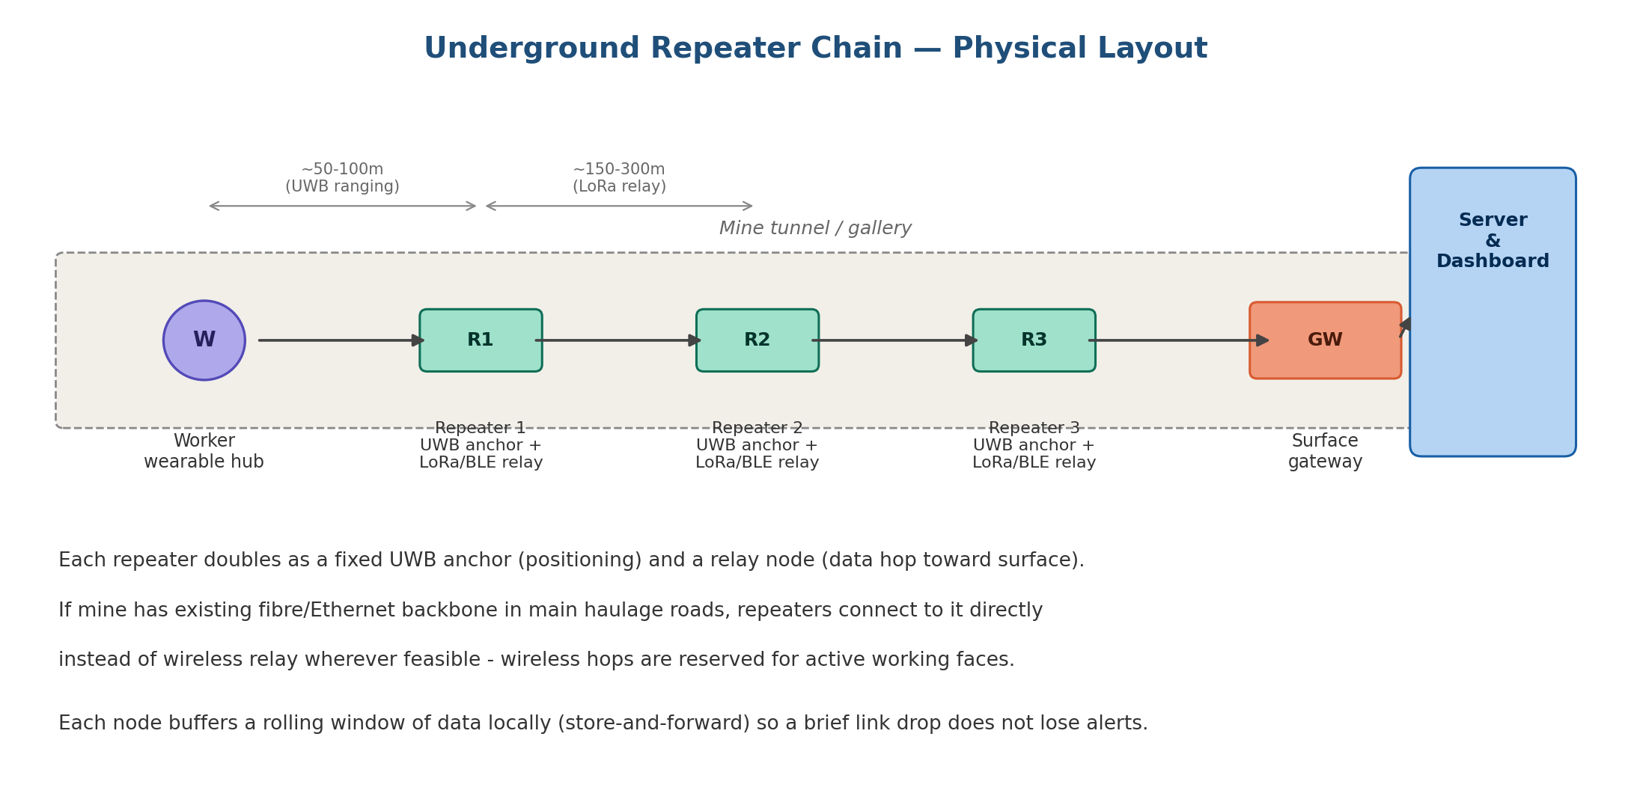
Function | Component | Note
Positioning anchor | UWB anchor module (DW3000), fixed & surveyed | Spacing ~50–100 m depending on tunnel cross-section and dust
Relay radio | LoRa transceiver (SX1262) ×2, or BLE mesh radio | One link toward the worker side, one toward the next hop to surface
Local aggregation | ESP32 (light junctions) or Raspberry Pi (busy junctions) | Buffers data locally if the next hop is briefly unreachable
Power | Mains where available, battery backup | Mains preferred at fixed points; battery-only nodes are a maintenance liability
Enclosure | IP66/IP67, ATEX-rated in gassy coal mines | Must withstand dust, humidity, and vibration per site conditions
Where a mine already has fibre or Ethernet backbone in the main haulage roads (as is common in larger operations), repeaters should connect to that wired backbone directly rather than relaying wirelessly — wireless hops are reserved for the last stretch into active, frequently-changing working faces where running cable is impractical.

2.5 Layer 5 — Surface Gateway and Server
- Surface gateway: the final node in the repeater chain, distinguished by having a real uplink out of the mine — Ethernet, 4G/LTE, or satellite as a backup for remote sites.
- Server: performs multilateration on the raw UWB ranging data to compute each worker's coordinate position, runs the rule engine (fall detected, vitals out of range, PPE tag missing beyond threshold, gas exceedance), and stores a timestamped audit log suitable for DGMS-style compliance reporting.

2.6 Layer 6 — Supervisor Dashboard
- Live mine map with real-time worker position dots, generated from the server's multilateration output.
- PPE compliance status per worker, combining the chamber's entry verification with the hub's continuous BLE/strap-switch checks.
- Vitals panel with anomaly highlighting (heart rate, SpO2, temperature trends).
- Gas/environmental overlay where zone or per-worker gas sensors are deployed.
- Alert and escalation workflow, including manual SOS, with an audit trail for post-incident review.

3. End-to-End Data Flow
Stage | Data carried | Protocol
Badge → Chamber reader | Worker ID (UID only) | NFC/HF, 13.56 MHz
PPE tags → Chamber portal | PPE item UIDs | UHF RFID, 860–960 MHz
Chamber → Server | Worker ID + PPE tag set + camera verification result | Ethernet/Wi-Fi (chamber is a fixed, powered location)
PPE tags → Wearable hub | PPE item UIDs + RSSI | BLE 5.0, continuous scan
Hub → Repeater 1 | Worker ID, vitals, PPE compliance flag, position ranging data, alerts | UWB (ranging) + LoRa/BLE (payload)
Repeater n → Repeater n+1 | Aggregated relay of all payloads in range, buffered if needed | LoRa point-to-point or wired Ethernet where available
Surface gateway → Server | All aggregated underground data | Ethernet/4G/satellite
Server → Dashboard | Computed positions, vitals, compliance status, alerts | Web application over HTTPS

4. Consolidated Bill of Materials (Indicative)
Costs below are indicative, India-market approximations for prototype/pilot-scale sourcing as of mid-2026, intended for early budgeting only — get current quotes from suppliers before finalizing your project budget, since component prices and INR/USD exchange rates fluctuate.

4.1 Per-Worker Cost (Wearable Hub + Tags)
Item | Approx. unit cost (INR) | Qty per worker | Notes
ESP32-S3 dev module | 400–600 | 1 | Or bare module for production build
UWB module (DW3000-based) | 1,500–2,500 | 1 | Higher cost item; drives most of hub BOM
MPU6050 IMU breakout | 80–150 | 1
MAX30102 HR/SpO2 breakout | 150–250 | 1
MLX90614 IR temperature sensor | 500–700 | 1
LoRa module (SX1262-based) | 300–500 | 1
PN532 NFC reader module | 300–450 | 1
Gas sensor (MQ-series, optional) | 150–300 | 1 | Optional per-worker; can rely on zone sensors instead
Li-ion battery pack + PMIC | 300–500 | 1
Helmet strap microswitch | 30–60 | 1
SOS button + misc wiring/enclosure | 150–300 | 1
UHF RFID PPE tags (helmet, vest, gloves, boots) | 25–50 each | 4 | ≈100–200 total
NFC worker ID badge | 20–40 | 1
Approx. subtotal per worker | ≈ 3,900–6,400 | — | Excludes assembly, enclosure fabrication, firmware dev time

4.2 Per-Chamber (Checkpoint) Cost
Item | Approx. cost (INR) | Notes
UHF RFID portal reader (multi-antenna gate) | 15,000–40,000 | Biggest chamber cost item; can start with a single fixed reader + 2 antennas for a pilot
AI camera (USB/IP camera, edge-suitable) | 1,500–4,000 | Resolution/frame-rate sized for Raspberry Pi inference
Raspberry Pi 4/5 (edge inference for YOLO PPE model) | 4,000–7,000 | Runs TensorFlow Lite PPE-detection model locally
Turnstile/gate lock mechanism | 8,000–20,000 | Can be a simple electromagnetic lock for a pilot instead of a full turnstile
NFC badge reader (fixed) | 300–600 | Standard commercial reader module
Approx. subtotal per chamber | ≈ 29,000–72,000 | One-time cost per mine entrance/lamp room

4.3 Per-Repeater Node Cost
Item | Approx. cost (INR) | Notes
UWB anchor module (DW3000-based) | 1,500–2,500 | Same module family as the wearable hub for consistency
LoRa transceiver ×2 (relay pair) | 600–1,000 | One link each direction of the chain
ESP32 or Raspberry Pi (aggregation) | 400–6,000 | ESP32 for light nodes, Raspberry Pi at busier junctions
IP66/67 (or ATEX-rated) enclosure | 300–1,500 | ATEX rating adds significant cost in gassy coal mines
Power supply (mains tap or battery backup) | 300–1,000 | Mains preferred; battery adds recurring maintenance cost
Approx. subtotal per repeater | ≈ 3,100–12,000 | Multiply by number of anchors/relays needed for tunnel length
For a pilot deployment (one shaft/section, ~10 workers, ~5–8 repeater nodes, 1 chamber), a rough total prototype budget lands in the ₹1.2–2.5 lakh range excluding server/cloud hosting, firmware development time, and DGMS-compliant enclosure certification — treat this as a planning order-of-magnitude, not a quotation.

5. Implementation Considerations
- Power budget: the wearable hub is the tightest constraint. Duty-cycle the UWB and BLE radios (ranging pulses rather than continuous streaming) and keep the MCU in deep sleep between sensor polls to stretch battery life across a full shift.
- ATEX/IP rating: any electronics deployed in gassy coal mines need intrinsically safe or ATEX-rated enclosures; metalliferous/opencast pilots can start with standard IP66/67 enclosures and add ATEX certification before a coal-mine deployment.
- Anchor survey accuracy: the UWB+IMU fusion accuracy your literature review cites (sub-metre) depends on accurately surveyed anchor coordinates — budget time for a proper as-built survey when repeaters are installed, and re-survey after any tunnel geometry change.
- Fallback behavior: design every layer to fail safe and loud — if the chamber camera can't verify PPE, log it as unverified rather than assuming compliance; if a repeater hop drops, buffer and alert on reconnect rather than silently dropping data.
- Phased rollout: pilot in a single section with a handful of workers before scaling — this lets you validate anchor spacing, battery life under real shift conditions, and false-positive rates on the PPE camera model before committing to a mine-wide BOM.

6. Next Steps
- Firmware/data-packet design for the wearable hub (packet structure, sensor polling intervals, sleep/wake logic).
- Server-side logic: multilateration algorithm from UWB ranging data, and the specific alert-rule thresholds (HR range, SpO2 floor, fall-detection acceleration signature, PPE-tag-missing timeout).
- Dashboard UI design: live map, compliance panel, and alert workflow.
Any of these can be the next working session — let me know which to tackle first.

