Presentation Brief: Existing Solutions - Flaws & Our Differentiation
Intelligent Safety Gear Compliance, Health Monitoring, and Navigation System for Miners
Prepared for: Manas | BE Mechatronics Engineering, TCET Mumbai | 31 July 2026

1. The One-Line Pitch
Every existing product or paper solves one or two pieces of underground mine-worker safety well - positioning, or vitals, or PPE alerts, or collision avoidance - but not one publicly confirmed product or paper combines all four (AI-vision PPE compliance, continuous health monitoring, sub-metre GPS-denied localization, and a unified dashboard) in one system. That fragmentation is the gap this project closes.

2. Existing Commercial Products - Flaws & How We Differ
Teknovate MineGuard 360
Flaw: Broadest feature list on paper (tracking + gas + vitals + dashboard) but no published accuracy data, no disclosed localization technology, and no camera-based PPE detection - compliance is sensor/wearable-based only.
How our system overcomes it: We publish a defined UWB+IMU fusion accuracy target and add an actual AI-vision PPE-detection layer instead of relying on wearable presence alone.
Source: https://www.teknovate.in/smart-mining
MineARC GuardIAN
Flaw: Field-proven gas monitoring and refuge-chamber integration, but personnel tracking is node/zone-level via cap lamps, not continuous sub-metre positioning, and there is no physiological (HR/SpO2) wearable.
How our system overcomes it: Continuous UWB+IMU tracking gives coordinate-level position (not just zone/node presence), plus an onboard vitals sensor suite GuardIAN does not offer.
Source: https://guardian.minearc.com/
Leantegra Safe Mining Platform
Flaw: The strongest pure-localization benchmark (sub-metre UWB, ATEX-certified) but has zero PPE-detection module and zero physiological health wearable - positioning and gas only.
How our system overcomes it: We match this positioning benchmark and add the two dimensions Leantegra explicitly lacks: AI PPE verification and continuous vitals monitoring, in the same wearable.
Source: https://leantegra.com/
HaloTag (Mine Safe Global)
Flaw: Best-in-class person-vehicle collision prevention (ISO 21815, Level 9 automated braking), but proximity-to-machinery is its only sensing dimension - no PPE, health, or general localization/navigation.
How our system overcomes it: We do not claim to out-engineer HaloTag's collision system; instead we cover the PPE-compliance and health gap it leaves completely open, and can co-exist with a dedicated CAS layer.
Source: https://minesafeglobal.com/collision-prevention-avoidance-systems-mining/
EasyM2M SmartKavach
Flaw: Core design is a consumer/eldercare wear-phone using GPS + 2G/3G cellular - both of which do not function reliably underground. Its 'mining' use case is a stated aspiration, not a demonstrated GPS-denied capability, and it has no PPE detection or built-in continuous HR/SpO2 sensing.
How our system overcomes it: We use UWB+IMU sensor fusion specifically because it works where GPS/cellular does not - solving the exact problem SmartKavach's architecture cannot address underground.
Source: https://easym2m.in/smartkavach/
Rajant Health (Q-Stat / Kinetic Mesh)
Flaw: Best-in-class mesh connectivity and a credible vitals wearable, but 'verifies compliance' means tag/presence detection, not AI object-detection confirming PPE is actually worn correctly, and positioning relies on mesh-node proximity rather than dedicated RTLS.
How our system overcomes it: Our YOLO-based camera module performs true object-level PPE classification (helmet/vest/gloves/boots), and UWB+IMU gives coordinate-level position rather than node-proximity estimates.
Source: https://rajanthealth.com/
ANTAR IoT Mining Solutions
Flaw: Most generic of all reviewed vendors - a short marketing overview with no named hardware, no stated localization technology, and no dedicated physiological sensor suite for mining specifically.
How our system overcomes it: Every subsystem in our design is a named, justified component (DWM3000 UWB, MPU-6050 IMU, MAX30102, MLX90614) with a documented literature basis, not a generic template.
Source: https://antariot.com/mining-2/
36Zero (+ Bodytrak acquisition)
Flaw: Most commercially validated of all nine (100,000+ workers monitored, published case-study metrics) but feature set is construction-megaproject oriented; no confirmed AI PPE object-detection, and - prior to the Bodytrak deal - no GPS-denied/UWB-style underground positioning.
How our system overcomes it: We are purpose-engineered for underground mining (ATEX/dust/humidity-hardened, UWB-based) from day one, rather than adapting a construction-site platform after the fact.
Source: https://36zero.io/
Jarsh Safety
Flaw: Widest single-vendor hardware catalogue (cooling helmets, voltage detectors, fall-arrester hardware, DownAlert, WorkAlive) but it is a modular catalogue - buy each product separately - with no single SKU combining PPE + health + location + comms.
How our system overcomes it: We deliver PPE compliance, health monitoring, localization, and gas sensing as one integrated wearable and dashboard, not a shopping list of separate purchases.
Source: https://jarshsafety.com/

3. Existing Research Papers - Gaps & How We Differ
These are peer-reviewed papers reviewed in the literature survey; each solves one piece of the puzzle well, but none integrates all four functions (PPE vision, health, localization, dashboard).
1. Advanced IoT-Based Smart Mining Helmet with LoRa-Enabled Communication (IJRASET, 2024)
Gap: Single-function design combining only gas sensing and helmet-status alerts with LoRa comms - no camera-based PPE verification, no localization.
Our approach: We keep LoRa for backhaul but add an AI-vision PPE-checkpoint and UWB+IMU localization layer on top.
2. LoRaWAN Based Smart Safety Helmet with Protection Mask for Miners (IEEE IC3IoT, 2024)
Gap: Protection-mask integration and hazard alerting only; no continuous physiological monitoring and no positioning capability.
Our approach: Continuous HR/SpO2/temperature sensing and UWB positioning are core modules in our design, not absent features.
3. Improved YOLOv7 for Miners' PPE Detection and Tracking (ScienceDirect, 2025)
Gap: Strong, high-accuracy PPE detection model, but validated as a standalone vision model - not integrated with any health or location system.
Our approach: We take this exact detection approach and fuse its output into one dashboard alongside vitals and position data, closing the integration gap the paper itself leaves open.
4. Real-Time PPE Compliance Detection Based on Deep Learning (MDPI Sustainability, 2023)
Gap: Deep-learning PPE classifier validated on general construction sites, not underground mining conditions (lighting, dust, helmet-lamp glare).
Our approach: Our checkpoint camera and model are tuned and tested for underground entry-chamber lighting and dust conditions specifically.
5. Healthcare Monitoring Using an IoT-Based Cardio System (MDPI IoT, 2025)
Gap: Continuous cardiac-vitals monitoring, but domain-general (clinical/consumer) - not built for mining ruggedness or integration with location/PPE.
Our approach: We ruggedise the same class of vitals sensing (MAX30102/MLX90614) into a mining-rated wearable, fused with position and PPE status.
6. Evaluating Accuracy of Low-Cost Wearable Sensors for Healthcare Monitoring (MDPI Sensors, 2025)
Gap: Useful low-cost sensor accuracy benchmarking, but no localization or PPE-compliance integration is considered at all.
Our approach: We use the same validated low-cost sensor components as one input into a larger fused system, not as a standalone health tracker.
7. IMU-Assisted UWB-Based Positioning in Underground Coal Mines (MDPI Micromachines / PMC, 2023)
Gap: Sub-metre accuracy demonstrated, but positioning-only - no health or PPE data captured alongside it.
Our approach: We adopt this fusion architecture as our localization core and extend it to also carry vitals and PPE telemetry over the same link.
8. Accurate Integrated Position Measurement for GPS-Denied Coal Mine (ScienceDirect (Measurement), 2023)
Gap: Solid integrated positioning accuracy for GPS-denied coal-mine conditions, but no wearable health-monitoring component.
Our approach: Health telemetry rides on the same wearable and communication path as the position data, rather than being a separate system.
9. UWB Indoor Positioning System for Underground Mines (Mining, Metallurgy & Exploration (Springer), 2024)
Gap: Field-validated UWB indoor positioning underground, but no PPE-compliance or physiological monitoring feature at all.
Our approach: We unify positioning with PPE-compliance and health modules in one wearable and one dashboard view.
10. UWB Localization Aided With Inertial Sensor for Coal Mines (IEEE Journals & Magazine)
Gap: Delivered as a standalone localization improvement, not packaged as part of a worker-safety platform.
Our approach: We package this exact inertial-aided UWB approach into a single integrated worker-safety wearable and supervisor dashboard.

4. Positioning Statement (Say This On Slide)
"An integrated, low-cost, underground-mining-purpose-built wearable and dashboard system - the first to combine AI computer-vision PPE compliance detection, continuous multi-parameter physiological monitoring, and sub-metre GPS-denied UWB+IMU localization in a single architecture."
- Lead with the integration gap - don't claim to beat Leantegra on positioning or HaloTag on collision avoidance; those are mature, narrow, field-proven systems.
- Second differentiator: cost-accessibility. Every reviewed vendor is enterprise/demo-request only - no published pricing - leaving an opening for a low-BOM, ESP32/UWB/TensorFlow-Lite design for India's smaller DGMS-regulated mines.
- Acknowledge 36Zero + Bodytrak as the closest emerging competitor, and frame our edge as underground-specific engineering versus their construction-megaproject history.

5. Software Integration - How the App Works
The system is one continuous data pipeline: sensors on the wearable and at the entry-chamber checkpoint feed a backend, which fuses and processes the data, and pushes results to a supervisor-facing web dashboard and a lightweight mobile app. Nothing is a separate 'app' bolted on afterward - the dashboard is simply the live view of the same fused data used internally for alerting.
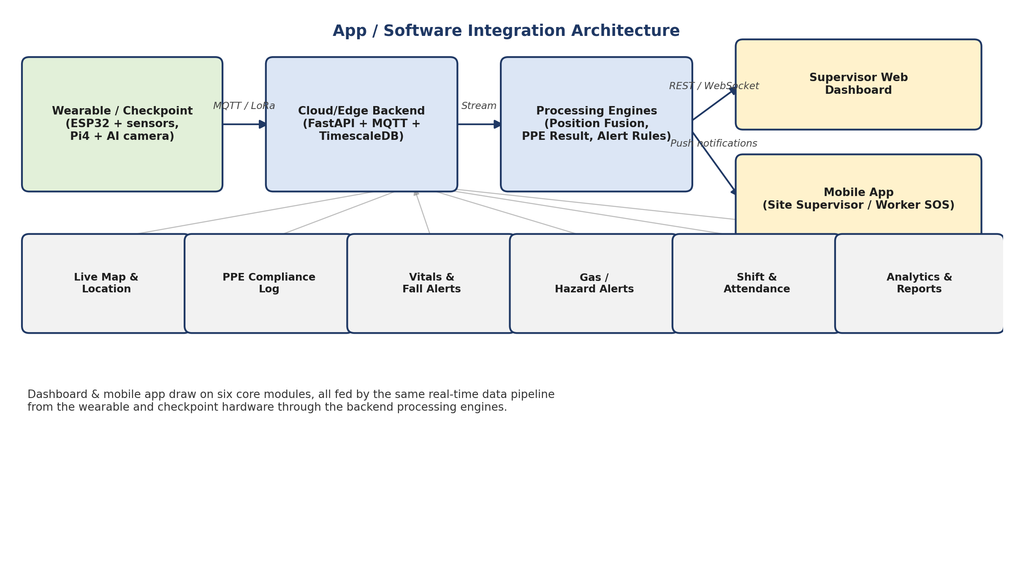
5.1 Data Flow (What Happens, Step by Step)
- Wearable hub streams UWB range, IMU, HR/SpO2, temperature, and gas readings over LoRa to the nearest repeater node, continuously.
- At shift start, the worker badges in at the Entry Chamber; the AI camera runs the YOLO PPE model on-device (Raspberry Pi 4) and only sends a pass/fail result plus a snapshot to the backend - keeping bandwidth low.
- The backend (FastAPI + MQTT broker + TimescaleDB) receives all sensor streams, timestamps and stores them, and runs the position-fusion engine (UWB + IMU, Kalman filter) to compute each worker's live coordinate.
- Rule-based and threshold logic (fall pattern, abnormal HR/SpO2, gas threshold breach, PPE fail) triggers alerts, which are pushed via WebSocket to the web dashboard and via push notification / SMS to the mobile app and supervisor phones.
- The dashboard renders the live mine map with worker positions, PPE compliance status, and vitals; historical data feeds the analytics and reporting module.
5.2 What the App / Dashboard Actually Does (Core Modules)
Module | What It Does
Live Map & Localization | Shows every worker's real-time position on the mine layout using UWB+IMU fused coordinates, with zone/geofence overlays.
PPE Compliance Log | Displays pass/fail AI-verified PPE status per worker at each checkpoint entry, with snapshot evidence and a compliance percentage per shift.
Vitals & Fall/SOS Alerts | Streams heart rate, SpO2, and body temperature per worker; auto-flags falls or abnormal vitals and lets a worker trigger a manual SOS.
Gas & Environmental Alerts | Surfaces gas-sensor readings against safe thresholds and raises immediate alerts on breach, tied to the worker's last known position.
Shift & Attendance Management | Logs badge-in/out via RFID/NFC at the entry chamber, tracks who is underground at any moment, and supports digital tag-board style shift rosters.
Analytics & Reporting | Generates compliance trends, incident history, and heatmaps of PPE violations or hazard zones for supervisors and DGMS-style compliance reporting.
Admin Panel | Manages worker registration, device/tag assignment, checkpoint configuration, and geofence/alert-threshold rules.
5.3 Suggested Tech Stack
Layer | Suggested Technology
Wearable Firmware | Arduino / ESP-IDF (C++) on ESP32; MQTT publish over Wi-Fi/LoRa
Edge AI (Checkpoint) | TensorFlow Lite running YOLO on Raspberry Pi 4; OpenCV for camera pre-processing
Communication | LoRaWAN for wearable-to-gateway; MQTT/HTTP for gateway-to-backend
Backend | Python (FastAPI) + MQTT broker (Mosquitto/EMQX); TimescaleDB/PostgreSQL for time-series storage
Position Fusion Engine | Python service running Kalman-filter-based UWB+IMU sensor fusion
Web Dashboard | React.js frontend with WebSocket live updates; map rendering via Leaflet/Mapbox for the mine layout
Mobile App | React Native or Flutter for supervisor/on-site use, with push notifications via Firebase Cloud Messaging
Alerting | Firebase Cloud Messaging (push) + Twilio/SMS gateway for critical SOS/gas alerts

6. Quick Reference - Talking Points for Today
- Open with the pitch: 'Every existing product or paper solves one or two pieces - we're the first to integrate all four.'
- Show the comparative matrix mentally: Leantegra = best positioning, Rajant/36Zero = best vitals, HaloTag = best collision-avoidance, Jarsh = widest catalogue - none combine them.
- If asked 'why not just buy Leantegra + Rajant Health together?' - answer: fragmentation means separate procurement, separate dashboards, no single source of truth, and enterprise-only pricing; our system is one integrated, lower-cost architecture.
- If asked about feasibility - point to the literature papers as proof each sub-component (YOLO PPE detection, UWB+IMU fusion, low-cost vitals sensors) is independently validated; our contribution is the integration, not unproven new sensing.
- Close with the software story: it isn't just hardware - the dashboard and mobile app turn the sensor data into real-time decisions for supervisors (map, compliance %, alerts, reports).

