Date: 31-07-2026
BE-Sem-VII - Project-I 2026-27 - Architecture Design and Algorithms / Block Diagram / Flowchart (Week-3)
Title of Project:- Intelligent Safety Gear Compliance, Health Monitoring, and Navigation System for Miners
Domain:- Mechatronics / Embedded Systems - IoT-Based Mining Safety
Name of Guide:- _____________________________________________
Group No:- _______________ SDG No:- __________ Target No:- __________
A) Name of Students and Roll No:
Sr. No | Roll No | Name of Student | Signature
1
2
3
4
B) Block Diagram:
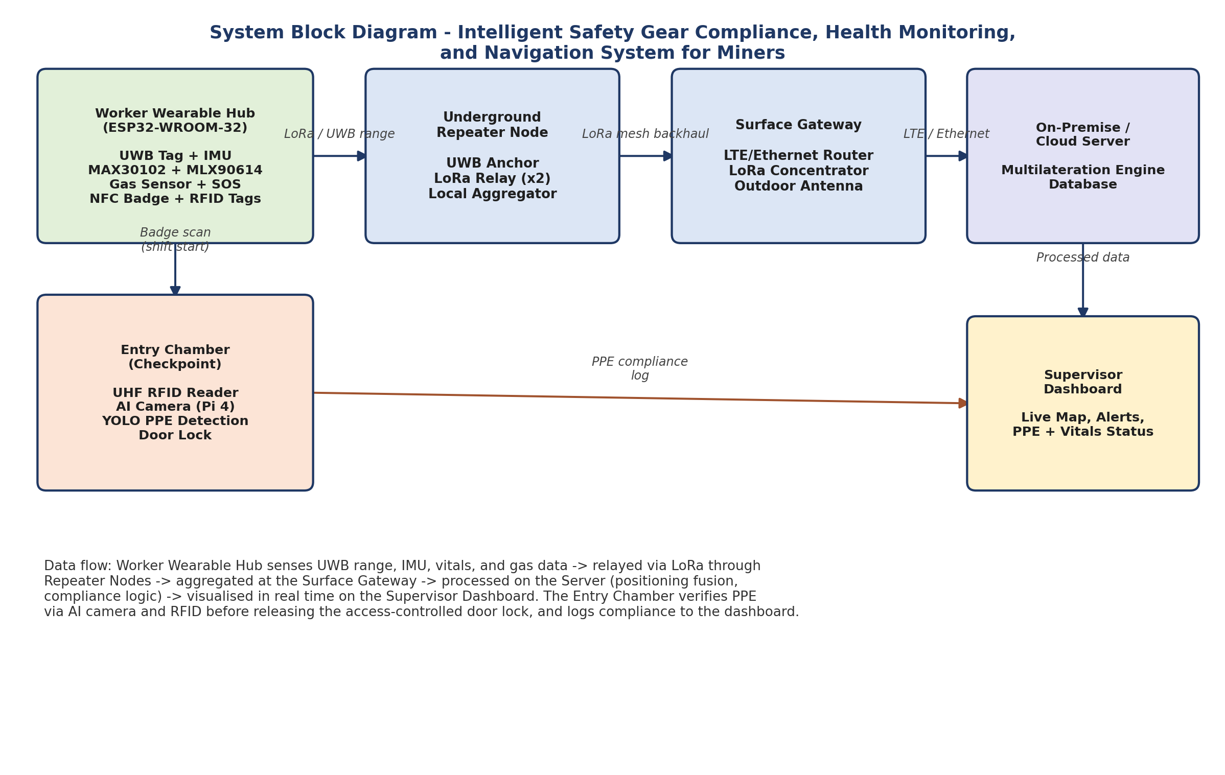
C) Hardware / List of Components
Sr. No | Name of Component | Specification | Quantity
1 | Microcontroller (Wearable Hub) | ESP32-WROOM-32 Dev Board - dual-core 240MHz, Wi-Fi + BLE 5.0 | 20
2 | UWB Positioning Module | DWM3000 (Qorvo/Decawave), IEEE 802.15.4z compliant | 20 (tags) + 8 (anchors)
3 | Inertial Measurement Unit | MPU-6050, 6-axis accelerometer + gyroscope, I2C | 20
4 | Heart Rate / SpO2 Sensor | MAX30102, PPG optical sensor, I2C | 20
5 | Body Temperature Sensor | MLX90614, non-contact IR thermometer, +-0.5 degC, I2C | 20
6 | LoRa Radio Module | SX1262-based (e.g. E22-900T22S), 868/915MHz, +22dBm | 20 (hub) + 16 (repeater)
7 | NFC / RFID Reader | PN532 (NXP) and UHF fixed reader (Chainway UR4) | 20 (wearable) + 2 (chamber)
8 | Gas Sensor | MQ-2 module, combustible gas / smoke, analog output | 20
9 | Edge AI Compute Unit | Raspberry Pi 4 Model B, 4GB RAM (runs YOLO PPE detection) | 2 (entry chambers)
10 | AI Verification Camera | Raspberry Pi Camera Module 3, 12MP autofocus | 2
11 | Electromagnetic Door Lock | 12V DC solenoid lock, 280kg holding force | 2
12 | Battery Pack | 18650 Li-ion, 3.7V 3400mAh + TP4056 charge module | 20
13 | Industrial LTE/Ethernet Gateway | Teltonika RUT956, dual-SIM 4G router | 1 (surface gateway)
14 | On-Premise Edge Server | Mini-PC, e.g. Intel NUC 13 Pro (i5, 16GB RAM, 512GB SSD) | 1
D) Software / List of Program Algorithm
Sr. No | Name of Program / Algorithm | Software / Tool
1 | PPE Compliance Detection | YOLO (v5/v7/v8) object-detection model on TensorFlow Lite, with OpenCV for camera pre/post-processing
2 | Worker Positioning | UWB + IMU sensor fusion using an Error-State Kalman Filter (ESKF) for sub-metre GPS-denied localization
3 | Fall / Unconsciousness Detection | IMU-based threshold and pattern-recognition algorithm run on the ESP32 firmware (Arduino / ESP-IDF)
4 | Vitals Processing | PPG signal-processing algorithm for heart rate / SpO2 (MAX30102 driver library) and IR temperature averaging (MLX90614)
5 | Wearable Firmware | Arduino / ESP-IDF C++ firmware for sensor polling, BLE/Wi-Fi + LoRa communication, and power management
6 | Edge Inference Runtime | TensorFlow Lite runtime on Raspberry Pi 4 for on-device PPE model inference at entry chambers
7 | Backend & Database | Python (Flask/FastAPI) backend with a time-series/relational database for sensor and compliance logs
8 | Supervisor Dashboard | Web-based dashboard (e.g. React/Node.js) for live map, alerts, and PPE/vitals status visualisation
9 | Communication Protocol Stack | LoRaWAN for long-range telemetry backhaul; MQTT/HTTP for gateway-to-server data transfer

Guide (Name & Signature): _________________________

