**Matrix PU Systems**

**Organisation Website**

**1. Introduction**

The Matrix PU Systems Website aims to create an online platform for MATRIX PU SYSTEMS (Polyurethane System House) to enhance its online presence, manage customer queries, process orders, and improve publicity. This document outlines the software requirements for developing this website using HTML, JavaScript, CSS, AngularJS, Node.js, and MongoDB.

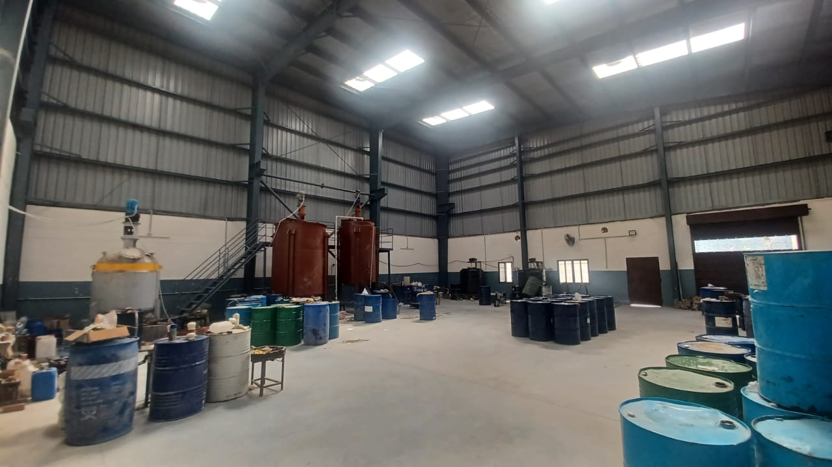

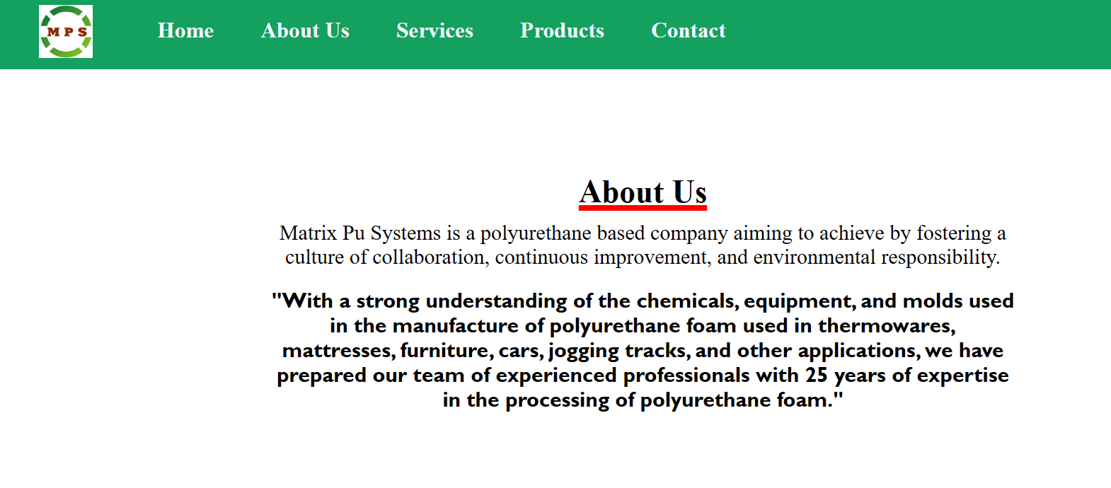

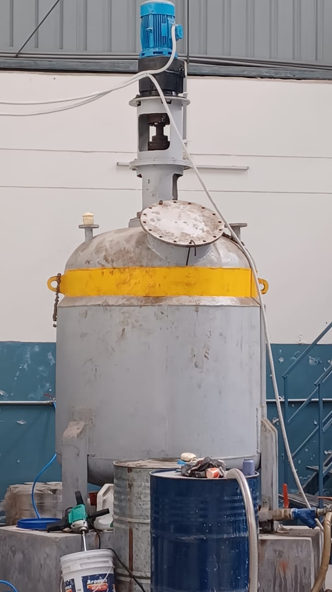

**2. Business Requirements**

Matrix PU Systems specializes in providing customized polyurethane products for various industries including Insulation Products, Automotive, Furniture, ISF, Adhesives, and Sealants. The website should support the following business objectives:

* Provide information about the company's products and services.
* Enable customers to submit queries and requests online.
* Facilitate the processing of customer orders.
* Showcase the company's expertise and technological capabilities.
* Enhance online visibility and brand awareness.

**3. Functional Requirements**

**3.1 User Management**

* **Registration and Login:**
  + Users (customers, administrators) should be able to register with the website using a valid email address and password.
  + Registered users can log in to access personalized features such as order history and profile management.
* **User Profile Management:**
  + Users can update their profile information including contact details and preferences.
  + Password reset functionality should be available for users who forget their passwords.

**3.2 Product Catalog**

* **Product Display:**
  + The website should showcase Matrix PU Systems' products organized by industry sectors (e.g., Insulation Products, Automotive, Furniture).
  + Each product listing should include detailed descriptions, specifications, images, and related products.
* **Product Search and Filter:**
  + Users can search for products by keywords or filter by industry, product type, or specific attributes.
  + Quick view options for product details should be available without leaving the main catalog page.

**3.3 Inquiry and Order Management**

* **Inquiry Form:**
  + Customers can submit inquiries or requests for quotes through a user-friendly form.
  + The website should send email notifications to users and administrators upon receiving inquiries.
* **Order Placement and Tracking:**
  + Registered users can add products to their cart and proceed to checkout.
  + Order status updates (e.g., processing, shipped, delivered) should be visible to users in their account dashboard.

**3.4 Content Management**

* **Admin Dashboard:**
  + An administrative dashboard should allow authorized users to manage website content, including adding/editing/deleting products and updating company information.
  + Content moderation tools to review and approve user-generated content (e.g., product reviews or testimonials).

**3.5 Integration and APIs**

* **Payment Integration:**
  + Integration with secure payment gateways (e.g., PayPal, Stripe) to facilitate online transactions.
  + Users should have multiple payment options (credit/debit card, online banking) at checkout.
* **Third-Party Services:**
  + Utilize APIs for real-time shipping calculations and order tracking.

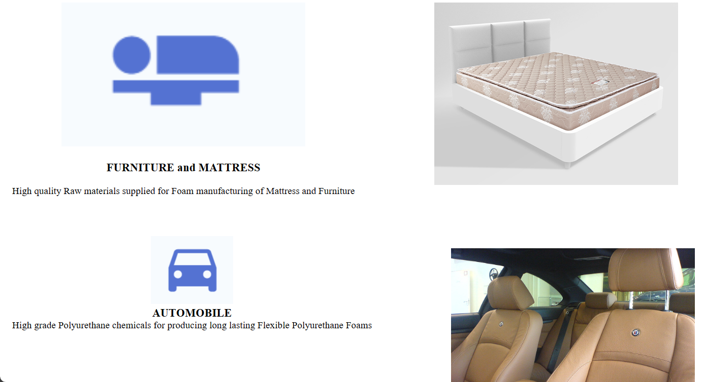

**4. Non-Functional Requirements**

**4.1 Performance**

* **Loading Speed:**
  + Web pages should load quickly to provide a seamless browsing experience.
  + Implement caching mechanisms and optimize image sizes to reduce loading times.
* **Scalability:**
  + The website architecture should be scalable to accommodate increasing user traffic and data volume over time.

**4.2 Security**

* **Data Encryption:**
  + Implement HTTPS protocol to ensure secure data transmission.
  + Use encryption techniques to protect sensitive user information stored in the database.
* **User Authentication:**
  + Implement secure user authentication mechanisms (e.g., OAuth) to prevent unauthorized access.

**4.3 Usability**

* **Responsive Design:**
  + The website layout should be responsive and adapt to various screen sizes (desktops, tablets, mobile devices).
  + Mobile-friendly navigation and touch-friendly controls for improved usability on smartphones.
* **Accessibility:**
  + Ensure compliance with web accessibility standards (WCAG) to make the website accessible to users with disabilities (e.g., screen readers support).
* **Intuitive Interface:**
  + Design an intuitive user interface with clear navigation menus and interactive elements.
  + Use consistent design patterns and visual cues to guide users through the website.

**4.4 Compatibility**

* **Browser Compatibility:**
  + Ensure compatibility with major web browsers (Chrome, Firefox, Safari, Edge) and their latest versions.
  + Perform cross-browser testing to identify and fix any layout or functionality issues.
* **Device Compatibility:**
  + Optimize the website for different devices and operating systems (Windows, macOS, iOS, Android).

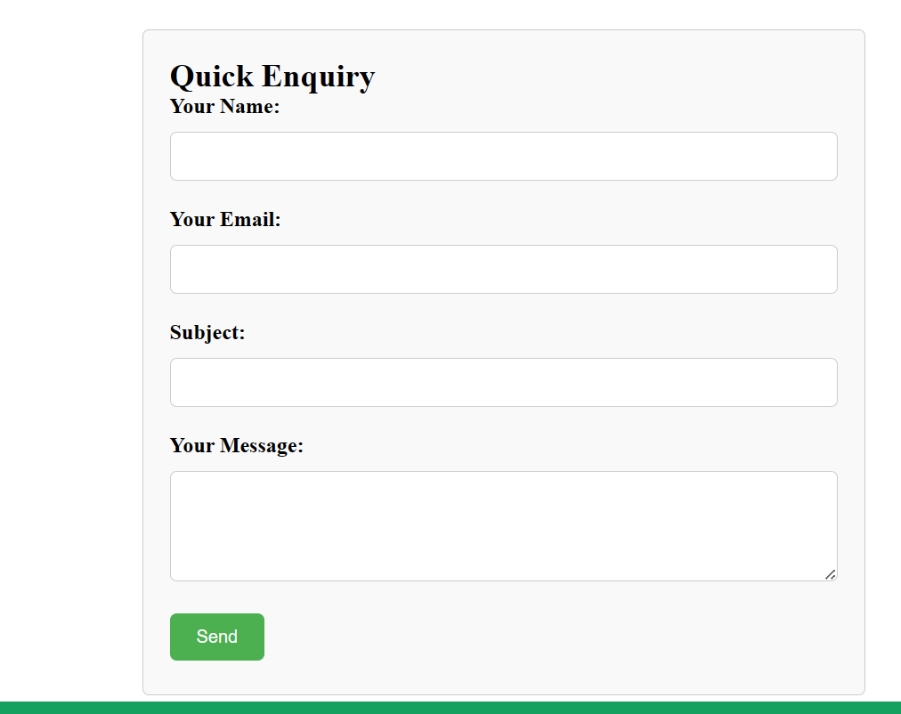

**5. Usability**

* **User Experience (UX):**
  + Conduct usability testing to gather feedback and improve the overall user experience.
  + Implement user-friendly features such as autocomplete search, clear call-to-action buttons, and error prevention mechanisms in forms.
* **Navigation and Information Architecture:**
  + Design a logical information architecture with well-organized menus and categories.
  + Implement breadcrumbs and site maps to assist users in navigating through the website.
* **Feedback and Support:**
  + Provide feedback messages for user actions (e.g., form submissions, successful orders).
  + Include contact information (phone number, email) and a FAQ section for customer support.

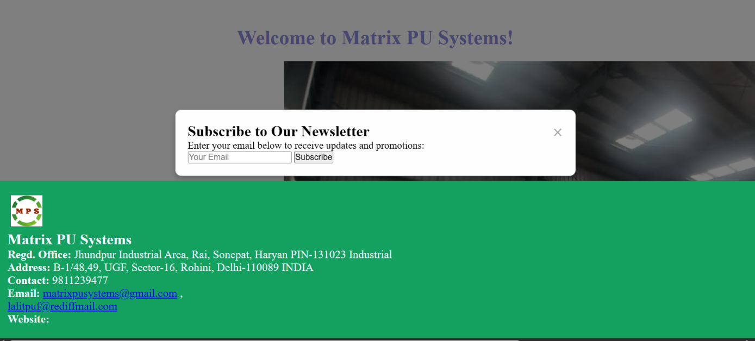

**6. Benefits**

**6.1 Scalability and Growth**

* **Market Expansion:**
  + The website will enable Matrix PU Systems to reach a broader audience beyond its traditional geographical boundaries, facilitating market expansion and growth opportunities.
* **Streamlined Operations:**
  + By automating inquiry and order management processes through the website, Matrix PU Systems can streamline operations, handle increased customer interactions efficiently, and scale their business operations effectively.
* **Enhanced Customer Engagement:**
  + Improved online visibility and accessibility will lead to increased customer engagement, ultimately driving sales growth and revenue generation.

**6.2 Targeting Consumer Base**

* **Improved Customer Acquisition:**
  + The website will serve as a powerful marketing tool to attract new customers by showcasing Matrix PU Systems' specialized polyurethane products and industry expertise.
* **Personalized Customer Experience:**
  + Through user registration and profile management features, Matrix PU Systems can personalize the customer experience, understand consumer preferences, and offer tailored product recommendations.
* **Building Customer Trust:**
  + A professional and user-friendly website enhances the company's credibility and builds trust among potential customers, leading to higher conversion rates and customer retention.
* **Market Research and Insights:**
  + The website's analytics tools can provide valuable insights into customer behavior, preferences, and market trends, enabling Matrix PU Systems to make data-driven decisions and refine their marketing strategies.

**6.3 Competitive Advantage**

* **Differentiation and Brand Positioning:**
  + A well-designed and functional website sets Matrix PU Systems apart from competitors, positioning the company as a leader in the polyurethane chemicals industry and reinforcing its brand image.
* **Adaptability to Industry Trends:**
  + The website can be easily updated to reflect evolving industry trends and customer demands, ensuring Matrix PU Systems remains competitive and adaptable in the dynamic marketplace.
* **Customer Education and Awareness:**
  + The website can serve as an educational platform, providing valuable information about polyurethane applications, benefits, and innovative solutions, thereby raising awareness and driving demand for Matrix PU Systems' products.

**6.4 Cost Efficiency**

* **Reduced Operational Costs:**
  + By shifting customer interactions and transactions online, Matrix PU Systems can reduce operational costs associated with traditional sales and customer service channels, such as phone inquiries and manual order processing.
* **Optimized Marketing Spend:**
  + Targeted digital marketing campaigns driven by website analytics can optimize marketing spend, ensuring maximum ROI and cost efficiency in customer acquisition and retention efforts.

**7. Conclusion**

The development and deployment of the Matrix PU Systems Website represent a strategic investment for the company, offering substantial benefits in terms of scalability, growth, customer targeting, and competitive advantage. By leveraging the power of digital technologies and online platforms, Matrix PU Systems is poised to enhance its market presence, foster customer relationships, and achieve sustainable business expansion in the polyurethane chemicals industry.

