**Predictive Analytics**

**NAME - MANAS ARORA**

**B.TECH CSE AIML BATCH 5**

**SAP ID – 500109627**

**ROLL.NO - R2142221204**

**Lab 2**

**Q1. Create and access tuples.**

* + **Create a tuple of colors.**

colors = ('red', 'green', 'blue', 'yellow', 'green')

* + **Access elements using indexing.**

print(colors[0])

print(colors[2])

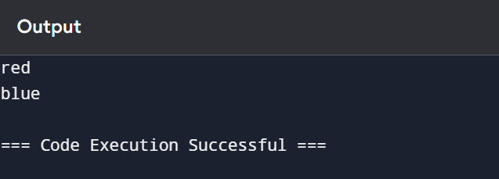

* + **Try to modify an element in the tuple (to demonstrate immutability).**

colors[1] = 'purple'

This will raise a TypeError because tuples are immutable.

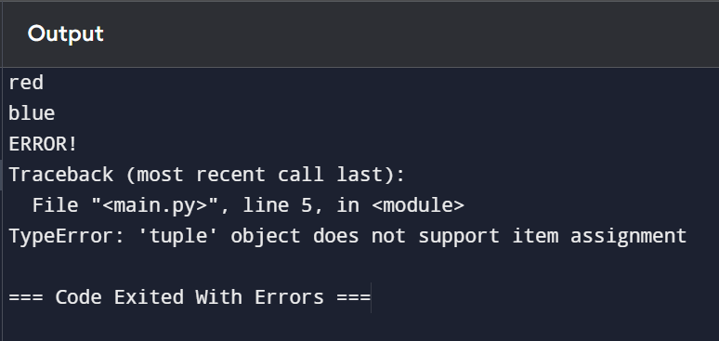

* + **Find the number of occurrences of a specific element**

**in the tuple.**

print(colors.count('green'))

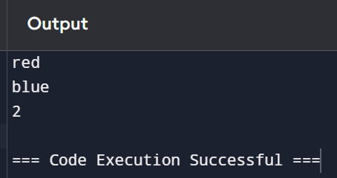

**Q2. Create and manipulate dictionaries.**

* + **Create a dictionary to store information about a person (name, age, city).**

person = {

'name': 'John',

'age': 30,

'city': 'New York'

}

* + **Access values using keys.**

print(person['name'])

print(person['age'])

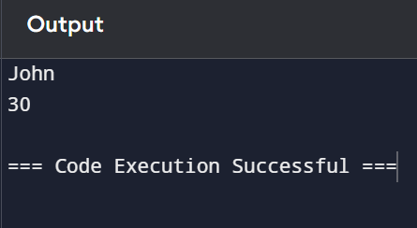

* + **Add a new key-value pair to the dictionary.**

person['profession'] = 'Engineer'

print(person)

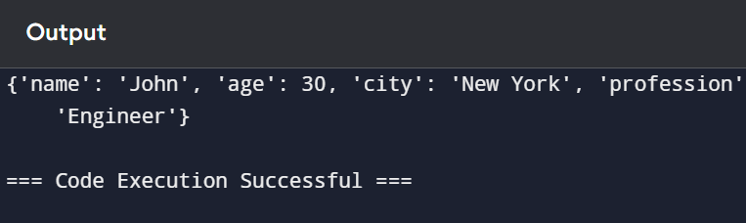

* + **Modify an existing value.**

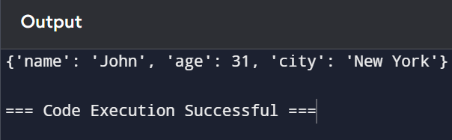

person['age'] = 31

print(person)

* + **Check if a key exists in the dictionary.**

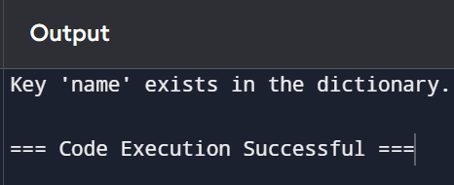

if 'name' in person:

print("Key 'name' exists in the dictionary.")

* + **Get a list of all keys and values.**

print(person.keys()) # Output: dict_keys(['name', 'age', 'city', 'profession'])

print(person.values()) # Output: dict_values(['John', 31, 'New York', 'Engineer'])

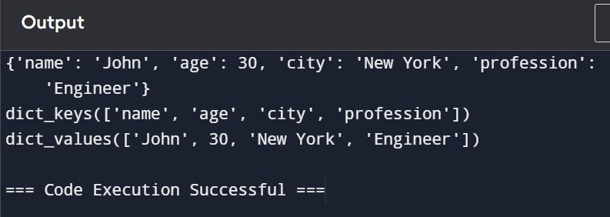

**Q3. Demonstrate the difference between mutable and immutable data types.**

* + **Create a list and a tuple.**

my_list = [1, 2, 3]

my_tuple = (1, 2, 3)

* + **Try to modify an element in both the list and the tuple.**

# Modifying an element in a list (Mutable)

my_list[1] = 20

print(my_list)

# Trying to modify an element in a tuple (Immutable)

# This will raise a TypeError

my_tuple[1] = 20

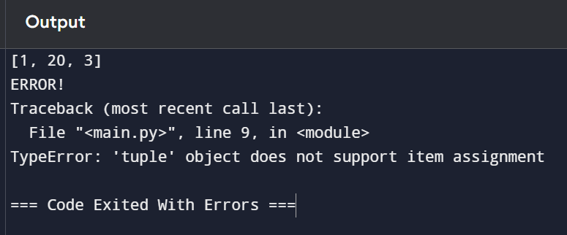

* + **Observe the results and explain the difference.**

Lists are mutable, meaning their elements can be changed or updated, while tuples are immutable, meaning their elements cannot be modified once the tuple is created.

**Q4. Create a program to print the multiplication table of a number.**

* + **Take a number as input from the user.**
  + **Use a for loop to iterate from 1 to 10.**
  + **Calculate the product of the input number and the current iteration.**
  + **Print the multiplication table.**

number = int(input("Enter a number: "))

for i in range(1, 11):

print(f"{number} x {i} = {number * i}")

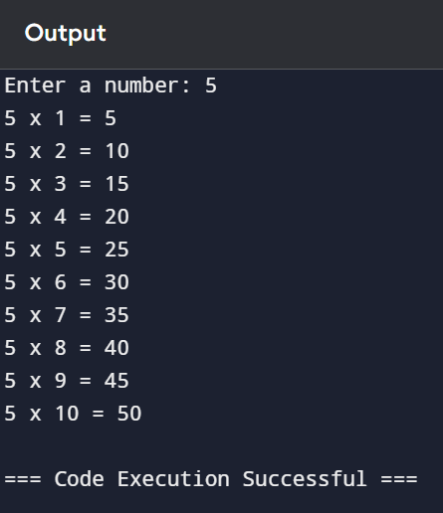

**Q5. Create a program to find the factorial of a number using a loop and conditional statements.**

number = int(input("Enter a number: "))

factorial = 1

if number < 0:

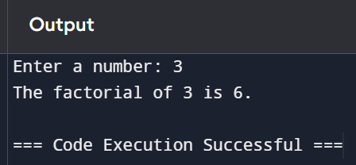 print("Factorial does not exist for negative numbers.")

elif number == 0:

print("The factorial of 0 is 1.")

else:

for i in range(1, number + 1):

factorial *= i

print(f"The factorial of {number} is {factorial}.")

**Q6. Write a program to check if a given number is prime.**

number = int(input("Enter a number: "))

if number <= 1:

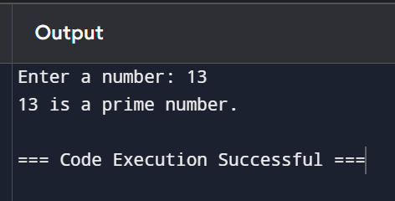 print(f"{number} is not a prime number.")

else:

for i in range(2, int(number ** 0.5) + 1):

if number % i == 0:

print(f"{number} is not a prime number.")

break

else:

print(f"{number} is a prime number.")

**Q7. Create a program to find the sum of all even numbers between 1 and 100.**

even_sum = sum(i for i in range(1, 101) if i % 2 == 0)

print(f"The sum of all even numbers between 1 and 100 is {even_sum}.")

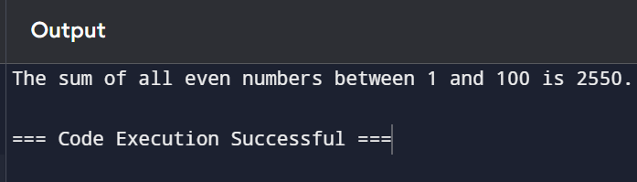

**Q8. Implement a simple calculator using conditional statements and loops.**

def calculator():

while True:

print("\nSimple Calculator")

print("1. Add")

print("2. Subtract")

print("3. Multiply")

print("4. Divide")

print("5. Exit")

choice = input("Enter your choice: ")

if choice == '5':

print("Exiting the calculator.")

break

if choice in ('1', '2', '3', '4'):

num1 = float(input("Enter first number: "))

num2 = float(input("Enter second number: "))

if choice == '1':

print(f"The result is: {num1 + num2}")

elif choice == '2':

print(f"The result is: {num1 - num2}")

elif choice == '3':

print(f"The result is: {num1 * num2}")

elif choice == '4':

if num2 != 0:

print(f"The result is: {num1 / num2}")

else:

print("Cannot divide by zero!")

else:

print("Invalid choice. Please choose a valid option.")

calculator()

