Linux File System
March 18

In computing, a file system or filesystem (often abbreviated to fs), controls how data is stored and retrieved. Without a file system, data placed in a storage medium would be one large body of data with no way to tell where one piece of data stops and the next begins. By separating the data into pieces and giving each piece a name, the data is easily isolated and identified.

The structure and logic rules used to manage the groups of data and their names is called a "file system".

There are many different kinds of file systems. Each one has different structure and logic, properties of speed, flexibility, security, size and more. Some file systems have been designed to be used for specific applications.

Linux File System or any file system generally is a layer which is under the operating system that handles the positioning of your data on the storage, without it; the system cannot knows which file starts from where and ends where.

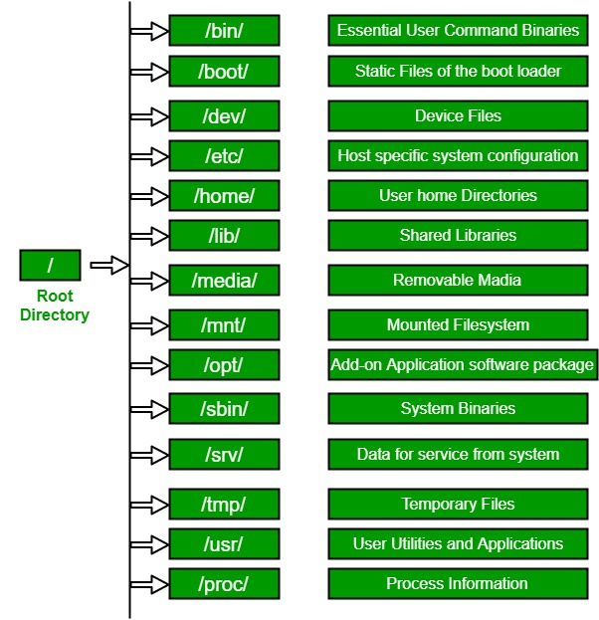

Directory Structure
Unix uses a hierarchical file system structure, much like an upside-down tree, with root (/) at the base of the file system and all other directories spreading from there.
- The entire Linux directory structure starting at the top (/) root directory.

The directories have specific purposes and generally hold the same types of information for easily locating files.

bin
/bin is the directory that contains binaries, that is, some of the applications and programs you can run. You will find the ls program mentioned above in this directory, as well as other basic tools for making and removing files and directories, moving them around, and so on. There are more bin directories in other parts of the file system tree, but we’ll be talking about those in a minute.

/boot
The /boot directory contains files required for starting your system. Do I have to say this? Okay, I’ll say it: DO NOT TOUCH!. If you mess up one of the files in here, you may not be able to run your Linux and it is a pain to repair. On the other hand, don’t worry too much about destroying your system by accident: you have to have superuser privileges to do that.

/dev
/dev contains device files. Many of these are generated at boot time or even on the fly. For example, if you plug in a new webcam or a USB pendrive into your machine, a new device entry will automagically pop up here.

/etc
/etc is the directory where names start to get confusing. /etc gets its name from the earliest Unixes and it was literally “et cetera” because it was the dumping ground for system files administrators were not sure where else to put.
Nowadays, it would be more appropriate to say that etc stands for “Everything to configure,” as it contains most, if not all system-wide configuration files. For example, the files that contain the name of your system, the users and their passwords, the names of machines on your network and when and where the partitions on your hard disks should be mounted are all in here. Again, if you are new to Linux, it may be best if you don’t touch too much in here until you have a better understanding of how things work.

/home
/home is where you will find your users’ personal directories. In my case, under /home there are two directories: /home/paul, which contains all my stuff; and /home/guest, in case anybody needs to borrow my computer.

/lib
/lib is where libraries live. Libraries are files containing code that your applications can use. They contain snippets of code that applications use to draw windows on your desktop, control peripherals, or send files to your hard disk.
There are more lib directories scattered around the file system, but this one, the one hanging directly off of / is special in that, among other things, it contains the all-important kernel modules. The kernel modules are drivers that make things like your video card, sound card, WiFi, printer, and so on, work.

/media
The /media directory is where external storage will be automatically mounted when you plug it in and try to access it. As opposed to most of the other items on this list, /media does not hail back to 1970s, mainly because inserting and detecting storage (pendrives, USB hard disks, SD cards, external SSDs, etc) on the fly, while a computer is running, is a relatively new thing.

/mnt
The /mnt directory, however, is a bit of remnant from days gone by. This is where you would manually mount storage devices or partitions. It is not used very often nowadays.

/opt
The /opt directory is often where software you compile (that is, you build yourself from source code and do not install from your distribution repositories) sometimes lands. Applications will end up in the /opt/bin directory and libraries in the /opt/lib directory.
A slight digression: another place where applications and libraries end up in is /usr/local, When software gets installed here, there will also be /usr/local/bin and /usr/local/lib directories. What determines which software goes where is how the developers have configured the files that control the compilation and installation process.

/proc
/proc, like /dev is a virtual directory. It contains information about your computer, such as information about your CPU and the kernel your Linux system is running. As with /dev, the files and directories are generated when your computer starts, or on the fly, as your system is running and things change.

/root
/root is the home directory of the superuser (also known as the “Administrator”) of the system. It is separate from the rest of the users’ home directories BECAUSE YOU ARE NOT MEANT TO TOUCH IT. Keep your own stuff in you own directories, people.

/run
/run is another new directory. System processes use it to store temporary data for their own nefarious reasons. This is another one of those DO NOT TOUCH folders.

/sbin
/sbin is similar to /bin, but it contains applications that only the superuser (hence the initial s) will need. You can use these applications with the sudo command that temporarily concedes you superuser powers on many distributions. /sbin typically contains tools that can install stuff, delete stuff and format stuff. As you can imagine, some of these instructions are lethal if you use them improperly, so handle with care.

/usr
The /usr directory was where users’ home directories were originally kept back in the early days of UNIX. However, now /home is where users kept their stuff as we saw above. These days, /usr contains a mish-mash of directories which in turn contain applications, libraries, documentation, wallpapers, icons and a long list of other stuff that need to be shared by applications and services.
You will also find bin, sbin and lib directories in /usr. What is the difference with their root-hanging cousins? Not much nowadays. Originally, the /bin directory (hanging off of root) would contain very basic commands, like ls, mv and rm; the kind of commands that would come pre-installed in all UNIX/Linux installations, the bare minimum to run and maintain a system. /usr/bin on the other hand would contain stuff the users would install and run to use the system as a work station, things like word processors, web browsers, and other apps.
But many modern Linux distributions just put everything into /usr/bin and have /bin point to /usr/bin just in case erasing it completely would break something. So, while Debian, Ubuntu and Mint still keep /bin and /usr/bin (and /sbin and /usr/sbin) separate; others, like Arch and its derivatives just have one “real” directory for binaries, /usr/bin, and the rest or *bins are “fake” directories that point to /usr/bin.

/srv
The /srv directory contains data for servers. If you are running a web server from your Linux box, your HTML files for your sites would go into /srv/http (or /srv/www). If you were running an FTP server, your files would go into /srv/ftp.

/sys
/sys is another virtual directory like /proc and /dev and also contains information from devices connected to your computer.
In some cases you can also manipulate those devices. I can, for example, change the brightness of the screen of my laptop by modifying the value stored in the /sys/devices/pci0000:00/0000:00:02.0/drm/card1/card1-eDP-1/intel_backlight/brightness file (on your machine you will probably have a different file). But to do that you have to become superuser. The reason for that is, as with so many other virtual directories, messing with the contents and files in /sys can be dangerous and you can trash your system. DO NOT TOUCH until you are sure you know what you are doing.

/tmp
/tmp contains temporary files, usually placed there by applications that you are running. The files and directories often (not always) contain data that an application doesn’t need right now, but may need later on.
You can also use /tmp to store your own temporary files — /tmp is one of the few directories hanging off / that you can actually interact with without becoming superuser.

/var
/var was originally given its name because its contents was deemed variable, in that it changed frequently. Today it is a bit of a misnomer because there are many other directories that also contain data that changes frequently, especially the virtual directories we saw above.
Be that as it may, /var contains things like logs in the /var/log subdirectories. Logs are files that register events that happen on the system. If something fails in the kernel, it will be logged in a file in /var/log; if someone tries to break into your computer from outside, your firewall will also log the attempt here. It also contains spools for tasks. These “tasks” can be the jobs you send to a shared printer when you have to wait because another user is printing a long document, or mail that is waiting to be delivered to users on the system.

- A specific type of data storage format, such as EXT3, EXT4, BTRFS, XFS, and so on. Linux supports almost 100 types of filesystems, including some very old ones as well as some of the newest. Each of these filesystem types uses its own metadata structures to define how the data is stored and accessed.

So what are these file systems that Linux offers?
Ext: an old one and no longer used due to limitations.
Ext2: first Linux file system that allows 2 terabytes of data allowed.
Ext3: came from Ext2, but with upgrades and backward compatibility.
The only problem about it that the servers don’t use this kind of file system because this file system doesn’t support file recovery or disk snapshots.
Ext4: faster and allow large files with significant speed.
It is a very good option for SSD disks and you notice when you try to install any Linux distro that this one is the default file system that Linux suggests.
JFS: old file system made by IBM. It works very well with small and big files, but it failed and files corrupted after long time use, reports say.
XFS: old file system and works slowly with small files.
Btrfs: made by Oracle. It is not stable as Ext in some distros, but you can say that it is a replacement for it if you have to. It has a good performance.
You may notice From the comparison above that Ext4 is the best Linux File System

- A partition or logical volume formatted with a specific type of filesystem that can be mounted on a specified mount point on a Linux filesystem.

Linux uses a two-part software implementation as a way to improve both system and programmer efficiency.
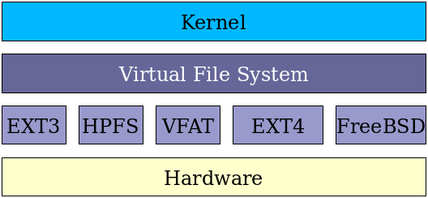
the first part of this two-part implementation is the Linux virtual filesystem. This virtual filesystem provides a single set of commands for the kernel, and developers, to access all types of filesystems. The virtual filesystem software calls the specific device driver required to interface to the various types of filesystems. The filesystem-specific device drivers are the second part of the implementation. The device driver interprets the standard set of filesystem commands to ones specific to the type of filesystem on the partition or logical volume.

Mounting
The term "to mount" a filesystem in Linux refers back to the early days of computing when a tape or removable disk pack would need to be physically mounted on an appropriate drive device. After being physically placed on the drive, the filesystem on the disk pack would be logically mounted by the operating system to make the contents available for access by the OS, application programs and users.

A mount point is simply a directory, like any other, that is created as part of the root filesystem. So, for example, the home filesystem is mounted on the directory /home. Filesystems can be mounted at mount points on other non-root filesystems but this is less common.

Having the ability to mount a new storage device at any point in the directory is very advantageous. For example, lets say that you have a web site stored in /usr/local/website. The web site has become very popular and you are running out of space on your 36 GB hard drive. You can simply go out and purchase a new 73 GB hard drive, install it in the computer, and then mount that entire drive as /usr/local/. Now your /usr/local mount point has a total hard drive space of 73 GB, and you can free up the old hard drive by copying everything from the old /usr/local to the new one. As you can see, adding more hard drive space to a computer, while still keeping the same exact directory structure, is now very easy.

mount -t file_system_type device_to_mount directory_to_mount_to

unmount device_to_mount

c: Character device
b: Block device
s: socket
p: pipe
DDirectories
l: symbolic link etc.

r – read
w – write
x – execute and

d | r | w | x | r | w | x | r | w | x
 | Owner |  |  | Group |  |  | Other

- Bright Green – Executable Files
- Bright Red – Archives or Compressed Files (.tar,.tgz,.zip,.bz2,.tbz,.tbz2)
- Magenta – Image Formats(.jpg,.gif,.bmp,.png,.tif,.png), Socket Files
- Blue – Directory Files
- White – Regular Files
- Cyan – Symbolic Links, Audio Formats
- Yellow – Character Device Files, Block Device Files, Pipe Files

