GitHub

1.git init

Ls -la : content of directory

git config --global user.name "Manas15-coder"

git config –global user.email”[abc@gmail.com](mailto:abc@gmail.com)”

stage changes and staging area

staging area: those files in which we have to tell GitHub that changes to be made in the file

stage changes:

changes area : new files added, those files don’t want to get uploaded

staged area: those files in which changes in file made and upload on git

commit: pushing code to git

stage and unstage

git commit : create a snapshot along with timeline

git push

git branch -M main

branch – exact copy of main project

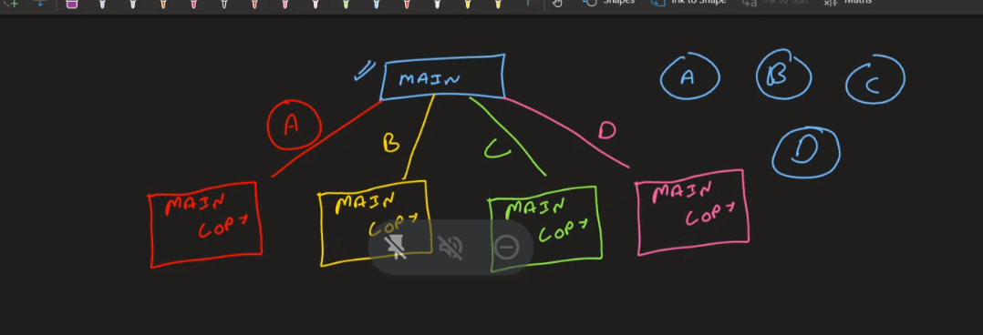

pr – pull request

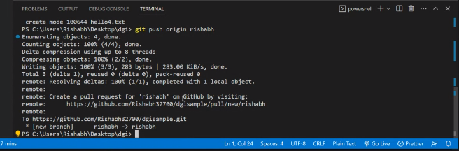

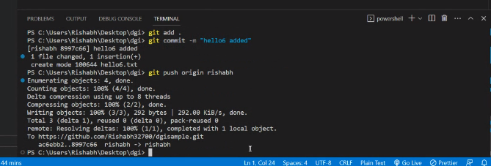

git add .

git remote add

git push -u origin main

Javascript : synchronous and single threaded language

Synchrous : line by line execute one line at a time and that to in a continuous manner.

Browser know html , css and javascript

DOM : change the existing html : DOM manipulation : reconciliation

Data types in Javascript

1. Number
2. String
3. Boolean
4. Undefined

5.Null

Datatypes

Preemptive: predefined : Number, Boolean , Undefiend , Null

Non Prempetive: user defined : objects and arrays

Var let and const

Object : stores data as key value pair

Array : type : object : because key value pairs

Arrays and objects : Master only

Object : data stored in key: value pair

Concept of Hoisting in Js : JavaScript Hoisting refers to the process whereby the interpreter appears to move the declaration of functions, variables or classes to the top of their scope, prior to execution of the code.

Hoisting : process of moving the declaration to process of moving declaration of function to the top of their scope

Var, Let and Const are Hoisted.

TDZ : Temporal Dead Zone

{

// This is the temporal dead zone for the age variable!

// This is the temporal dead zone for the age variable!

// This is the temporal dead zone for the age variable!

// This is the temporal dead zone for the age variable!

let age = 25; // Whew, we got there! No more TDZ

console.log(age);

}

Working of Javascript Program

1.Memory Allocation Phase

2. Code Execution

Empty File : smallest program of javascript

Letf to right

var a = 10 -------- left to right ---- second phase

function hello(){

var b=20;

console.log(b)

}

console.log(a);

hello();

first phase --- variable

second phase – function calling

Global Execution Context

Html -> link js file : global execution context is created

Till when js code runs Gobal execution context wil run ;A

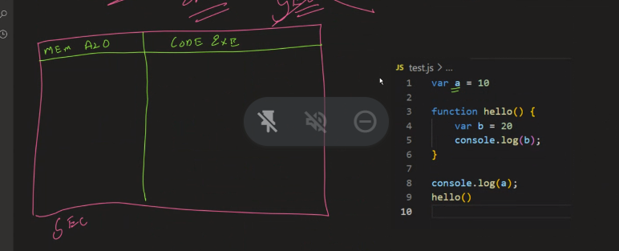

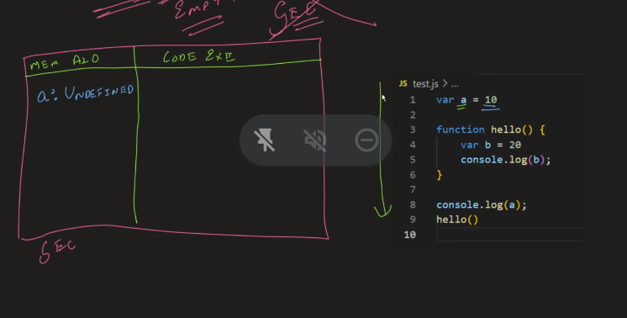

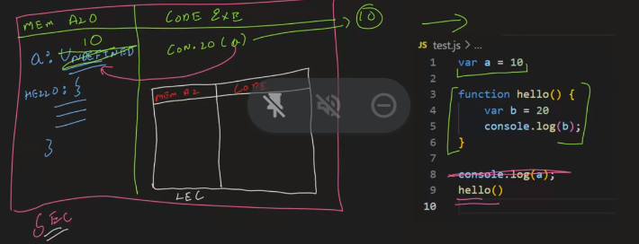

Variables : undefined keyword

Function : line by line stored