Customer Shopping Behavior Analysis
An End-to-End Data Analytics Project
Python • PostgreSQL • Tableau
Prepared by: Manas Jaiswal
August 2026

1. Business Problem
A retail company wants to better understand its customers' shopping behavior in order to improve sales, customer engagement, and long-term loyalty. Management has observed shifting purchase patterns across demographics, product categories, and sales channels, and wants to know which factors — discounts, reviews, seasonality, or payment preferences — most influence purchase decisions and repeat business.
Overarching question: How can the company use its customer shopping data to identify trends, improve customer engagement, and optimize its marketing and product strategy?

2. Dataset Overview
Source file: customer_shopping_behavior.csv — 3,900 rows, 18 columns. Each row represents one customer's most recent purchase.
Key fields:
- Demographics: Customer ID, Age, Gender, Location
- Purchase details: Item Purchased, Category, Purchase Amount, Size, Color, Season
- Engagement signals: Review Rating, Subscription Status, Discount Applied
- Fulfillment: Shipping Type, Payment Method
- Loyalty proxies: Previous Purchases (count), Frequency of Purchases
Limitation: the dataset captures each customer's latest purchase plus an aggregate purchase count/frequency — not a full transaction history. This is a common real-world constraint and does not prevent meaningful analysis.

3. Methodology

3.1 Data Cleaning & Feature Engineering (Python, Jupyter Notebook)
- Loaded the raw CSV into a pandas DataFrame and performed initial exploration using df.head(), df.info(), and df.describe(include="all") to understand the table's structure, data types, value ranges, and category distributions before any cleaning.
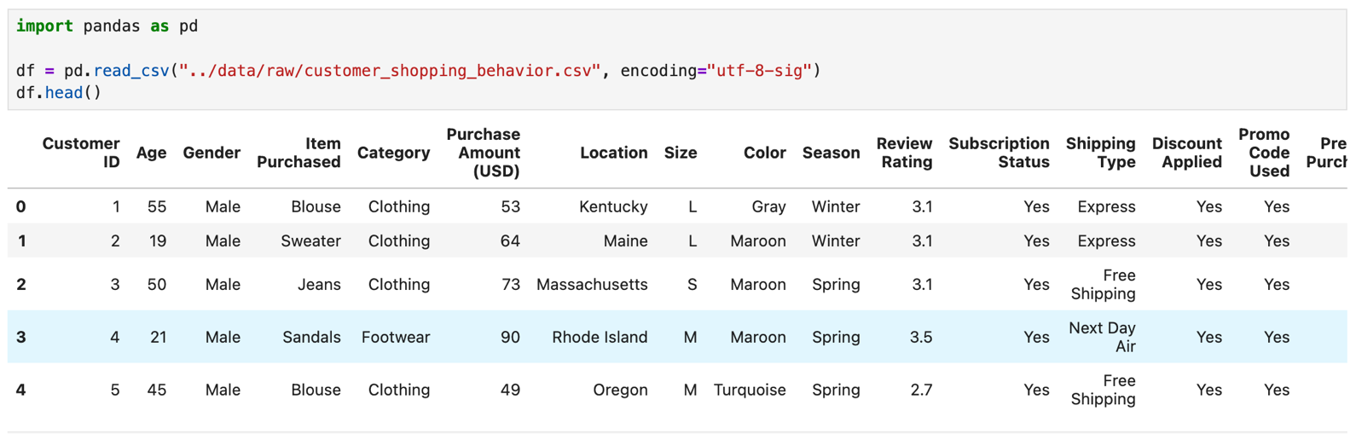
Jupyter: df.head() — raw data preview
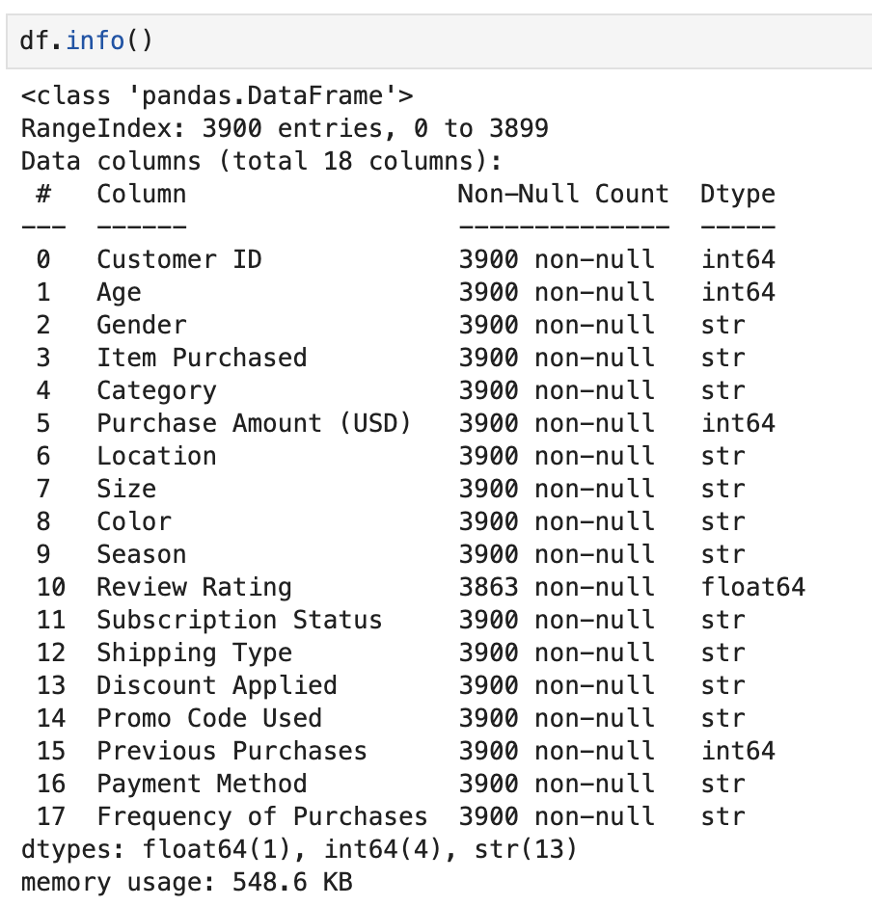
Jupyter: df.info() — structure & non-null counts (review_rating shows 3863)

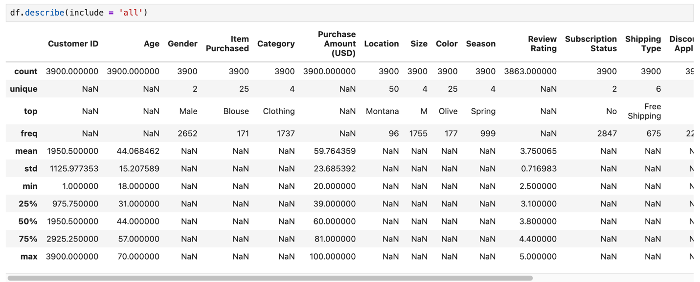
Jupyter: df.describe(include="all") — summary statistics

- Identified 37 missing values in review_rating (≈ 0.9% of rows), and imputed them using the median rating within each product category — avoiding bias from one category's typical rating being forced onto another.
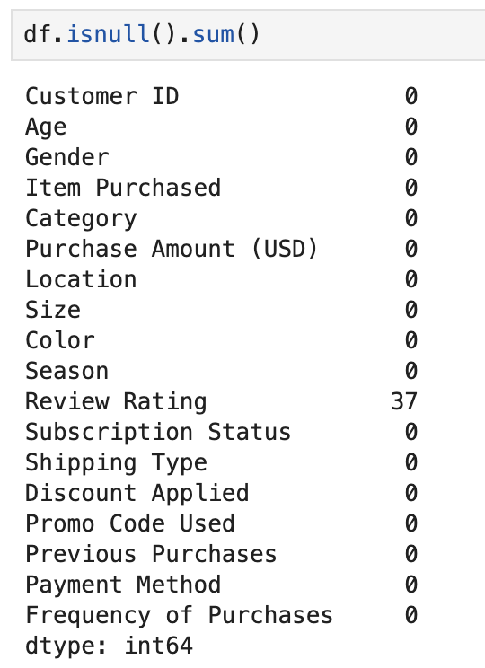
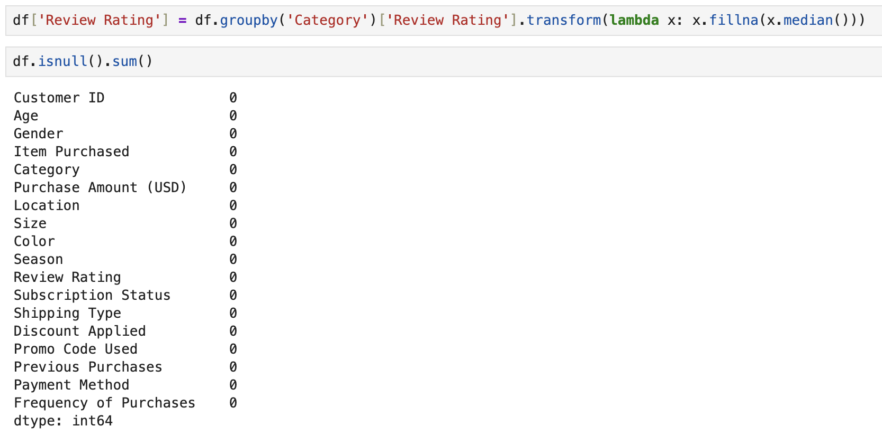
Jupyter: df.isnull().sum() before (37) and after (0) + the median-by-category imputation code

- Standardized all column names to snake_case for consistency across Python and SQL.
- Engineered age_group: split customers into four roughly equal-sized segments (Young Adult, Adult, Middle-aged, Senior) using quartile-based binning.
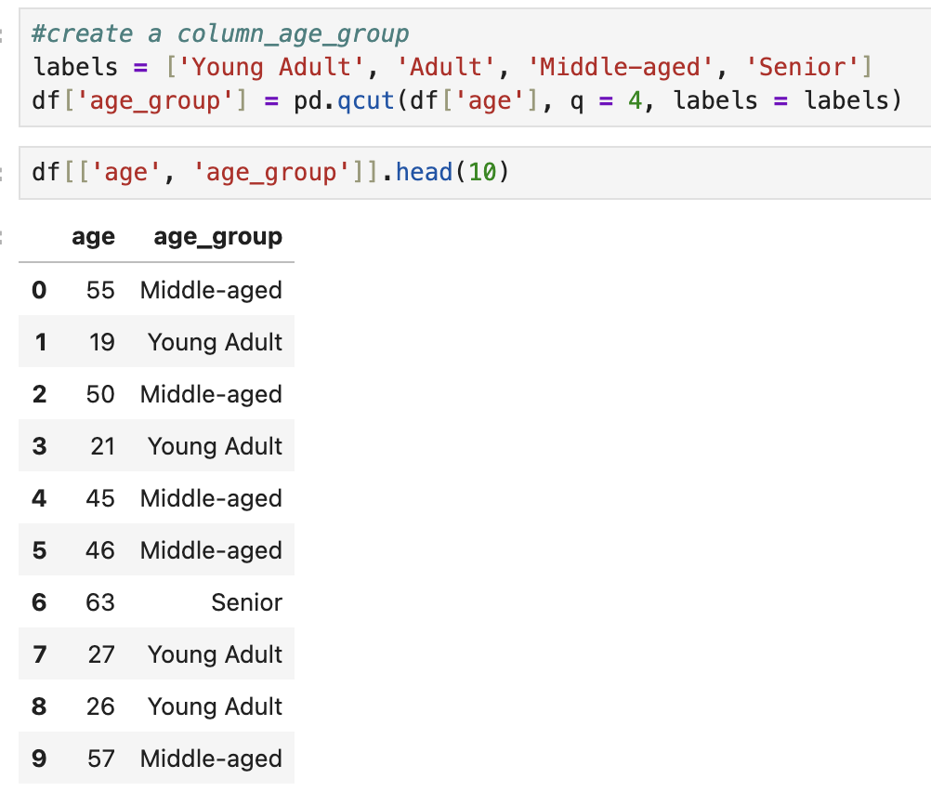
Jupyter: age_group creation code + df[['age','age_group']].head() preview

- Engineered purchase_frequency_days: converted the qualitative Frequency of Purchases field (e.g., Weekly, Monthly) into a numeric day-count for quantitative analysis.
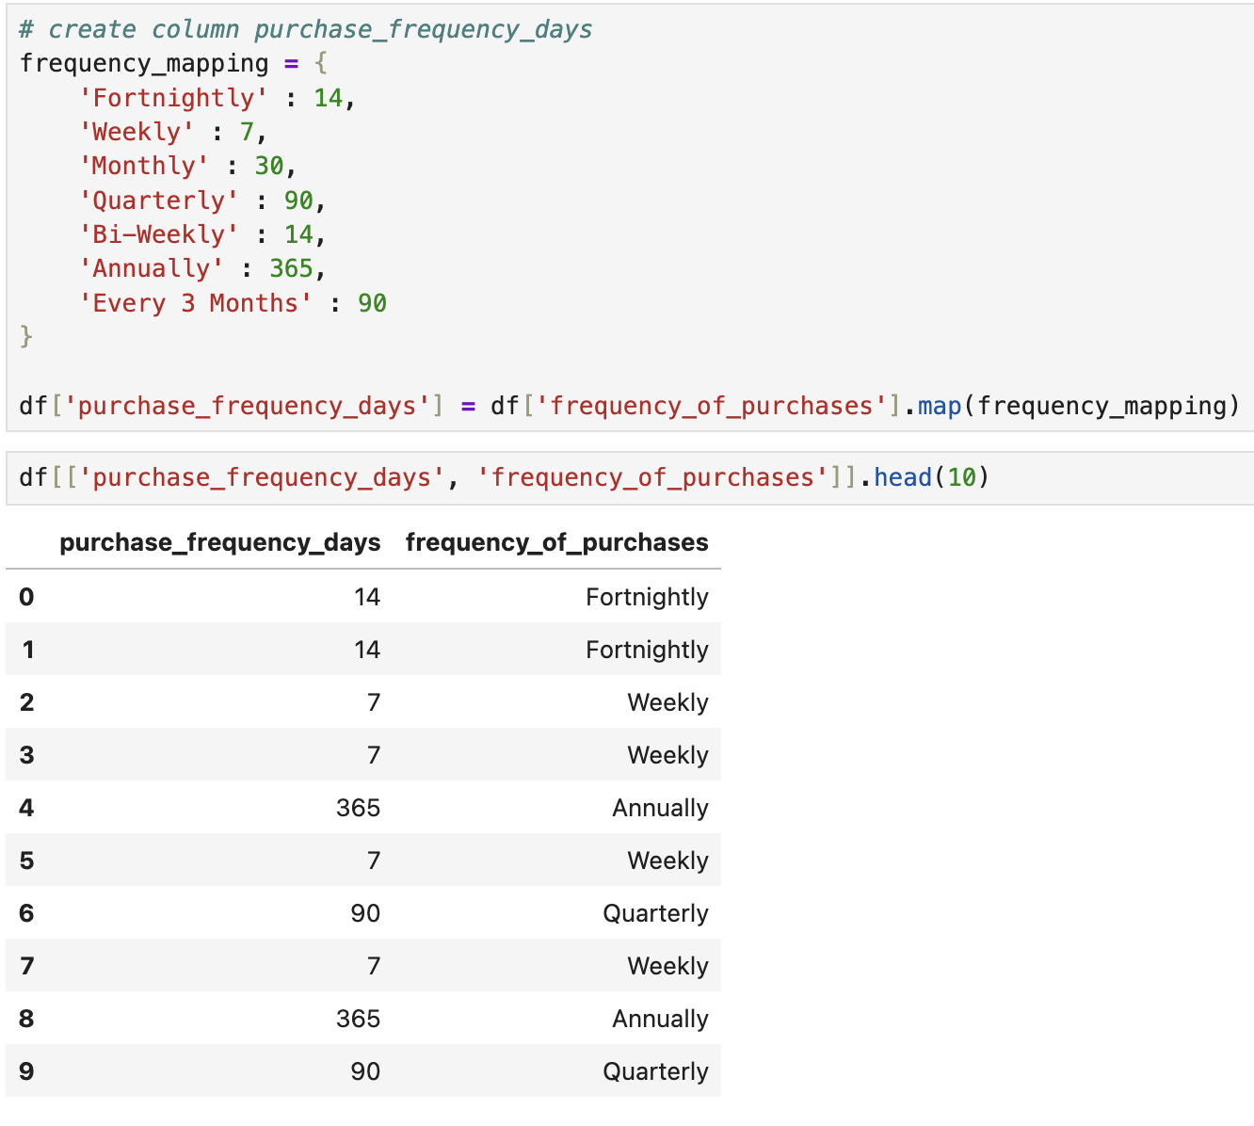
Jupyter: purchase_frequency_days mapping code + preview

- Identified that promo_code_used was 100% identical to discount_applied and removed the redundant column.
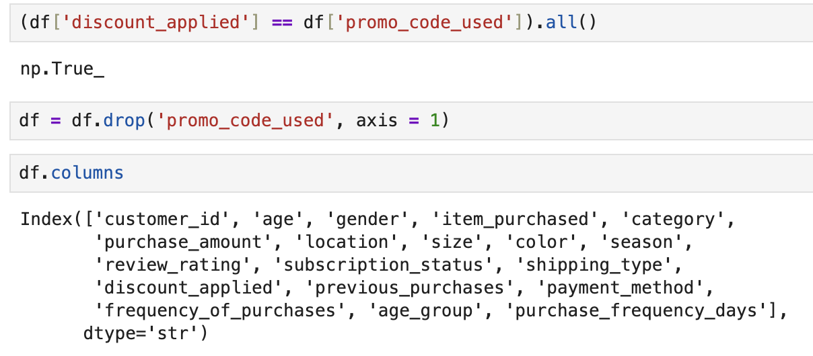
Jupyter: discount_applied == promo_code_used check (.all() = True) + the drop

- Exported the cleaned dataset and loaded it into PostgreSQL for SQL analysis.
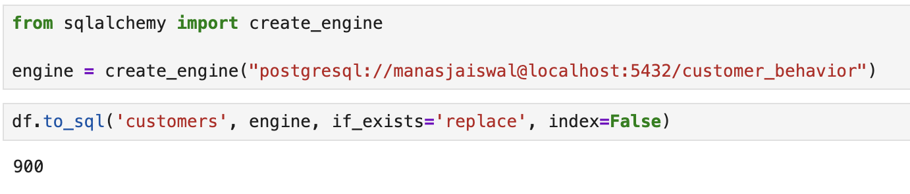
Jupyter: create_engine(...) + df.to_sql('customers', ...) — the load-to-Postgres cell

3.2 Data Warehousing & Business-Question Analysis (PostgreSQL)
Loaded the cleaned dataset into a PostgreSQL database (customer_behavior) via SQLAlchemy and psycopg2, then answered 10 targeted business questions using SQL — applying aggregate functions, GROUP BY segmentation, subqueries, CASE WHEN logic, Common Table Expressions (CTEs), and window functions (ROW_NUMBER) for category-level rankings.
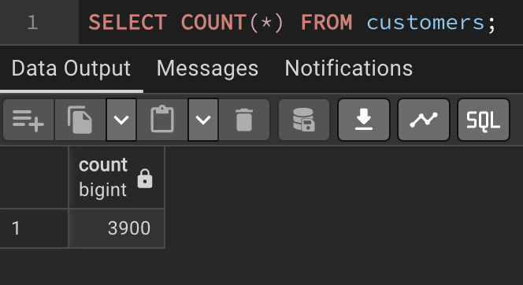
pgAdmin: SELECT COUNT(*) FROM customers; = 3900 (confirms the data loaded)

3.3 Interactive Dashboard (Tableau Desktop)
- Connected Tableau directly to the PostgreSQL database with a live connection — the dashboard reflects the underlying database in real time, not a static export.
- Built three headline KPI cards, a subscription breakdown, and revenue/sales-volume charts by Category and Age Group, plus four cross-filtering controls (Subscription Status, Gender, Category, Shipping Type) that update every chart together.
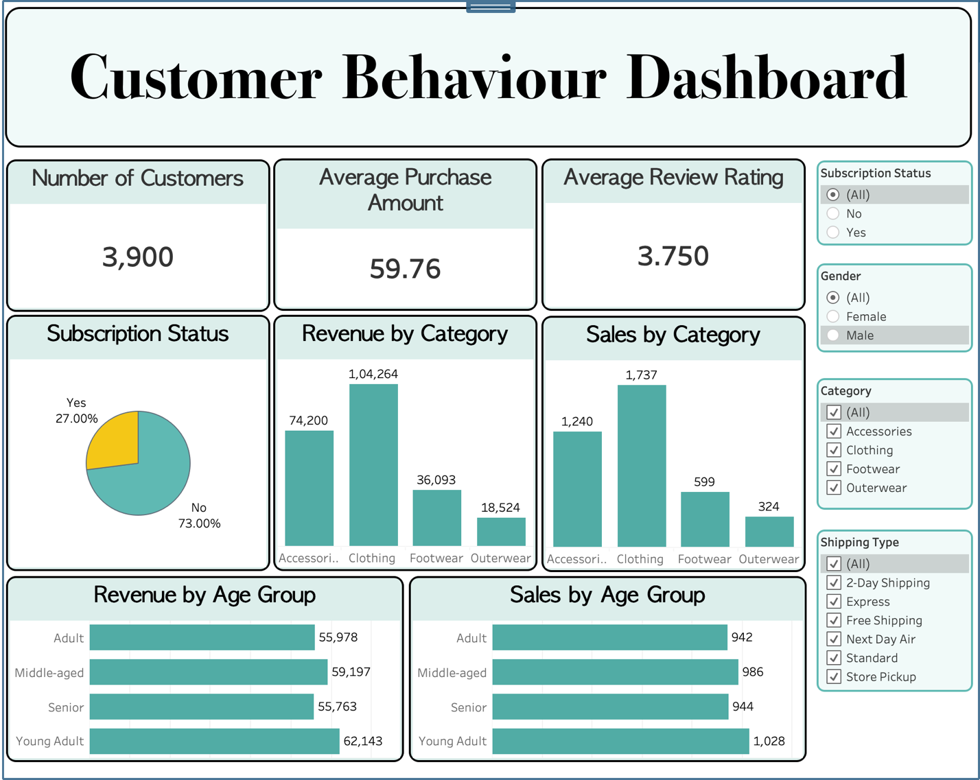
Tableau: full Customer Behaviour Dashboard (the finished teal dashboard)

4. Key Findings

4.1 Revenue & Sales Volume by Category
Category | Revenue | Orders
Clothing | $104,264 | 1,737
Accessories | $74,200 | 1,240
Footwear | $36,093 | 599
Outerwear | $18,524 | 324

Insight: Clothing drives the largest share of both revenue and order volume — roughly 45–47% of the total across both metrics — making it the business's core category.

4.2 Revenue & Sales Volume by Age Group
Age Group | Revenue | Orders
Young Adult | $62,143 | 1,028
Middle-aged | $59,197 | 986
Adult | $55,978 | 942
Senior | $55,763 | 944

Insight: Revenue and order volume are fairly evenly distributed across all four age segments (each represents close to 25% of customers by design). Young Adults lead marginally, but no single age group dominates — a more nuanced picture than “one generation drives the business.”

4.3 Subscription Status
27% of customers are subscribed; 73% are not.
Insight: The large unsubscribed base (73%) represents a significant, currently untapped opportunity to grow recurring revenue through subscription-conversion efforts.

4.4 SQL Business Questions — Queries & Results
Q1. Revenue by gender
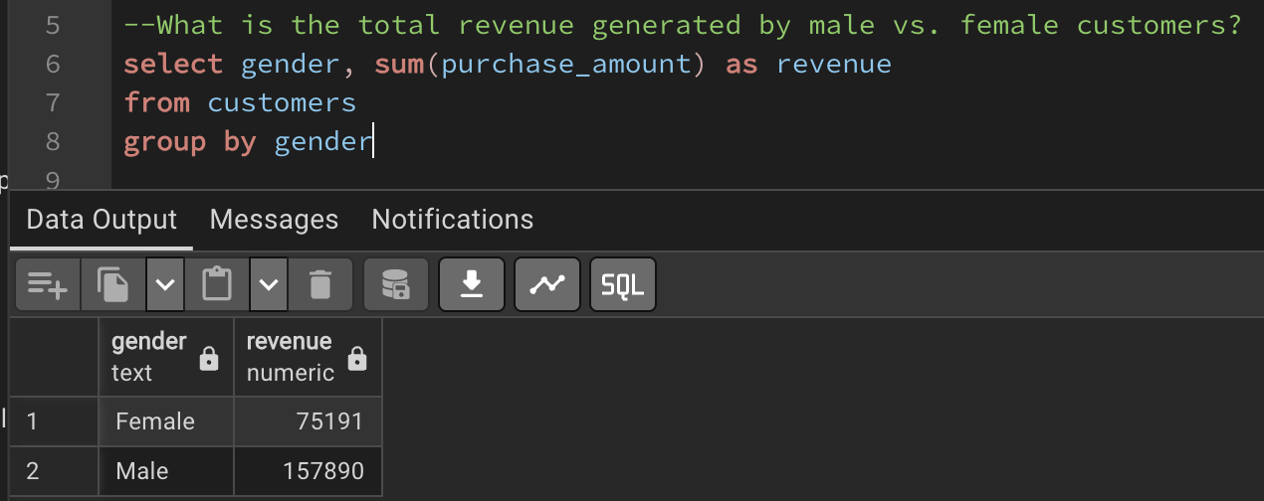
pgAdmin: Q1 query + result
Q2. Customers who spent above average despite using a discount
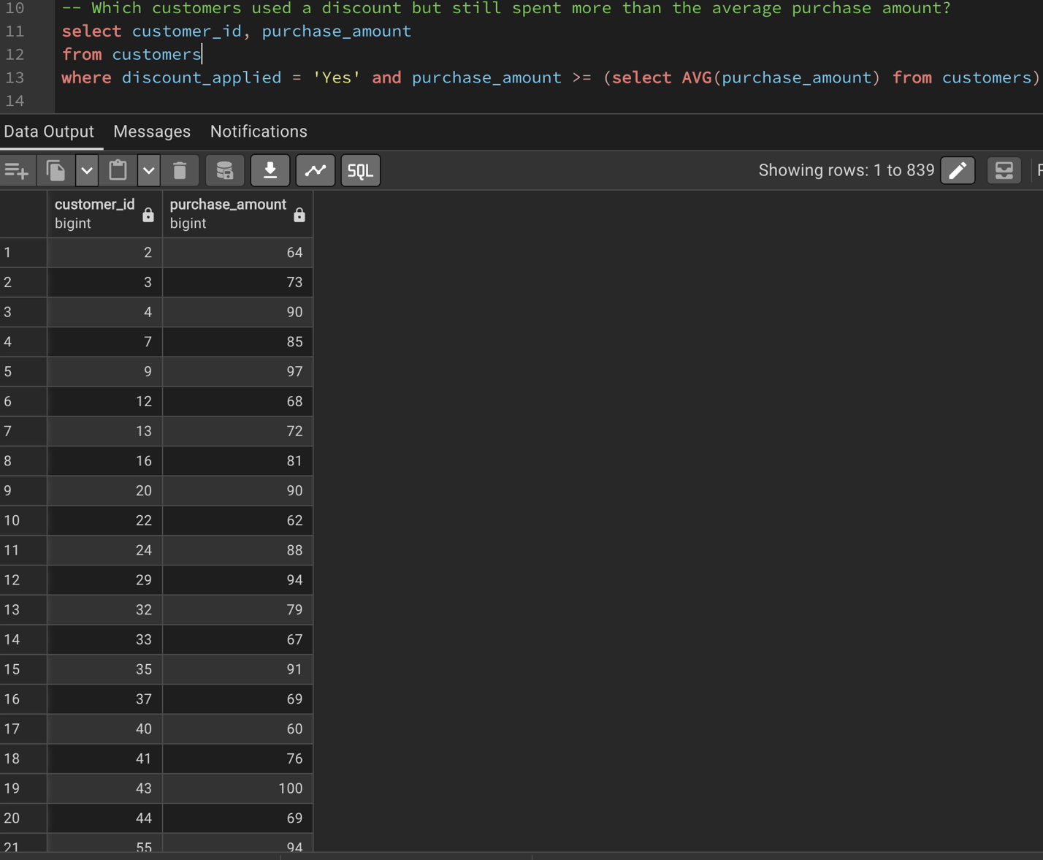
pgAdmin: Q2 query + result
Q3. Top 5 products by average review rating
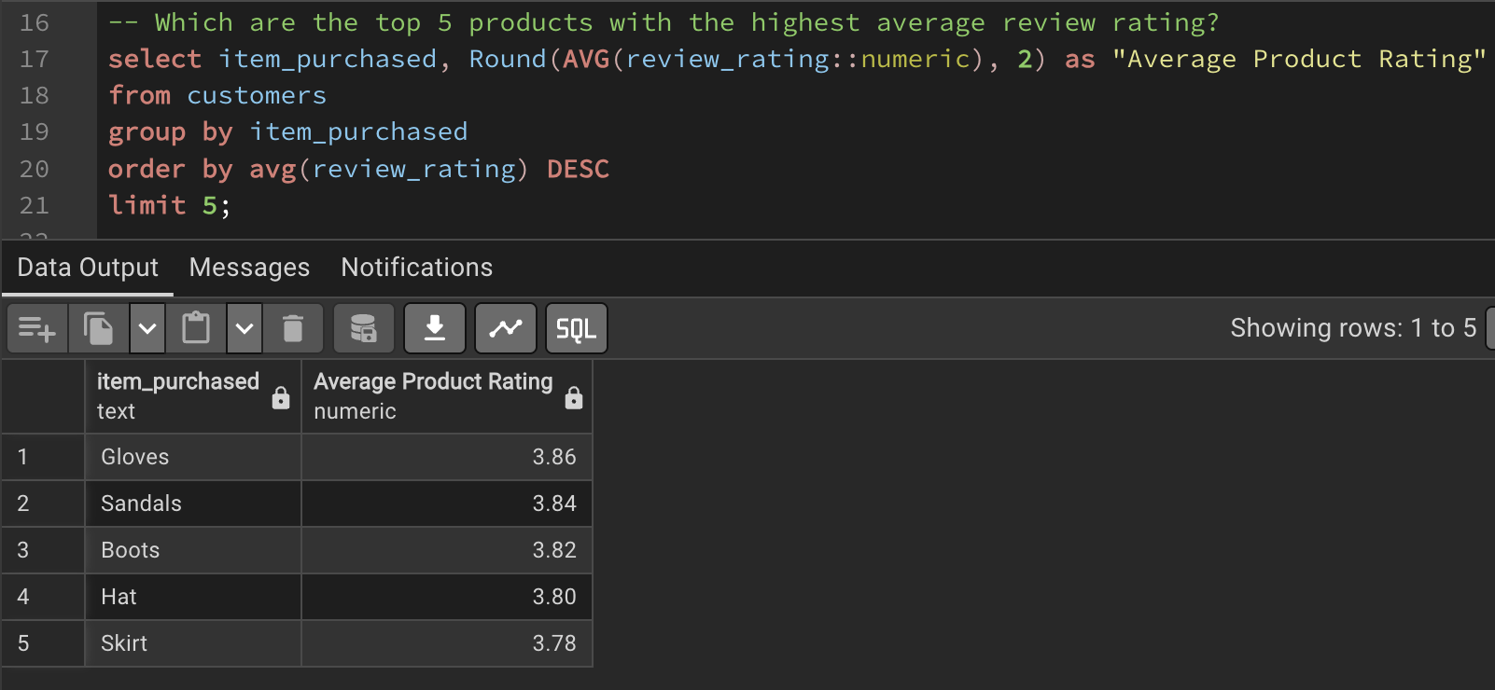
pgAdmin: Q3 query + result
Q4. Standard vs. express shipping — average purchase amount
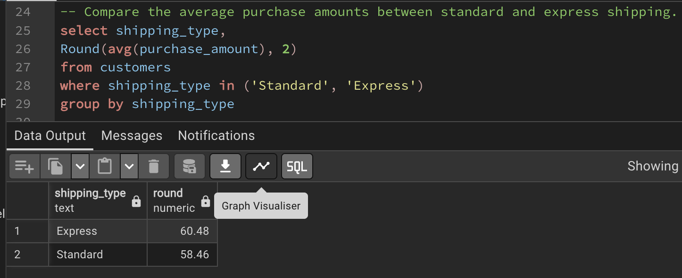
pgAdmin: Q4 query + result
Q5. Subscribers vs. non-subscribers — average spend & total revenue
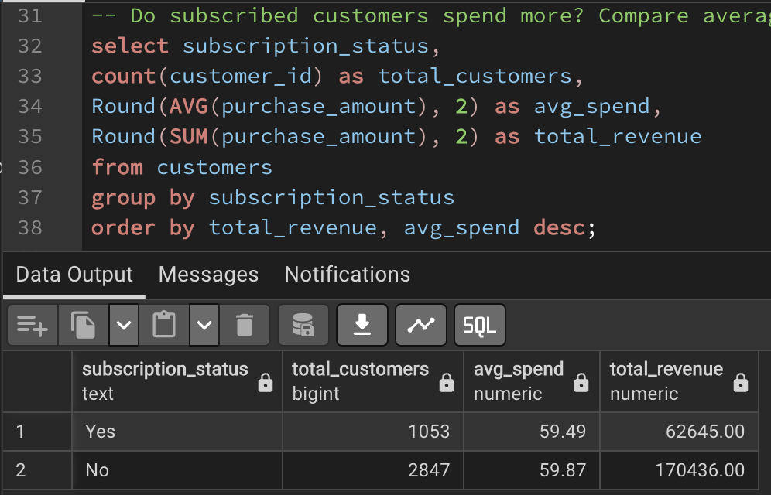
pgAdmin: Q5 query + result
Q6. Products with the highest discount-usage rate
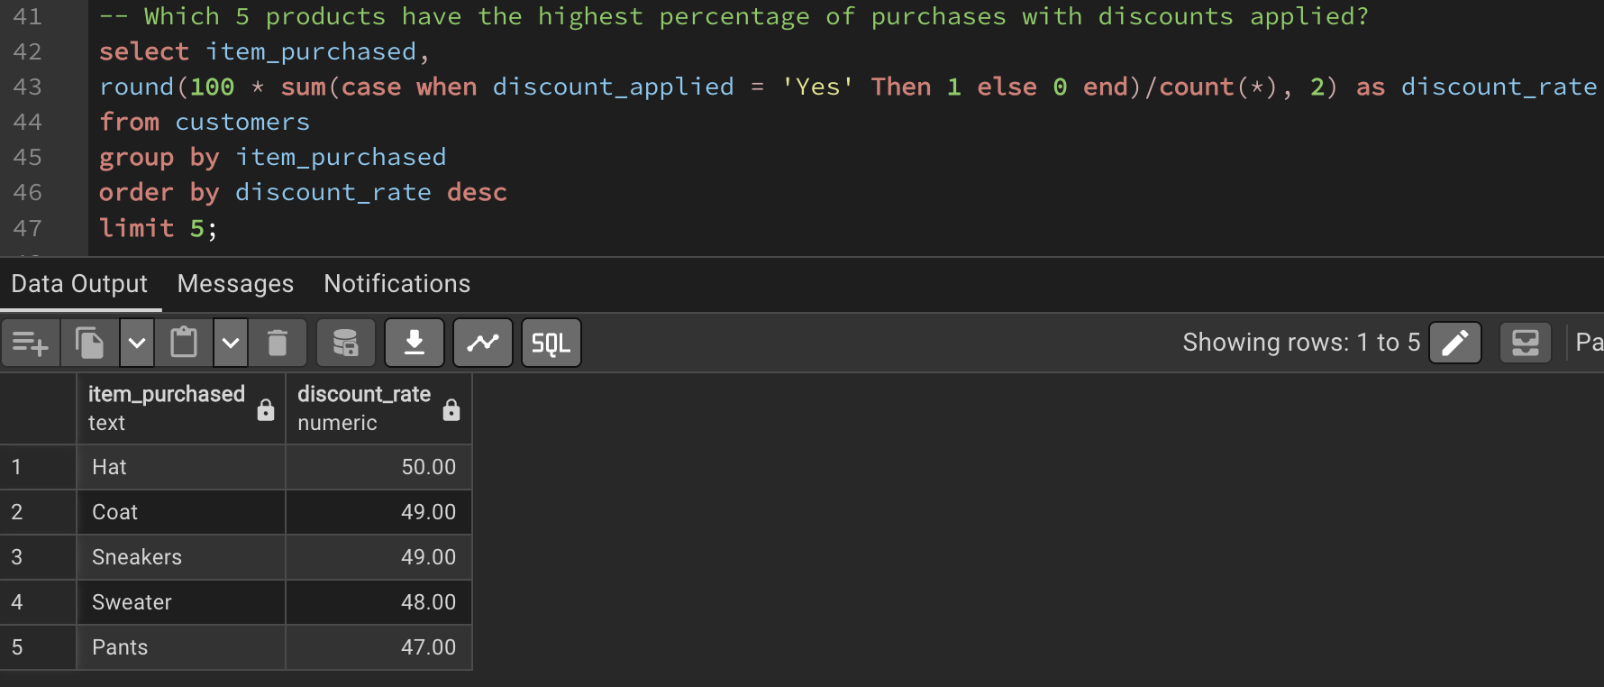
pgAdmin: Q6 query + result
Q7. Customer segmentation (New / Returning / Loyal) counts
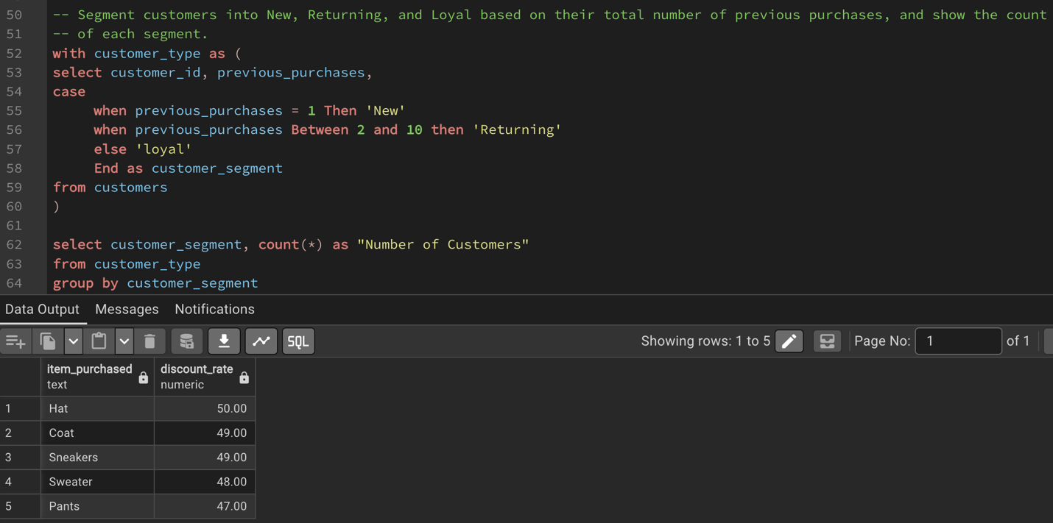
pgAdmin: Q7 query + result
Q8. Top 3 most purchased products within each category
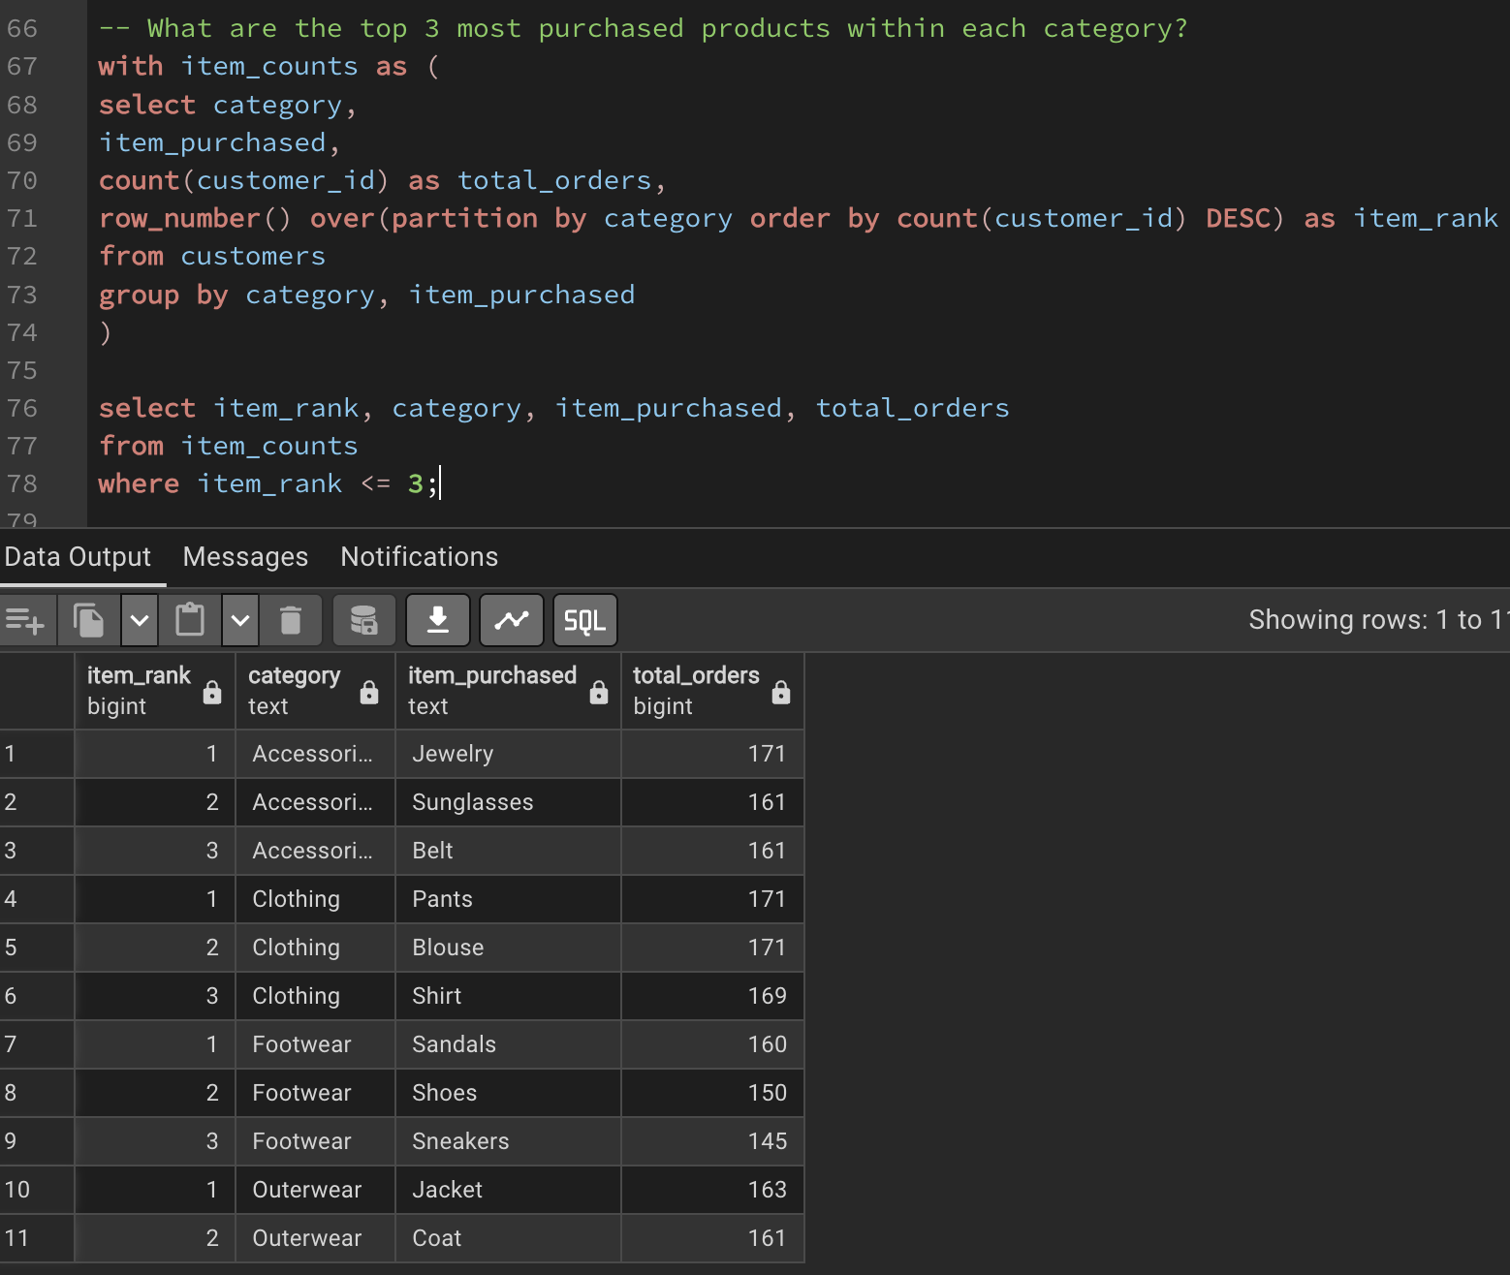
pgAdmin: Q8 query + result
Q9. Repeat buyers (5+ purchases) — subscription rate
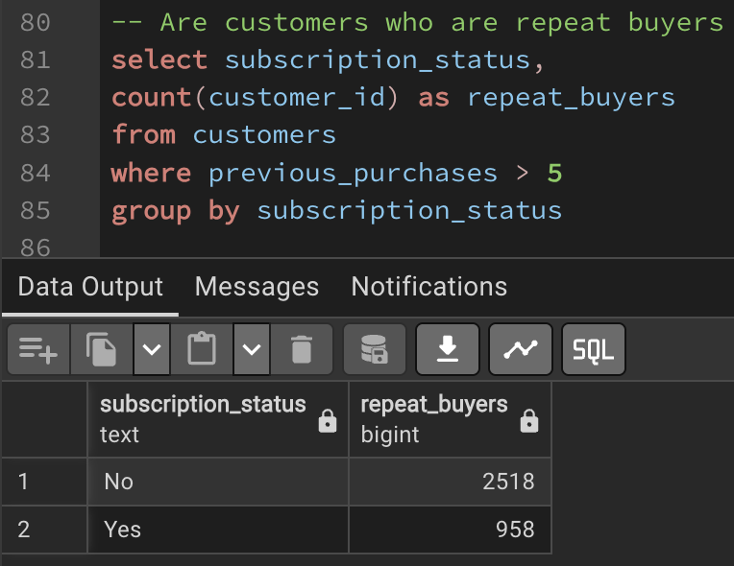
pgAdmin: Q9 query + result
Q10. Revenue by age group
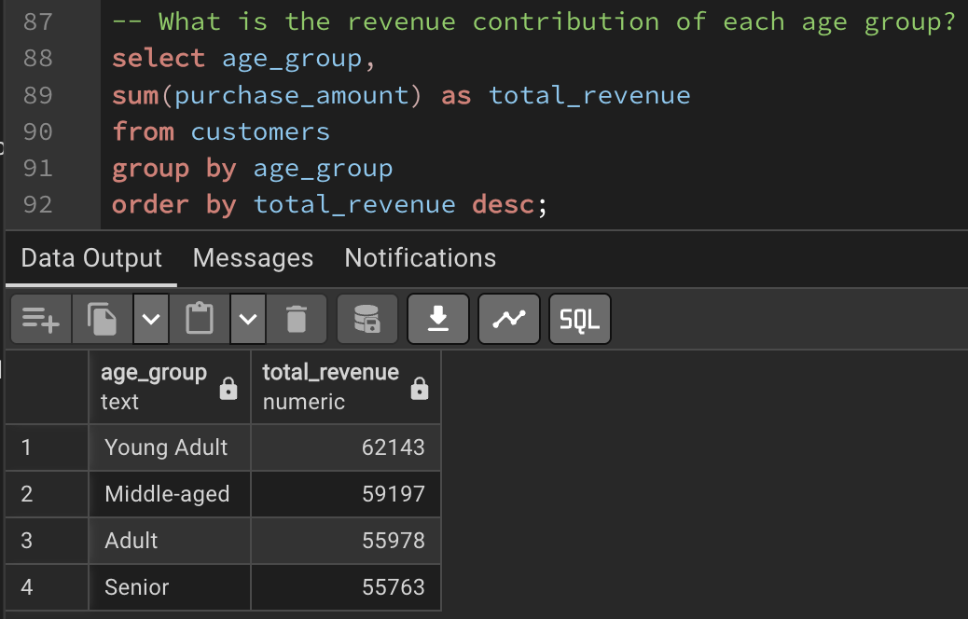
pgAdmin: Q10 query + result

5. Business Recommendations
- Launch a subscription-conversion campaign targeting the 73% of customers who are not currently subscribed — this is the single largest identified growth lever in the data.
- Continue prioritizing Clothing as the flagship category, while evaluating whether Outerwear's comparatively low share reflects a catalog gap or genuine low demand.
- Avoid over-indexing marketing spend on any single age bracket — revenue is spread nearly evenly across all four segments, so a broad-appeal strategy is more appropriate than narrow age-based targeting.
- Customer loyalty programs — reward repeat buyers with incentives that nudge them from the Returning into the Loyal segment, deepening lifetime value (informed by the segmentation and repeat-buyer analysis in Q7 and Q9).
- Review the discount policy — balance the sales lift from discounts against margin erosion, paying attention to products that rely most heavily on discounts to sell and to customers who spend above average even with a discount applied (informed by Q2 and Q6).
- Product positioning — feature the highest-rated products and the best-sellers within each category prominently in marketing campaigns, and consider premium pricing for consistently top-rated items (informed by Q3 and Q8).
- Targeted marketing & fulfillment — since revenue is spread evenly across age groups, prioritize experience and channel levers over narrow age targeting; in particular, if express-shipping customers spend more on average, promote and invest in faster delivery options (informed by Q4 and Q10).

6. Tools & Technologies
Purpose | Tools
Data Cleaning & EDA | Python (pandas), Jupyter Notebook
Database | PostgreSQL, pgAdmin
Python ↔ Database Bridge | SQLAlchemy, psycopg2
Dashboard & Visualization | Tableau Desktop (live connection)

7. Conclusion
This project followed the full analytics lifecycle a working data analyst uses: defining a business problem, cleaning and engineering data in Python, answering targeted business questions in SQL against a live relational database, and communicating results through an interactive, live-connected dashboard. The confirmed findings already point to two clear, actionable opportunities — growing the subscriber base and reinforcing the Clothing category — with further recommendations to follow once the remaining SQL results are incorporated above.

