Virtual Environmental Station Using MQTT and ThingSpeak

**Name:** Manas Bhilare  
SUID : 881435179

**1. Brief Explanation of Steps**

In this assignment, I developed a cloud-based IoT system using MQTT and ThingSpeak. I created a virtual environmental station in Python that simulates three sensors: temperature, humidity, and CO₂ levels. The sensor data is published using MQTT with a unique client ID to a topic hosted on a public broker.

A separate Python script subscribes to the topic and sends the incoming data to a ThingSpeak channel using its Write API key. I then used a third script to fetch and plot the last five hours of data from ThingSpeak for each sensor using its Read API key.

I used Python libraries like paho-mqtt, requests, and matplotlib to implement the system. All scripts were tested and verified using real-time plotting and successful HTTP responses from ThingSpeak.

virtual_environmental_station.py

thingspeak_publisher.py

**2. Output Plots**

Temperature graph

CO₂ graph

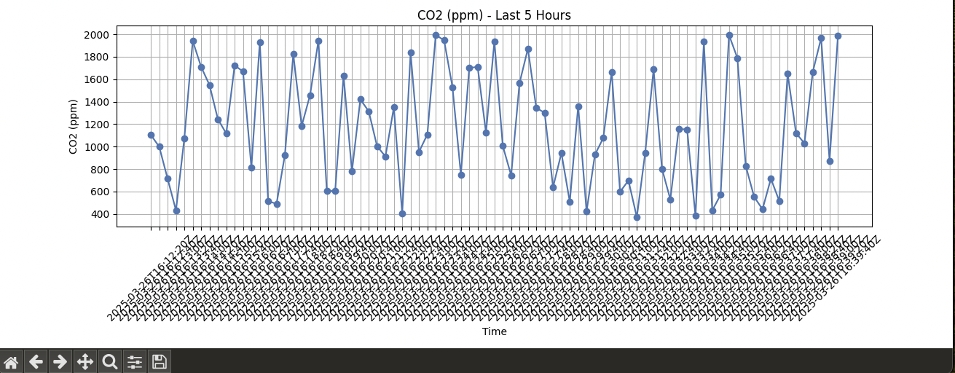

ThingSpeak channel stats view

3) ­­­­­­­­

All the code used in this assignment is available on GitHub at:

https://github.com/ManasBhilare/virtual-environmental-station-iot

4) Reflection

This assignment was a great learning experience as it combined multiple areas—MQTT protocol, cloud integration, and Python programming. I learned how to simulate sensor data, send it to a public broker, and connect it to a cloud platform like ThingSpeak. Debugging the API issues and verifying data flow helped me understand real-world IoT communication flows and troubleshooting techniques. Overall, it gave me hands-on experience building and deploying a mini IoT pipeline.