Assignment 15:
Name: Manas Kelkar
Batch and Roll No: KD1 & 80098
=======================================================================
Q1) Assume there is a table called Multicust, with all of the same column definitions as
Salespeople. Write a command that inserts all salespeople with more than one customer
into this table.
Answer:
Query: create table Multicust as select * from SALESPEOPLE where Snum in (select Snum from CUSTOMERS group by Snum having count(Snum)>1);

select * from Multicust;

Screenshot:
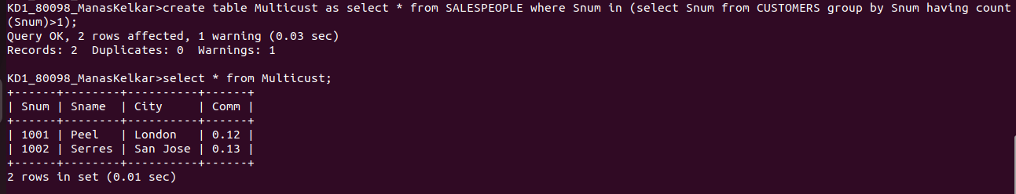

Q2) Write a command that deletes all customers with no current Orders.
Ans:
Query: select * from CUSTOMERS;
delete from CUSTOMERS where Cnum not in (Select Cnum from Orders);
select * from CUSTOMERS;

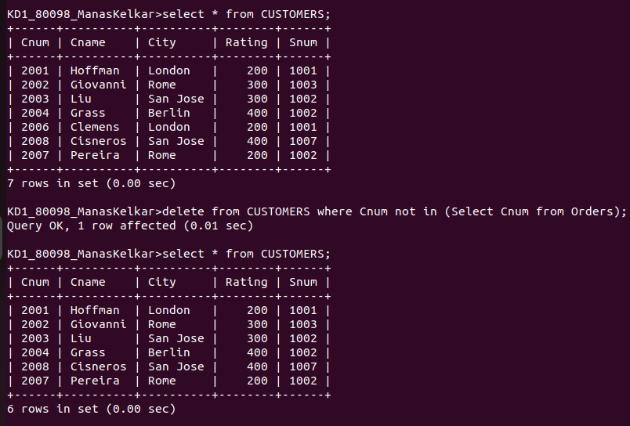
Screenshot:
Q3) Write a command that increases by 20% the commissions of all salespeople with total orders above Rs. 3000.

Answer:
Query: update SALESPEOPLE set Comm=Comm*1.2 where Snum in(select Snum from Orders group by Snum having sum(Amt)>3000);

Screenshot:

