Assignment 14
Name: Manas Kelkar
Batch and Roll No: KD1 & 80098
=======================================================================

Q1) 1)Write a command that puts the following values, is their given order, into the salespeople
table: city San Jose, name - Blanco, comm - NULL, cnum -1100.

Query: insert into SALESPEOPLE (City,Sname,Comm,Snum) values('San Jose','Blanco',null,1100);

Screenshot:
Q2) Write a command that removes all orders from customer Clemens from the Orders
table.

Query: delete from Orders where Cnum in(select Cnum from CUSTOMERS where Cname='clemens');

Screenshot:
Q3) Write a command that increases the rating of all customers in Rome by 100.

Query: update CUSTOMERS set Rating = Rating+100;
select * from CUSTOMERS;

Screenshot:
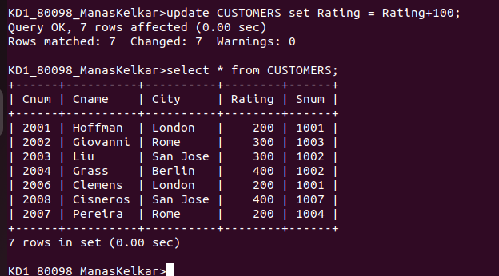

Q4) Salesperson Serres has left the company. Assign her CUSTOMERS to Monika.

Answer:
Query: update CUSTOMERS set Snum=(select Snum from SALESPEOPLE where Sname='Serres') where Snum=(select Snum from SALESPEOPLE where Sname='Motika');

Screenshot:

