Assignment 8:
Name: Manas Kelkar
Batch & Roll No: KD1 & 80098
=======================================================================

Formatting query output:

Q1) Assume each salesperson has a 12% commission. Write a query on the orders table that will produce the order number, the salesperson number, and the amount of the salesperson’s commission for that order.

Ans:
Query: select Onum "Order_Number",Snum "SalesPerson_Number",Amt*0.12 "SalesPerson's_Commission" from Orders;

Screenshot:
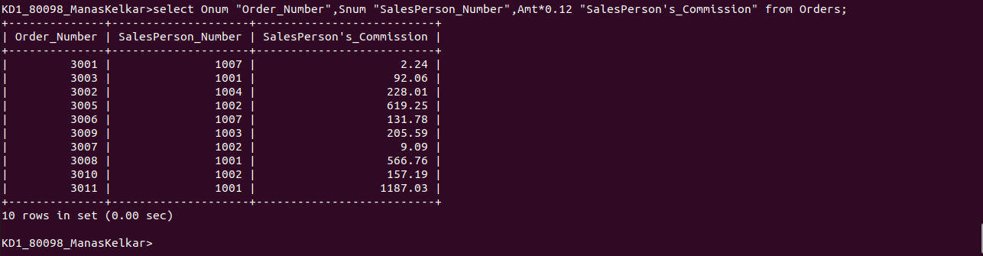

Q2) Write a query on the CUSTOMERS table that will find the highest rating in each city. Put the output in below form:
For the city (city), the highest rating is: (Rating).

Ans:

Query: select concat('For the City ',Concat(City,Concat(', the highest rating is : ', max(Rating)))) "Highest Rating" from CUSTOMERS group by City;

Screenshot:
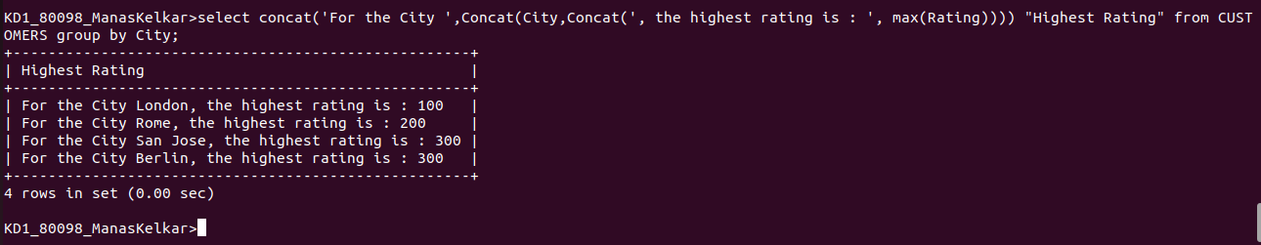

Q3) Write a query that lists customers in descending order of rating. Output the rating field first, followed by the customer’s name and number.

Ans:

Query: select Rating, Cname "Customer Name",Cnum "Customer's Number" from CUSTOMERS order by Rating desc;

Screenshot:
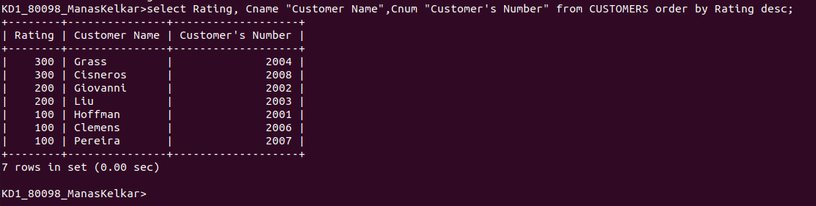

Q4) Write a query that totals the orders from each day and places the result in descending order.

Ans:

Query: select Odate "Order Date",count(Onum) "Number of Orders" from Orders group by Odate order by 2 desc;

Screenshot:
