Assignment 4:

Q1) Write a select command that produces the order number,amount and date for all rows in orders table.

Query:
select Onum,Amt,Odate from Orders;

Screenshot:
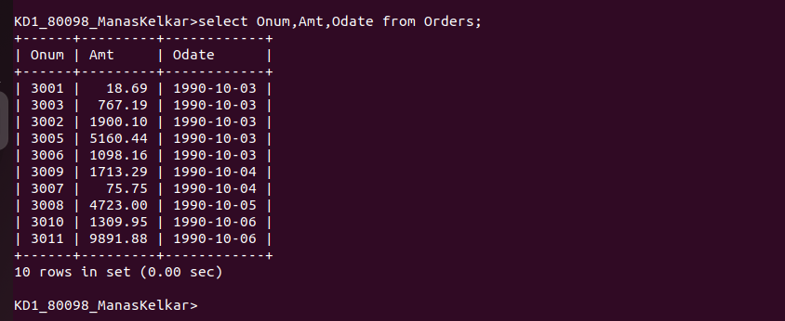

Q2)Write a query that produces all rows from the customers table for which the salesperson’s number is 1001.

Query:
SELECT * FROM CUSTOMERS WHERE Snum=1001;

Screenshot:
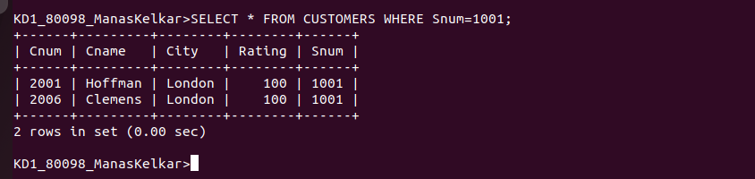
Q3)Write a query that displays the salespeople table with the columns in the following orders: city,sname,snum,comm.

Query:
select City,Sname,Snum,Comm from SALESPEOPLE;

Screenshot:
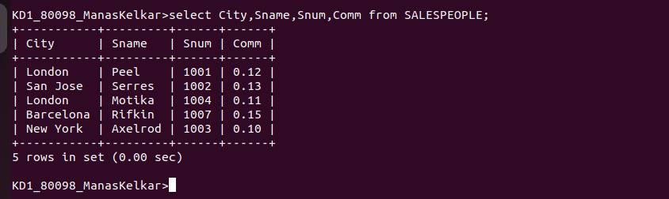

Q4) Write a select command that produces the rating followed by the name of each customers in San Jose.

Query:
select Rating,Cname from CUSTOMERS where City='San Jose';

Screenshot:
