Assignment 1 :

1) Creating sample table for SALESPEOPLE.

Query:
create table SALESPEOPLE (Snum int(4),Sname varchar(10),City varchar(10),Comm float(3,2));

Screenshot:
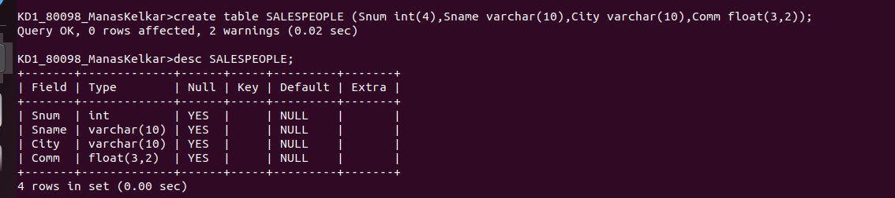

2)Creating sample table for CUSTOMERS.

Query:
create table CUSTOMERS (Cnum int(40),Cname varchar(10),City varchar(10), Rating int(4), Snum int(4));

Screenshot:
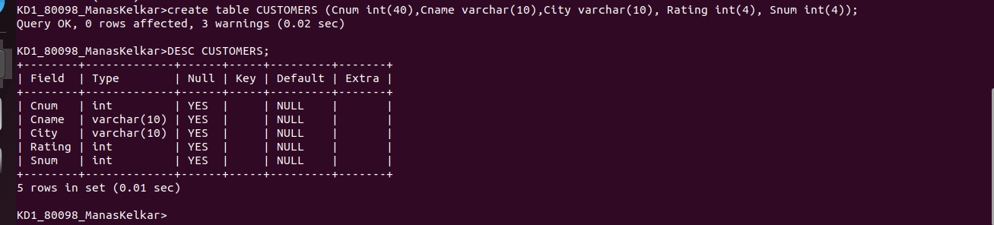

3)Creating sampe table for ORDERS.

Query:
create table Orders(Onum int(4),Amt float(7,2), Odate date, Cnum int(4), Snum int(4));

Screenshot:
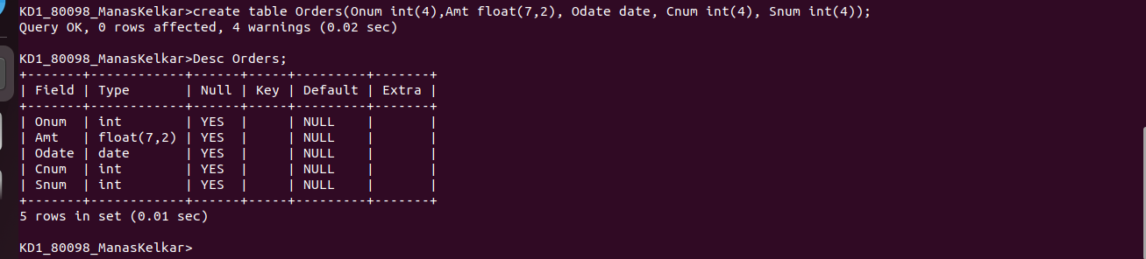

4)Inserting data into the table SALESPEOPLE :

Query:

insert into SALESPEOPLE values(1001,'Peel','London',0.12),(1002,'Serres','San Jose',0.13),(1004,'Motika','London',0.11),(1007,'Rifkin','Barcelona',0.15),(1003,'Axelrod','New York',0.1);

Screenshot:
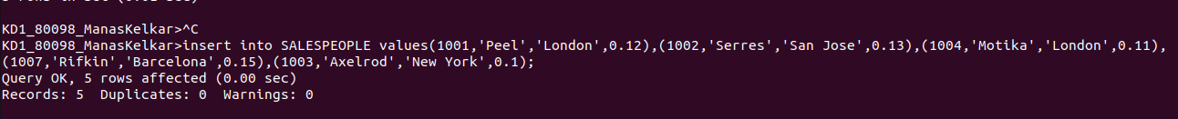
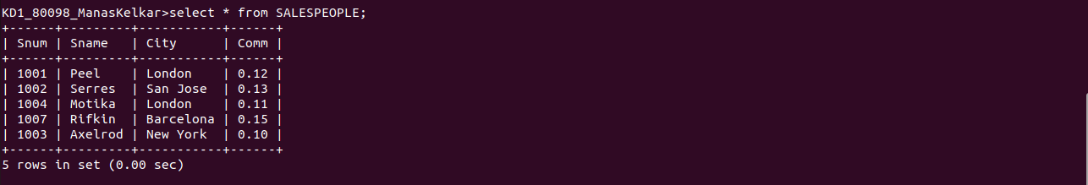

5) Inserting data into the table CUSTOMERS :

Query:

INSERT into CUSTOMERS values(2001,'Hoffman','London',100,1001),(2002,'Giovanni','Rome',200,1003),(2003,'Liu','San_Jose',200,1002),(2004,'Grass','Berlin',300,1002),(2006,'Clemens','London',100,1001),(2008,'Cisneros','San Jose',300,1007),(2007,'Pereira','Rome',100,1004);

Screenshot:
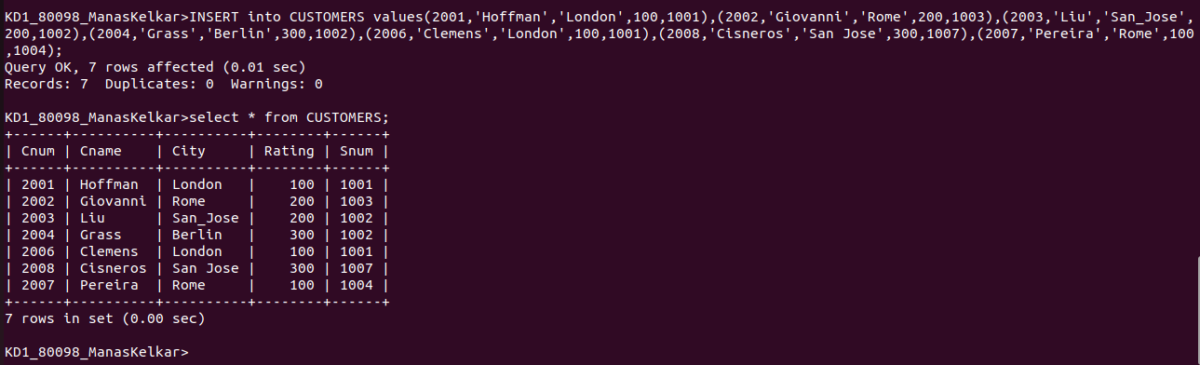

6) Inserting data into the table Orders:

Query:
insert into Orders values(3001,18.69,'1990-10-03',2008,1007),(3003,767.19,'1990-10-03',2001,1001),(3002,1900.10,'1990-10-03',2007,1004),(3005,5160.44,'1990-10-03',2003,1002),(3006,1098.16,'1990-10-03',2008,1007),(3009,1713.29,'1990-10-04',2002,1003),(3007,75.75,'1990-10-04',2004,1002),(3008,4723.00,'1990-10-05',2006,1001),(3010,1309.95,'1990-10-06',2004,1002),(3011,9891.88,'1990-10-06',2006,1001);

Screenshot:
