Assignment 10:
Name: Manas Kelkar
Batch and Roll No: KD1 & 80098
=======================================================================

Q1)Write a query that produces all pairs of salespeople who are living in the same city. Exclude combinations of salespeople with themselves as well as duplicate rows with the order reversed.

Ans:
Query: select a.Sname "Salespeople Name" ,b.Sname "Salespeople Name",a.City "Same City" from SALESPEOPLE a, SALESPEOPLE b where a.City=b.City and a.Sname<b.Sname;

Screenshot:
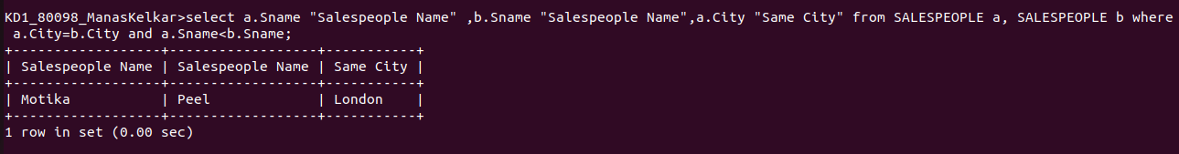

Q2)Write a query that produces the names and cities of all customers with the same rating as Hoffman.

Ans:
Query: select b.Cname, b.City from CUSTOMERS a,CUSTOMERS b where
a.Rating =b.Rating and a.Cname='Hoffman';

Screenshot:
