Assignment 5

Q1) Write a query that will give you all orders for more thtan Rs.1000;

Query:
select * from Orders where Amt>1000;

Screenshot:


Q2) Write a query that will give you the names and cities of all salespeople in london with a commision above 0.10

Query:
SELECT Sname,City from SALESPEOPLE where City='London' and Comm>0.10;

Screenshot:
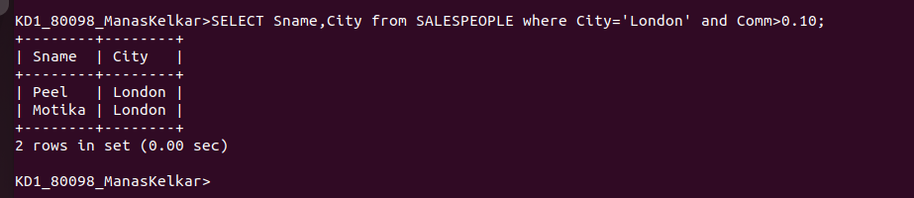
Q3) Write a query on the CUSTOMERS table whose output will exclude all the customers with a rating <=100, unless they are located in Rome.

Query:
SELECT * FROM CUSTOMERS WHERE Rating>100 or City='Rome';

Screenshot:


Q4) What will be the output from the following query?

Query:
Select * from Orders
where (Amt<1000 or
not (Odate =’1990-10-03’ and Cnum >2003));

Screenshot :
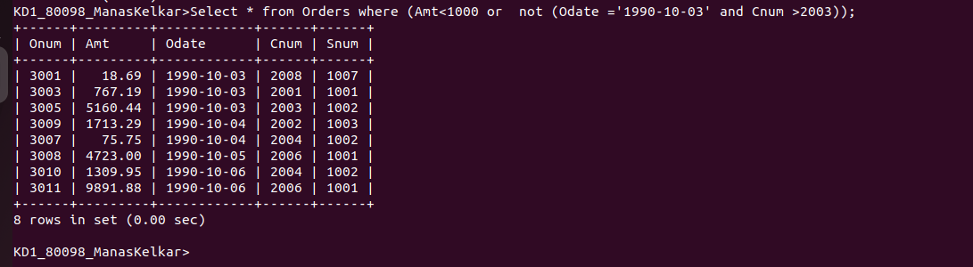

Q5)What will be the output of the following query?

Query:
Select * from Orders
where NOT ((Odate = ‘1990-10-03’ or Snum>1006) AND Amt >= 1500);

Screenshot :
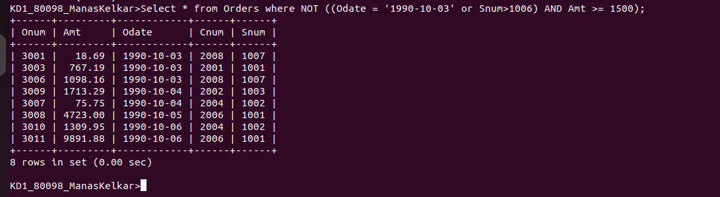

Q6) What is the simpler way to write below query.
Select Snum,Sname,City,Comm from SALESPEOPLE where (Comm > 0.12 or Comm < 0.14);
Answer :- Select Snum,Sname,City,Comm from SALESPEOPLE;

Screenshot:
