Assignment 11 :
Name: Manas Kelkar
Batch & Roll_No: KD1 & 80098
=======================================================================

Q1) Write a query tht uses a subquery to obtain all orders for customers named Cisneros. Assume you do not know his customers number (Cnum).

Ans:
Query: select Onum,Amt,Odate from Orders where Cnum=(select Cnum from CUSTOMERS where Cname='Cisneros');

Screenshot:
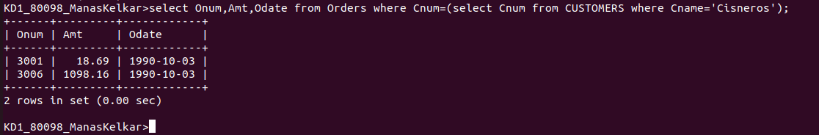

Q2) Write a query that produces the Names and Ratings of all customers who have above average orders.

Ans:
Query:sselect Cname,Rating,sum(Amt) from Orders,CUSTOMERS where Orders.Cnum=CUSTOMERS.Cnum group by Cname,Rating having sum(Amt)>(select avg(total) from (select Cnum,sum(Amt) "total" from Orders group by Cnum) Abc);

Screenshot:
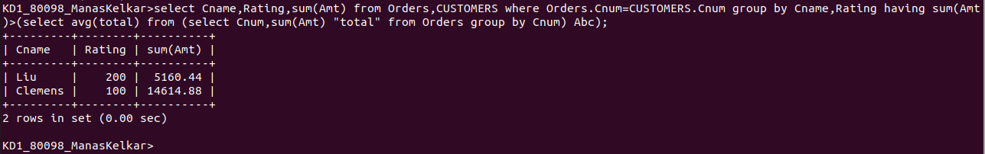

Q3) Write a query that selects the total amount in orders for each salesperson for whome this total is greater than the amount of the largest orderin the table.

Ans:
Query: select Snum,sum(Amt) from Orders group by Snum having sum(amt)>(select max(Amt) from Orders);

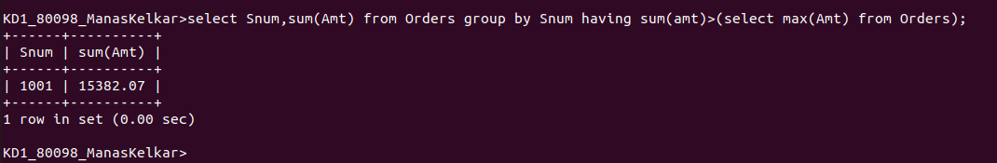
Screenshot:

